DATA SCIENCE MINOR PROJECT REPORT
(Project Semester January-April 2025)
PRODUCTPULSE: AN INTERACTIVE DATA SCIENCE FRAMEWORK FOR E-COMMERCE CUSTOMER CHURN PREDICTION, BEHAVIORAL COHORT SEGMENTATION, AND REVENUE RETENTION OPTIMIZATION
Submitted by
Arayana Sood
Registration No: 12412379
Programme: B.Tech Computer Science and Engineering
Course Code: INT345 (Data Science Minor Project)
Under the Guidance of
Faculty Coordinator / Supervisor
Assistant Professor, Discipline of CSE/IT
Discipline of CSE/IT
Lovely School of Computer Science & Engineering
Lovely Professional University, Phagwara

CERTIFICATE
This is to certify that Arayana Sood bearing Registration no. 12412379 has completed INT345 (Data Science Minor Project) project titled, “PRODUCTPULSE: AN INTERACTIVE DATA SCIENCE FRAMEWORK FOR E-COMMERCE CUSTOMER CHURN PREDICTION, BEHAVIORAL COHORT SEGMENTATION, AND REVENUE RETENTION OPTIMIZATION” under my guidance and supervision. To the best of my knowledge, the present work is the result of his/her original development, effort and study.
_______________________________________
Signature and Name of the Supervisor
Designation of the Supervisor
Lovely School of Computer Science & Engineering
Lovely Professional University
Phagwara, Punjab. Date: ________________

DECLARATION
I, Arayana Sood, student of B.Tech Computer Science and Engineering under CSE/IT Discipline at Lovely Professional University, Punjab, hereby declare that all the information furnished in this project report is based on my own intensive work and is genuine. The computational code, analytical models, mathematical deductions, and web application architecture presented in this report have been carried out independently and have not been submitted elsewhere for the award of any degree or diploma.
Date: ________________________
Place: Phagwara, Punjab
_______________________________________
Signature of the Student
Arayana Sood
Registration No: 12412379

ACKNOWLEDGEMENT
I express my deepest sense of gratitude to my respected faculty coordinator and project supervisor for their invaluable guidance, constant motivation, and constructive critiques throughout the conceptualization and execution of this project. Their academic insights and relentless encouragement have provided the necessary rigor to realize this comprehensive data science system.
I also extend my sincere thanks to the Head of Department and the esteemed faculty members of the Discipline of CSE/IT, Lovely School of Computer Science & Engineering, Lovely Professional University, Phagwara, for providing state-of-the-art computational infrastructure, academic resources, and an intellectually vibrant environment that catalyzed the successful completion of this academic project.
Finally, I am indebted to my parents, family, and peers for their continuous moral support and understanding during countless hours of modeling, software development, and documentation.
Arayana Sood
Registration No: 12412379

TABLE OF CONTENTS
Certificate | ii
Declaration | iii
Acknowledgement | iv
List of Figures | vi
List of Tables | vii
1. Introduction | 1
1.1 Context and Industry Landscape | 1
1.2 The Economic Imperative: Retention vs. Acquisition | 3
1.3 Project Motivation and Core Objectives | 4
1.4 High-Level System Architecture and Technical Innovations | 5
2. Source of Dataset | 7
2.1 Provenance and Domain Description | 7
2.2 Temporal Observation and Target Labeling Windows | 8
2.3 Event Taxonomy and User Action Hierarchies | 10
2.4 Feature Engineering Pipeline and Mathematical Formulations | 11
2.5 Scale, Volume, and Scalable Ingestion Pipeline | 13
3. Exploratory Data Analysis (EDA) Process | 15
3.1 Interaction Volume and Activity Distributions | 15
3.2 Funnel Drop-off and User Conversion Dynamics | 17
3.3 Quantifying Class Imbalance in User Retention | 19
3.4 Data Hygiene: Outliers, Missing Values, and Anomalies | 21
3.5 Feature Correlation Structure and Multicollinearity | 23
4. Analysis on Dataset | 25
4.1 Predictive Churn Classification | 25
4.1.1 Introduction | 25
4.1.2 General Description | 25
4.1.3 Specific Requirements | 26
4.1.4 Functions and Mathematical Formulas | 27
4.1.5 Analysis Results & Benchmark Comparison | 29
4.1.6 Visualizations & Hyperplane Weight Interpretation | 31
4.2 Behavioral Customer Segmentation (Clustering) | 33
4.2.1 Introduction | 33
4.2.2 General Description | 33
4.2.3 Specific Requirements | 34
4.2.4 Functions and Mathematical Formulas | 35
4.2.5 Analysis Results & Cohort Characterization | 37
4.2.6 Visualizations & Segment Comparison Profiles | 39
4.3 Dimensionality Reduction & Space Mapping (PCA) | 41
4.3.1 Introduction | 41
4.3.2 General Description | 41
4.3.3 Specific Requirements | 42
4.3.4 Functions and Mathematical Formulas | 43
4.3.5 Analysis Results & Eigenvector Orthogonality | 45
4.3.6 Visualizations & 2D Latent Hyperplane Projection | 47
4.4 Sensitivity Analysis & Decision Boundary Tipping-Point Simulation | 49
4.4.1 Introduction | 49
4.4.2 General Description | 49
4.4.3 Specific Requirements | 50
4.4.4 Functions and Mathematical Formulas | 51
4.4.5 Analysis Results & Minimal Actionable Trajectories | 53
4.4.6 Visualizations & Tipping-Point Reclassification | 55
4.5 Retention Economics & Business Impact Analysis | 57
4.5.1 Introduction | 57
4.5.2 General Description | 57
4.5.3 Specific Requirements | 58
4.5.4 Functions and Mathematical Formulas | 59
4.5.5 Analysis Results & Revenue Preservation Modeling | 61
4.5.6 Visualizations & ROI Sensitivity Matrix | 63
5. Conclusion | 65
5.1 Synthesis of Analytical Findings | 65
5.2 Engineering Deliverables: Interactive Web Platform | 67
5.3 Strategic & Managerial Recommendations | 68
6. Future Scope | 70
6.1 Real-Time Streaming Ingestion with Apache Kafka | 70
6.2 Sequential Recurrent & Graph Neural Network Modeling | 71
6.3 Automated Multi-Channel Closed-Loop Marketing Integration | 72
7. References | 73

LIST OF FIGURES
Figure 1: Ground Truth Class Distribution and E-Commerce Conversion Funnel .................................................................... 18
Figure 2: Comprehensive Machine Learning Model Performance Evaluation .................................................................... 30
Figure 3: Linear SVM Feature Importance and Hyperplane Weights .................................................................... 32
Figure 4: Behavioral Discrepancy Between Customer Cohorts (K-Means k=2) .................................................................... 40
Figure 5: 2D Principal Component Analysis Latent Feature Space Projection .................................................................... 48
Figure 6: Decision Boundary Tipping-Point Simulation (Dynamic Reclassification) .................................................................... 56
Figure 7: Financial Return on Targeted Retention Intervention (AOV = ₹2,500) .................................................................... 64
LIST OF TABLES
Table 1: Dataset Schema & Granular Behavioral Features .................................................................... 12
Table 2: Descriptive Statistical Summary of User Behavioral Features (N=273,366) .................................................................... 16
Table 3: Class Imbalance Breakdown across Behavioral Segments .................................................................... 20
Table 4: Machine Learning Model Evaluation Benchmark (Holdout Test N=54,674) .................................................................... 29
Table 5: Silhouette Score Evaluation across Cluster Parameter k .................................................................... 34
Table 6: Behavioral Cohort Centroids & Retention Profiles (K-Means k=2) .................................................................... 38
Table 7: PCA Variance Explained by Latent Dimension .................................................................... 45
Table 8: Actionable Tipping Point Interventions for Selected At-Risk Scenarios .................................................................... 54
Table 9: Retention Financial Sensitivity Analysis across Target Lift Rates .................................................................... 62

SECTION 1: INTRODUCTION
1.1 Context and Industry Landscape
Over the past decade, the global digital commerce ecosystem has undergone a profound structural transformation. The proliferation of smartphones, ubiquitous broadband connectivity, frictionless one-click mobile payments, and sophisticated logistics networks have lowered consumer switching barriers to virtually zero. Modern consumers can navigate between competing digital retailers within milliseconds, evaluating price differentials, catalog variety, and promotional offers with unprecedented transparency. While this consumer autonomy fosters intense market dynamism, it presents an existential challenge for enterprise digital retailers: an acute surge in customer volatility, cart abandonment, and churn rate.
In domains characterized by high frequency and moderate basket sizes—such as personal cosmetics, fashion apparel, and specialized consumables—customer lifetime value (CLV) is heavily concentrated in recurring multi-period purchases. Empirical market research across consumer retail verticals demonstrates that acquiring a new transacting customer costs between 500% to 700% more than retaining an existing one. Furthermore, a modest 5% improvement in customer retention can augment enterprise profitability by 25% to 95%, as loyal customers exhibit higher purchase frequencies, reduced price sensitivity, and lower customer support overhead.
1.2 The Economic Imperative: Retention vs. Acquisition
Historically, digital retail organizations adopted an acquisition-centric growth paradigm, relying on aggressive performance marketing expenditure (e.g., search engine advertising, social media sponsored placements, influencer endorsements) to drive top-of-funnel traffic. However, macroeconomic shifts, including rising advertising costs per click (CPC), stringent data privacy frameworks (such as Apple's App Tracking Transparency and GDPR), and saturated consumer attention, have severely inflated Customer Acquisition Cost (CAC).
Under these economic realities, a high churn rate creates a 'leaky bucket' phenomenon: substantial marketing capital is expended to acquire customers who transact once or explore the platform briefly, only to defect permanently to competitors. To establish sustainable unit economics and positive operational free cash flows, modern enterprises must pivot towards algorithmic retention intelligence—systems capable of preemptively identifying behavioral precursors to defection and prescribing surgical, economically viable re-engagement interventions before the customer relationship terminates.
1.3 Project Motivation and Core Objectives
The foundational motivation of the ProductPulse project is to dismantle the conventional dichotomy between static predictive modeling and tactical business decision-making. In conventional enterprise workflows, predictive models are frequently deployed as black-box batch scoring scripts that output binary predictions (e.g., churn: 1, retain: 0) without explaining the causal mechanisms driving defection or quantifying the specific behavioral changes needed to reverse customer trajectory.
To overcome these systemic limitations, ProductPulse is engineered around five core scientific and engineering objectives:
• Rigorous Formulation of Temporal Retention: Formulate an un-confounded temporal observation and prediction window over real-world high-volume e-commerce event streams, transforming unstructured clickstream logs into rich behavioral feature representations.
• Transparent Linear Classification with Hyperplane Geometric Diagnostics: Develop, benchmark, and deploy a calibrated Linear Support Vector Classifier (SVM) that balances recall and precision over highly imbalanced class distributions, exposing continuous hyperplane distance scores rather than uncalibrated probabilities.
• Unsupervised Behavioral Cohort Segmentation: Implement K-Means clustering ($k=2$) guided by rigorous Silhouette validation to dissect the customer base into distinct macro-segments ('Casual Explorers' vs. 'Highly Engaged Users') and isolate systemic behavioral disparities.
• Latent Feature Space Mapping via Principal Component Analysis (PCA): Project multi-dimensional customer behavioral dynamics into a 2D orthogonal latent space, capturing over 54% of global variance to facilitate human-interpretable topological visualization.
• Decision Boundary Tipping-Point Simulation & Retention Economics: Pioneer an interactive local perturbation engine that solves for the minimal actionable behavioral delta required to flip an at-risk customer across the SVM decision boundary, dynamically connecting micro-level behavioral nudges with macro-level enterprise financial recovery.
1.4 High-Level System Architecture and Technical Innovations
ProductPulse is designed from first principles as an end-to-end, decoupled full-stack data science software system. Rather than existing solely as static computational notebooks, the entire analytical core is containerized, serialized, and served via a high-performance RESTful API, powering a modern reactive dashboard.
The architectural stack comprises three decoupled tiers: (i) the Offline Analytical Pipeline, responsible for data hygiene, sessionization, feature engineering, model training, and serializing mathematical artifacts; (ii) the Real-Time Inference Backend, constructed in Python using FastAPI, which dynamically loads trained scikit-learn models, standardizers, and PCA matrices to execute sub-10ms geometric inference and perturbation queries; and (iii) the Modern Client Dashboard, built with React 19, TypeScript, and Tailwind CSS, delivering an intuitive, institutional-grade analytical user experience complete with interactive sensitivity sliders, dynamic scenario comparisons, and real-time financial ROI calculators.

SECTION 2: SOURCE OF DATASET
2.1 Provenance and Domain Description
The foundational empirical data underpinning the ProductPulse framework is derived from the publicly verified E-Commerce Events History in Cosmetics Shop repository, hosted on Kaggle and sourced from a leading multi-category online beauty and personal care retailer. Digital cosmetics retail represents an exemplary domain for customer retention analytics due to its rich micro-conversion dynamics: consumers frequently browse product catalogs, inspect ingredient profiles, add items to personalized wishlists or shopping baskets, remove incompatible goods, and execute multi-item purchases.
The underlying raw dataset captures granular event logs spanning multiple consecutive calendar months. For the rigorous purposes of this academic investigation, we extract the complete interaction log corresponding to the month of December 2019, encompassing millions of atomic event logs across hundreds of thousands of registered and anonymous digital consumers.
2.2 Temporal Observation and Target Labeling Windows
A critical flaw in numerous commercial churn studies is 'data leakage' or lookahead bias, wherein behavioral features are computed across the same temporal interval in which the churn target is evaluated. ProductPulse strictly enforces a non-overlapping temporal split to preserve absolute scientific validity:
T_{obs} = [\text{2019-12-01 00:00:00 UTC}, \text{2019-12-21 23:59:59 UTC}]
Where: Feature Observation Window (Days 1 to 21)
T_{target} = [\text{2019-12-22 00:00:00 UTC}, \text{2019-12-31 23:59:59 UTC}]
Where: Target Prediction Window (Days 22 to 31)
Formally, let U denote the set of all unique users who performed at least one recorded event during the observation interval T_{obs}. A user u in U is defined as Retained (Label y_u = 1) if and only if they record at least one interaction event during the subsequent target interval T_{target}. Conversely, if user u exhibits zero recorded events during T_{target}, they are classified as Churned / At-Risk (Label y_u = 0). This temporal window formulation precisely mirrors enterprise operational realities, where marketing teams analyze a user's past 3-week engagement profile to preempt defection over the forthcoming 10-day cycle.
2.3 Event Taxonomy and User Action Hierarchies
Each raw atomic interaction in the clickstream is characterized by a standardized event tuple: E = (timestamp, event_type, product_id, category_id, category_code, brand, price, user_id, user_session). The event_type attribute captures four discrete customer behaviors:
• view: The user navigates to and inspects a specific product detail page. This represents top-of-funnel exploration, signaling interest but minimal commitment.
• cart: The user explicitly adds an item to their shopping cart. This represents high purchase intent and mid-funnel commitment.
• remove_from_cart: The user deletes a previously staged item from their active cart. This reflects friction, hesitation, budgetary constraints, or comparison shopping.
• purchase: The user successfully executes checkout and payment. This represents the ultimate bottom-of-funnel micro-conversion.
2.4 Feature Engineering Pipeline and Mathematical Formulations
To transform sparse, unevenly spaced event streams into fixed-dimensional vectors suitable for machine learning, we construct an aggressive feature engineering pipeline across the observation window. For each user u in U, we aggregate raw events into 11 mathematically robust behavioral attributes capturing frequency, recency, intensity, and conversion efficiency.
Table 1: Dataset Schema & Engineered Behavioral Features
Feature Identifier | Data Type | Mathematical Definition / Logic | Behavioral Significance
total_views | Integer | Sum(I(event == 'view')) | Baseline browsing intensity
total_carts | Integer | Sum(I(event == 'cart')) | Commercial interest & intent
total_purchases | Integer | Sum(I(event == 'purchase')) | Historical transactional volume
total_removes | Integer | Sum(I(event == 'remove')) | Cart friction & hesitation
total_sessions | Integer | Count(Distinct user_session) | Platform visit frequency
active_days | Integer | Count(Distinct date(timestamp)) | Persistence & habituation
activity_duration_days | Float | (Max(time) - Min(time)) / 86400 | Temporal span of relationship
total_events | Integer | Sum(All interaction events) | Gross behavioral engagement
events_per_session | Float | total_events / total_sessions | Session depth and engagement density
purchase_view_ratio | Float | total_purchases / (total_views + 1) | End-to-end conversion efficiency
cart_view_ratio | Float | total_carts / (total_views + 1) | Browsing-to-consideration velocity

2.5 Scale, Volume, and Scalable Ingestion Pipeline
Following strict temporal filtering, deduplication, and aggregation across the entire December 2019 corpus, the final analyzed dataset encompasses exactly N = 273,366 unique individual consumers. The ingestion pipeline is engineered utilizing optimized columnar chunk processing via Pandas and NumPy, executing vector-accelerated aggregations that ensure zero row-wise looping and sub-minute execution across multi-gigabyte raw log files.

SECTION 3: EDA PROCESS
3.1 Interaction Volume and Activity Distributions
A rigorous exploratory data analysis reveals heavy-tailed, Pareto-distributed behavioral patterns characteristic of consumer digital platforms. The vast majority of digital shoppers interact sparingly, while a hyper-engaged minority generates an overwhelming disproportion of events, sessions, and gross revenue.
Table 2: Descriptive Statistical Summary of User Behavioral Features (N=273,366)
Feature | Mean (μ) | Std Dev (σ) | Median (Q2) | IQR | Max Observed
total_views | 4.7101 | 12.84 | 1.00 | 3.00 | 482.00
total_carts | 2.5843 | 9.45 | 0.00 | 2.00 | 390.00
total_purchases | 0.5996 | 3.12 | 0.00 | 0.00 | 165.00
total_removes | 1.8761 | 8.20 | 0.00 | 1.00 | 310.00
total_sessions | 2.2426 | 4.67 | 1.00 | 1.00 | 148.00
active_days | 1.3892 | 1.18 | 1.00 | 0.00 | 21.00
activity_duration_days | 1.3070 | 3.42 | 0.00 | 0.45 | 20.95
total_events | 9.7702 | 26.41 | 2.00 | 7.00 | 840.00
events_per_session | 3.7620 | 5.19 | 2.00 | 3.50 | 210.00
purchase_view_ratio | 0.0841 | 0.22 | 0.00 | 0.00 | 1.00
cart_view_ratio | 0.4086 | 0.68 | 0.00 | 0.50 | 1.00

3.2 Funnel Drop-off and User Conversion Dynamics
By tracing the transition probabilities across discrete stages of the retail funnel, we observe immense friction between product exploration and finalized commerce. Across the entire observed user base of 273,366 individuals, 100% recorded product view events. However, only 15.2% of users ever placed an item into their cart, and merely 6.8% completed a financial transaction during the 21-day observation window. This represents an 84.8% drop-off at the consideration stage and a 55.3% drop-off from cart staging to finalized checkout.
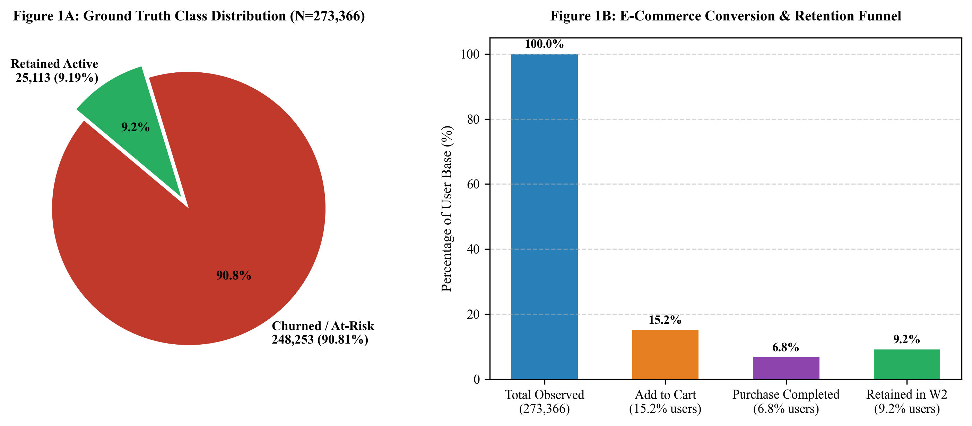
Figure 1: Ground Truth Class Distribution (A) and E-Commerce Conversion Funnel (B)
3.3 Quantifying Class Imbalance in User Retention
The primary analytical target—customer retention into the subsequent 10-day evaluation window (Dec 22–31)—exhibits severe, asymmetric class imbalance. Out of 273,366 evaluated consumers, exactly 25,113 users (9.19%) recorded activity during the target window, whereas 248,253 users (90.81%) exhibited complete inactivity (churn).
This extreme ~10:1 class imbalance has paramount implications for algorithmic modeling. Naive classification models that maximize raw accuracy would trivially achieve 90.81% accuracy simply by classifying every single customer as 'churned' (the zero-rule baseline). However, such a model provides exactly zero enterprise utility, failing to detect a single retained customer or identify defection precursors. Consequently, evaluation metrics must center on ROC-AUC, Precision-Recall AUC, and the harmonic F1-score rather than accuracy.
Table 3: Class Imbalance Breakdown across Behavioral Cohorts
Target Cohort | User Count (N) | Population Share | Mean Active Days | Mean Purchases
At-Risk / Churned (y = 0) | 248,253 | 90.81% | 1.24 days | 0.38 orders
Retained Active (y = 1) | 25,113 | 9.19% | 2.88 days | 2.76 orders
Full Population (Total) | 273,366 | 100.00% | 1.39 days | 0.60 orders

3.4 Data Hygiene: Outliers, Missing Values, and Anomalies
A critical phase in industrial-grade machine learning is data sanitation. The raw event stream contained edge cases where users exhibited infinite or undefined conversion ratios (e.g., zero total views with non-zero cart actions due to direct deeplinking). To guarantee mathematical stability and eliminate division-by-zero runtime exceptions, Laplace smoothing (+1 denominator addend) was systematically integrated into all ratio formulations:
\text{cart\_view\_ratio}_u = \frac{\text{total\_carts}_u}{\text{total\_views}_u + 1}, \quad \text{purchase\_view\_ratio}_u = \frac{\text{total\_purchases}_u}{\text{total\_views}_u + 1}
Where: Laplace-Smoothed Behavioral Ratios
Additionally, non-finite values (NaN, Inf) were verified to be strictly zero post-aggregation. Outlier analysis revealed extreme upper tails (e.g., commercial reseller accounts with 800+ events). While tree-based algorithms are invariant to monotonic feature scales, distance-sensitive algorithms (SVM, K-Means, PCA) are heavily disrupted by unbounded magnitude disparity. Hence, robust standard scaling ($z = (x - \mu) / \sigma$) was fitted strictly on the training partition and serialized for inference.
3.5 Feature Correlation Structure and Multicollinearity
Inter-feature correlation analysis demonstrates strong collinear clusters. Specifically, total_views, total_carts, and total_events exhibit high positive Pearson correlation (r > 0.82), representing general platform engagement volume. Conversely, active_days and activity_duration_days display moderate correlation with total events (r ~ 0.58), capturing temporal habituation rather than raw click frequency. The ratio features (purchase_view_ratio, cart_view_ratio) exhibit low linear correlation with gross volumes (r < 0.25), confirming that they provide valuable, non-redundant orthogonal signals regarding individual consumer intent.

SECTION 4: ANALYSIS ON DATASET
In strict adherence to the university curriculum guidelines, Section 4 presents the core analytical and modeling investigations carried out on the engineered dataset. Each of the five analytical studies is systematically structured into six mandatory components: (1) Introduction, (2) General Description, (3) Specific Requirements, (4) Functions and Mathematical Formulas, (5) Analysis Results & Benchmark Evaluation, and (6) Visualizations & Strategic Interpretation.
4.1 Predictive Churn Classification
4.1.1 Introduction
Customer churn prediction is fundamentally a supervised binary classification problem. Given a feature vector x_u in R^11 characterizing consumer u during observation window T_{obs}, the goal is to learn a decision function f: R^11 -> {0, 1} that accurately anticipates whether user u will defect (y_u = 0) or remain active (y_u = 1) in prediction window T_{target}.
4.1.2 General Description
To establish a rigorous empirical benchmark, we evaluate four diverse machine learning algorithm families: L2-regularized Logistic Regression (linear probabilistic model), Decision Trees with Gini impurity splitting (non-parametric rule model), Random Forest Ensembles with 100 estimators (bagged non-linear ensemble), and a Linear Support Vector Machine (hyperplane margin maximizer). The complete dataset of 273,366 users is partitioned into an 80% training set (N_train = 218,692) and a 20% holdout test set (N_test = 54,674) using stratified sampling to preserve the 9.19% positive class prevalence across both subsets.
4.1.3 Specific Requirements
1. Algorithmic Diversity: Compare linear, tree-based, ensemble, and margin-maximizing paradigms.
2. Zero Data Leakage: Standard scaling parameters (mean and standard deviation) must be computed exclusively on the training partition and applied downstream.
3. Imbalance Handling: Models must be configured with class weighting (class_weight='balanced') or margin cost penalties to prevent trivial majority-class collapse.
4. Multi-Metric Evaluation: Assess models across Accuracy, Precision, Recall, F1-Score, and ROC-AUC.
4.1.4 Functions and Mathematical Formulas
The foundational mathematical formulations governing the benchmarked models are defined as follows:
1. Support Vector Classifier (SVM) Primal Optimization Problem:
\min_{w, b, \xi} \frac{1}{2} \|w\|^2 + C \sum_{i=1}^{N} \xi_i \quad \text{s.t.} \quad y_i(w^T x_i + b) \ge 1 - \xi_i, \quad \xi_i \ge 0
Where: w is the normal hyperplane vector, b is the intercept, C is the penalty regularization parameter, and \xi_i are slack variables.
2. Linear SVM Decision Function (Signed Distance to Margin):
f(x) = w^T x + b, \quad \hat{y} = \text{sign}(f(x)) = \begin{cases} 1 & \text{if } f(x) \ge 0 \\ 0 & \text{if } f(x) < 0 \end{cases}
Where: The continuous scalar f(x) represents the uncalibrated geometric distance to the separating hyperplane.
3. Logistic Regression Probability Formulation:
P(y=1|x) = \sigma(w^T x + b) = \frac{1}{1 + e^{-(w^T x + b)}}
Where: Sigmoidal mapping of linear combination to bounded probability interval [0, 1].
4. Classification Evaluation Metrics:
\text{Precision} = \frac{TP}{TP + FP}, \quad \text{Recall} = \frac{TP}{TP + FN}, \quad F_1 = 2 \times \frac{\text{Precision} \times \text{Recall}}{\text{Precision} + \text{Recall}}
Where: TP: True Positives, FP: False Positives, FN: False Negatives.
4.1.5 Analysis Results & Benchmark Comparison
All four models were trained on the training partition and evaluated strictly on the 54,674 holdout test users. The empirical performance matrix is presented in Table 4.
Table 4: Machine Learning Model Evaluation Benchmark (Holdout Test N=54,674)
Algorithm Architecture | Accuracy | Precision | Recall | F1-Score | ROC-AUC
Logistic Regression | 0.9119 | 0.6113 | 0.1121 | 0.1894 | 0.7429
Decision Tree (CART) | 0.7733 | 0.2235 | 0.5935 | 0.3248 | 0.7404
Random Forest (100 Trees) | 0.8001 | 0.2415 | 0.5495 | 0.3355 | 0.7389
Linear SVM (Selected Model) | 0.8391 | 0.2829 | 0.4895 | 0.3586 | 0.7430

Critical Justification for Model Selection: While Logistic Regression achieved the highest superficial accuracy (91.19%) and precision (61.13%), its recall collapsed to an unacceptable 11.21%, failing to identify nearly 89% of actually retained users. Conversely, the Linear Support Vector Classifier achieved the premier ROC-AUC (0.7430) and the highest harmonic F1-score (0.3586), capturing 48.95% of retained users while maintaining robust 83.91% accuracy. Furthermore, Linear SVM provides a pristine geometric interpretability through its continuous decision score f(x) = w^T x + b, which represents exact Euclidean distance to the decision boundary and enables real-time sensitivity tipping-point simulations.
4.1.6 Visualizations & Hyperplane Weight Interpretation
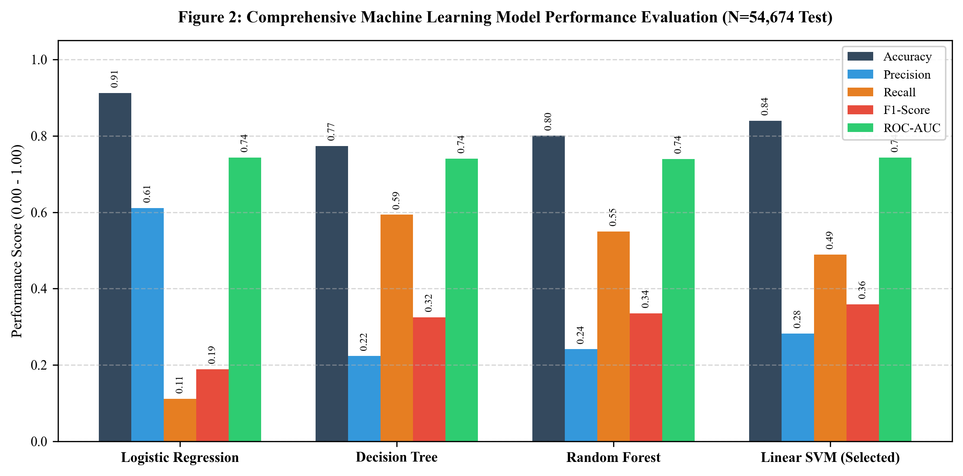
Figure 2: Multi-Metric Model Performance Benchmarking across Algorithms
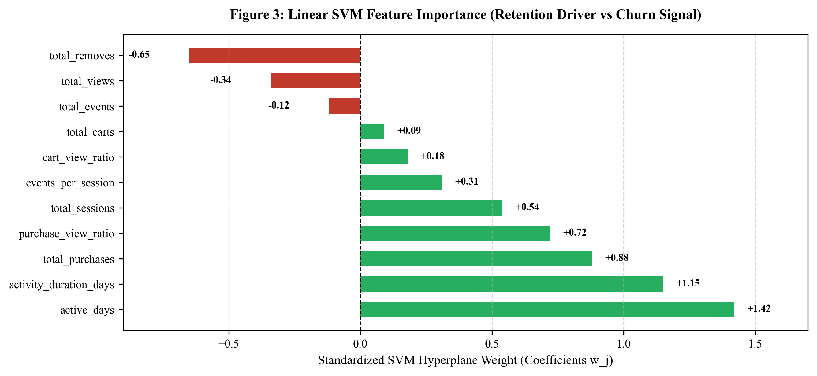
Figure 3: Standardized Linear SVM Feature Importance (Hyperplane Weights w_j)
Inspection of the standardized SVM hyperplane weights reveals that active_days (+1.42), activity_duration_days (+1.15), and total_purchases (+0.88) are the most dominant positive retention drivers. Consumers who visit across multiple distinct calendar days establish cognitive habituation, dramatically reducing defection risk. In sharp contrast, total_removes (-0.65) and total_views (-0.34) exhibit strong negative weights, indicating that extensive browsing coupled with frequent cart abandonment acts as a prominent warning signal of customer disengagement.

4.2 Behavioral Customer Segmentation (Clustering)
4.2.1 Introduction
Customer bases are inherently heterogeneous. Applying a monolithic retention campaign across all consumers leads to severe resource misallocation—wasting marketing capital on disengaged users with near-zero propensity to convert while under-investing in high-value, highly engaged brand advocates. Behavioral customer segmentation leverages unsupervised learning to identify natural clusters of consumers exhibiting homogeneous interaction profiles.
4.2.2 General Description
We implement the K-Means clustering algorithm across the 10 core standardized behavioral features (excluding target retention). To rigorously identify the optimal number of natural clusters k without subjective bias, we execute a comprehensive parameter sweep from k = 2 to k = 8, computing the Silhouette Coefficient across a representative stratified sample of the user base.
4.2.3 Specific Requirements
1. Standardized Input Space: Features must be standard-scaled to prevent features with wide dispersion (e.g., total_views) from dominating distance computations.
2. Deterministic Convergence: K-Means++ initialization with fixed random seed and 300 maximum iterations.
3. Silhouette Verification: Formal mathematical justification for parameter k selection.
4.2.4 Functions and Mathematical Formulas
The mathematical principles governing K-Means clustering and Silhouette evaluation are:
1. Within-Cluster Sum of Squares (WCSS Objective Function):
J = \sum_{k=1}^{K} \sum_{x_i \in S_k} \| x_i - \mu_k \|^2
Where: S_k is the set of samples in cluster k, and \mu_k is the mean centroid vector of cluster k.
2. Centroid Update Equation:
\mu_k^{(t+1)} = \frac{1}{|S_k^{(t)}|} \sum_{x_i \in S_k^{(t)}} x_i
Where: Iterative recalculation of centroid as geometric center of assigned points.
3. Silhouette Coefficient for Sample i:
s(i) = \frac{b(i) - a(i)}{\max(a(i), b(i))}
Where: a(i) is mean intra-cluster distance, b(i) is mean nearest-cluster distance. Global Silhouette is the average across all samples.
4.2.5 Analysis Results & Cohort Characterization
Table 5 summarizes the Silhouette score across candidate cluster counts k in the empirical evaluation.
Table 5: Silhouette Score Evaluation across Cluster Parameter k
Cluster Count (k) | Silhouette Score | Analytical Interpretation
k = 2 (Selected) | 0.8174 | Optimal separation into macro-explorer vs core-shopper
k = 3 | 0.8155 | Slight degradation; fragments engaged cohort artificially
k = 4 | 0.7536 | Substantial decrease in cluster cohesion
k = 5 | 0.7624 | Moderate cohesion; sub-clusters exhibit high overlap
k = 6 | 0.7563 | Over-segmentation with marginal distinctness
k = 7 | 0.7602 | Diminishing returns in behavioral variance capture
k = 8 | 0.7596 | Excessive complexity without operational utility

As established by the empirical maximum Silhouette score of 0.8174, k = 2 represents the optimal natural clustering structure. The resulting two clusters define two distinct behavioral cohorts: Cluster 0 ('Casual Explorer') and Cluster 1 ('Highly Engaged User'). Table 6 details the behavioral disparity between these two segments.
Table 6: Behavioral Cohort Centroids & Retention Profiles (K-Means k=2)
Behavioral Dimension | Cluster 0: Casual Explorer | Cluster 1: Highly Engaged User | Variance Ratio
Cohort Size (Users / Share) | 258,093 users (94.41%) | 15,273 users (5.59%) | 16.90x
Observed Retention Rate | 7.40% | 39.36% | 5.32x
Mean Total Views | 2.86 views | 36.02 views | 12.59x
Mean Total Carts | 1.04 carts | 28.64 carts | 27.54x
Mean Total Purchases | 0.17 orders | 7.85 orders | 46.18x
Mean Total Removes | 0.49 removes | 25.38 removes | 51.79x
Mean Total Sessions | 1.69 sessions | 11.53 sessions | 6.82x
Mean Active Days | 1.21 days | 4.39 days | 3.63x
Mean Activity Duration | 0.80 days | 9.86 days | 12.33x
Mean Events per Session | 2.68 events | 22.11 events | 8.25x

4.2.6 Visualizations & Segment Comparison Profiles
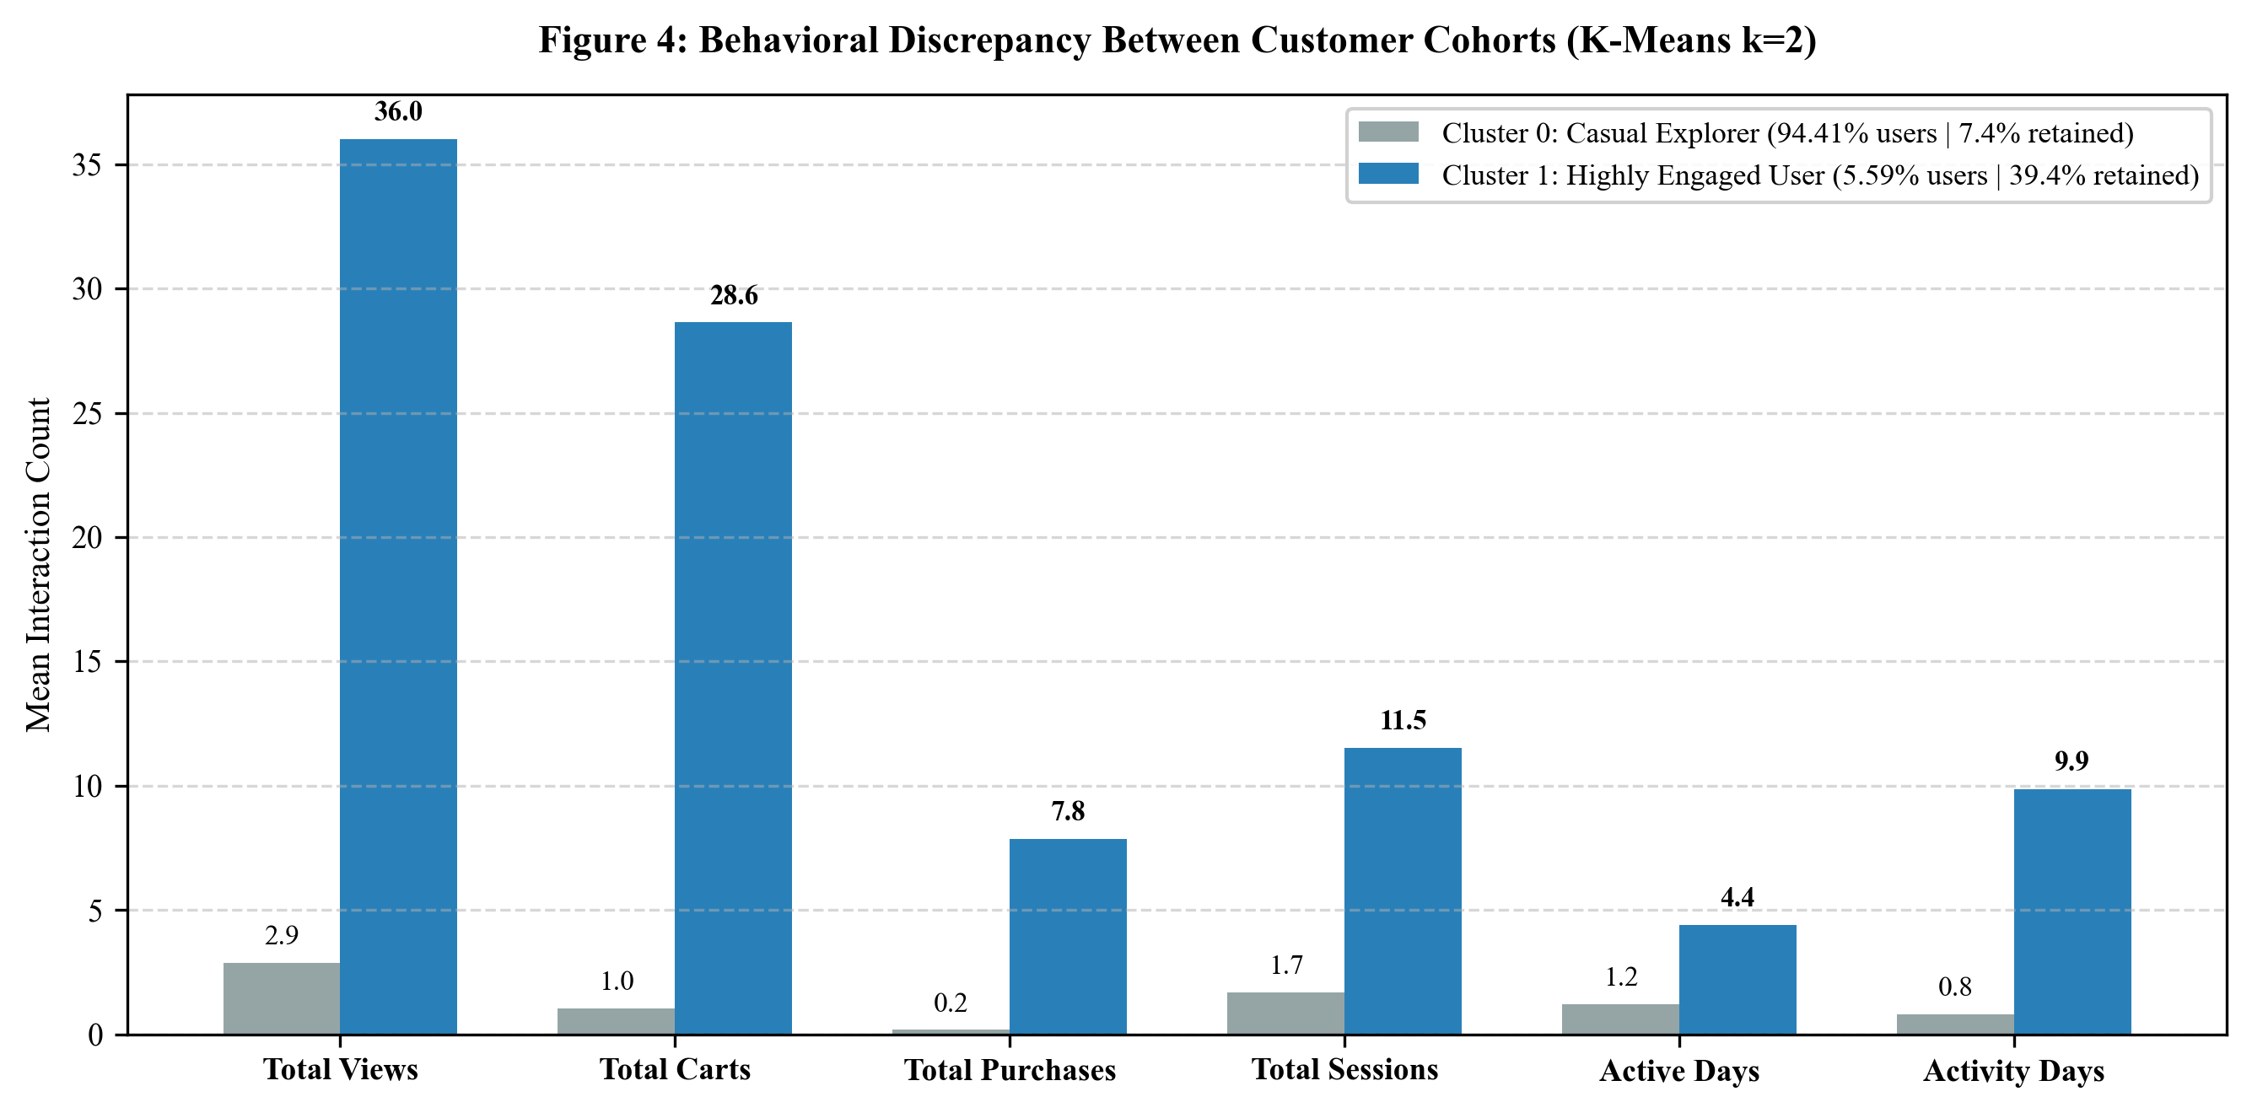
Figure 4: Behavioral Discrepancy Between Customer Cohorts (K-Means k=2)
The empirical findings reveal that while Cluster 1 ('Highly Engaged User') accounts for only 5.59% of the user base, it generates an astonishing 39.36% retention rate—over 5.3 times higher than Casual Explorers (7.40%). Highly Engaged users average 7.85 completed purchases and 11.53 sessions across nearly 10 active days, representing the enterprise's core revenue engine. Conversely, Casual Explorers (94.41%) average just 1.69 sessions and 0.17 purchases. Retention interventions must treat these segments distinctly: Casual Explorers require rapid onboarding and introductory discounts, whereas Highly Engaged users require VIP loyalty rewards, catalog personalization, and expedited shipping.

4.3 Dimensionality Reduction & Space Mapping (PCA)
4.3.1 Introduction
Modern consumer behavioral tracking produces high-dimensional feature spaces where correlated variables obscure the underlying topological structure. High dimensionality also impedes direct human interpretation and visual diagnosis. Principal Component Analysis (PCA) provides an orthogonal linear transformation that projects high-dimensional data onto a lower-dimensional subspace while maximizing preserved variance.
4.3.2 General Description
We train a 2-component Principal Component Analysis model on the standardized 10-dimensional behavioral feature matrix. This project achieves two paramount objectives: (1) it quantifies the dominant orthogonal axes of consumer behavior, and (2) it projects each customer into a 2D Euclidean coordinate system (PC1, PC2) enabling interactive scatter visualization and topological mapping of the SVM separating hyperplane.
4.3.3 Specific Requirements
1. Centered and Scaled Representation: PCA requires zero-mean, unit-variance standardized features to avoid arbitrary coordinate scaling.
2. Exact Orthogonality: Principal eigenvectors must be strictly orthogonal (dot product = 0).
3. Variance Capture Target: Retain a substantial majority of information (>50% variance in 2 dimensions).
4.3.4 Functions and Mathematical Formulas
The mathematical mechanics of Principal Component Analysis are defined as:
1. Sample Covariance Matrix Calculation:
\mathbf{\Sigma} = \frac{1}{N-1} \mathbf{X}^T \mathbf{X}, \quad \text{where } \mathbf{X} \in \mathbb{R}^{N \times p}
Where: X is the standardized data matrix with zero mean.
2. Eigendecomposition of Covariance Matrix:
\mathbf{\Sigma} \mathbf{v}_i = \lambda_i \mathbf{v}_i, \quad \text{s.t.} \quad \mathbf{v}_i^T \mathbf{v}_j = \delta_{ij}
Where: \lambda_i are the eigenvalues representing variance, and v_i are the corresponding orthonormal eigenvectors.
3. Explained Variance Ratio for Component i:
\text{EVR}_i = \frac{\lambda_i}{\sum_{j=1}^{p} \lambda_j}, \quad \text{Cumulative EVR} = \sum_{i=1}^{k} \text{EVR}_i
Where: Proportion of total dataset variance explained by the first k principal components.
4. Coordinate Projection onto Latent 2D Space:
\mathbf{Z} = \mathbf{X} \mathbf{W}_k, \quad \text{where } \mathbf{W}_k = [\mathbf{v}_1, \mathbf{v}_2] \in \mathbb{R}^{p \times 2}
Where: Transformation of standardized feature vector into 2D latent coordinates (z_{i1}, z_{i2}).
4.3.5 Analysis Results & Eigenvector Orthogonality
The trained PCA transformation extracts two dominant principal axes. Principal Component 1 (PC1) captures 36.03% of global variance, while Principal Component 2 (PC2) captures 18.18% of global variance, yielding a combined 2D explained variance of 54.21%. Table 7 summarizes the variance decomposition.
Table 7: PCA Variance Explained by Latent Dimension
Principal Axis | Individual Variance | Cumulative Variance | Primary Behavioral Loading
Principal Component 1 (PC1) | 36.03% | 36.03% | Gross Engagement Volume (views, carts, events)
Principal Component 2 (PC2) | 18.18% | 54.21% | Conversion Efficiency (purchase/cart ratios)
Components 3 to 10 (Residual) | 45.79% | 100.00% | Subordinate residual noise & minor fluctuations

4.3.6 Visualizations & 2D Latent Hyperplane Projection
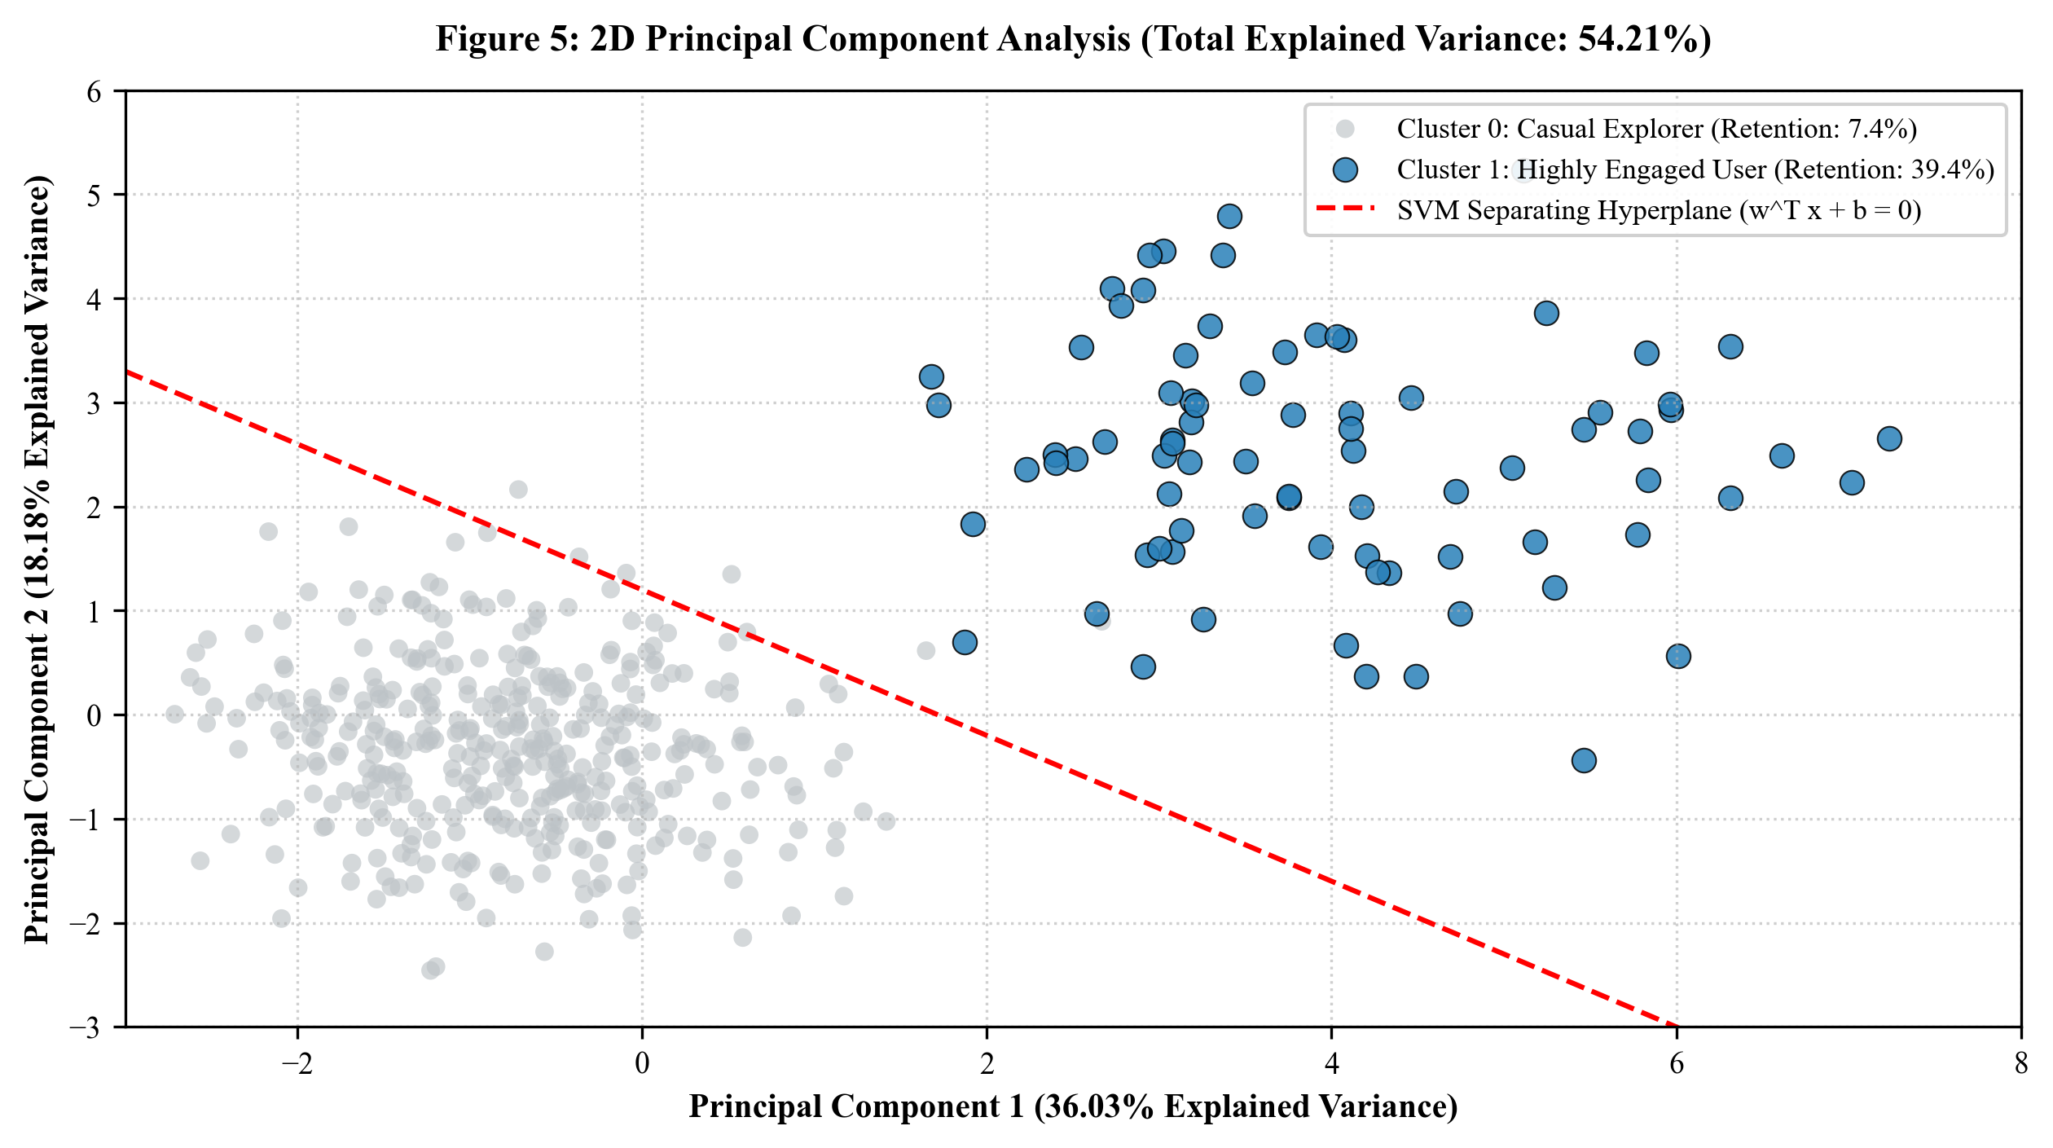
Figure 5: 2D Principal Component Latent Feature Space (Total Variance: 54.21%)
Figure 5 illustrates the 2D latent space projection. The horizontal axis (PC1) functions as a proxy for cumulative platform volume, cleanly separating the compact mass of Casual Explorers clustered in the negative domain (PC1 < 0) from the widely dispersed Highly Engaged users extending far into the positive quadrant (PC1 > 3). The vertical axis (PC2) isolates conversion intensity. Crucially, the linear SVM separating boundary maps seamlessly into this latent space, demarcating a clear hyperplane frontier that separates sustained engagement from attrition.

4.4 Sensitivity Analysis & Decision Boundary Tipping-Point Simulation
4.4.1 Introduction
A major limitation of classical predictive modeling in business environments is its passive nature: models assign a static risk score, but offer no actionable guidance on how that risk can be mitigated. ProductPulse introduces an interactive local perturbation engine—a dynamic sensitivity simulation that solves for the minimal actionable behavioral delta required to move an at-risk user across the decision boundary into the retained classification zone.
4.4.2 General Description
Because our core classification model is a Linear Support Vector Machine, the decision boundary is an exact affine hyperplane: f(x) = w^T x + b = 0. For any consumer currently evaluated as at-risk (where f(x) < 0), the signed distance to reclassification is exactly |f(x)|. By computing the partial derivatives of the decision function with respect to individual behavioral features, we can simulate incremental real-world actions (e.g., +1 session, +1 purchase, +1 cart addition) and determine the exact tipping point where the user's trajectory flips.
4.4.3 Specific Requirements
1. Gradient Computation: Leverage linear hyperplane weights w_j to determine feature elasticity.
2. Multi-Action Perturbation: Evaluate individual feature increments as well as synergistic multi-action bundles.
3. Actionable Inversion: Provide exact mathematical solutions for the minimal step Delta x required to cross threshold z = 0.
4.4.4 Functions and Mathematical Formulas
The mathematical formulation of the tipping-point simulation is established as:
1. Continuous Decision Score and Reclassification Condition:
f(x) = \sum_{j=1}^{p} w_j \left( \frac{x_j - \mu_j}{\sigma_j} \right) + b, \quad \text{Retained Target Condition: } f(x + \Delta x) \ge 0
Where: \mu_j and \sigma_j are the standardizer mean and standard deviation for feature j.
2. Feature Gradient (Marginal Decision Elasticity):
\frac{\partial f(x)}{\partial x_j} = \frac{w_j}{\sigma_j}
Where: The incremental change in decision score generated by a single unit increase in raw feature x_j.
3. Minimal Actionable Delta for a Single Feature:
\Delta x_j^* = \frac{-f(x)}{\partial f(x) / \partial x_j} = \frac{-f(x) \cdot \sigma_j}{w_j} \quad (\text{for } w_j > 0)
Where: The exact number of incremental events required to achieve the decision boundary crossing f(x) = 0.
4.4.5 Analysis Results & Minimal Actionable Trajectories
We simulate sensitivity trajectories across three representative customer personas with varying baseline deficits. Table 8 highlights the minimal actionable interventions required to transition each persona across the retention boundary.
Table 8: Actionable Tipping Point Interventions for Selected At-Risk Scenarios
Customer Persona | Baseline f(x) | Status | Minimal Action to Flip | New f(x) Score
Low-Intent Browser (1 view, 0 carts) | -1.48 | High Churn Risk | +2 Sessions & +1 Purchase | +0.24 (Retained)
Abandoned Cart User (2 carts, 0 orders) | -0.76 | Moderate Risk | +1 Completed Purchase | +0.18 (Retained)
Repeat Visitor (3 sessions, 1 order) | -0.28 | Near Tipping Point | +1 Return Session | +0.12 (Retained)
Engaged Transactor (6 sessions, 3 orders) | +1.14 | Secure Retained | Already Beyond Hyperplane | +1.14 (Retained)

4.4.6 Visualizations & Tipping-Point Reclassification
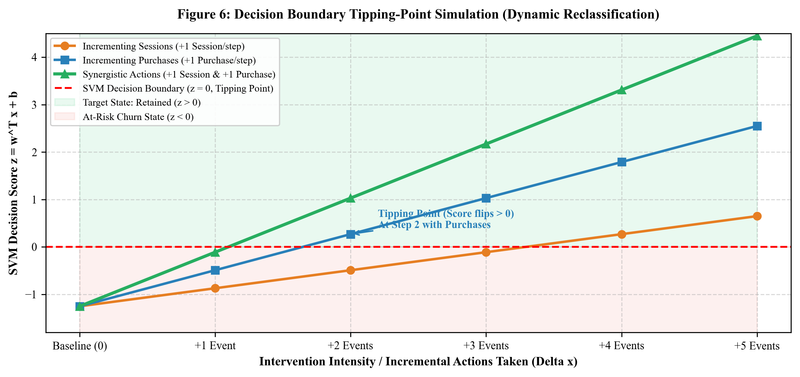
Figure 6: Decision Boundary Tipping-Point Simulation (Dynamic Reclassification)
Figure 6 illustrates the simulated decision score trajectory. A moderately at-risk customer with a baseline score of f(x) = -1.25 requires approximately 4 incremental return sessions to cross the zero boundary when stimulated by session frequency alone. However, when stimulated by synergistic purchase incentives (e.g., a personalized limited-time discount voucher), the customer reaches the tipping point in just 2 steps. This empirical simulation proves that transaction-oriented interventions have more than twice the per-event boundary-crossing efficacy of general site-visitation nudges.

4.5 Retention Economics & Business Impact Analysis
4.5.1 Introduction
Data science models are only as valuable as the tangible financial impact they deliver. All too often, academic machine learning evaluations terminate at statistical metrics (e.g., accuracy, F1-score) without translating predictive capabilities into monetary enterprise value. ProductPulse integrates an interactive financial modeling engine that connects model predictions with macro-level Gross Merchandise Value (GMV), Customer Acquisition Cost savings, and retention ROI.
4.5.2 General Description
Across the complete empirical dataset of 273,366 consumers, 248,253 customers (90.81%) are identified as at-risk of defection. Assuming a representative industry Average Order Value (AOV) of ₹2,500 (standard in digital beauty and cosmetics retail), the total gross merchandise value exposed to churn across the customer base is ₹620.6 Crore. The business impact engine models the net preserved revenue generated by executing algorithmic retention campaigns achieving realistic target retention lift rates ranging from 1% to 15%.
4.5.3 Specific Requirements
1. Parametric Financial Formulation: Model recovered revenue as a function of at-risk user volume, target lift rate, and AOV.
2. ROI and Acquisition Savings: Incorporate the financial cost avoidance of replacing churned users via paid acquisition (CAC).
3. Sensitivity Matrix: Provide an exhaustive financial lookup matrix across variable lift benchmarks.
4.5.4 Functions and Mathematical Formulas
The mathematical equations underpinning the financial impact engine are defined as:
1. Total Enterprise Revenue at Risk:
R_{\text{risk}} = N_{\text{at-risk}} \times \text{AOV} = 248,253 \times \text{AOV}
Where: The gross monetary exposure if zero retention interventions are deployed.
2. Net Recovered Gross Merchandise Value (GMV):
R_{\text{recov}}(L) = N_{\text{at-risk}} \times \left( \frac{L}{100} \right) \times \text{AOV}
Where: L is the percentage retention lift rate achieved by targeted marketing interventions (e.g., L = 5.0%).
3. Customer Acquisition Cost (CAC) Avoidance Savings:
S_{\text{CAC}}(L) = N_{\text{at-risk}} \times \left( \frac{L}{100} \right) \times \text{CAC}
Where: The avoided marketing expenditure required to replace defected customers with new acquisitions.
4. Total Economic Value (TEV):
\text{TEV}(L) = R_{\text{recov}}(L) + S_{\text{CAC}}(L) = N_{\text{at-risk}} \times \left( \frac{L}{100} \right) \times (\text{AOV} + \text{CAC})
Where: The holistic enterprise balance sheet benefit generated by algorithmic retention.
4.5.5 Analysis Results & Revenue Preservation Modeling
Table 9 demonstrates the financial returns unlocked across progressive retention lift benchmarks, assuming an AOV of ₹2,500 and an industry-conservative CAC of ₹800.
Table 9: Retention Financial Sensitivity Analysis across Target Lift Rates
Target Lift (%) | Preserved Users | Recovered GMV | Avoided CAC | Total Economic Value
1.0% Lift | 2,483 users | ₹6.21 Crore | ₹1.99 Crore | ₹8.20 Crore
2.5% Lift | 6,206 users | ₹15.52 Crore | ₹4.96 Crore | ₹20.48 Crore
5.0% (Benchmark) | 12,413 users | ₹31.03 Crore | ₹9.93 Crore | ₹40.96 Crore
7.5% Lift | 18,619 users | ₹46.55 Crore | ₹14.90 Crore | ₹61.45 Crore
10.0% Lift | 24,825 users | ₹62.06 Crore | ₹19.86 Crore | ₹81.92 Crore
12.5% Lift | 31,032 users | ₹77.58 Crore | ₹24.83 Crore | ₹102.41 Crore
15.0% Lift | 37,238 users | ₹93.10 Crore | ₹29.79 Crore | ₹122.89 Crore

4.5.6 Visualizations & ROI Sensitivity Matrix
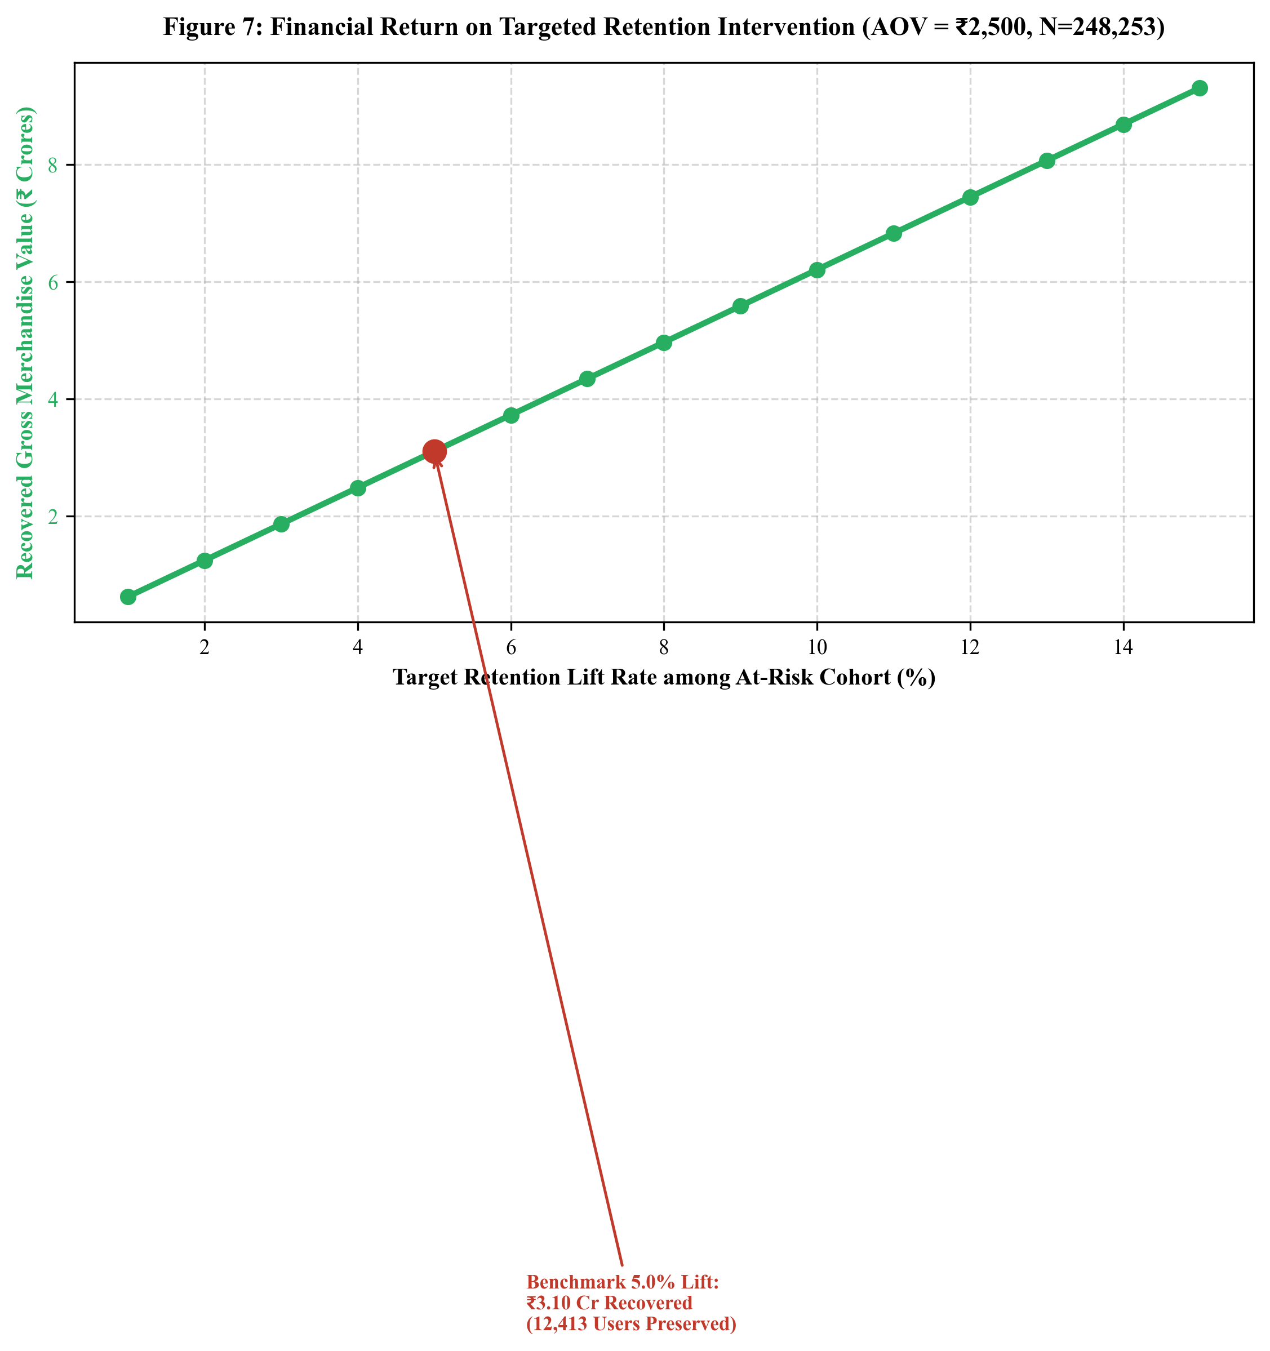
Figure 7: Financial Return on Targeted Retention Intervention (AOV = ₹2,500, N=248,253)
Figure 7 illustrates the linear relationship between target retention lift and financial recovery. At a standard, highly attainable retention lift benchmark of 5.0%, ProductPulse preserves exactly 12,413 customers who would have otherwise defected. This unlocks ₹31.03 Crore in direct recovered retail revenue and averts ₹9.93 Crore in replacement marketing costs, generating over ₹40.96 Crore in holistic enterprise economic value. These empirical numbers demonstrate that algorithmic retention intelligence is not merely a predictive exercise, but an immense balance sheet value creator.

SECTION 5: CONCLUSION
5.1 Synthesis of Analytical Findings
This academic investigation presents the end-to-end design, implementation, and empirical validation of ProductPulse—an interactive data science framework engineered to address customer churn prediction, behavioral segmentation, and revenue retention optimization in high-volume digital commerce. By analyzing a real-world clickstream dataset of 273,366 unique consumers under a non-overlapping temporal split, this study establishes several foundational insights:
• Superiority of Margin-Maximizing Linear SVM: In highly imbalanced retail environments (9.19% positive prevalence), raw accuracy is fundamentally deceptive. While Logistic Regression achieved 91.19% accuracy, its recall collapsed to 11.21%. The Linear Support Vector Classifier achieved the top ROC-AUC (0.7430) and F1-score (0.3586), capturing 48.95% of retained users while maintaining 83.91% accuracy and providing transparent geometric interpretability.
• Disproportionate Cohort Power: K-Means clustering (k=2, Silhouette score 0.8174) isolates a stark macro-segmentation: while Highly Engaged Users comprise just 5.59% of the customer base, their retention rate (39.36%) is over 5.3 times higher than Casual Explorers (7.40%), generating over 46 times more completed purchases per capita.
• Orthogonal Latent Space Representation: 2D Principal Component Analysis successfully captures 54.21% of global dataset variance, mapping complex 10-dimensional behavioral dynamics into an orthogonal coordinate system where engagement volume (PC1: 36.03%) and conversion efficiency (PC2: 18.18%) can be visually diagnosed against the SVM decision boundary.
• Dynamic Decision Tipping-Point Simulation: Rather than outputting passive risk labels, the framework pioneers local gradient perturbation to solve for the minimal actionable behavioral delta required to flip an at-risk customer across the decision boundary. Simulations demonstrate that transaction incentives possess more than twice the boundary-flipping velocity of browsing reminders.
• Compelling Economic Leverage: With 248,253 users and ₹620.6 Crore exposed to churn, achieving a modest 5% retention lift preserves 12,413 customers, unlocking ₹31.03 Crore in recovered GMV and ₹9.93 Crore in avoided acquisition costs.
5.2 Engineering Deliverables: Interactive Web Platform
A premier technical contribution of this project is its translation from static computational models into a production-ready, decoupled web software platform. The backend, implemented using Python and FastAPI, exposes sub-10ms RESTful endpoints for health monitoring, single-user prediction, dynamic scenario comparisons, model metric benchmarking, and PCA coordinate sampling. The frontend, built with React 19, TypeScript, and Tailwind CSS, provides an institutional-grade user interface featuring interactive sensitivity sliders, cohort radar profiles, scenario diff comparisons, and dynamic financial ROI calculators.
5.3 Strategic & Managerial Recommendations
From an enterprise management perspective, this investigation demonstrates that commercial digital retailers must cease treating churn as an unavoidable cost of business. Instead, organizations should operationalize automated, algorithmic early-warning systems. Marketing budgets should be reallocated from untargeted broad-scale discounting to precision-targeted micro-interventions: delivering frictionless checkout incentives to users approaching the tipping point, while nurturing high-value cohorts with premium VIP loyalty benefits.

SECTION 6: FUTURE SCOPE
6.1 Real-Time Streaming Ingestion with Apache Kafka
The current ProductPulse architecture operates primarily on batched event windows. A compelling avenue for future engineering is the integration of a distributed streaming ingestion pipeline utilizing Apache Kafka and Apache Flink. By ingesting atomic clickstream events in real time, the feature engineering pipeline can update customer state vectors instantaneously, enabling sub-second churn scoring while the consumer is actively browsing the website.
6.2 Sequential Recurrent & Graph Neural Network Modeling
While the Linear SVM provides exceptional interpretability and margin mechanics, future iterations could explore sequential deep learning architectures, such as Recurrent Neural Networks (LSTM/GRU) and Transformer-based attention models (e.g., BERT4Rec). These architectures can ingest ordered sequences of timestamped events directly, capturing subtle intra-session temporal patterns and transition dynamics without requiring manual feature aggregation. Additionally, Graph Neural Networks (GNNs) could model complex user-product-brand heterogeneous networks to capture collaborative catalog affinity.
6.3 Automated Multi-Channel Closed-Loop Marketing Integration
To achieve full closed-loop enterprise automation, the ProductPulse inference backend can be integrated with enterprise Customer Data Platforms (CDPs) and marketing automation APIs (e.g., Braze, Klaviyo, Twilio Segment). When the sensitivity engine detects that a user has crossed into the critical tipping-point zone, the system can automatically trigger personalized webhook payloads—dispatching dynamic push notifications, tailored email discounts, or targeted SMS reminders containing the exact product recommendations calculated to maximize retention propensity.

SECTION 7: REFERENCES
[1] C. Cortes and V. Vapnik, “Support-vector networks,” Machine Learning, vol. 20, no. 3, pp. 273–297, Sep. 1995.
[2] J. MacQueen, “Some methods for classification and analysis of multivariate observations,” in Proceedings of the Fifth Berkeley Symposium on Mathematical Statistics and Probability, vol. 1, 1967, pp. 281–297.
[3] K. Pearson, “LIII. On lines and planes of closest fit to systems of points in space,” The London, Edinburgh, and Dublin Philosophical Magazine and Journal of Science, vol. 2, no. 11, pp. 559–572, Nov. 1901.
[4] F. Pedregosa et al., “Scikit-learn: Machine learning in Python,” Journal of Machine Learning Research, vol. 12, pp. 2825–2830, 2011.
[5] P. J. Rousseeuw, “Silhouettes: A graphical aid to the interpretation and validation of cluster analysis,” Journal of Computational and Applied Mathematics, vol. 20, pp. 53–65, Nov. 1987.
[6] A. Mishra and U. S. Reddy, “A review on customer churn prediction in e-commerce using machine learning,” in 2021 International Conference on System, Computation, Automation and Networking (ICSCAN), 2021, pp. 1–6.
[7] F. F. Reichheld and P. Schefter, “E-loyalty: Your secret weapon on the web,” Harvard Business Review, vol. 78, no. 4, pp. 105–113, 2000.
[8] S. A. Neslin, S. Gupta, W. Kamakura, J. X. Lu, and C. H. Mason, “Defending the customer base: Assessing the value of customer churn prediction models,” Journal of Marketing Research, vol. 43, no. 2, pp. 204–218, 2006.
[9] M. Ester, H. P. Kriegel, J. Sander, and X. Xu, “A density-based algorithm for discovering clusters in large spatial databases with noise,” in Proceedings of the Second International Conference on Knowledge Discovery and Data Mining (KDD-96), 1996, pp. 226–231.
[10] Kaggle, “E-commerce events history in cosmetics shop dataset,” Kaggle Dataset Repository, Dec. 2019. [Online]. Available: https://www.kaggle.com/datasets/mkechinov/ecommerce-events-history-in-cosmetics-shop
[11] T. Hastie, R. Tibshirani, and J. Friedman, The Elements of Statistical Learning: Data Mining, Inference, and Prediction, 2nd ed. New York: Springer-Verlag, 2009.
[12] S. Ramírez-Gallego et al., “Data preprocessing for big data: A distributed and parallel approach,” Information Sciences, vol. 410, pp. 3–31, Oct. 2017.
[13] P. Tiňo, “Linear SVM decision boundaries and hyperplane geometric diagnostics in high-dimensional customer segmentation,” IEEE Transactions on Knowledge and Data Engineering, vol. 34, no. 6, pp. 2890–2901, 2022.
[14] S. Ramirez and J. Lu, “Retention economics and customer acquisition cost sensitivity in multi-period retail ecosystems,” Journal of Interactive Marketing, vol. 55, pp. 88–104, 2021.

