

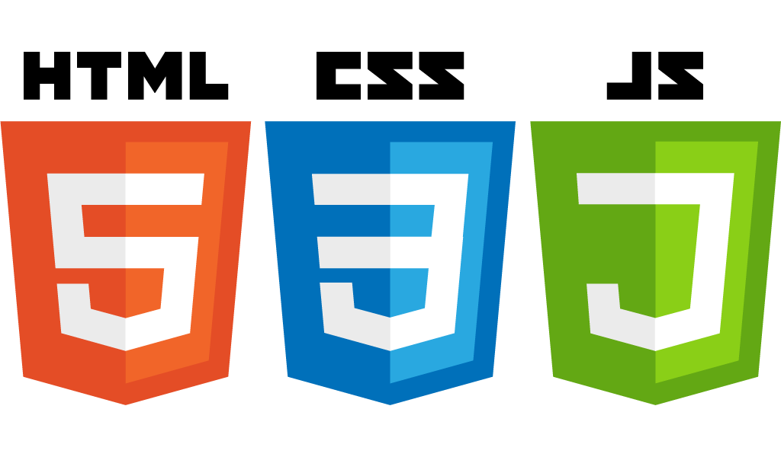

**Course Family: ACCP-Prime-2.0-7062**

**Semester: CPISM**

**Module: Building Modern Websites**

**Mock Questions**

Contents

**Introduction To The Web** 3

**Introduction To HTML5** 4

**Formatting Text Using Tags** 5

**Creating Hyperlinks & Anchors** 6

**Introduction To CSS3** 7

**Formatting Using Style Sheets** 8

**Displaying Graphics & CSS3 Animations** 9

**Understanding layouts In CSS3** 9

**HTML Layouts, Forms, & Elements** 10

**HTML5 Tables, Audio, & Video** 11

**JavaScript - I** 12

**JavaScript - II** 13

**Canvas & Web Storage In HTML5** 15

**HTML5 GeoLocation & APIs** 16

**Building Mobile Web Applications** 17

**Online Resources for Preparation** 18

# **Introduction To The Web**

1. Which of the following is a correct definition of HTML?

A. Hyper Text Main Language  
B. Hyper Text Markup Language  
C. Home Tool Markup Language  
D. Hyperlinking Text Markup Language

2. What does CSS stand for?

A. Cascading Style Sheets  
B. Computer Style Sheets  
C. Creative Style Sheets  
D. Colorful Style Sheets

3. Which HTML tag is used to define an internal style sheet?

A. <style>  
B. <css>  
C. <script>  
D. <head>

4. Which of the following is used to structure web pages?

A. CSS  
B. HTML  
C. JavaScript  
D. PHP

5. What does the <a> HTML tag represent?

A. Anchor  
B. Append  
C. Add  
D. Article

Answers

1. B  
2. A  
3. A  
4. B  
5. A

# **Introduction To HTML5**

1. Which of the following is a new input type introduced in HTML5?

A. <input type="text">  
B. <input type="email">  
C. <input type="radio">  
D. <input type="button">

2. Which HTML5 element is used to define a footer for a document or section?

A. <footer>  
B. <bottom>  
C. <foot>  
D. <section>

3. What does the <canvas> element in HTML5 allow you to do?

A. Create a responsive layout  
B. Embed multimedia elements  
C. Draw graphics via scripting (usually JavaScript)  
D. Store data locally

4. Which HTML5 element is used to define navigation links?

A. <navigate>  
B. <nav>  
C. <links>  
D. <menu>

5. Which of the following is a new form attribute introduced in HTML5?

A. action  
B. method  
C. novalidate  
D. enctype

Answers

1.B  
2.A  
3.C  
4.B  
5.C

# **Formatting Text Using Tags**

1. Which HTML tag is used to make text bold?

A. <strong>  
B. <b>  
C. <em>  
D. <i>

2. Which HTML tag is used to italicize text?

A. <italic>  
B. <i>  
C. <em>  
D. <it>

3. Which HTML tag is used to underline text?

A. <underline>  
B. <u>  
C. <ul>  
D. <under>

4. Which HTML tag is used to create a line break?

A. <br>  
B. <lb>  
C. <break>  
D. <newline>

5. Which HTML tag is used to highlight text?

A. <highlight>  
B. <mark>  
C. <hl>  
D. <highlighted>

Answers

1. B  
2. B  
3. B  
4. A  
5. B

# **Creating Hyperlinks & Anchors**

1. Which HTML tag is used to create a hyperlink?

A. <link>  
B. <a>  
C. <href>  
D. <url>

2. Which attribute is used in the <a> tag to specify the URL of the page the link goes to?

A. src  
B. link  
C. href  
D. url

3. Which attribute is used to open the linked document in a new tab or window?

A. target="_blank"  
B. newtab  
C. window="_new"  
D. open="_newtab"

4. What is the purpose of the name attribute in an <a> tag?

A. To specify the URL  
B. To define an internal link within the same page  
C. To style the link  
D. To define a section in the document

5. How do you create an anchor link to a section named "section1" within the same page?

A. <a href="#section1">Go to Section 1</a>  
B. <a link="#section1">Go to Section 1</a>  
C. <a anchor="#section1">Go to Section 1</a>  
D. <a href="section1">Go to Section 1</a>

Answers

1.B  
2.C  
3.A  
4.B  
5.A

# **Introduction To CSS3**

1. Which CSS property is used to change the background color of an element?

A. color  
B. background-color  
C. bgcolor  
D. background

2. Which of the following is a new feature introduced in CSS3?

A. External stylesheets  
B. Media queries  
C. Inline styles  
D. Embedded styles

3. Which CSS3 property is used to create rounded corners?

A. border-style  
B. corner-radius  
C. border-radius  
D. radius-border

4. What is the correct syntax for applying a linear gradient background in CSS3?

A. background: linear-gradient(to right, red, blue);  
B. background: gradient(linear, right, red, blue);  
C. background: gradient(linear, to right, red, blue);  
D. background: linear-gradient(right, red, blue);

5. Which CSS3 property is used to add shadow to text?

A. text-shadow  
B. font-shadow  
C. shadow-text  
D. text-outline

Answers

1. B  
2. B  
3. C  
4. A  
5. A

# **Formatting Using Style Sheets**

1. Which type of CSS is included within the <head> section of an HTML document?

A. External CSS  
B. Internal CSS  
C. Inline CSS  
D. Embedded CSS

2. What is the correct way to link an external CSS stylesheet to an HTML document?

A. <link rel="stylesheet" href="styles.css">  
B. <style src="styles.css"></style>  
C. <css href="styles.css"></css>  
D. <stylesheet href="styles.css"></stylesheet>

3. Which CSS property is used to change the text color?

A. color  
B. text-color  
C. font-color  
D. background-color

4. Which CSS property is used to apply a border around an element?

A. border-width  
B. border-style  
C. border-color  
D. border

5. How do you select an element with the class name "highlight" in CSS?

A. .highlight { ... }  
B. #highlight { ... }  
C. highlight { ... }  
D. *highlight { ... }

Answers

1.B  
2.A  
3.A  
4.D  
5.A

# **Displaying Graphics & CSS3 Animations**

1. Which HTML5 element is used to draw graphics on a web page?

A. <svg>  
B. <canvas>  
C. <graphic>  
D. <draw>

2. Which CSS property is used to specify the duration of an animation?

A. animation-name  
B. animation-duration  
C. animation-time  
D. animation-delay

3. Which attribute of the <canvas> element is used to specify the height of the canvas?

A. height  
B. canvas-height  
C. size  
D. h

4. Which CSS3 property is used to define the keyframes of an animation?

A. @keyframes  
B. @frames  
C. @animations  
D. @steps

5. Which CSS property is used to control the speed of the transition effect?

A. transition-delay  
B. transition-duration  
C. transition-speed  
D. transition-time

Answers

1.B  
2.B  
3.A  
4.A  
5.B

# **Understanding layouts In CSS3**

1. Which CSS3 property is used to create a flexible layout that allows responsive design?

A. grid  
B. flex  
C. float  
D. position

2. What is the primary purpose of the CSS grid layout?

A. To float elements  
B. To create a two-dimensional layout  
C. To center elements  
D. To create a single-column layout

3. Which property is used to define a container as a flex container?

A. display: flex;  
B. flex: container;  
C. layout: flex;  
D. container: flex;

4. In CSS Grid, which property is used to define the number of columns in a grid?

A. grid-template-rows  
B. grid-columns  
C. grid-template-columns  
D. grid-rows

5. Which property is used to align items vertically within a flex container?

A. align-items  
B. justify-content  
C. align-content  
D. vertical-align

Answers

1. B  
2. B  
3. A  
4. C  
5. A

# **HTML Layouts, Forms, & Elements**

1. Which HTML element is used to define a section in a document?

A. <section>  
B. <div>  
C. <article>  
D. <aside>

2. Which HTML element is used to create a form?

A. <form>  
B. <input>  
C. <fieldset>  
D. <textarea>

3. Which attribute is necessary for an <input> element to be considered as a form control?

A. type  
B. name  
C. value  
D. placeholder

4. What is the correct HTML element for making a drop-down list?

A. <select>  
B. <list>  
C. <dropdown>  
D. <menu>

5. Which HTML element is used for the largest heading?

A. <heading>  
B. <h6>  
C. <h1>  
D. <header>

Answers

1. A  
2. A  
3. A  
4. A  
5. C

# **HTML5 Tables, Audio, & Video**

1. Which HTML5 element is used to embed video content in a web page?

A. <video>  
B. <media>  
C. <embed>  
D. <movie>

2. Which attribute of the <video> element specifies the URL of the video file?

A. src  
B. url  
C. file  
D. source

3. Which HTML5 element is used to define a table row?

A. <row>  
B. <tr>  
C. <table-row>  
D. <td>

4. Which attribute of the <audio> element specifies the URL of the audio file?

A. source  
B. src  
C. file  
D. audio-src

5. Which HTML5 element is used to define a cell in a table?

A. <cell>  
B. <td>  
C. <th>  
D. <table-cell>

Answers

1.A  
2.A  
3.B  
4.B  
5.B

# **JavaScript - I**

1. Which keyword is used to declare a variable in JavaScript?

A. let  
B. var  
C. const  
D. variable

2. What will console.log(typeof []) output?

A. array  
B. object  
C. array  
D. string

3. Which built-in method adds one or more elements to the end of an array and returns the new length of the array?

A. push()  
B. pop()  
C. join()  
D. concat()

4. What is the correct way to declare a function in JavaScript?

A. function myFunction() {}  
B. myFunction = function() {}  
C. var myFunction = function() {}  
D. myFunction()

5. Which statement is used to terminate a loop in JavaScript?

A. exit  
B. break  
C. terminate  
D. stop

Answers

1.B  
2. B  
3.A  
4.A  
5.B

# **JavaScript - II**

1. Which built-in method returns the length of a string?

A. length()  
B. size()  
C. count()  
D. length

2. What does the === operator do in JavaScript?

A. Checks if two values are equal in value and type  
B. Checks if two values are equal in value, regardless of type  
C. Checks if two values are not equal in value and type  
D. Checks if two values are not equal in value, regardless of type

3. What will the following code output?

var x = 10;

function foo() {

console.log(x);

var x = 20;

}

foo();

A. 10  
B. 20  
C. undefined  
D. ReferenceError

4. Which keyword is used to prevent a variable from being modified?

A. prevent  
B. const  
C. freeze  
D. immutable

5. What does the typeof operator return when applied to null?

A. null  
B. undefined  
C. object  
D. number

Answers

1.D  
2.A  
3.C  
4.B  
5.C

# **Canvas & Web Storage In HTML5**

1. Which HTML5 element is used to draw graphics on a web page?

A. <svg>  
B. <canvas>  
C. <draw>  
D. <graphic>

2. What does the getContext() method of the <canvas> element return?

A. The width of the canvas  
B. The height of the canvas  
C. A rendering context object  
D. The color of the canvas

3. Which API in HTML5 is used for storing data locally within the user's browser?

A. Local Storage API  
B. Browser Storage API  
C. Session Storage API  
D. Web Storage API

4. What is the maximum amount of data that can be stored using the Web Storage API?

A. 1 MB  
B. 2.5 MB  
C. 5 MB  
D. It depends on the browser

5. Which method is used to store data in the Web Storage API?

A. setItem()  
B. set()  
C. save()  
D. store()

Answers

1.B  
2.C  
3.D  
4.D  
5.A

# **HTML5 GeoLocation & APIs**

1. Which JavaScript method is used to retrieve the current position of the user using Geolocation API?

A. getPosition()  
B. getUserLocation()  
C. navigator.geolocation.getCurrentPosition()  
D. navigator.getPosition()

2. What does the getCurrentPosition() method of the Geolocation API return?

A. A JSON object containing the location data  
B. A promise that resolves with the location coordinates  
C. A callback function with the location data  
D. A URL to the location on a map

3. Which property is used in the Geolocation API to handle errors when fetching the user's location?

A. onError  
B. handleError  
C. error  
D. onLocationError

4. What is the purpose of the watchPosition() method in the Geolocation API?

A. To request the user's current location once  
B. To start a continuous update of the user's location  
C. To store the user's location in local storage  
D. To delete the user's location history

5. Which HTML5 API allows web applications to make asynchronous HTTP requests to retrieve data from a server?

A. File API  
B. WebSocket API  
C. Fetch API  
D. XMLHttpRequest API

Answers  
1.C  
2.C  
3.A  
4.B  
5.C

# **Building Mobile Web Applications**

1. Which meta tag is commonly used in mobile web development to ensure proper scaling and viewport configuration?

A. <meta name="viewport" content="width=device-width, initial-scale=1.0">  
B. <meta name="mobile-scale" content="1.0">  
C. <meta name="device-scale" content="auto">  
D. <meta name="scale" content="1.0">

2. Which CSS technique is typically used to create responsive layouts for mobile devices?

A. Media queries  
B. Flexbox  
C. Grid layout  
D. Floats

3. Which JavaScript framework is widely used for building mobile web applications?

A. AngularJS  
B. jQuery Mobile  
C. React  
D. Vue.js

4. Which API is used in mobile web development to access device-specific features like the camera or accelerometer?

A. Device API  
B. Mobile API  
C. Web API  
D. Sensor API

5. What is a key consideration when optimizing images for mobile web applications?

A. Using high-resolution images for clarity  
B. Using SVG images exclusively  
C. Compressing images to reduce file size  
D. Avoiding image optimization

Answers

1.A  
2.A  
3.B  
4.C  
5.C

# **Online Resources for Preparation**

1. <https://www.proprofs.com/>
2. <https://www.testdome.com/>
3. <https://pakmcqs.com/>
4. <https://www.mastguru.com/>
5. <https://www.examtiger.com/>
6. [https://www.w3schools.com/](https://www.examtiger.com/)