|  |
| --- |
| **BAHRIA UNIVERSITY (KARACHI CAMPUS)**  **ASSGINMENT # 2 - FALL 2020**  **Operating Systems (CSC-320)**  Class: **BSE 4 B** Submission Deadline: **9th June, 2020**  Course Instructor: **Dr. Osama Rehman**  Lab Instructor: **Engr. Fareeha Dilawar** Max Marks: **5** |

1. Study and learn Dining Philosophers Problem. Implement semaphores based solution to Dining Philosopher’s problem.

**[CLO#1, 2.0 Marks]**

**Dining Philosophers Problem:**

There is a dining room containing a circular table with five chairs. At each chair is a plate, and between each plate is a single chopstick. In the middle of the table is a bowl of spaghetti. Near the room are five philosophers who spend most of their time thinking, but who occasionally get hungry and need to eat so they can think some more.

A solution of the Dining Philosophers Problem is to use a semaphore to represent a chopstick. A chopstick can be picked up by executing a wait operation on the semaphore and released by executing a signal semaphore.

**Semaphores based Implementation:**

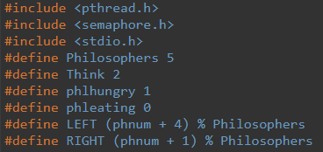

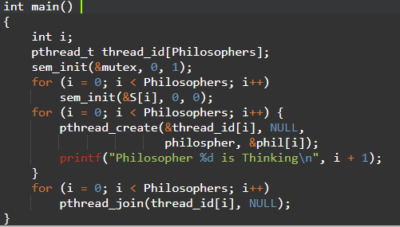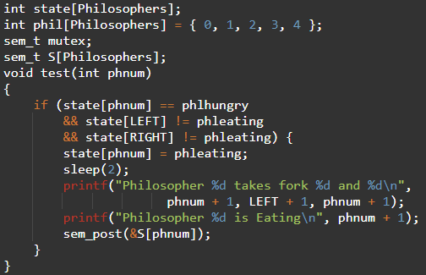

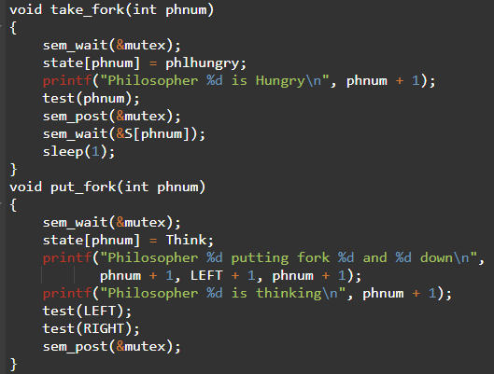

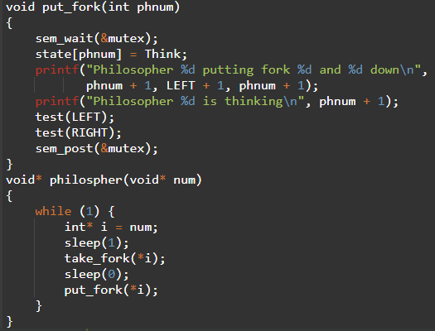

**Output:**

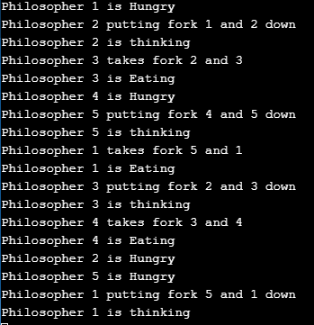

1. Study and learn the placement algorithms. Write a C language program for Best-Fit, First-Fit and Next-Fit Placement algorithms.

**[CLO#1, 3.0 Marks]**

**Best-Fit Algorithm:**

Best fit uses the best memory block based on the Process memory request. In best fit implementation the algorithm first selects the smallest block which can adequately fulfill the memory request by the respective process. In simple Best Fit is a memory management algorithm; it deals with allocating smallest free partition which meets the requirement of the requesting process.

**Implementation:**

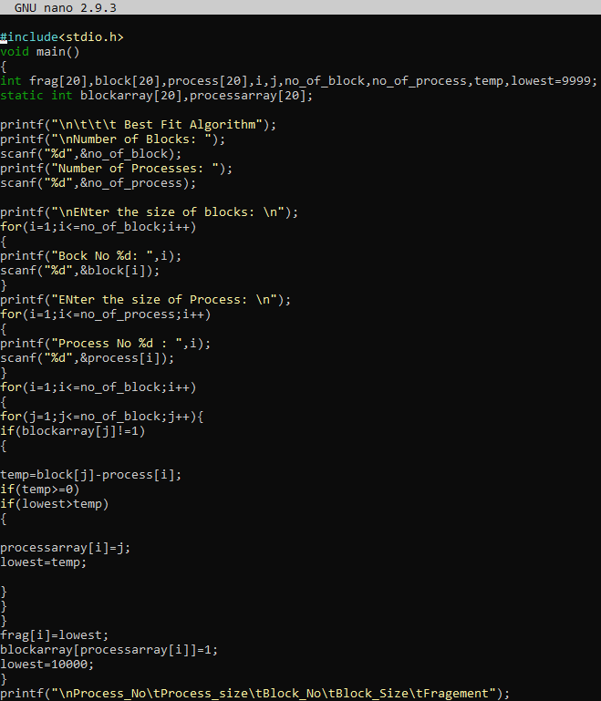



**Output:**

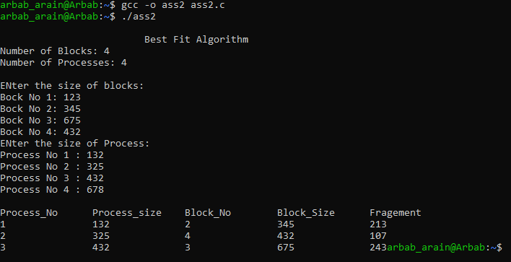

**First-Fit Algorithm:**

In this scheme we check the blocks in a sequential manner which means we pick the first process then compare it’s size with first block size if it is less than size of block it is allocated otherwise we move to second block and so on.

**Implementation:**

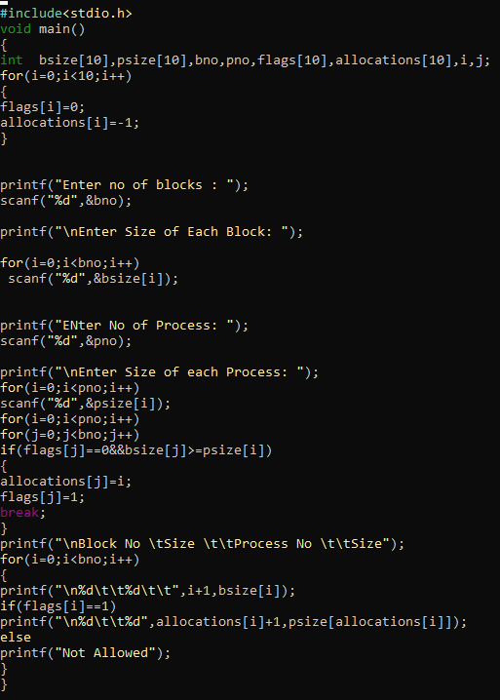

**Output:**

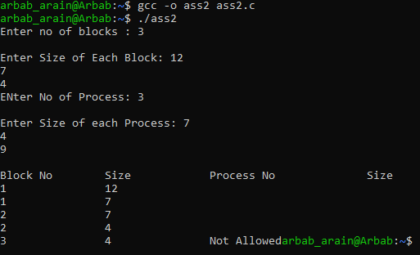

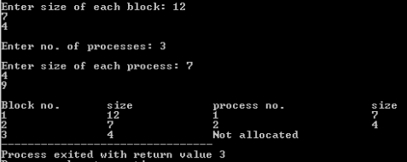

**Next-Fit Algorithm:**

This algorithm keeps a track of the positions where every file is written in the memory. It then allocates the very next available memory block to the succeeding processes. So, when a process is executed to be stored in the memory, the previous bin or the memory block is checked for its availability.

**Implementation:**

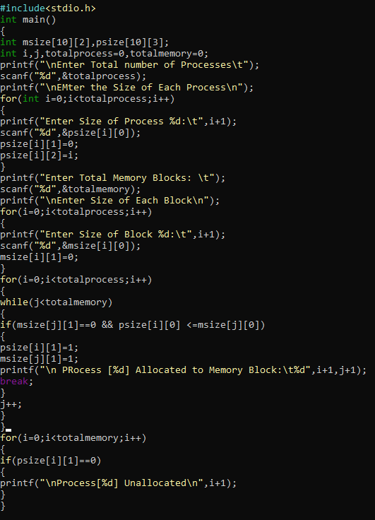

**Output:**

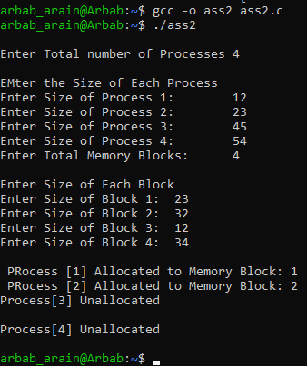

Take **Note**:

* + If you submit your assignment after the given deadline then **2 Marks** will be deducted for the late submissions.
  + Copied assignment will be marked **zero (means zero plagiarism)**.
  + Make sure you paste your code and screenshots both.
  + Do write explanations in both questions.

If you have any query, feel free to contact at: fareeha1810@yahoo.com