|  |
| --- |
| Student Name: Muhammad Arbab Anjum Reg No: 57226 |

 **BAHRIA UNIVERSITY (KARACHI CAMPUS)**

**ASSIGNMENT # 1 - FALL 2020**

# Operating Systems (CSC-320)

Class: **BSE 4 B** Submission Deadline: **17/18 March, 2020**

Course Instructor: **Dr. Osama Rehman**

Lab Instructor: **Engr. Fareeha Dilawar** Max Marks: **10**

1. Study and implement pipes in Linux. List down three examples with outputs attached in the screenshots.

**Example 1:**

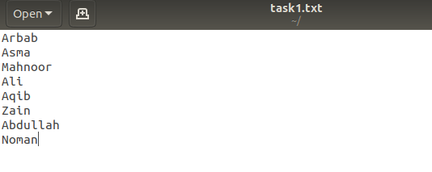

* **grep: is a command-line utility for searching plain-text data sets for lines that match a regular expression.**

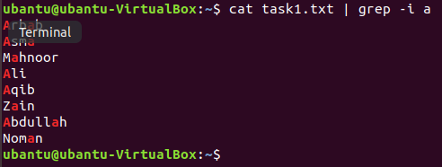

**Example 2:**

* **Lists only those entries from txt file having “A”, sorts them and finally stores the output in record.txt**

**Output:**





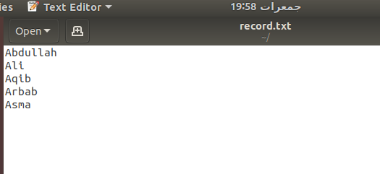

**Example 3:**

* **wc –w this command is used to count the words in the file.**





1. Write a C program that asks users to provide an integer input in the main () function. The program would call a function even_odd () from the main () function, where the function even_odd () accepts an integer as an argument, determine and display if the passed integer is either even or odd.

**Code:**

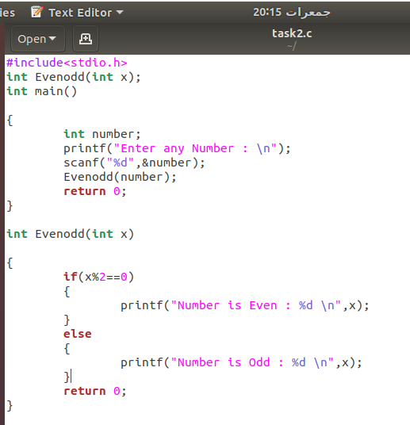

**Output:**

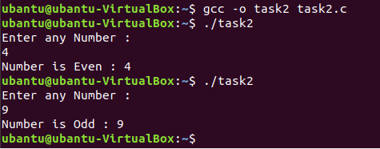

1. Study and implement system calls in Linux. List down three examples with output screenshot attached.

**Code:**

**System Call:**

System calls are how a program enters the kernel to perform some task. Programs use system calls to perform a variety of operations such as: creating processes, doing network and file IO, and much more.

**Services:**

System call provides the services of the operating system to the user programs via Application Program Interface (API). It provides an interface between a process and operating system to allow user-level processes to request services of the operating system. System calls are the only entry points into the kernel system.

**Types of System Calls**

Here are the types of system calls

### **Process Control**

These system calls deal with processes such as process creation, process termination etc.

### **File Management**

These system calls are responsible for file manipulation such as creating a file, reading a file, writing into a file etc.

### **Device Management**

These system calls are responsible for device manipulation such as reading from device buffers, writing into device buffers etc.

### **Information Maintenance**

These system calls handle information and its transfer between the operating system and the user program.

### **Communication**

These system calls are useful for interprocess communication. They also deal with creating and deleting a communication connection.

**Example 1: fork();**

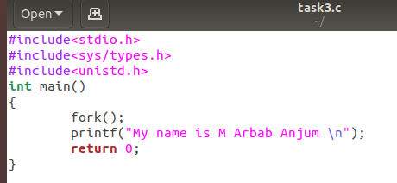



**Example 2: getpid();**

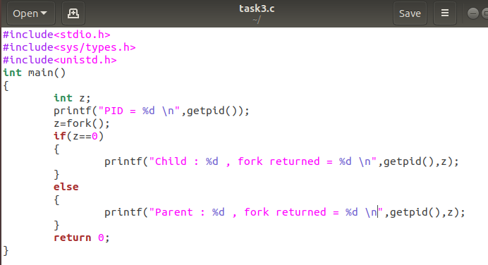

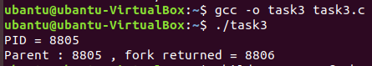

**Example 3: wait();**

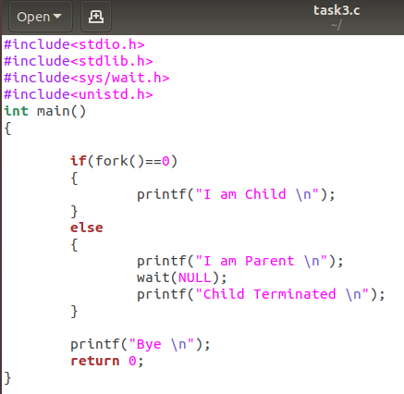

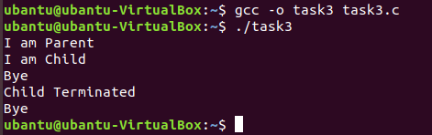

1. Think and propose two projects that can be delivered as the final lab projects in Operating Systems lab. The ideas must be valid and should be explained with research topics and examples.

# Contact Management System Using C language

Contact Management System is a simple console application without graphics. It is similar to the contact manager in cell phones. In this project, you can add, view, edit, search and delete contacts. All added and edited records are saved in a file. You can list contacts by name, phone no., address and email. Overall, understanding the simple source code of this project will teach you how to add, edit, search, list and remove data using file.

The key features of contact management system are listed below:

* Add new contacts: with information such as name, phone number, address, and email
* List all contacts: lists all the contacts stored in file with their respective contact details
* Search contacts: based on name and phone number
* Edit contacts: edit information given while adding the contacts – name, phone number, address, and email
* Delete contacts: deletes contacts from file
* **TIC TAC TOE Game.**

You have probably played the Tic-Tac-Toe game to pass time during school hours. It’s fun when you play with paper and pencil. It is a simple console application without graphics. It is the same nougats and crosses or the Xs and Os, the other names for Tic-Tac-Toe, you’ve played with paper and pencil.

While making a Tic Tac Toe game using C language, it is important to make use of arrays. The Xs and Os are kept in different arrays, and they are passed between several functions in the code to keep track of how the game goes. With the code here you can play the game choosing either X or O against the computer.

This Tic Tac Toe C game is such that you will have to input a numerical character, from 1 to 9, to select a position for X or O into the space you want. For example: if you are playing with O and you input 2, the O will go to first row – second column. If you want to place O in third row – first column, you have to enter 7. And, it is similar for the other positions.

This has been done this way because it is just a console application without graphics designed in C language.

Take **Note**:

* If you submit your assignment after the given deadline then **2 Marks** will be deducted for the late submissions.
* Copied assignment will be marked **zero (means zero plagiarism)**.

If you have any query, feel free to contact at: [fareeha1810@yahoo.com](mailto:fareeha1810@yahoo.com)