**Task 1**: Create an empty file with a .txt extension. Write a shell script that would write the current date, student’s name and registration number into that file, while using variables for all three entries.

**Code:-**

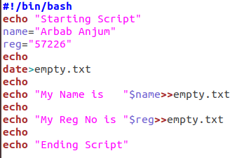

**Output:-**

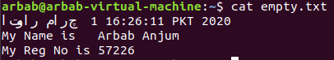

**Task 2**: Create a .txt file and input ten lines of entry while mixing it with both alphanumeric characters. Sort the contents of the created file in an ascending order and write the sorted output into another file.

**Code:-**

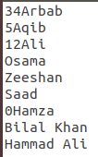

**Output:-**

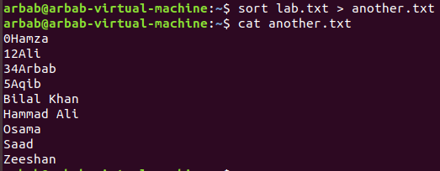

**Task 3**: Write two different C language programs that would generate the following for a given number , e.g. :

1. Calculate the factorial of .
2. Calculate the Fibonacci series (0,1,1,2,3,5,8…) up to .

Compile and run both programs using a single shell script, while having a running gap of 5 seconds between the first and second program. The generated output should properly display on which program is currently running (tip use ***echo*** command).

**Code:-**

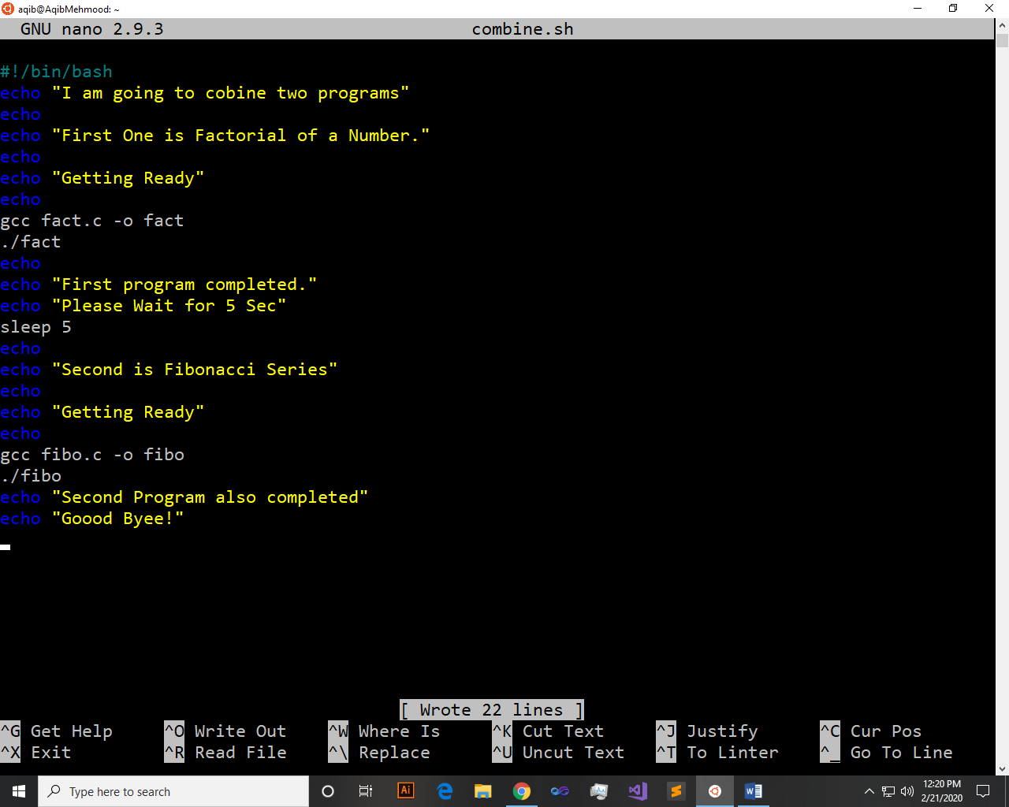

**Output:-**

