**Task1: Execute both commands. Try different options and observe the results. What have you learnt? Discuss.**

**TOP command:**

Top command is used to display Linux processes and all information related to current processes and threads that are running or being managed by the kernel. All the information is user configurable. This program provides limited interactive interface for process manipulation as well as a much more extensive interface for personal configuration.

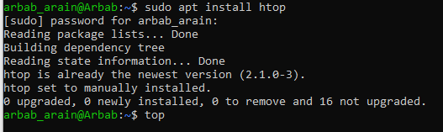

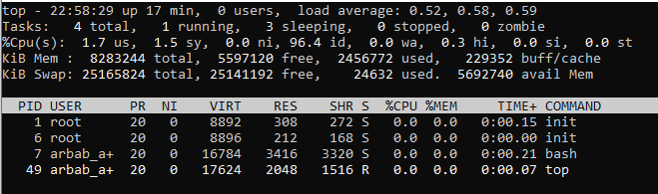



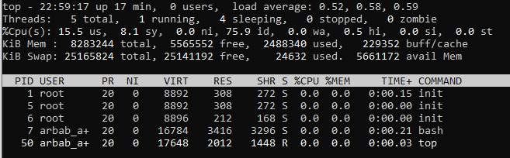

**PS command:**

Ps command is used to report a snapshot of the current running processes. Ps displays information about a selection of the active processes. Ps selects all processes that are related to current user and associated with the same terminal as the process that invoked it.

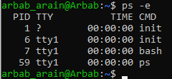

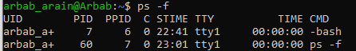

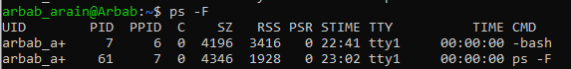

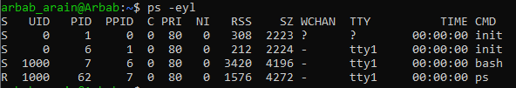

**Task2: Explore HTOP, including its all options. Attach Outputs for the same. Discuss your Observations.**

HTOP command in Linux System us a command line utility that allows the user to interactively monitor the system’s vital resources or server’s processes in real time.

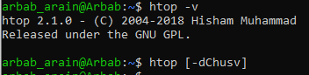

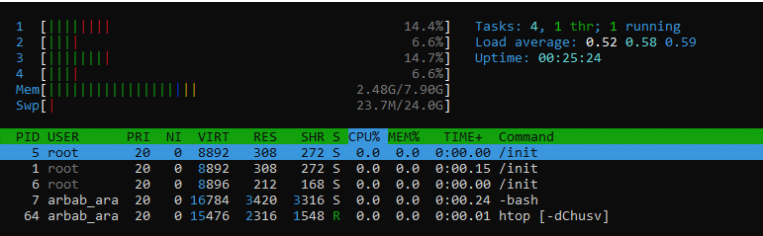



**Task3: Write a multithreaded C program for performing summation of numbers**

**Code:**

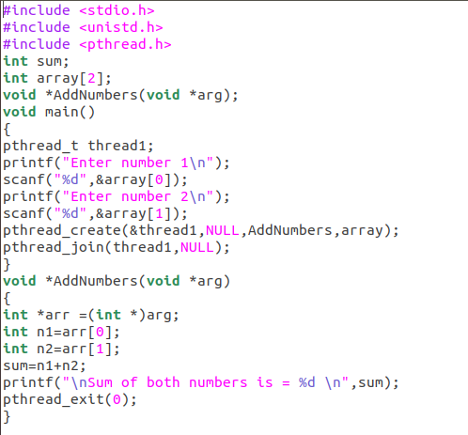

**Output:**

