**Task 1**: Answer the following questions.

Q1. In Linux operating system, describe the kernel.

**Answer:-**

The Linux kernel is the main component of a Linux operating system (OS) and is the core interface between a computer’s hardware and its processes. It communicates between the two, managing resources as efficiently as possible.

The kernel has four jobs:

1. **Memory management:** Keep track of how much memory is used to store what, and where
2. **Process management:** Determine which processes can use the CPU, when, and for how long.
3. **Device drivers:** Act as mediator/interpreter between the hardware and processes
4. **System calls and security:** Receive requests for service from the processes.

Q2. In Linux desktop environment, describe the benefits of virtual desktops.

**Answer:-**

Desktop virtualization is an increasingly important technology for many organizations. A virtual desktop or virtual desktop infrastructure (VDI) means that a user’s desktop environment is stored remotely on a server, rather than on a local PC or other client computing device. Desktop virtualization software separates the desktop operating systems, applications and data from the hardware client, storing this “virtual desktop” on a remote server. The remote server that runs and supports virtual desktops uses software called a hypervisor to create a “virtual machine” that simulates the user’s desktop environment and capabilities. In a virtual desktop environment, users access their personal desktop remotely, over the Internet, from any client device.

Desktop virtualization is a valuable technology platform and solves several business problems. With the many benefits desktop virtualization has to offer for an environment, there are four prominent categories that stand out:

1. ***Cost Savings***
2. ***Simplified Management***
3. ***Enhanced Security***
4. ***Increased Productivity***

Q3. While GUI based tools do exist in Linux, what is the purpose of using the command line interface, i.e. shell?

**Answer:-**

A Command Line Interface is a powerful way of user interacting with an operating system. One of the first CLIs was the MS-DOS. It was the operating system for the original personal digital computer (PC), which had been built in the 1980s.

Due to the following reasons command line interface are used:

* If the user knows the correct commands then this type of interface can be much faster than any other type of interface.
* This type of interface needs much less memory (Random Access Memory) in order to use compared to other types of user interfaces.
* This type of interface does not use as much CPU processing time as others
* A low resolution, cheaper monitor can be used with this type of interface.
* A CLI does not require Windows to run.

Q4. Use one of the options with the **ls** command, and describe its usage.

**Answer:-**

ls command is used to view the contents of a directory. By default, this command will display the contents of your current directory.

To display total information about Files/Directories(ls -l):



**Task 2:** By using the command line shell interface, practice the commands given in this lab. Write briefly about the usage of each command.

**ls command**:

It is used to list all the contents in the current working directory.

**Syntax:** $ ls – options <arguments>

**Example:-**



**date Command:**

This command is used to display the current date and time.

**Syntax:**

$date

$date +%ch

**Example:-**



**echo Command:**

Writes all its parameters to standard output, separated by spaces.

**Syntax:**

$echo –<options>

**Example:-**





**cd Command:**

Changes the directory.

**Syntax:**

$cd [parameter]

**Example:-**



**man Command:**

This command is used to display text-only manual pages.

**Syntax:**

$man –<options>

**Example:-**



**clear Command:**

This command is used to clear the terminal screen.

**Syntax:**

$clear

**Example:-**



**exit Command:**

Shell sessions can generally be terminated using this command.

**Syntax:**

$exit

**Example:-**



**Task 3**: By using gedit, open a text editor and write the C program given below. Save the written file as “hello.c”. In order to compile and execute the output file, do the following:

Write down the output of the program below (provide snapshot).

Code:-

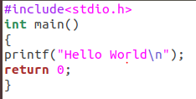

Output:-

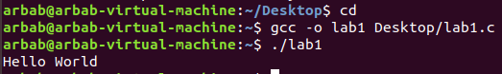

**Task 4**: Make changes within the above program to display a new output text as given below. Write down the developed program.

Code:-

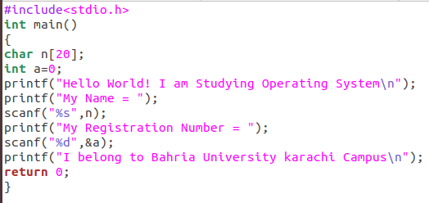

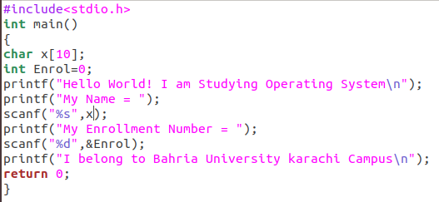

Output:-

