**OPERATING SYSTEMS LAB CSC-320**

**OPEN ENDED LAB – I**

**BSE-4B**

**Max Marks = 15**

**Deadline: 23 April 2020 11:59 PM**

Task 1: Write a shell script to check whether a number is prime number or not and save this script as a separate file. Copy this script in a new file followed by removing the original file. Then create another shell script and write a program to check whether a character is vowel or not. Create a third shell script which takes input from the user on which program from the previous two (i.e. prime number and vowel checker) should it execute. According the user’s input, the selected program should be executed. **[CLO#2, 4.0 Marks]**

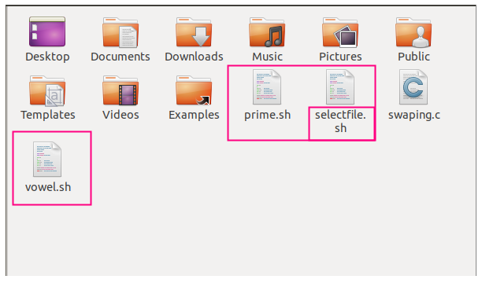

**Prime.sh file (To check Primary Number)**

**Vowel.sh file (To check Vowel)**

**Selectfile.sh (To get open any of these file on user choice)**

**PRIME NUMBER CHECKING SCRIPT FILE:**

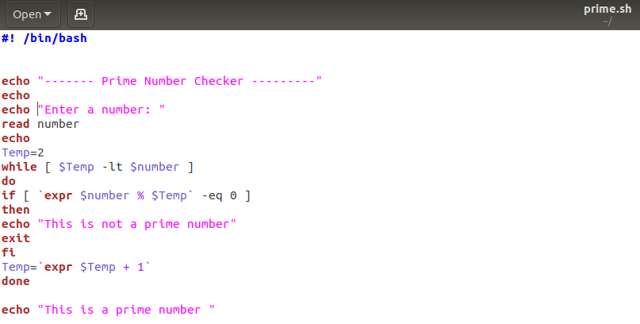

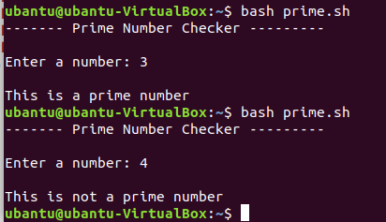

Copying text to **newprimefile.sh** and **removing prime.sh**

**BEFORE:**

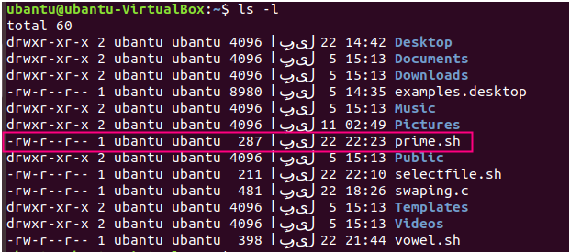

**AFTER:**

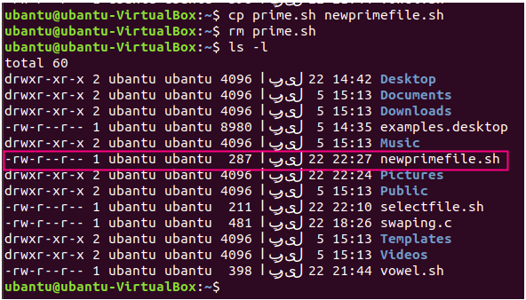

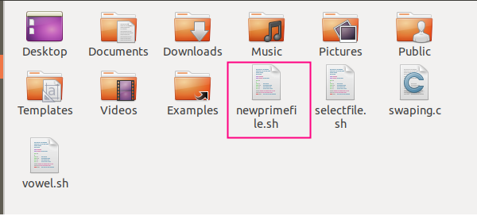

**VOWEL CHECKING SCRIPT FILE:**

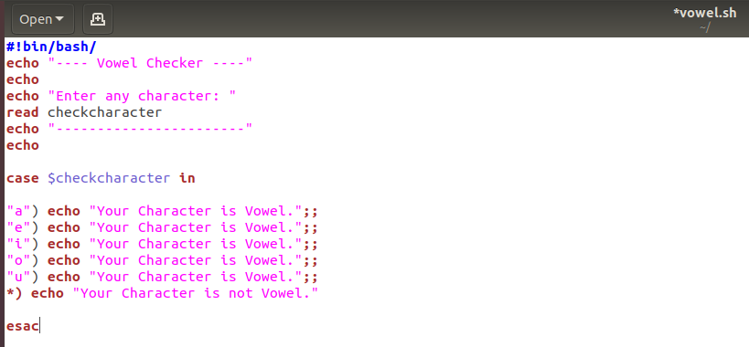

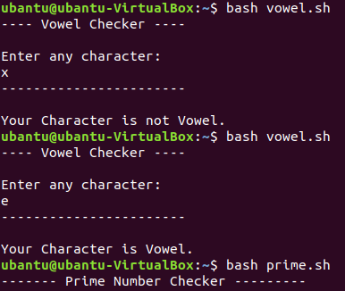

**Selected Program Execution:**

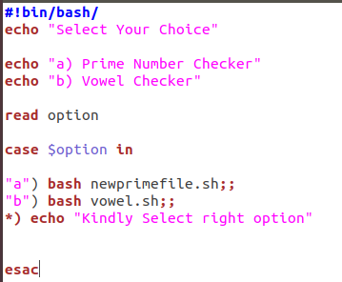

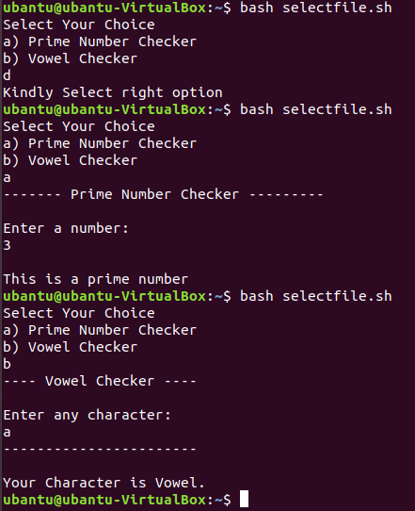

Task 2: Write a C program to display sum of all natural numbers between 1-100 whose sum is a prime number. The output should be displayed in descending order. The task should be executed eight times and each time a process ID should be generated.

**[CLO#2, 4.0 Marks]**

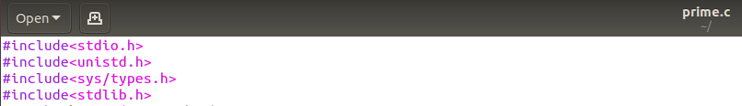

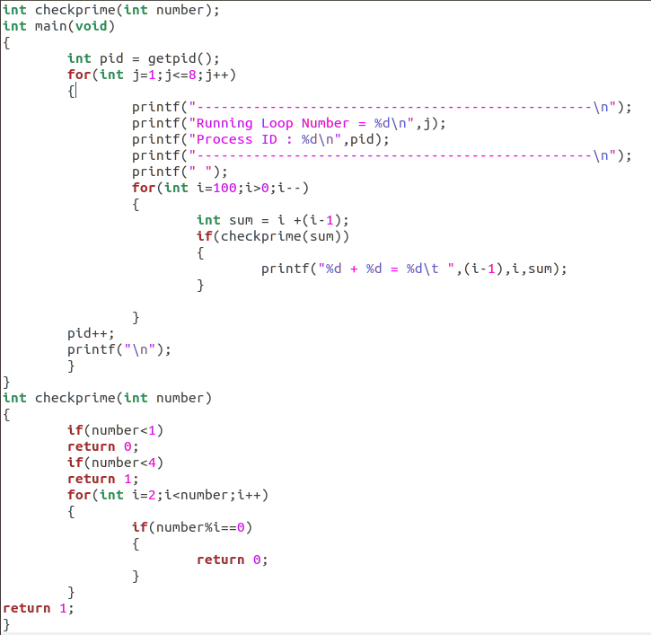

OUTPUT:

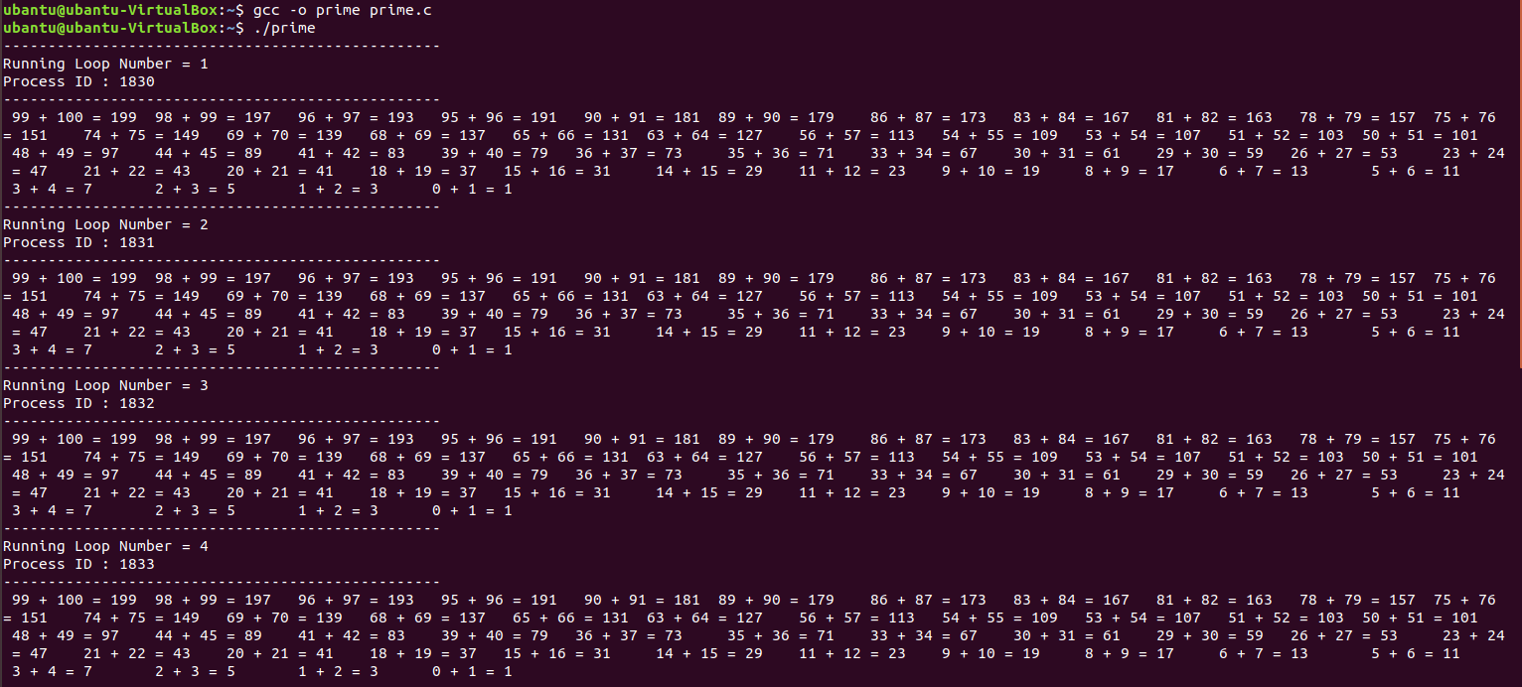

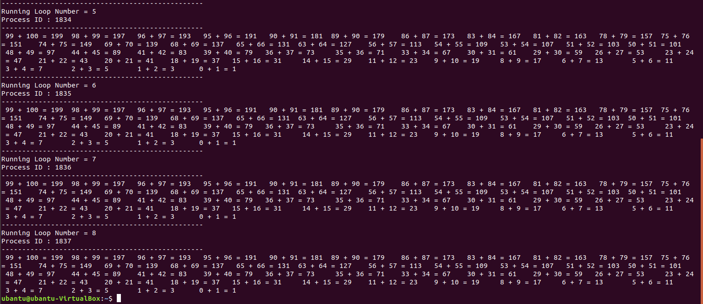

Task 3: Find contents of one file and display the search results in a second file. Also, display the total word count and line count in the file and all this should be displayed sorted in the second file. All this should be done using a single command. **[CLO#2, 3.0 Marks]**

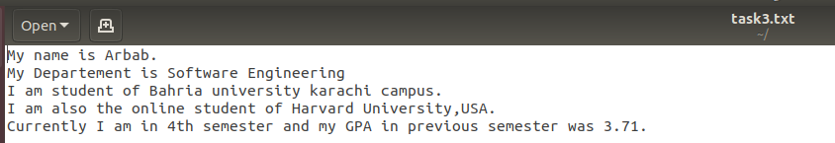

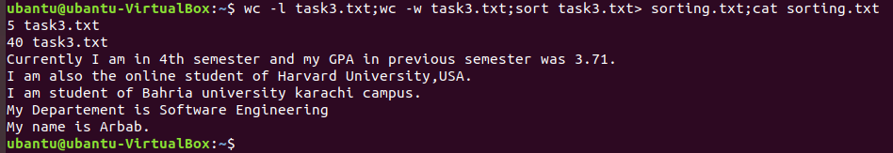

Task 4: By using C- language, swap five numbers in cyclic form. The output for three number cyclic swap is as below, similarly do it for five numbers and the output should also be displayed in the same form?

Value before swapping:

a = 1

b = 2

c = 3

Value after swapping:

a = 3

b = 1

c = 2

**[CLO#2, 4.0 Marks]**

**CODE:**

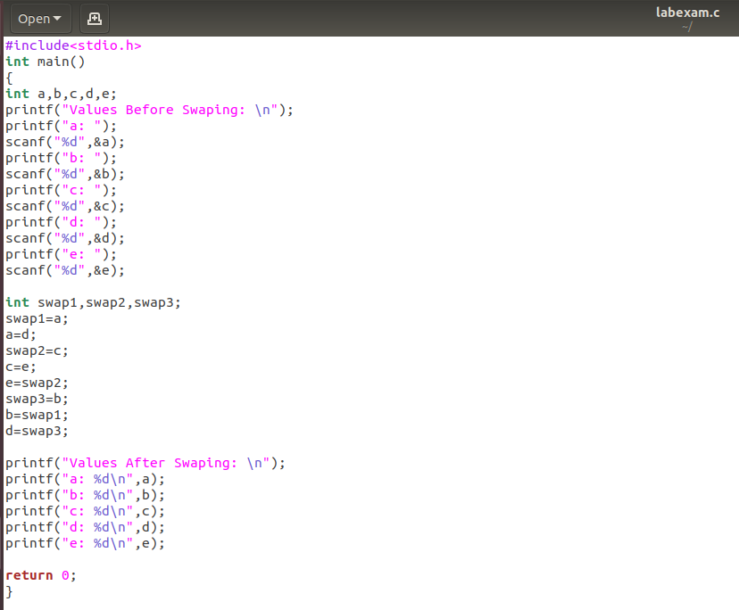

**OUTPUT:**

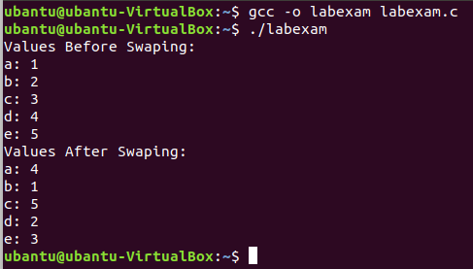

**FOLLOW THE BELOW INSTRUCTIONS:**

1. **ATTACH OUTPUT SCREENSHOTS FOR EVERY COMMAND EXECUTION, SHELL SCRIPTS, OUTPUTS MEANS EVERYTHING. FAILED TO DO SO WILL RESULT IN DEDUCTIONS**
2. **MAKE SURE TO ANSWER THE QUESTION AS PER THE PROCESSES, COMMANDS AND LOGICS STUDIED.**
3. **ZERO PLAGARISM MEANS NO COPYING FROM THE INTERNET AND FROM OTHERS (THE ONE WHO WILL COPY AND THE ONE WHO SHARES BOTH WILL FACE THE CONSEQUENCES).**
4. **TIMELY SUBMISSION IS IMPORTANT. FAILED TO DO WILL LEAD TO 5 MARKS DEDUCTION.**