**Task:**

Following the code guideline of Best-Fit Placement algorithm, write the C language program for First-Fit and Next-Fit Placement algorithms.

**First-Fit Algorithm:**

In this scheme we check the blocks in a sequential manner which means we pick the first process then compare it’s size with first block size if it is less than size of block it is allocated otherwise we move to second block and so on.

**Implementation:**

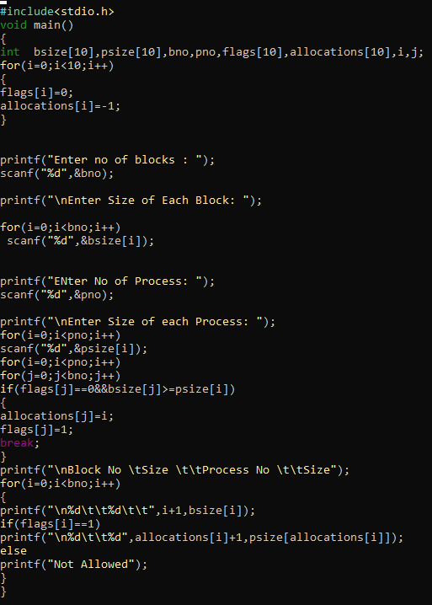

**Output:**

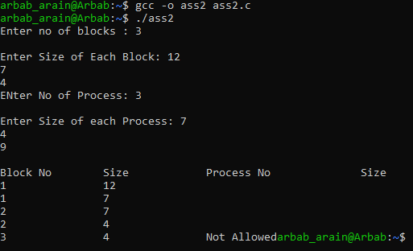

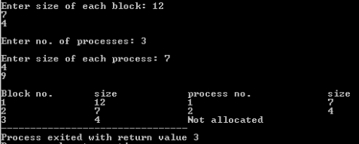

**Next-Fit Algorithm:**

This algorithm keeps a track of the positions where every file is written in the memory. It then allocates the very next available memory block to the succeeding processes. So, when a process is executed to be stored in the memory, the previous bin or the memory block is checked for its availability.

**Implementation:**

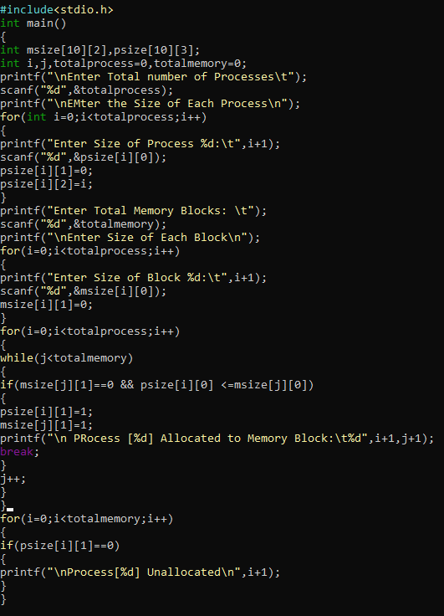

**Output:**

