# TASKS

1. Implement the semaphore-based solution to Dining Philosophers’ Problem explained above in C language.

**Dining Philosophers Problem:**

There is a dining room containing a circular table with five chairs. At each chair is a plate, and between each plate is a single chopstick. In the middle of the table is a bowl of spaghetti. Near the room are five philosophers who spend most of their time thinking, but who occasionally get hungry and need to eat so they can think some more.

A solution of the Dining Philosophers Problem is to use a semaphore to represent a chopstick. A chopstick can be picked up by executing a wait operation on the semaphore and released by executing a signal semaphore.

**Semaphores based Implementation:**

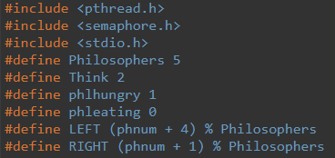

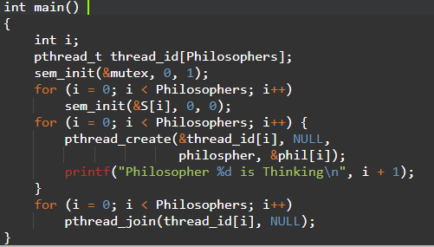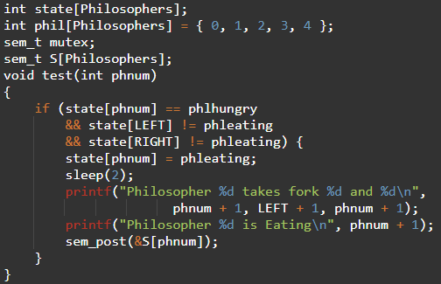

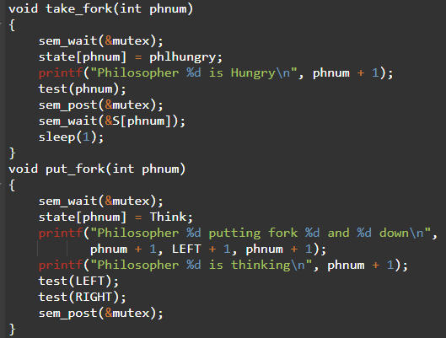

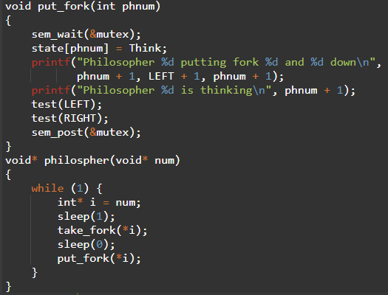

**Output:**

