**TASK 1:**

**Write a program that prints triangle using loops in python.**

**Code:**

for i in range(0,5):

    for j in range(5-i-1):

        print(end=" ")

    for j in range(0,i+1):

        print("*",end=" ")

    print()

**Output:**

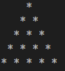

**TASK 2:**

**Write a program that prints Fibonacci series.**

**Code:**

nterms = int(input("How many terms? "))

n1, n2 = 0, 1

count = 0

if nterms <= 0:

    print("Please enter a positive integer")

elif nterms == 1:

    print("Fibonacci sequence upto", nterms, ":")

    print(n1)

else:

    print("Fibonacci sequence:")

    while count < nterms:

        print(n1)

        nth = n1 + n2

        n1 = n2

        n2 = nth

        count += 1

**Output:**

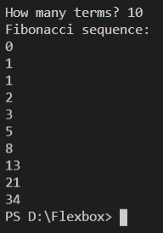

**TASK 3:**

**Write a short program that prints each number from 1 to 100 on a new line.**

* **For each multiple of 3, print “SAM" instead of the number.**
* **For each multiple of 5, print “SUNG" instead of the number.**
* **For numbers which are multiples of both 3 and 5, print “SAMSUNG" instead of the number.**

**Code:**

num = int(input("Enter Limit = "))

for x in range(1,num):

    if(x%3==0 and x%5==0):

        print("SAMSUNG")

    elif(x%3==0):

        print("SAM")

    elif(x%5==0):

        print("SUNG")

    else:

        print(x)

**Output:**

