Lab 01: Activity Tasks

Activity A:
App: WhatsApp Web
- What Client do: Renders the chat UI — messages, typing indicator, emoji picker, and type/scroll without needing to contact the server for every keystroke.
- What Server must do: Stores our messages, verifies our login session, and routes each message to the correct recipient's device.
- What breaks if the network fails mid-load: New messages get stuck with a clock/pending icon and never actually send; incoming messages stop arriving; the chat list can freeze on stale/outdated data until the connection comes back.

Activity B:
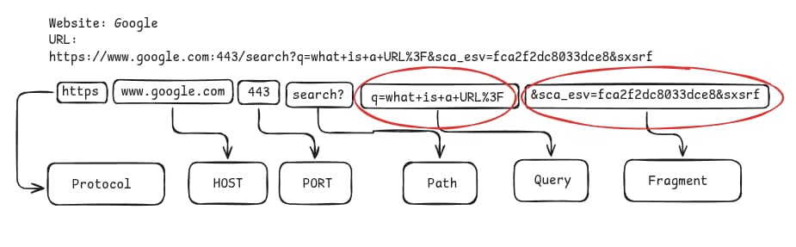

Activity C:
Instructor or neighbour calls out a situation. You answer with a status family or code:
- Page file not found on the server → 404
- You submitted a form and it was created → 201 (or 2xx)
- Server crashed while handling your request → 5xx
- You are not logged in to a private page → 401 (or 403 if authenticated but not allowed)

Activity D:
confirmation of tools installation.
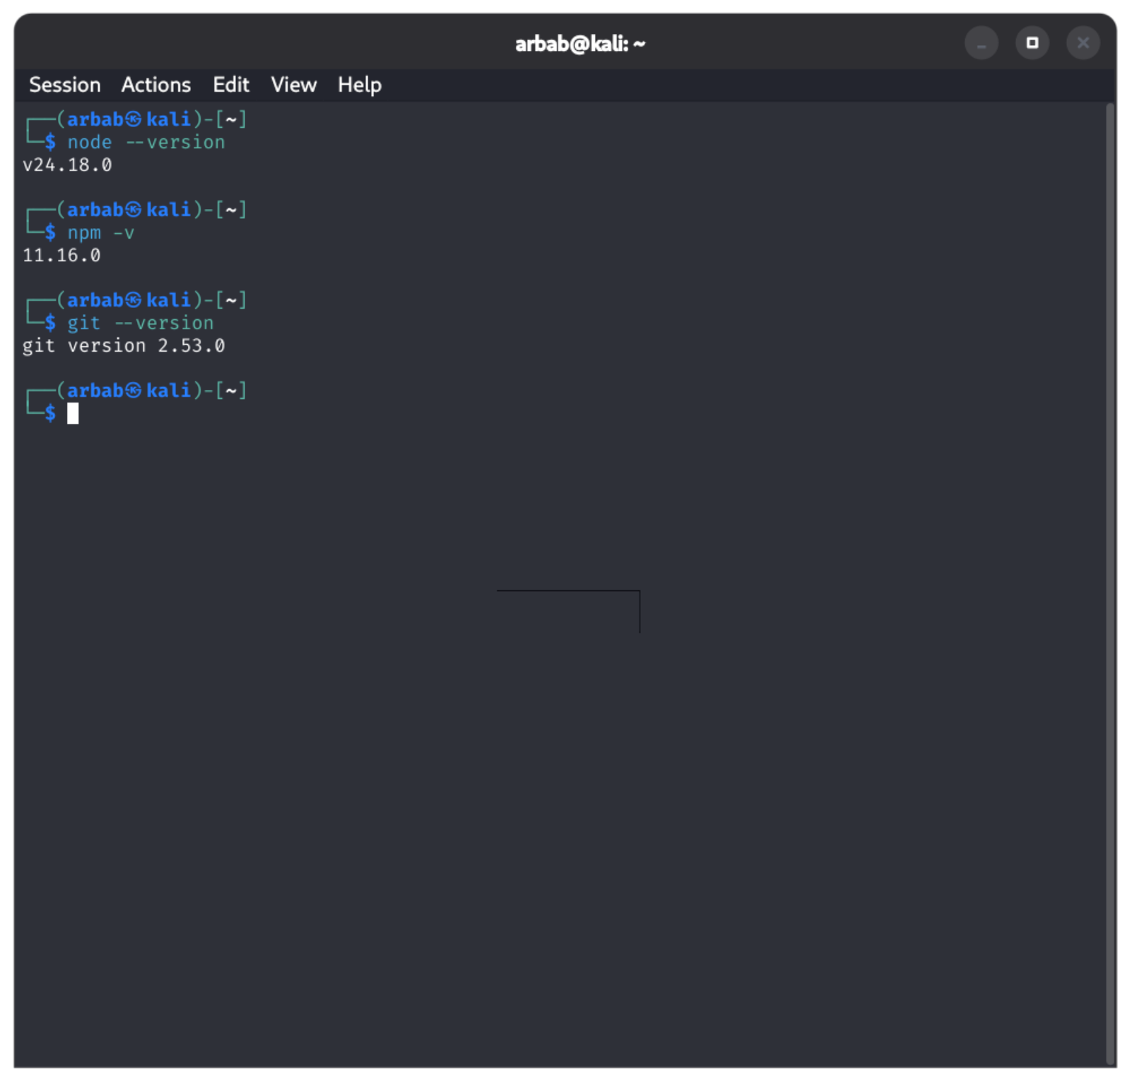

Live server is installed:
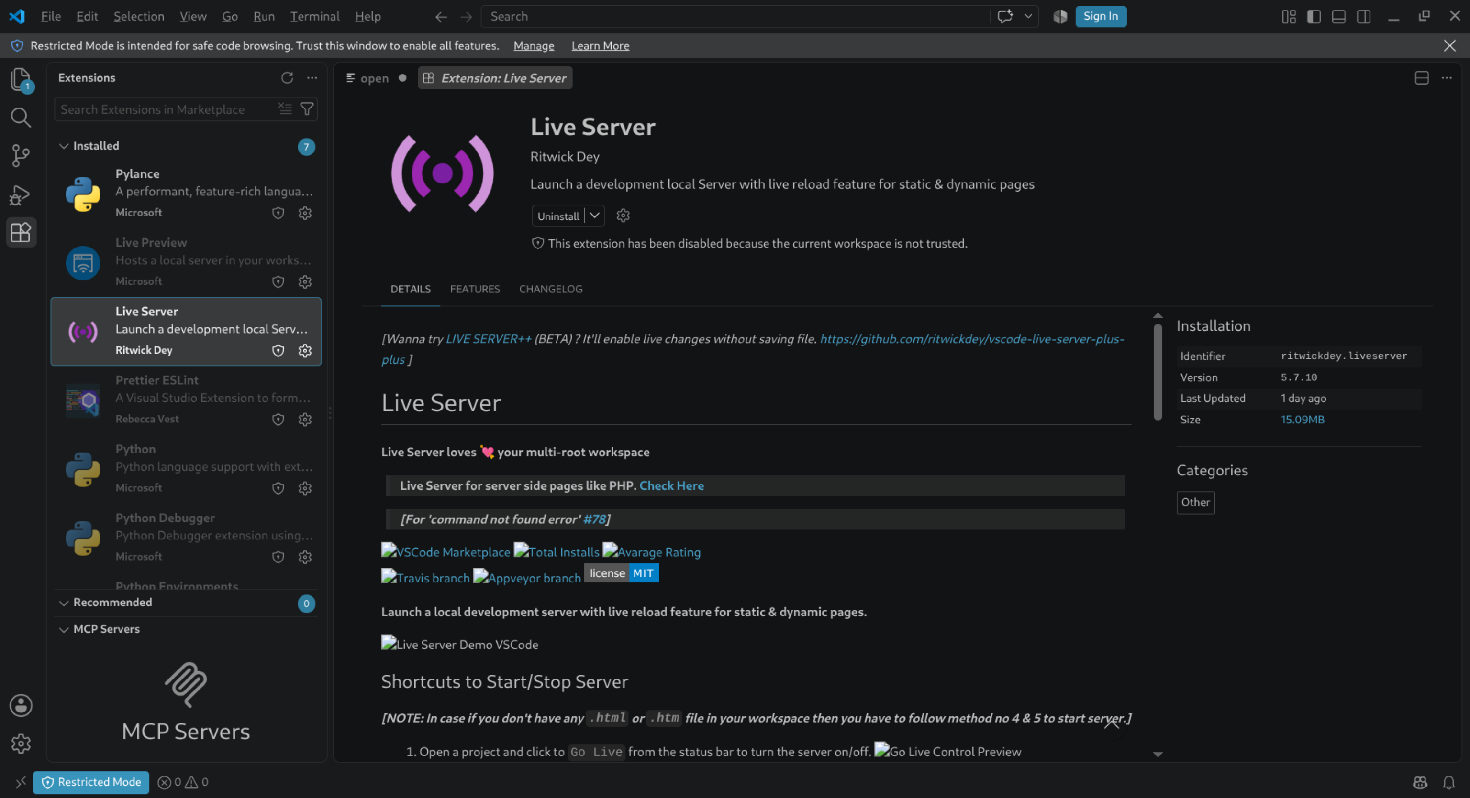

format on save is on:
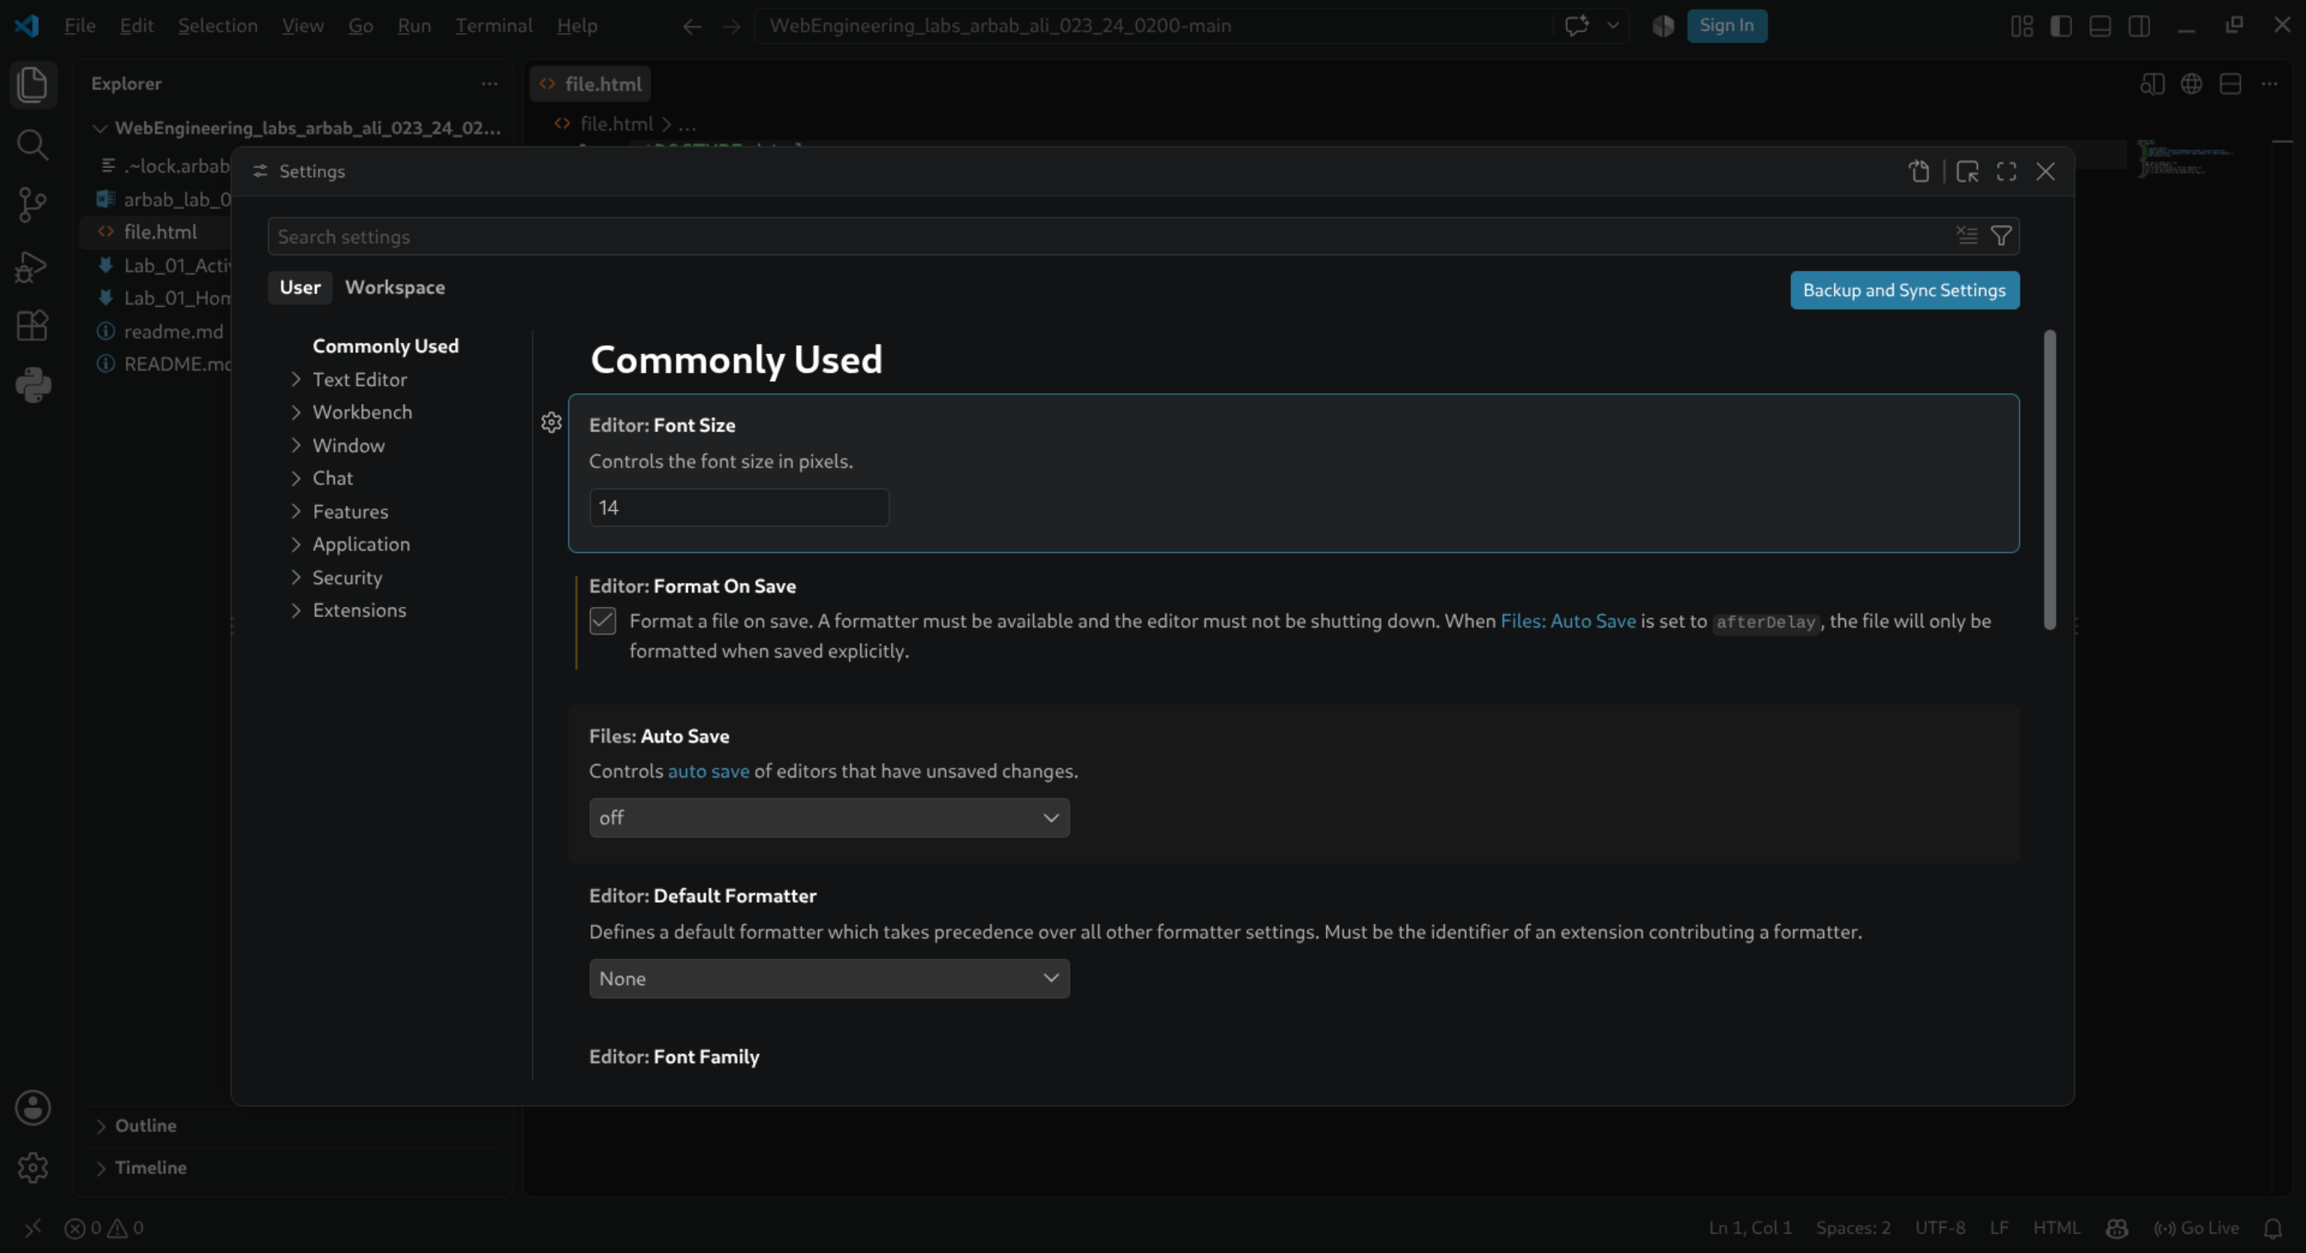

Activity E:
Activity E is perfomed and can be seen inside the folder.

Activity F:
Network (Status 200 confirmation):
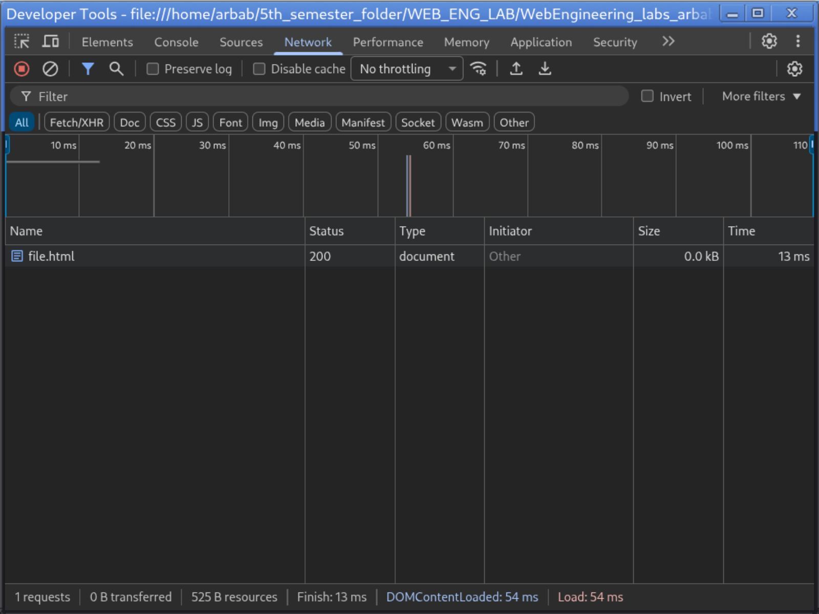
- Console: I typed document.title and got the page title. Then I called notARealFunction(), which produced a red error because the function does not exist or is not defined in the page.
- Elements: I changed the <h1> text directly in DevTools. After reloading the page, the change disappeared because DevTools only changes the webpage temporarily in the browser; it does not modify the actual index.html file.

Lab 01 Home Work Tasks:

Task 1 — Prove the toolchain:



Task 2 — Network detective (hands-on)
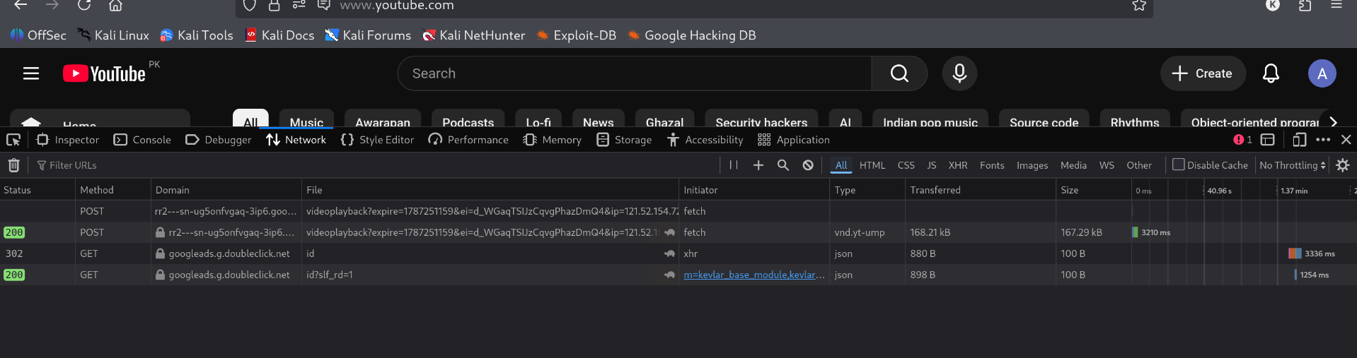

- The page made 04 requests.
- The largest file shown is base.js, which is a JavaScript file. Its size is about 446 kB.
- One request that was not 200 is the id request, which shows (blocked:other). I think the browser blocked this request for some reason, so it was not successfully completed.

