Once we click on AI &Cyber career academy it should go to the current landing page. Please alumini resources page will be added as a link later.
Keep this section as it is

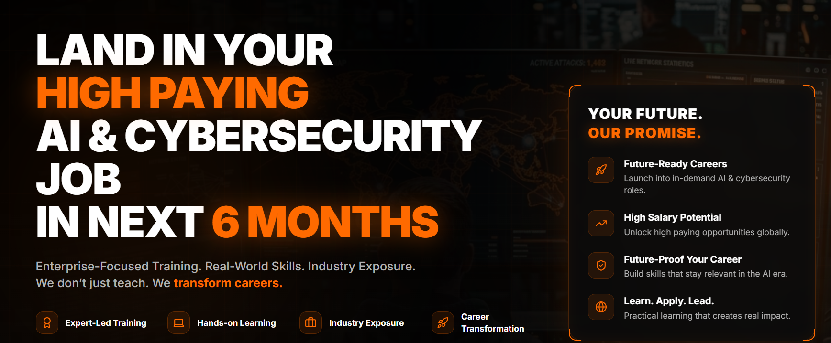
These are the changes from ‘OUR CAREER TRANSFORMATION COURSES

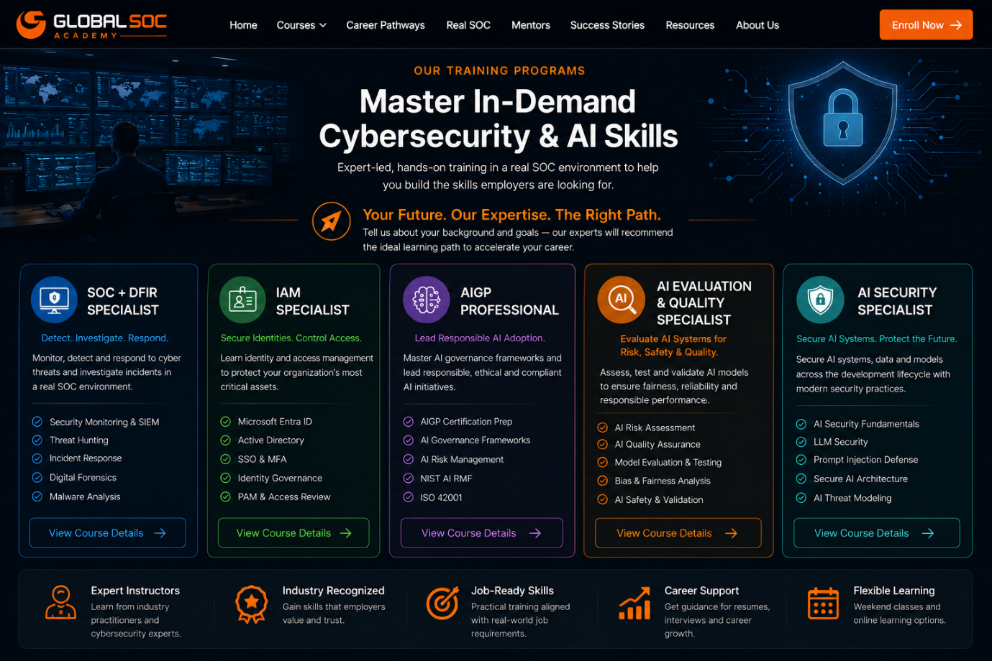

When you click on each course it should take to that course page

