**RESUME**

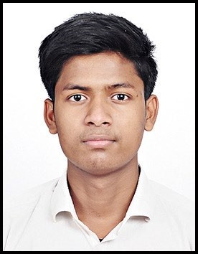**ARBAZ ANSARI**

Address: **339/1/12, Sector-7 Extension, Gurugram, Haryana.**

Email ID: **ARBAZ.ANSARI2606@GMAIL.COM**

Contact No.: **+91 9899222800**

LinkedIn Profile Link: - [**https://www.linkedin.com/in/arbazansari4u/**](https://www.linkedin.com/in/arbazansari4u/)

**CAREER OBJECTIVE:**

* To be a part of an enthusiastic work environment, where I can use my technical skills to accomplish organizational goals.

**ACADEMIC BACKGROUND:**

Pursuing B.Tech in COMPUTER SCIENCE ENGINEERING & TECHNOLOGY from Dronacharya College of Engineering, Gurgaon, Approved by AICTE.

|  |  |  |  |
| --- | --- | --- | --- |
| **Institute/University** | **Degree/Examination** | **Percentage** | **Year** |
| Dronacharya College | B.Tech | Pursuing (1st year) | ------ |
| Haryana Board | 12th | 85% | 2021 |
| Haryana Board | 10th | 43% | 2019 |

**TECHNICAL SKILLS:**

* Language: Basic concepts of C, C++, Web Designing, Python
* Operating Systems: Windows, macOS, Linux

**CERTIFICATIONS AND MEMBERSHIPS:**

* Certification of Computer Applications.
* Certification of Web Designing.
* C Certification from IIT Bombay
* Coordinator of Tech Pariksha Team
* 4 Star on Hacker Earth.

**WORKSHOPS AND TECHNICAL EVENTS:**

* Participated in poster-making competition held at Dronacharya College of Engineering on 25th January 2022.
* Tech Pariksha Team Coordinator
* Attended two days Web Development Workshop at Dronacharya College of Engineering in December 2021.
* Attended Drone workshop at Dronacharya College of Engineering in December 2021.

**STRENGTHS:**

* The ability to Work in a team.
* Leadership Qualities.
* Hard-working with lots of patience.