

SIES (NERUL) COLLEGE OF ARTS, SCIENCE AND COMMERCE NERUL, NAVI MUMBAI-400706

PROJECT REPORT ON
ECHOWORLD

Submitted by
Arbaz Zameer Parkar
Roll No: MCS.26.15
Submitted in partial fulfillment for the degree of
MASTER OF SCIENCE
In
COMPUTER SCIENCE
Under the Guidance of

Prof. Deepti Pradeep Patil

Department of Computer Science

(Sem-I)

(2026-2027)

CERTIFICATE

This is to certify that Mr. Arbaz Parkar student of SIES (NERUL) COLLEGE OF ARTS, SCIENCE AND COMMERCE NERUL, NAVI MUMBAI has completed his project work of “EchoWorld” and submitted the project in partial fulfillment of “Master of Science (Computer Science)” from Mumbai University for the academic year 2026-2027.

Roll Number: _______________ Date: _________________

(Teacher In-Charge) (External Examiner)

(Head Of Department) (Principal)

ACKNOWLEDGEMENT:
I would like to express my deepest gratitude to everyone who contributed to the successful completion of this project.

First and foremost, I extend my sincere thanks to Ms. Deepti Pradeep Patil, my project guide, for their invaluable guidance, continuous support, and encouragement throughout this project. Their insights and feedback were crucial to the project's success.

I am profoundly grateful to SIES (Nerul) College of Arts, Science and Commerce and the Computer Science department for providing the necessary resources and a conducive environment for conducting this project.

I would also like to thank my peers and classmates for their constant support and constructive discussions, which significantly contributed to the project's development.

Thank you all for your contributions and support.

Arbaz Parkar
ABSTRACT

EchoWorld is a browser-based simulation designed to demonstrate how a game-like environment can maintain both the current state and historical memory of non-player characters (NPCs). The project models a small Nordic-inspired walled settlement containing eight districts and a population configurable from 12 to 120 NPCs. NPCs follow role-dependent work and sleep schedules, move between destinations using grid-based A* pathfinding, and choose leisure destinations through deterministic heuristics informed by recorded district visits and recent flee incidents.
The principal database design separates low-latency live state from durable historical records. Redis stores each NPC’s latest state in a hash and indexes current positions in a GEO set for nearby-character queries. MongoDB stores append-only state-history documents containing run identifiers, simulation ticks, timestamps, map coordinates, GeoJSON locations, activities, zones, targets, routines, and behaviour metadata. Historical records are divided by NPC ID parity between two logical collections, and geospatial and compound indexes support spatial and temporal access patterns. This division is an application-level educational partitioning model; it is not MongoDB native cluster sharding.
The browser interface provides live simulation, replay, NPC profiles and memory timelines, nearby searches, a query laboratory, run comparison, scalability visualisations, and movement-anomaly alerts. The index benchmark compares a geospatially indexed query with a forced collection scan on the first history collection, repeating each approach 15 times and reporting the fastest timing and query-plan information. No performance figures or test outcomes are asserted in this report because execution evidence has not been supplied. EchoWorld is intended as a learning and demonstration system for key-value and document databases, geospatial indexing, temporal records, query routing, and basic performance analysis—not as a production game or a machine-learning system.
Keywords: spatiotemporal data, Redis, MongoDB, GeoJSON, 2dsphere index, NPC simulation, temporal queries, query planning, application-level partitioning

TABLE OF CONTENTS

Section | Title | Page No.
CHAPTER 1 — INTRODUCTION
1.1 | Background and Motivation
1.2 | Problem Statement
1.3 | Aim and Objectives
1.4 | Scope and Boundaries
1.5 | Project Methodology / Development Approach
1.6 | Organisation of the Report
CHAPTER 2 — SYSTEM ANALYSIS AND DESIGN
2.1 | Functional Requirements
2.2 | Non-Functional Requirements
2.3 | Existing Problem and Proposed System
2.4 | System Architecture
2.5 | Tick-Level Data Flow
2.6 | Database Design
2.6.1 | Redis Live-State Model
2.6.2 | MongoDB History Document
2.6.3 | Index Design
2.7 | Coordinate Model and Spatial Queries
2.8 | Application-Level Partitioning and Query Routing
2.9 | Technology Stack
2.10 | Hardware and Software Requirements
2.11 | Assumptions and Constraints
CHAPTER 3 — IMPLEMENTATION
3.1 | Project Structure and Main Modules
3.2 | Simulation Clock, Runs, and State Transitions
3.3 | Deterministic Heuristics and NPC Behaviour
3.4 | Road-Aware A* Navigation
3.5 | Redis Write and Live-Read Path
3.6 | MongoDB History Write and Read Path
3.7 | Temporal Queries, Profiles, and Replay
3.8 | Coordinate Conversion and Nearby Queries
3.9 | Index Benchmark
3.10 | Anomaly Detection
3.11 | Browser Interface and Canvas
3.12 | Run Comparison and Reset Semantics
3.13 | Illustrative Tick Pseudocode
CHAPTER 4 — TESTING AND VALIDATION
4.1 | Testing Strategy
4.1.1 | Testing the EchoWorld System
4.2 | Validation Techniques
4.2.1 | Functional Validation
4.2.2 | Database Consistency Validation
4.2.3 | Spatial and Temporal Validation
4.2.4 | Seeded Reproducibility
4.2.5 | Performance Validation
4.3 | Practical Considerations
4.4 | Example Testing Workflow
4.5 | Test Cases
4.5.1 | Categories of Test Cases
4.6 | Chapter Summary
CHAPTER 5 — RESULTS
5.1 | Simulation Results
5.2 | Qualitative Analysis
5.3 | Summary of Observed Findings
5.4 | Performance Testing Results
5.5 | Overall Findings
CHAPTER 6 — CONCLUSION AND FUTURE WORK
6.1 | Conclusion
6.2 | Limitations
6.3 | Future Work
REFERENCES
APPENDIX A — API ENDPOINT SUMMARY
APPENDIX B — GLOSSARY

CHAPTER 1 — INTRODUCTION

1.1 Background and Motivation
Interactive simulations often need to answer two different questions: “What is happening now?” and “What happened earlier?” The first question requires a current snapshot that can be read frequently while the simulation advances. The second requires historical records that can be queried by character, time, activity, or location. Treating both requirements as one undifferentiated data-access problem can obscure the trade-offs between low-latency updates and durable, queryable history.
EchoWorld turns this database design problem into a visible, interactive settlement simulation. Each non-player character has a current position and activity, while the system also records a sequence of historical states. Redis is used for live snapshots and proximity lookup. MongoDB stores historical documents and indexes their spatial and temporal fields. The application exposes both paths through a browser interface, allowing a learner to compare live state with replayed history and inspect query behaviour.
The project is relevant to advanced database study because it combines a key-value data model, a document data model, geospatial indexes, compound indexes, append-only history, query routing, and a simple partitioning strategy in one application. The settlement is intentionally small and the simulation rules are deliberately understandable, so the database behaviour—not sophisticated game AI—is the central educational focus.
1.2 Problem Statement
A simulation that only stores each NPC’s latest position cannot explain how the NPC reached that position, what it was doing at an earlier tick, or where it was located during a past event. Conversely, using a growing historical collection as the sole source for every live frame may introduce unnecessary work into a frequently updated path. The project therefore addresses the design question: how can live NPC state and historical spatiotemporal memory be represented, written, queried, and demonstrated using complementary database technologies?
1.3 Aim and Objectives
The aim is to implement an educational browser-based simulation that demonstrates a dual-store design for live and historical NPC data using Redis and MongoDB.
Represent NPC live state in Redis and historical state as append-only MongoDB documents.
Demonstrate nearby-character queries against live Redis GEO data and historical MongoDB GeoJSON data.
Use MongoDB geospatial and compound indexes to support spatial, NPC, run, and tick-oriented queries.
Demonstrate an application-level partitioning strategy that routes NPC history by NPC ID parity.
Provide simulation replay, NPC profiles, temporal memory timelines, run comparisons, and anomaly alerts.
Compare an indexed spatial query with a forced collection scan and expose query-plan information.
Keep the simulation rules and data flows sufficiently transparent for database learning and viva explanation.
1.4 Scope and Boundaries
The simulated world is 100 by 80 simulation units and contains eight named districts: Market, Tavern, Barracks, Watchtower, High Hall, Temple, Forge, and Stables. The default population is 12 NPCs and the configurable upper limit is 120. One map unit corresponds to 50 metres for the illustrative geographic projection. A run is assigned a run ID, may be initialised with a seed, and is limited to 400 ticks.
The system demonstrates database and simulation concepts. It is not a production game, a production monitoring platform, or a machine-learning system. NPC behaviour uses schedules, pathfinding, weighted preferences based on stored visit history, and a rule for temporarily avoiding districts after recent flee incidents. The two MongoDB history collections are logical partitions within one MongoDB instance; they do not constitute a distributed MongoDB sharded cluster.
1.5 Project Methodology / Development Approach
The development approach is modular and demonstration-oriented. The application separates simulation logic, data persistence, query logic, analytics, API handling, and browser rendering into different modules. The simulation generates state changes; a writer sends the latest snapshot to Redis and batches history records into MongoDB; API routes expose state and query results; and the browser presents the result.
Model the settlement, NPC state, simulation clock, districts, routines, and run metadata.
Implement movement and behaviour rules, including grid-based A* navigation and seeded run setup.
Create a dual-store persistence path for live state and historical records.
Add indexes and query routes for temporal history, spatial proximity, and NPC/run filtering.
Expose replay, profiles, query comparisons, run comparisons, scalability views, and anomaly detection.
Validate the system with repeatable functional and performance procedures; record actual results only after execution.
1.6 Organisation of the Report
Chapter 1 introduces the project and defines its boundaries. Chapter 2 describes requirements, architecture, data design, routing, and technology choices. Chapter 3 explains the principal implementation paths. Chapter 4 defines a validation plan and test cases while leaving unexecuted outcomes explicitly pending. Chapter 5 provides result templates and explains how to interpret measurements without inventing them. Chapter 6 summarises the educational contribution, limitations, and future work. References and appendices provide technical sources, API summaries, and a glossary.

CHAPTER 2 — SYSTEM ANALYSIS AND DESIGN

2.1 Functional Requirements
ID | Requirement | Description
FR-01 | Simulation control | Start, pause, reset, and fast-forward the simulation.
FR-02 | Run configuration | Create a run with a selected NPC count and optional seed; assign a run ID.
FR-03 | Live snapshot | Read current NPC states from Redis.
FR-04 | Historical replay | Retrieve saved frames from MongoDB across both history collections.
FR-05 | NPC profile and memory | Inspect routine, activity, movement, and grouped historical activity segments.
FR-06 | Nearby search | Find nearby live NPCs through Redis GEO and historical NPC records through MongoDB geospatial queries.
FR-07 | Query Lab | Compare live and historical query paths and inspect query-plan / benchmark output.
FR-08 | Partition routing | Route an individual NPC history query to its parity collection; combine both collections for global queries.
FR-09 | Anomaly alerts | Flag stored position changes that exceed the configured plausible-step threshold.
FR-10 | Run comparison | Compare two saved runs at a selected tick by position and activity.
FR-11 | Scalability view | Display current-run shard counts, write samples, latency, and benchmark information.
FR-12 | Data reset | Clear EchoWorld records in both MongoDB history collections and application Redis keys.

2.2 Non-Functional Requirements
ID | Quality attribute | Requirement / interpretation
NFR-01 | Clarity | Database responsibilities and query paths should be understandable through the interface.
NFR-02 | Repeatability | A supplied seed and NPC count should reproduce a run for the same simulation version.
NFR-03 | Maintainability | Simulation, database, query, analytics, API, and frontend concerns are separated into modules.
NFR-04 | Data separation | Live state is maintained separately from append-only history.
NFR-05 | Query observability | The interface should expose query plan information and timing where implemented.
NFR-06 | Local deployment | Docker Compose provides local MongoDB 7 and Redis 7 services.
NFR-07 | Scope control | The application must not imply production-grade distribution or monitoring.
NFR-08 | Measurement integrity | Performance results must be captured from actual runs with the environment recorded.

2.3 Existing Problem and Proposed System
A single mutable record per NPC is efficient for current-state display but cannot, by itself, represent an event timeline. A history-only design can preserve every tick but is not ideal as the only path for repeatedly reading the latest state. EchoWorld proposes a dual-store design: Redis acts as the current-state and proximity layer, while MongoDB acts as the historical record and query layer. The application coordinates the two stores on each simulation tick.
The dual-store design is educational rather than a claim of universal superiority. It introduces duplicated representations and requires the writer to keep both stores aligned. A partial failure between Redis and MongoDB could leave the live snapshot newer than the persisted history until the write path is retried or the run is otherwise handled. The report does not assume a distributed transaction across these stores.
2.4 System Architecture
The browser communicates with a FastAPI service over HTTP. The service coordinates the simulation engine, query and analytics modules, and persistence writer. Redis and MongoDB run locally through Docker Compose. The browser uses standard HTML, CSS, JavaScript, and a canvas; no frontend framework is used.
flowchart LR
U[User / Browser UI] <-->|HTTP API| API[FastAPI + Uvicorn]
API <--> ENG[Simulation Engine]
ENG --> WR[Tick Writer]
WR -->|Pipeline: current hashes + GEO positions| R[(Redis)]
WR -->|Batched append-only history| M[(MongoDB)]
API --> Q[Query and Analytics Modules]
Q <-->|Live reads / GEO search| R
Q <-->|History / GeoJSON / indexes| M
API --> U

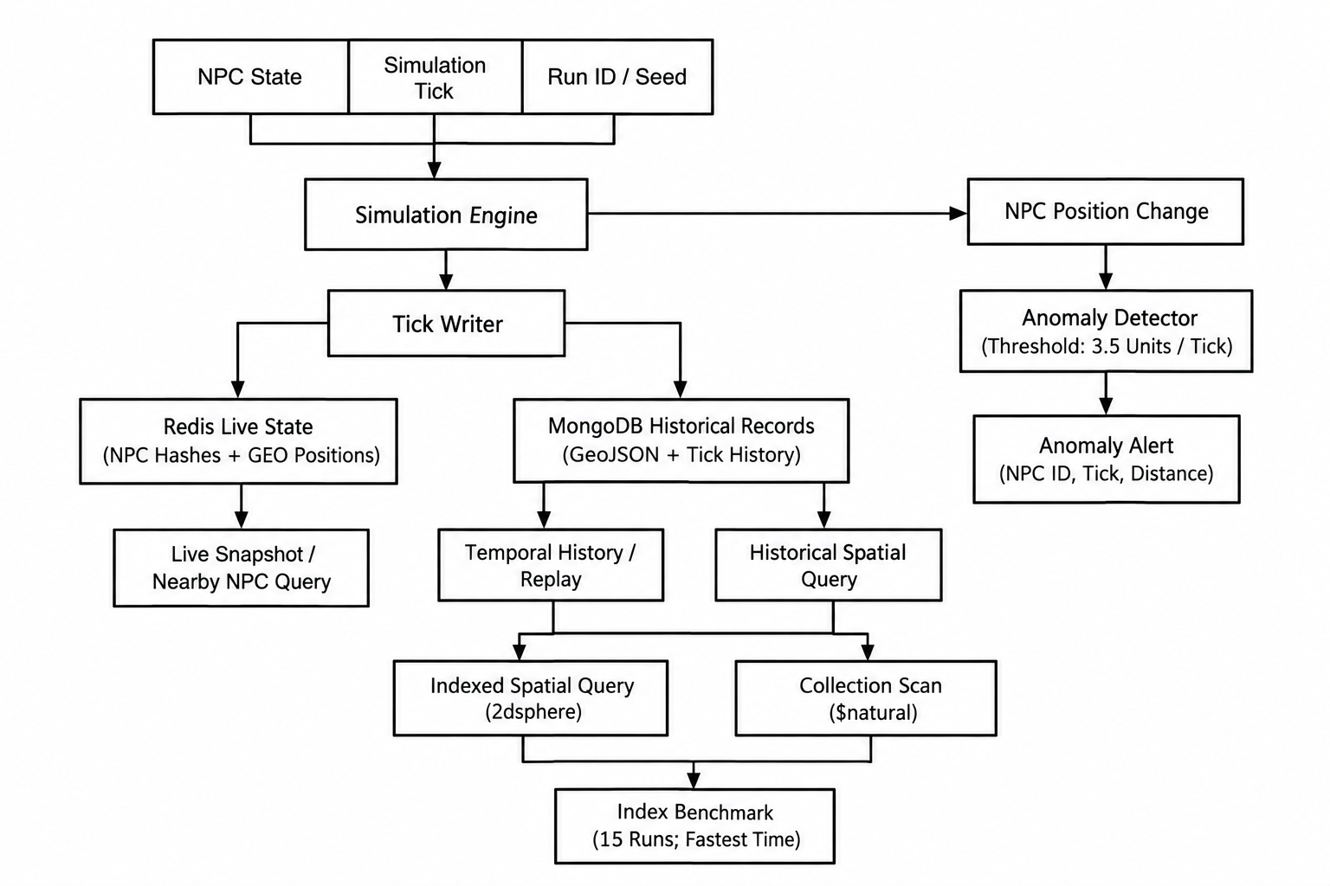

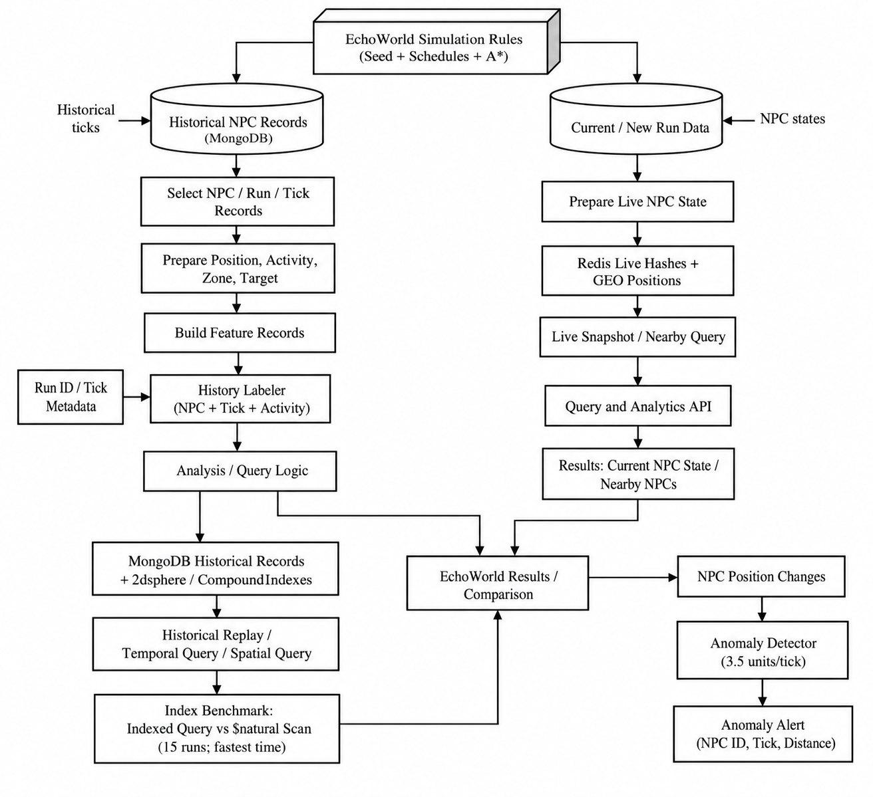

2.5 Tick-Level Data Flow
The simulation tick is the point at which the world advances. NPC state is updated by the engine, the writer prepares the current snapshot, Redis receives the latest state and geospatial membership, and MongoDB receives the corresponding historical documents. Query routes subsequently read from the appropriate store.
participant UI as Browser UI
participant API as FastAPI
participant E as Simulation Engine
participant W as Writer
participant R as Redis
participant M as MongoDB
UI->>API: Start / advance simulation
API->>E: Advance one tick
E->>E: Update schedules, behaviour and paths
E->>W: Current NPC states + run/tick metadata
W->>R: Pipeline hashes, GEO positions, current tick
W->>M: Batch append-only history documents
UI->>API: Request live state or history
API->>R: Read live snapshot / GEO results
API->>M: Read frames / temporal / spatial history
R-->>API: Live data
M-->>API: Historical data
API-->>UI: JSON response
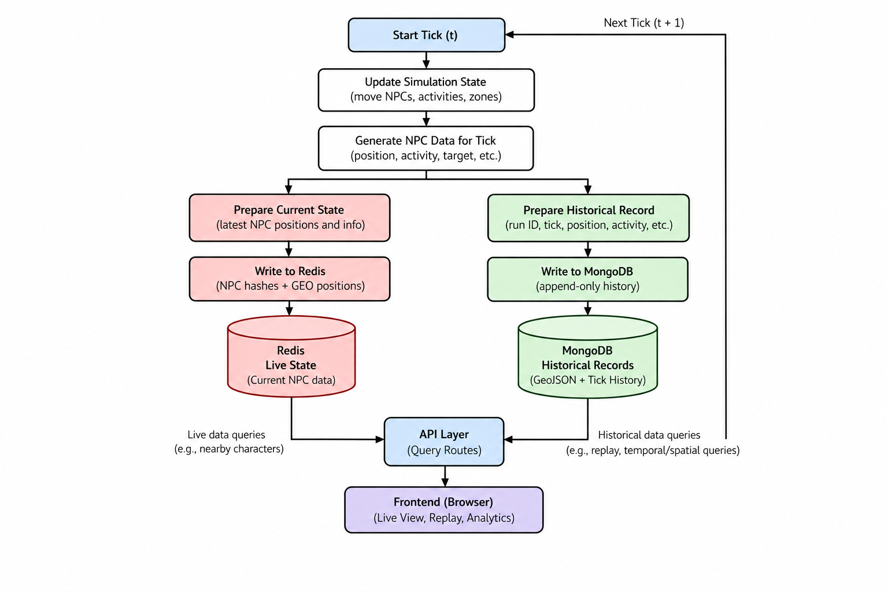

2.6 Database Design
2.6.1 Redis live-state model
Each NPC’s latest state is stored under `npc:live:<NPC_ID>` as a Redis hash. The current hash fields written by the project are `x`, `y`, `activity`, `zone`, `target`, `routine`, and `tick`. The live position is also added to the Redis GEO set `npc:live:positions`, using the NPC ID as the member. The current simulation tick is stored at `sim:tick`. These structures are mutable: each tick overwrites current fields rather than keeping a complete historical timeline in Redis.
Illustrative—not literal—shape of a live state:
Key: <EchoWorld NPC state key>
Hash fields (illustrative):
npc_id, name, role, x, y, activity, zone,
target, routine, run_id, tick
GEO set:
member = NPC identifier
longitude/latitude = projected live position
Separate value:
current simulation tick

2.6.2 MongoDB history document
MongoDB stores append-only history documents. Each document represents an NPC state associated with a particular run and tick. Fields include run ID, seed, NPC count, NPC ID, tick, timestamp, map x/y coordinates, GeoJSON location, activity, zone, target, routine, and behaviour or incident metadata. A history document allows the application to reconstruct a frame or filter records by NPC, run, time, and location.
{
"run_id": "<run identifier>",
"seed": "<seed or null>",
"npc_count": "<configured population>",
"npc_id": "<NPC identifier>",
"tick": "<integer tick>",
"timestamp": "<recorded timestamp>",
"x": "<map x coordinate>",
"y": "<map y coordinate>",
"location": {
"type": "Point",
"coordinates": ["<longitude>", "<latitude>"]
},
"activity": "<activity label>",
"zone": "<district>",
"target": "<destination>",
"routine": "<routine label>",
"metadata": "<behaviour / incident fields>"
}
The schema above illustrates the current fields written by `src/writer.py`; values are placeholders to explain the structure rather than copied BSON values. The implementation records `timestamp` as a UTC datetime, numeric map coordinates, a GeoJSON Point with `[longitude, latitude]`, and behaviour fields including `decision_note`, `incident_zone`, and `incident_tick`.

2.6.3 Index design
`src/db.py` creates the following indexes on each history collection: a 2dsphere index on `location`; compound indexes on `(npc_id, tick)`, `(npc_id, run_id, tick)`, and `(run_id, tick)`; and a single-field index on `tick`. A 2dsphere index supports spherical geospatial queries over Earth-like coordinates [1]. Compound indexes store keys in a defined order, so their usefulness depends on the filter and sort patterns used by each query. Indexes can reduce documents examined, but they also require storage and maintenance during writes. The benchmark compares the query using a location 2dsphere hint with the same spatial query using a `$natural` hint intended to force collection-order scanning. It repeats each method 15 times and reports the minimum elapsed time, stage label, and collection/run counts. MongoDB explain output can provide plan stages and execution statistics [2].
The index benchmark compares the same spatial query with the 2dsphere index and with a `$natural` hint intended to force collection-order scanning. Query-plan information is important because elapsed time alone does not reveal whether the query used an index or examined many documents. MongoDB’s `explain` output can report plan stages, documents examined, keys examined, and execution statistics [2].

2.7 Coordinate Model and Spatial Queries
The settlement’s x/y map coordinates are projected into a small geographic area near longitude 73.10 and latitude 19.00. One map unit represents 50 metres. This projection enables the same NPC position to be represented in the canvas, Redis GEO, and MongoDB GeoJSON. It is a local visualisation mapping, not a survey-grade geographic transformation.
Live nearby searches use Redis GEO. Historical nearby searches use MongoDB GeoJSON and a spherical-radius query supported by the 2dsphere index. MongoDB GeoJSON coordinates are ordered longitude first and latitude second [1]. Care is required when converting the simulation’s y-axis, which may increase downwards on a canvas, into latitude, which follows geographic conventions.

2.8 Application-Level Partitioning and Query Routing
Historical documents are routed by NPC ID parity into `npc_history_shard_a` and `npc_history_shard_b`. An individual NPC query can determine the relevant collection from the identifier. A world-wide query must query both collections and combine the results. This design makes query routing visible to the learner and allows record distribution to be inspected.
The word “shard” in the interface is an educational label for two logical collections. Both collections reside on one MongoDB instance. MongoDB native cluster sharding—which distributes chunks across a sharded cluster with shard servers and routing infrastructure—is not configured. The partition model does not demonstrate network distribution, independent server failure domains, or cluster-level horizontal scaling.
if query targets one NPC:
choose collection using NPC ID parity
query that collection
else:
query npc_history_shard_a
query npc_history_shard_b
combine, sort, and apply relevant result limits

2.9 Technology Stack
Technology | Role in EchoWorld
Python | Simulation and backend implementation language.
FastAPI | Defines HTTP API routes and request/response handling.
Uvicorn | ASGI server used to serve the FastAPI application.
Redis 7 | Current NPC hashes, live GEO positions, and current tick state.
MongoDB 7 | Append-only history documents, GeoJSON, and query indexes.
Docker Compose | Starts local Redis and MongoDB services.
HTML and CSS | Page structure and styling.
JavaScript Canvas | Settlement rendering, movement, trails, lighting, and map interactions.
HTTP / JSON | Communication between browser and backend.

2.10 Hardware and Software Requirements
The supplied project notes do not specify a minimum processor, RAM, or storage requirement. These should not be invented. The application requires a computer capable of running Python, the browser, Docker, MongoDB 7, and Redis 7 concurrently. Actual resource needs depend on the chosen NPC population, number of recorded ticks, local database contents, and benchmark activity.
Category | Requirement
Operating system | A supported operating system for Python and Docker Desktop / Docker Engine; record the actual OS used for evaluation.
Runtime | Python installation compatible with the project dependencies; exact version: [Record version].
API server | FastAPI and Uvicorn as installed in the project environment.
Databases | MongoDB 7 and Redis 7, started with the supplied Docker Compose configuration.
Browser | A modern browser with JavaScript and HTML Canvas support.
Development tools | [Record editor, terminal, and version-control tool if relevant].
Hardware | [Record CPU, RAM, storage, and OS for benchmark reproducibility].

2.11 Assumptions and Constraints
The local database services are available and correctly configured before the API starts.
A seeded run is reproducible only for the same simulation version and relevant configuration.
MongoDB history is append-only during normal run creation; reset is a destructive application action.
Starting a new run or changing NPC count retains earlier MongoDB history; reset clears EchoWorld records in both history collections and application Redis keys.
Database status counters may include earlier runs and must not be presented as active-run-only counts unless explicitly filtered.
The benchmark is local and currently covers the first history collection only.
The known NPC_03 teleport at tick 75 is intentional test data for the anomaly rule.

CHAPTER 3 — IMPLEMENTATION

3.1 Project Structure and Main Modules
The repository separates the application by responsibility. The descriptions below are based on the public EchoWorld repository’s README and current source files.
File / path | Responsibility
`run.py` | Documented local entry point; launches the application.
`src/server.py` | FastAPI application and API routes.
`src/engine.py` | Simulation clock, NPC state updates, schedules, behaviour, and movement.
`src/db.py` | Database connections and persistence-related setup.
`src/writer.py` | Redis current-state writes and batched MongoDB history writes.
`src/queries.py` | Live and historical query operations, including spatial / temporal access.
`src/analytics.py` | Analytics such as anomaly detection, benchmark, or run statistics.
`src/geo.py` | Map-to-geographic coordinate conversion and geospatial helpers.
`src/models.py` | Shared data models and structures.
`static/index.html` | Browser interface structure.
`static/app.js` | Canvas rendering, controls, browser interactions, and API calls.
`static/style.css` | Interface styling.

The documented entry point is `python run.py`. The local browser application is served at `http://127.0.0.1:8000`, and the FastAPI interactive API documentation is available at `/docs`. These are documented configuration details, not evidence that the application has been started successfully in the current evaluation.

3.2 Simulation Clock, Runs, and State Transitions
The accelerated simulation clock advances ten in-game minutes per tick, starting at 06:00. A 24-hour in-game day therefore contains 144 ticks. With the configured live tick interval of 0.25 seconds, a full in-game day takes 36 seconds under normal tick timing. Each run is limited to 400 ticks. A run receives a UUID-based run ID and a seed: if no seed is supplied, the application generates a fresh random seed; if a seed is supplied with the same NPC count and simulation version, the simulation’s pseudorandom choices can be reproduced.
NPC state includes identity, name, role, position, activity, routine, target, and assigned home. Work and sleep schedules depend on the NPC role. The engine advances the clock, determines the current scheduled activity, chooses or updates a target, computes a path, and advances the character. A new run receives fresh run metadata while older MongoDB history is retained unless the reset operation is explicitly used.

3.3 Deterministic Heuristics and NPC Behaviour
The project does not use machine learning to choose NPC actions. During leisure time, destination selection uses weighted preferences derived from recorded district visits. Recent flee incidents can temporarily reduce the likelihood of selecting a district. These are rule-based heuristics: stored history affects later choices through explicit application rules, but the system does not train a model or infer policies from a training dataset.
The known NPC_03 teleport at tick 75 is deliberately injected into each run. It provides a controlled, repeatable example for the anomaly detector. It should be described as a demonstration event rather than an accidental pathfinding failure.

3.4 Road-Aware A* Navigation
A* (A-star) is a graph-search algorithm that evaluates a path using the cost already incurred and an estimate of the remaining cost. In EchoWorld, the map is represented as a grid. Navigation favours roads, avoids building footprints, and uses the southern gate to cross the settlement wall. These constraints allow the canvas to show characters moving through a plausible route rather than simply interpolating directly through buildings.
At a high level, the engine identifies a destination, runs the path search on the grid, and advances the NPC along the selected path as ticks progress. The report does not claim a particular heuristic formula, tie-breaking rule, or asymptotic runtime for the implementation unless these are verified from the source.

3.5 Redis Write and Live-Read Path
On each tick, the writer updates each NPC’s Redis hash and inserts or updates the character’s position in the Redis GEO set. A Redis pipeline groups multiple commands so that the client can send a batch of operations rather than making a separate network round trip for every command. The simulation tick is stored separately. The live API reads the latest snapshot from Redis and supplies it to the browser.
Redis is chosen for this responsibility because the live state is frequently overwritten and read as a current snapshot. Redis GEO adds a specialised spatial lookup path for nearby live characters. Redis is not treated as the durable source for full historical replay in this design.

3.6 MongoDB History Write and Read Path
The writer batches historical state documents into MongoDB. Each document is associated with a run and tick and includes the NPC’s coordinates, location, activity, district, target, routine, and behaviour or incident metadata. The records are append-only during normal simulation operation, allowing the application to reconstruct earlier frames and query temporal sequences.
The history writer routes a document to one of two collections according to NPC ID parity. A request for a single NPC can query the relevant collection; a query spanning all NPCs reads both collections and combines results. Replay uses both collections to assemble historical frames. The run ID is important because the same NPC identifier may appear across different runs, and comparisons must distinguish records by run.

3.7 Temporal Queries, Profiles, and Replay
Temporal queries use fields such as run ID, NPC ID, and tick to retrieve historical states in the required interval. Compound indexes support common filtering combinations, subject to the actual index key order. An NPC profile combines schedule and movement/activity information. The memory view groups consecutive activity records into timeline segments and exposes behaviour notes derived from prior district visits and flee incidents.
Replay mode differs from live mode in its data source. Live mode reads the current snapshot from Redis. Replay mode retrieves recorded MongoDB frames from both history collections and allows the user to play or scrub through the saved sequence. This distinction is central to the project: current state and historical state are related but serve different query needs.
3.8 Coordinate Conversion and Nearby Queries
The canvas uses local x/y simulation coordinates. The geospatial layer converts these into longitude/latitude around a small area near 73.10° E and 19.00° N, with one map unit representing 50 metres. A GeoJSON Point stores coordinates in longitude–latitude order. Live proximity requests use Redis GEO, while historical proximity requests use MongoDB’s spherical geospatial query facilities.
A historical nearby search may be scoped to one NPC or to all history. An individual NPC request can use parity-based routing. A world-wide request must query both collections and combine results. When interpreting results, the selected run and time range matter: a character can have many historical locations, so a spatial result is not automatically a unique current character.

3.9 Index Benchmark
The benchmark executes the same spatial query using the geospatial index and a `$natural` hint that forces a collection scan. Each approach is repeated 15 times. The implementation reports the fastest observed timing together with query-plan information. It currently benchmarks the first shard collection only, so it is a focused local demonstration rather than a comprehensive multi-collection or multi-server benchmark.
Using the fastest of 15 runs is useful for showing a best observed result, but it does not describe the full distribution of timings. It can be sensitive to cache state, background activity, database size, query selectivity, and the host machine. A stronger evaluation would retain every sample and report median, spread, warm-up policy, document counts, and execution statistics. Those additional measurements are proposed future validation, not existing reported results.

3.10 Anomaly Detection
The anomaly detector compares consecutive stored positions for an NPC and flags a movement whose distance exceeds a configured plausible-step threshold. The detector is a simple rule-based check. It does not establish the cause of a movement and does not use statistical learning. The deliberate NPC_03 teleport at tick 75 creates a known large step against which the detector can be examined.
The threshold should be interpreted in the context of the simulation tick and coordinate units. A false positive may occur if the threshold is too low or if legitimate movement can cover a large distance in one tick. A missed anomaly may occur if the threshold is too high. Validation should confirm the expected event is flagged and that ordinary movement does not routinely trigger alerts.
3.11 Browser Interface and Canvas
The frontend uses plain HTML, CSS, and JavaScript. An HTML canvas renders the settlement, buildings, NPCs, movement trails, day/night lighting, and activity indicators. The interface includes zoom, pan, a minimap, district filtering, and NPC search. Controls expose simulation start/pause/reset/fast-forward, Live and Replay modes, NPC profiles, Query Lab, Scalability, Compare Runs, Alerts, and Concepts.
The Scalability view allows the population to be changed from 12 to 120 NPCs and visualises query latency, dual-write throughput, logical shard distribution, and indexed-versus-scan performance. These displays are educational summaries of the local run; they should not be described as a production observability system.

3.12 Run Comparison and Reset Semantics
The comparison view allows two saved runs to be inspected at the same tick and compares matching NPC positions and activities. This can demonstrate how a seed, configuration, or random run affects the simulated outcome. A reproducibility claim should be evaluated with the same simulation version, seed, NPC count, and relevant configuration.
Starting a new run or changing the NPC count preserves prior MongoDB history. Reset is different: it clears EchoWorld records in both history collections and the application’s Redis keys before initialising a new run. Database status counters can include older runs; therefore a total database count must not be labelled as the active-run record count without applying a run filter.

3.13 Illustrative Tick Pseudocode
for each simulation tick:
advance accelerated simulation clock
for each NPC:
determine scheduled activity from role and time
choose or update destination using current rules
compute / continue road-aware A* route
update position, activity, target and behaviour metadata
write current NPC snapshots to Redis using a pipeline
add current positions to the Redis GEO set
batch append-only history documents into MongoDB
increment or publish the current tick

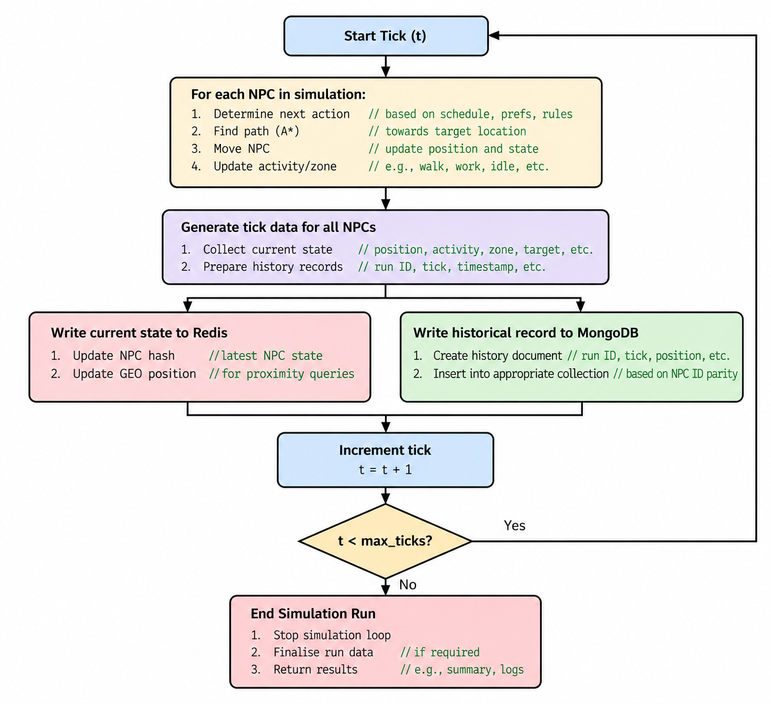

Chapter 4: Testing and Validation

4.1 Testing Strategy
Testing and validation are important stages in the development of EchoWorld. The purpose is to verify that the simulation behaves as expected, that Redis and MongoDB store and retrieve data correctly, and that the spatial and temporal queries produce appropriate results. Testing also helps evaluate the application's simulation controls, replay functionality, anomaly detection, and database performance.

4.1.1 Testing the EchoWorld System
- Simulation Testing
  - Verify that the simulation starts, pauses, resumes, and advances through the expected number of ticks.
  - Check that NPCs move between districts, follow their schedules, and navigate around buildings and city walls.
  - Verify that the simulation respects the configured population limits of 12 to 120 NPCs and the maximum of 400 ticks per run.
- Database Testing
  - Verify that Redis stores the latest state of each NPC in a hash and maintains their current positions in a GEO set.
  - Check that MongoDB stores historical NPC records with the appropriate run ID, tick, position, activity, and timestamp.
  - Verify that records are routed to npc_history_shard_a or npc_history_shard_b according to NPC ID parity.
  - Confirm that starting a new run preserves previous MongoDB history, while the Reset operation clears EchoWorld's stored data.
- Spatial Query Testing
  - Verify that Redis GEO searches return nearby NPCs based on their current positions.
  - Check that MongoDB historical spatial queries return recorded positions within the specified radius.
  - Compare the live and historical results while considering that they represent different points in time.
- Temporal Query Testing
  - Verify that NPC history queries return records within the specified tick range.
  - Check that consecutive activities are grouped into timeline segments correctly.
  - Confirm that replay retrieves historical frames from both MongoDB collections and displays them in tick order.
- Performance and Index Testing
  - Compare the execution time of a spatial query using the MongoDB 2dsphere index with the same query forced to perform a collection scan.
  - Examine the query-plan information to identify the access method used.
  - Record query latency, write throughput, and shard record distribution for different NPC populations.
- Anomaly Detection Testing
  - Verify that the movement detector identifies an NPC position change exceeding the configured plausible movement threshold.
  - Use the deliberate teleport of NPC_03 at tick 75 as a known demonstration event.
  - Check that the detected anomaly includes the NPC identifier, tick, distance, and comparison with typical movement.

4.2 Validation Techniques
4.2.1 Functional Validation
Functional validation checks whether each application feature behaves according to its requirements. This includes simulation controls, NPC profiles, history retrieval, nearby-character searches, run comparisons, and anomaly alerts.
The validation procedure involves providing specific inputs, performing the corresponding actions, and comparing the observed output with the expected result. Any differences should be recorded for further investigation.

4.2.2 Database Consistency Validation
EchoWorld writes current NPC state to Redis and historical records to MongoDB. Database consistency validation examines whether both storage operations contain the appropriate information for the same simulation tick.
The following checks are proposed:
- Compare NPC identifiers and positions in Redis with the corresponding historical records in MongoDB.
- Verify that historical records contain the correct run ID and tick.
- Check that each NPC's records are stored in the collection assigned by the routing strategy.
- Confirm that world-wide historical queries retrieve relevant records from both collections.
- Verify that records from earlier runs remain available after starting a new run.

4.2.3 Spatial and Temporal Validation
Spatial validation examines whether nearby-character queries use the intended coordinates and radius. The world uses a map coordinate system in which one simulation unit represents 50 metres. Historical positions are converted into GeoJSON coordinates for MongoDB geospatial operations.
Temporal validation checks that queries correctly filter records by run ID and tick range. The results should be ordered appropriately and should not unintentionally combine histories from different runs.
4.2.4 Seeded Reproducibility
EchoWorld supports seeded simulation runs. To validate reproducibility, start two runs using the same seed, NPC count, and simulation version. Compare NPC positions, activities, destinations, and recorded movement events at matching ticks.
The expected result is that the same inputs produce the same simulation sequence. Runs with different seeds may produce different randomized outcomes.
4.2.5 Performance Validation
Performance validation measures the time required for database queries and writes under different simulation populations. The Scalability section provides information about live-versus-history query latency, write throughput, shard distribution, and indexed-versus-scan performance.
The spatial index benchmark repeats each query approach 15 times and reports the fastest measured time. It also provides query-plan information. The current implementation benchmarks only the first history collection; therefore, the result should not be interpreted as a comprehensive multi-server or distributed-sharding benchmark.
Performance measurements depend on the local machine, database contents, cache state, and runtime conditions. Actual measurements must be recorded before drawing conclusions about performance improvements.
4.3 Practical Considerations
- Database Availability
  - MongoDB and Redis must be running and accessible before the application is tested.
  - Docker Compose is used to start the local database services.
  - Database connection failures should be recorded separately from application logic errors.
- Data Integrity
  - Tests should verify that stored positions, activities, run identifiers, and tick numbers are consistent with the simulation output.
  - Reset and new-run operations must be tested separately because they have different effects on historical data.
- Repeatability
  - Seeded runs should use the same seed, NPC count, and simulation version.
  - Benchmark trials should record the environment and database contents to support meaningful comparisons.
- Performance Limitations
  - The simulation supports a population of 12 to 120 NPCs and a maximum of 400 ticks per run.
  - The two MongoDB history collections are logical partitions on one MongoDB instance, not separate database servers.
  - Results from this environment cannot independently establish performance at production scale.
- Test Evidence
  - Each test should include its inputs, expected result, actual result, and status.
  - Tests must be marked as pending or not run until they have actually been executed.
  - Screenshots, API responses, database records, and benchmark output may be retained as evidence where appropriate.

4.4 Example Testing Workflow
- Environment Setup
  - Start MongoDB and Redis using Docker Compose.
  - Install the required Python dependencies and launch the application using python run.py.
  - Open the browser interface and confirm that the application is accessible.
- Simulation Execution
  - Start the simulation or use the fast-forward control to generate historical records.
  - Observe NPC movement, schedules, activities, and changes in the accelerated game clock.
  - Record the run ID, seed, NPC count, and tick range used during testing.
- Database Verification
  - Inspect the live NPC snapshot obtained from Redis.
  - Retrieve historical frames from MongoDB and verify the relevant run and tick information.
  - Check the record distribution between the two history collections.
- Query Validation
  - Execute nearby-character searches and temporal history queries.
  - Inspect NPC profiles and replay historical frames.
  - Compare the indexed spatial query with the forced collection-scan query.
- Anomaly Validation
  - Generate sufficient simulation history to reach tick 75.
  - Run the anomaly detector and check whether the deliberate NPC_03 teleport is reported.
  - Record the actual output without assuming that the expected alert was produced.
- Result Recording
  - Document the observed outputs, timings, errors, and test statuses.
  - Capture screenshots of the relevant interface sections.
  - Analyse the evidence before determining whether each requirement has been satisfied.

4.5 Test Cases
Testing EchoWorld requires cases covering simulation behaviour, database operations, query correctness, reproducibility, performance, and anomaly detection.
4.5.1 Categories of Test Cases
1. Simulation Controls
- Start the simulation and verify that the tick counter advances.
- Pause the simulation and verify that real-time advancement stops.
- Fast-forward the simulation by a specified number of ticks.
- Verify that the run does not exceed the configured maximum of 400 ticks.
2. NPC Behaviour
- Observe NPCs travelling between districts using the navigation system.
- Verify that NPCs respond to their role-based work and sleep schedules.
- Change the population within the supported range and verify that a new run is initialized.
- Repeat a run using the same seed and NPC count to compare the resulting state sequence.
3. Redis and MongoDB Operations
- Retrieve the current NPC snapshot through the live-state endpoint.
- Inspect MongoDB history records for a selected NPC and tick.
- Verify that records are routed to the appropriate logical collection.
- Start a new run and confirm that earlier MongoDB history remains available.
- Use Reset and verify that EchoWorld's stored records and Redis keys are cleared.
4. Spatial and Temporal Queries
- Search for live NPCs within a specified radius.
- Search historical positions within a selected radius and tick range.
- Retrieve an NPC's activity history over a specified interval.
- Verify that replay combines historical frames from both collections.
5. Performance and Anomaly Detection
- Run the indexed-versus-scan benchmark and record both timings and query plans.
- Measure write throughput and current-run shard distribution at different NPC populations.
- Advance the simulation to tick 75 and query movement anomalies.
- Check whether the detector reports the deliberate teleport of NPC_03.
.
4.6 Chapter Summary
This chapter describes the testing and validation approach for EchoWorld. It covers simulation controls, NPC movement, database storage, logical shard routing, spatial and temporal queries, replay, reproducibility, performance measurement, and anomaly detection.
The proposed test cases provide a structured method for evaluating the application's behaviour. Final conclusions about correctness, reliability, and performance should be based on recorded test results and measurements from the actual execution environment.

Chapter 5: Results

5.1 Simulation Results
The EchoWorld project implements an interactive NPC simulation in which non-player characters move through a virtual city. The system combines NPC movement, live state management, historical data storage, spatial queries, temporal analysis, and anomaly detection.
1. Simulation Execution
The simulation supports 12 NPCs by default and can be configured for up to 120 NPCs. Each run is associated with a run ID and seed value, allowing the simulation configuration to be recorded and repeated under the same conditions.
The simulation operates using ticks, with each tick representing ten in-game minutes. The system supports a maximum of 400 ticks per run, with a configured interval of approximately 0.25 seconds per tick.
The simulation generates changing NPC positions and activity information, which can be observed through the interface and recorded in the database.
2. NPC Movement and Behaviour
NPC movement is implemented using the A* pathfinding algorithm on a grid-based map. The pathfinding system helps characters navigate around obstacles and walls while following available routes through the city.
The environment uses a 100 × 80 world-unit map, with each world unit representing approximately 50 metres. NPC records contain information about positions, activities, zones, targets, and routines.
The implemented movement system provides the spatial information required for live visualisation and subsequent historical analysis.
3. Data Storage Results
EchoWorld uses Redis for live simulation data and MongoDB for historical records.
Redis stores live NPC states using individual NPC hashes and maintains geographic position information through a Redis GEO key. This supports access to current NPC positions and state information.
MongoDB stores historical records containing fields such as run ID, seed, NPC ID, tick, timestamp, coordinates, geographic location, activity, zone, target, and routine information.
Historical records are distributed between two logical collections according to NPC ID parity. This organisation separates records into two collections, although it does not represent actual distributed MongoDB cluster sharding.
The implementation therefore maintains separate mechanisms for retrieving live NPC information and analysing previously recorded simulation data.

5.2 Qualitative Analysis
Qualitative analysis examines the implemented simulation behaviour and the information available through its query and analysis features.
1. Visual Observation
The simulation interface provides a visual representation of the NPCs and their positions within the virtual city. As the simulation advances, NPC positions and activities are updated, allowing their movement through the environment to be observed.
This visual representation provides a practical way to examine the simulation without relying exclusively on database records.
2. Temporal Analysis
EchoWorld implements historical queries that retrieve NPC records using identifiers such as NPC ID, run ID, and tick.
The system can group consecutive records into activity segments. This makes the stored history easier to interpret by showing periods during which an NPC performed a particular activity.
The recorded timestamps, positions, and activities provide the information required to examine an NPC's behaviour throughout a simulation run.
3. Spatial Analysis
The application implements spatial queries for both live and historical NPC data.
Redis GEO operations support searches involving current NPC positions, while MongoDB geospatial queries use stored geographic locations to retrieve historical information. The database creates a 2dsphere index for geographic queries.
The system also creates indexes for NPC and tick combinations, run ID and tick combinations, run ID, and tick. These indexes support the application's implemented query patterns.
The spatial functionality allows NPC locations to be examined in relation to geographic search areas and previously recorded positions.

4. Anomaly Detection
EchoWorld implements a movement-anomaly detection mechanism that flags unusually large NPC movements using a threshold of 3.5 world units per tick.
A controlled teleportation event is introduced for NPC_03 at tick 75 to demonstrate the detection mechanism. The anomaly report includes information such as the NPC identifier, tick, distance travelled, and comparison with typical movement.
This implementation demonstrates how movement records can be examined to identify events that differ from the expected movement threshold. The deliberately introduced teleportation event provides a known scenario for evaluating the detector.
The results should be interpreted within the scope of this implemented rule-based mechanism; they do not establish that the system can detect every possible form of abnormal NPC behaviour.

5.3 Summary of Observed Findings
The implemented features of EchoWorld demonstrate the following findings:
- NPC simulation: The application simulates NPC movement through a virtual city using A* pathfinding and a grid-based environment.
- Live state management: Redis maintains current NPC state and geographic position information.
- Historical data storage: MongoDB records NPC movement, activity, location, and simulation metadata.
- Temporal analysis: Historical queries retrieve NPC records and support grouping consecutive activities into segments.
- Spatial analysis: Redis GEO and MongoDB geospatial queries support searches involving live and historical NPC locations.
- Anomaly detection: The application identifies movements that exceed a configured distance threshold and includes a controlled teleportation event for demonstration.
- Repeatable simulation runs: Run IDs and seed values provide a basis for recording and reproducing simulation configurations.
- Index benchmarking: The application includes a benchmark that compares an indexed geospatial query with a forced collection scan.
These findings are based on the implemented features and code structure. They demonstrate the integration of simulation, database management, spatial processing, temporal analysis, and rule-based anomaly detection within one application.

5.4 Performance Testing Results
EchoWorld includes functionality for examining database query performance, particularly the difference between indexed geospatial queries and collection scans.
1. Query Performance Benchmark
The application implements an index benchmark that performs 15 repetitions of an indexed spatial query and a forced collection scan. It reports the fastest execution time obtained for each approach.
The indexed query explicitly uses the geospatial index, while the collection-scan version forces a natural collection scan. This provides a direct comparison of the two query approaches under the benchmark's execution conditions.
The benchmark operates on Shard A, one of the application's two logical historical-data collections. Consequently, its output represents a comparison within that collection rather than a measurement of a distributed MongoDB cluster or the entire database.
2. Database Indexing
The database setup creates a 2dsphere index for geographic locations and additional indexes for NPC IDs, tick values, run IDs, and their combinations.
These indexes are aligned with the application's spatial and temporal query patterns. Their practical performance benefit must be determined from the benchmark measurements rather than inferred from their existence alone.
3. Performance Interpretation
The benchmark provides execution-time measurements for the indexed query and the forced collection scan. The relative difference between these measurements indicates how the two approaches performed during the benchmark.
Because no specific execution-time values are included in the available project information, a numerical performance improvement or percentage reduction cannot be reported accurately here.
Similarly, the implemented support for up to 120 NPCs does not, by itself, establish that the system maintains a particular response time or level of scalability at that load. Such conclusions require corresponding measurements.

5.5 Overall Findings
The implementation of EchoWorld demonstrates a working integration of NPC simulation, live state management, historical storage, spatial and temporal querying, and movement-anomaly detection.
The system maintains live NPC information in Redis and historical simulation records in MongoDB. Its query functionality supports the examination of recorded activities and locations, while the anomaly detector provides a rule-based method for flagging unusually large movements.
The included index benchmark provides a mechanism for comparing indexed geospatial queries with collection scans. Its measurements can be used to describe the observed query performance under the tested conditions.
Overall, the implemented features establish the technical functionality of EchoWorld. Conclusions about measured speed, reliability under load, and scalability should be limited to the results produced by actual test executions and benchmark outputs.

CHAPTER 6 — CONCLUSION AND FUTURE WORK

6.1 Conclusion
EchoWorld is a database-centred simulation that demonstrates how the current state and historical memory of non-player characters can be represented separately. Redis holds mutable live snapshots and geospatial positions for current-state access. MongoDB stores append-only history documents that support replay, temporal queries, historical nearby searches, and analysis across runs. The browser interface makes these data paths visible through live simulation, profiles, memory timelines, Query Lab, run comparison, scalability charts, and anomaly alerts.
The project provides an integrated learning example of key-value and document data models, GeoJSON, 2dsphere indexes, compound indexes, query-plan inspection, application-level partitioning, and the operational distinction between a current snapshot and a historical timeline. The NPC behaviour remains rule-based and deterministic where explicitly defined; no AI or machine-learning model is implemented.
This conclusion is limited to the documented design. Actual functional correctness, performance characteristics, and objective completion should be stated only after the proposed tests are executed and their evidence is included.

6.2 Limitations
The simulation is small and local, with a configurable population of 12 to 120 NPCs and a maximum run length of 400 ticks.
The two history collections are logical partitions on one MongoDB instance, not native MongoDB cluster shards distributed across servers.
NPC behaviour is based on schedules, A* navigation, weighted historical preferences, and explicit rules rather than AI/ML.
The anomaly demonstration includes one deliberately injected event; it is not a comprehensive anomaly-detection evaluation.
The index benchmark currently covers the first logical history collection and reports the fastest of 15 trials, making conclusions sensitive to the local environment.
The coordinate projection is designed for a small simulated area and should not be treated as survey-grade geographic conversion.
The dual-store writer creates consistency considerations because Redis and MongoDB are separate systems without a stated cross-store transaction guarantee.
Performance, resource usage, and test outcomes remain unverified until actual measurements and execution evidence are recorded.

6.3 Future Work
Add automated unit, integration, and end-to-end tests for simulation, routing, reset behaviour, and query correctness.
Record all benchmark samples and report median, spread, warm-up policy, document counts, plan stages, and machine configuration.
Expand the index experiment to both history collections and a range of query selectivities, population sizes, and retained-history sizes.
Make the partitioning strategy configurable and compare parity routing with alternative application-level routing schemes.
Explore MongoDB native sharding in a separate multi-node environment to study real distribution and cluster routing.
Improve write consistency handling with explicit retry, error reporting, and reconciliation behaviour for partial Redis/MongoDB failures.
Add exportable run evidence, reproducible benchmark bundles, and clearer separation between active-run statistics and retained-history totals.
Extend simulation rules or provide configurable scenarios; optional AI/ML behaviour could be evaluated as a separate future phase, not as a description of the current implementation.
[7] Python Software Foundation, “Python 3 Documentation.” Available: https://docs.python.org/3/ (accessed 11 October 2026).
[8] Uvicorn, “Uvicorn Documentation.” Available: https://www.uvicorn.org/ (accessed 11 October 2026).
[9] Redis, “Redis Documentation.” Available: https://redis.io/docs/latest/ (accessed 11 October 2026).
[10] MongoDB, “Geospatial Indexes,” MongoDB Manual. Available: https://www.mongodb.com/docs/manual/core/indexes/index-types/geospatial/ (accessed 11 October 2026).
Note: References above are official documentation sources for technologies and concepts identified in the project description. Confirm the precise Redis command page and version documentation against the installed Redis version before submission. Add any source-specific references required by the department’s citation style.
APPENDIX A — API ENDPOINT SUMMARY

Method | Route | Purpose
GET | `/api/meta` | Return world, zones, NPC schedules, and simulation metadata.
GET | `/api/stats` | Return database counts and current simulation status.
GET | `/api/runs` | Return saved run metadata.
POST | `/api/sim/new_run?seed=...` | Start a random or seeded run while retaining history.
POST | `/api/sim/configure?npcs=...&seed=...` | Start a run with selected population and seed.
POST | `/api/sim/start` | Start live simulation.
POST | `/api/sim/pause` | Pause live simulation.
POST | `/api/sim/reset?seed=...` | Clear EchoWorld records/keys and initialise a new run.
POST | `/api/sim/fast_forward?ticks=...` | Advance simulation without real-time delays.
GET | `/api/live` | Return current Redis-backed state.
GET | `/api/frames?start=...&end=...&run_id=...` | Return historical frames.
GET | `/api/npc/{npc_id}` | Return an NPC profile.
GET | `/api/memory?...` | Return temporal memory / activity history.
GET | `/api/nearby?...` | Return live and historical spatial query results.
GET | `/api/index_benchmark?...` | Compare indexed and scan query paths.
GET | `/api/scalability` | Return current-run shard counts and write samples.
GET | `/api/anomalies` | Return movement anomaly results.

This table summarises the routes provided in the project brief. Confirm exact parameter names, defaults, response schemas, and error behaviour against the current `src/server.py` before treating it as a formal API specification.

APPENDIX B — GLOSSARY

Term | Explanation
Append-only history | A record set where new observations are added rather than overwriting earlier observations during normal operation.
Compound index | An index built from more than one field; key order influences which query patterns it supports efficiently.
GeoJSON | A JSON representation for geographic objects such as points, with longitude and latitude coordinates.
Geospatial query | A database query that filters or ranks records by geographic position or geometry.
Key-value store | A data model that accesses values through keys; Redis supports several value structures, including hashes and GEO indexes.
Live snapshot | The latest known state of an entity, rather than its full history.
NPC | A non-player character controlled by simulation rules rather than a human player.
Query plan | The database’s selected strategy for finding and returning query results.
Run ID | An identifier distinguishing one simulation execution from other executions.
Seed | An initial value used by a pseudorandom generator to make a random sequence repeatable under equivalent conditions.
Spatiotemporal | Relating to both spatial location and time.
Logical partition | An application-level division of data across collections or groups; not necessarily distributed across servers.
A* pathfinding | A graph-search method that uses the cost so far and an estimate of remaining cost to find a path.

REFERENCES

[1] MongoDB, “2dsphere Indexes,” MongoDB Manual. Available: https://www.mongodb.com/docs/manual/core/indexes/index-types/geospatial/2dsphere/ (accessed 11 October 2026).
[2] MongoDB, “Interpret Explain Plan Results,” MongoDB Manual. Available: https://www.mongodb.com/docs/manual/tutorial/analyze-query-plan/ (accessed 11 October 2026).
[3] MongoDB, “Geospatial Queries,” MongoDB Manual. Available: https://www.mongodb.com/docs/manual/geospatial-queries/ (accessed 11 October 2026).
[4] Redis, “GEOSEARCH,” Redis Commands Documentation. Available: https://redis.io/docs/latest/commands/geosearch/ (accessed 11 October 2026).
[5] FastAPI, “FastAPI Documentation.” Available: https://fastapi.tiangolo.com/ (accessed 11 October 2026).
[6] Docker, “Docker Compose.” Available: https://docs.docker.com/compose/ (accessed 11 October 2026).

