Name : Arbaz Shaikh
Class : BE-(B)
Roll No.: COBB58
Assignment No.: 03(BT)

PROGRAM CODE :

pragma solidity ^0.6;

contract banking {
mapping(address => uint256) public user_account;
mapping(address => bool) public user_exists;

function create_account() public payable returns (string memory) {
require(user_exists[msg.sender] == false, "Account already created");
if (msg.value == 0) {
user_account[msg.sender] = 0;
user_exists[msg.sender] = true;
return "Account created";
}
require(user_exists[msg.sender] == false, "Account already created");
user_account[msg.sender] = msg.value;
user_exists[msg.sender] = true;
return "Account created";
}

function deposit() public payable returns (string memory) {
require(user_exists[msg.sender] == true, "Account not created");
require(msg.value > 0, "Value for deposit is Zero");
user_account[msg.sender] = user_account[msg.sender] + msg.value;
return "Deposited Successfully";
}

function withdraw(uint256 amount) public payable returns (string memory) {
require(user_account[msg.sender] > amount, "Insufficient Balance");
require(user_exists[msg.sender] == true, "Account not created");
require(amount > 0, "Amount should be more than zero");
user_account[msg.sender] = user_account[msg.sender] - amount;
msg.sender.transfer(amount);
return "Withdrawl Successful";
}

function transfer(address payable userAddress, uint256 amount)
public
returns (string memory)
{
require(
user_account[msg.sender] > amount,
"Insufficient balance in Bank account"
);
require(user_exists[msg.sender] == true, "Account is not created");
require(
user_exists[userAddress] == true,
"Transfer account does not exist"
);
require(amount > 0, "Amount should be more than zero");
user_account[msg.sender] = user_account[msg.sender] - amount;
user_account[userAddress] = user_account[userAddress] + amount;
return "Transfer Successful";
}

function send_amt(address payable toAddress, uint256 amount)
public
payable
returns (string memory)
{
require(
user_account[msg.sender] > amount,
"Insufficeint balance in Bank account"
);
require(user_exists[msg.sender] == true, "Account is not created");
require(amount > 0, "Amount should be more than zero");
user_account[msg.sender] = user_account[msg.sender] - amount;
toAddress.transfer(amount);
return "Transfer Success";
}

function user_balance() public view returns (uint256) {
return user_account[msg.sender];
}

function account_exist() public view returns (bool) {
return user_exists[msg.sender];
}
}

OUTPUT:

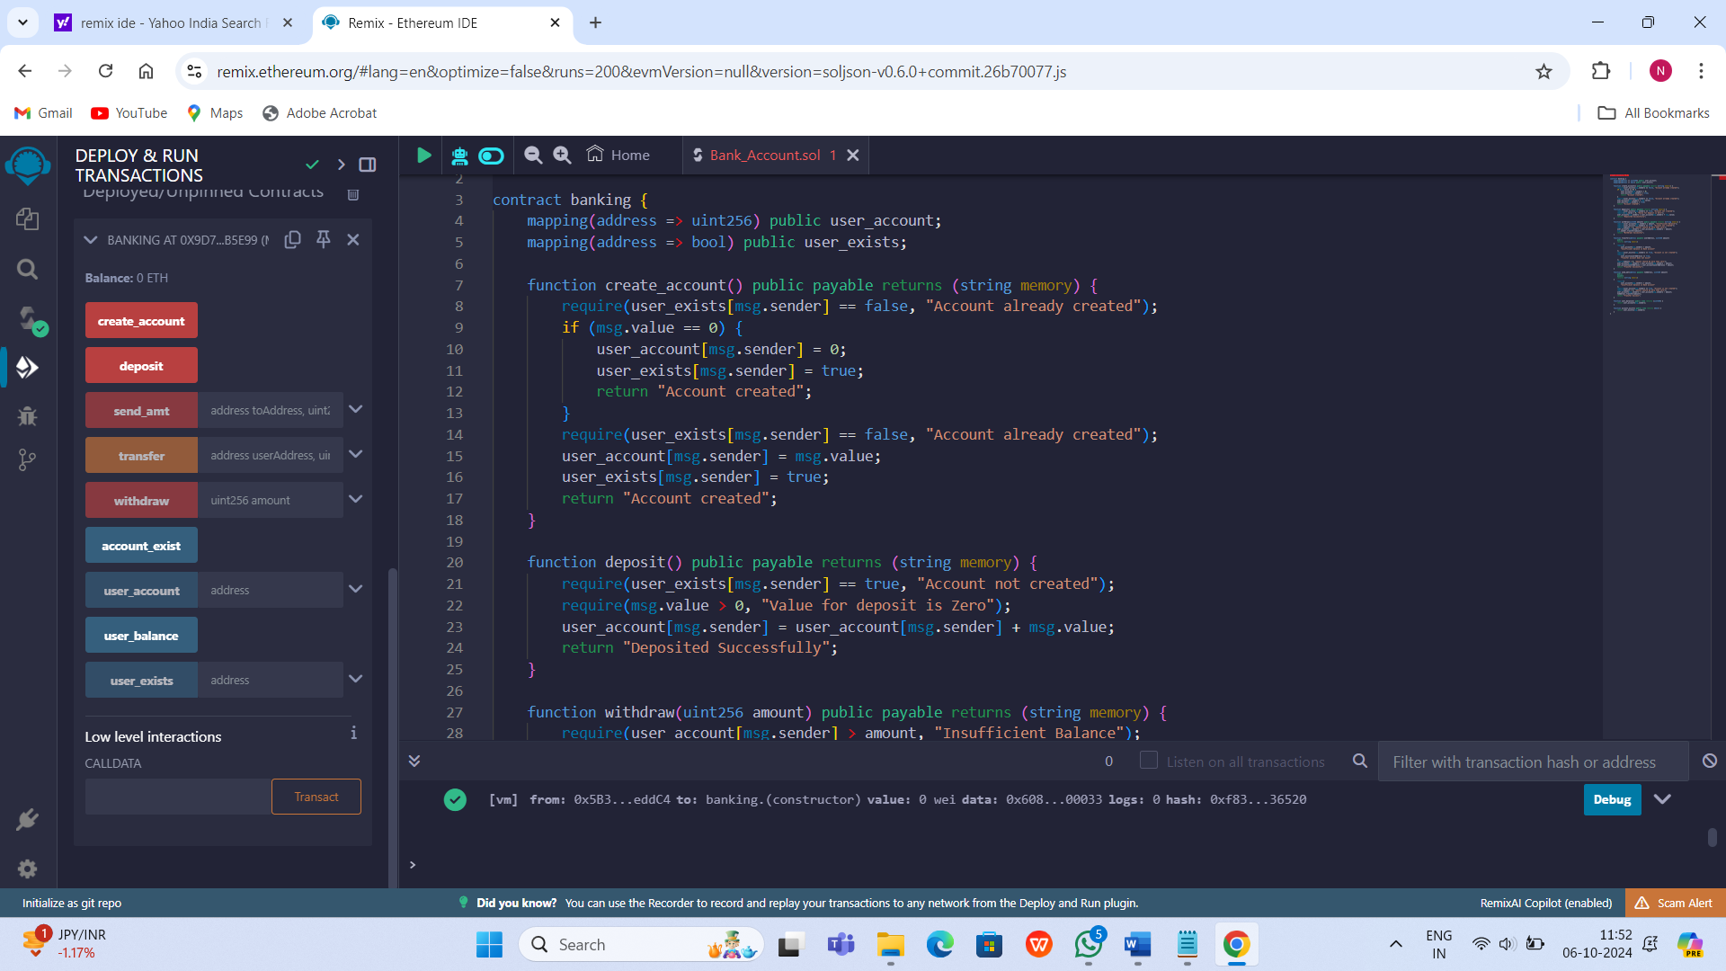
- Deploy

- Create Account
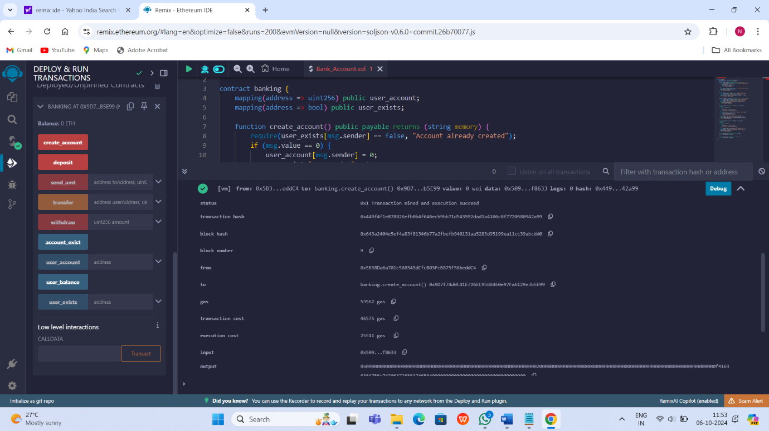
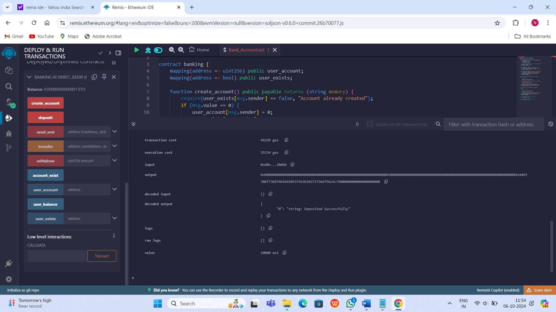
- Deposit

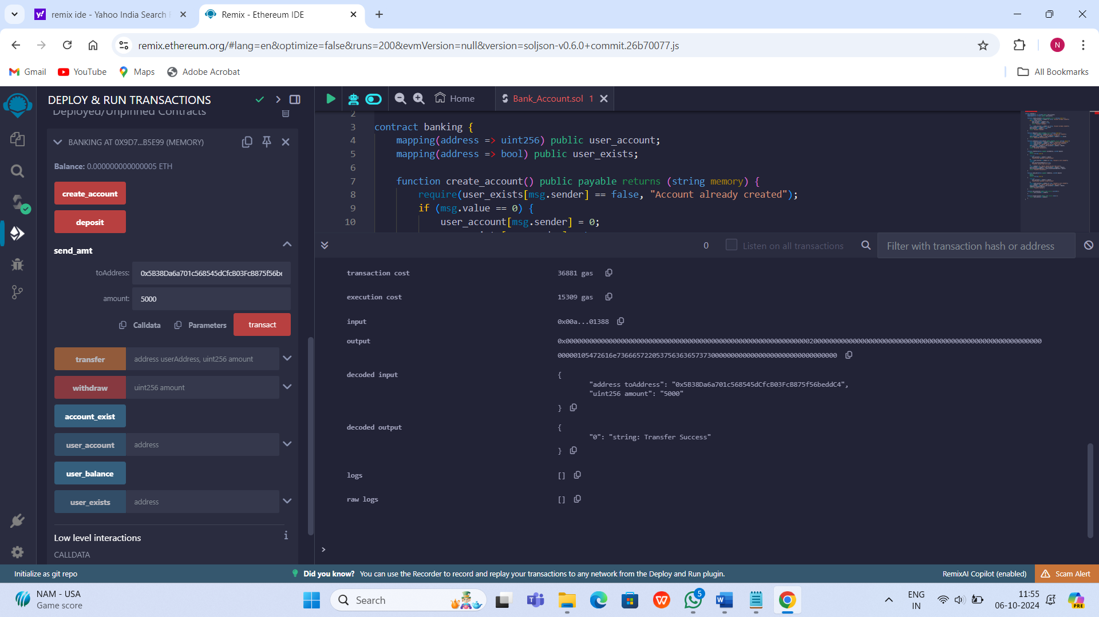

- Transfer

- Withdraw
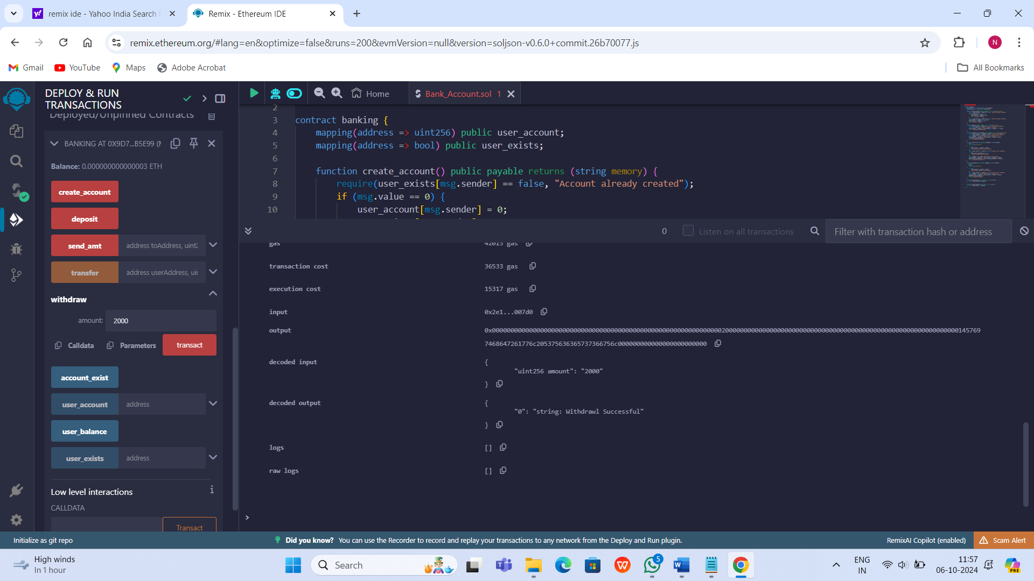

- Account Exist
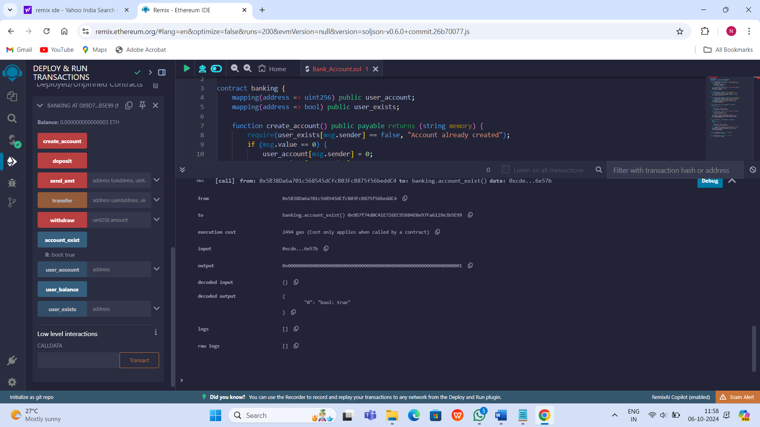

- User Balance
