Name : Arbaz Shaikh
Class : BE-(B)
Roll No.: COBB58
Assignment No.: 04(BT)

PROGARM CODE:

pragma solidity ^0.6;

contract Student_management {
struct Student {
int256 stud_id;
string name;
string department;
}
Student[] Students;

function add_stud(
int256 stud_id,
string memory name,
string memory department
) public {
Student memory stud = Student(stud_id, name, department);
Students.push(stud);
}

function getStudent(int256 stud_id)
public
view
returns (string memory, string memory)
{
for (uint256 i = 0; i < Students.length; i++) {
Student memory stud = Students[i];
if (stud.stud_id == stud_id) {
return (stud.name, stud.department);
}
}
return ("Not Found", "Not Found");
}
}

OUTPUT:

- Deploy
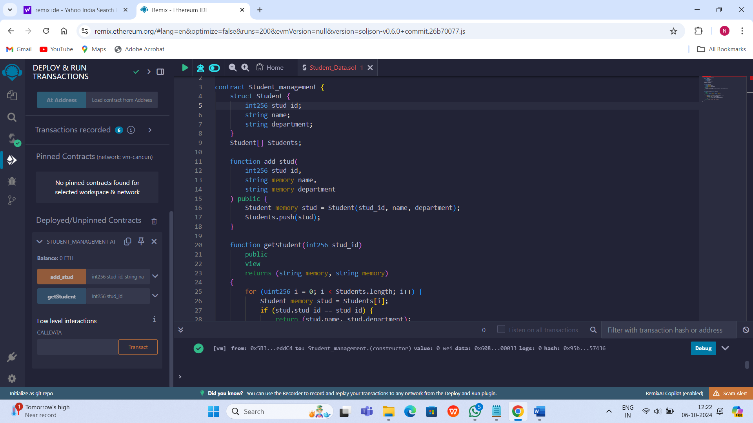

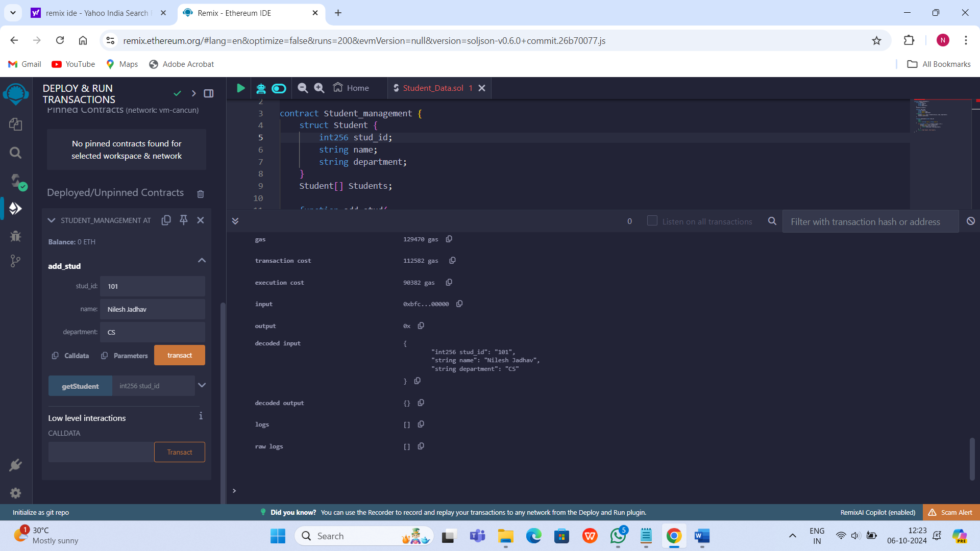
- Add Student

- Get Student
