# VISVESVARAYA TECHNOLOGICAL UNIVERSITY

**“JnanaSangama”, Belgaum -590014, Karnataka.**



### PROJECT WORK-1 REPORT

**on**

**COLLEGE EXAM APPLICATION FORM SUBMISSION SYSTEM**

***Submitted by***

**Soundarya Lakshmi Anand (DIP) Swathi V (DIP)**

**Md Yaseen Ahmed(DIP) Triveny Y (DIP)**

***Under the Guidance of***

**Mrs. Sheetal V Assistant Professor, BMSCE**

***in partial fulfillment for the award of the degree of***

**BACHELOR OF ENGINEERING**

***in***

### COMPUTER SCIENCE AND ENGINEERING



**B.M.S. COLLEGE OF ENGINEERING**

**(Autonomous Institution under VTU)**

### BENGALURU-560019 DEC 2019

**B. M. S. College of Engineering,**

**Bull Temple Road, Banglore 560019**

(Affiliated To Visvesvaraya Technological Universit, Belgaum)

**Department of Computer Science and Engineering**



**CERTIFICATE**

This is to certify that the project work entitled “**College Exam Application Form Submission System**” carried out by Soundarya Lakshmi Anand **(DIP), Swathi V (DIP), Md Yaseen Ahmed (DIP)** & **Triveny Y (DIP)** who are bonafide students of **B. M. S. College of Engineering.** It is in partial fulfillment for the award of **Bachelor of Engineering in Computer Science and Engineering** of the Visveswaraiah Technological University, Belgaum during the year 2019. The project report has been approved as it satisfies the academic requirements in respect of **Project Work-1 (19CS3PWPW1)** work prescribed for the said degree.

Signature of the Guide Signature of the HOD Mr. SheetalV Dr. Umadevi

Assistant Professor Prof & Head of Dept of CSE

BMSCE, Bengaluru BMSCE, Bengaluru

External Viva

Name of the Examiner Signature with date

1.

2.

### B.M.S. COLLEGE OF ENGINEERING DEPARTMENT OF COMPUTER SCIENCE AND ENGINEERING



***DECALARATION***

We, Soundarya Lakshmi Anand (DIP), Swathi V (DIP), Md Yaseen Ahmed (DIP), Triveny Y (DIP), studentsof 3rd Semester, B.E, Department of Computer Science and Engineering,BMS College of Engineering, Bangalore, herebydeclare that, this Project Work-1entitled "**College Exam Application Form Submission System**" has beencarried out by us under the guidance of Prof. SheetalV,Assistant Professor, Department of CSE, BMS College of Engineering,Bangalore during the academic semester Aug-Dec 2019.

We also declare that to the best of ourknowledge and belief, the developmentreported here is not from part of any otherreport by any other students.

Signature

Soundarya Lakshmi Anand(DIP) Swathi V (DIP)

Md Yaseen Ahmed(DIP) Triveny Y (DIP)

# TABLE OF CONTENTS

|  |  |  |
| --- | --- | --- |
| **CHAPTER NO.** | **TITLE** | **PAGE NO.** |
| 1 | **Introduction** | 1 |
| 1.1 | Overview | 1 |
| 1.2 | Motivation | 1 |
| 2 | **Software Requirement Specification** | 2 |
| 2.1 | Hardware Requirements | 2 |
| 2.2 | Software Requirements | 2 |
| 3 | **User Interface Design** | 3 |
| 3.1 | Login screen | 3 |
| 3.2 | Registration page | 3 |
| 3.3 | Home Page | 4 |
| 3.4 | Department Selection Page | 4 |
| 3.5 | Computer Science Department Page (Sem Selection) | 5 |
| 3.6 | Subject Selection Page | 5 |
| 3.7 | Admin Home Screen | 6 |
| 3.8 | Admin Panel | 6 |

## Chapter 1

### Overview

**INTRODUCTION**

Exam Registration system is used in the effective dispatch of registration form to all of the students. This system adopts a comprehensive approach to minimize the manual work and schedule resources, time in a cogent manner. The core of the system is to get the online registration form (with details such as name, reg.no etc.,) filled by the student

### Motivation

Our major advantages can be summarized as follows:

1. Online Exam Registration Portal helps the Student’s in registering their Semester End Examination Subjects easily without Manually registering but instead through Online Web Portal
2. wastage of Time, Effort is reduced
3. All the student details regarding the Exam Registration is maintained in the single Database that can be accessed easily anytime anywhere
4. Loss of data is minimized as the details the is maintained in Database
5. Student can fill the form anywhere and anytime
6. Helps in maintaining and Accessing the data easily
7. Responses by the candidate will be checked automatically and instantly
8. Being an online exam application form submission system, it will reduce paper work
9. Students can easily check the registered subjects just by using username and password, without which it would lead to confusion
10. Leads to easy administration as admin can easily check the number of students who have registered and who have not
11. Ease of access
12. Probability of making errors is less with the use of GUI
13. Useful for educational institutes where number of students involved are high
14. Prevents students from manipulating the number of registered courses

## Chapter 2

**SOFTWARE REQUIREMENTS**

### Hardware Requirements:

* + - A PC with the following or greater specifications:
      * Intel Pentium
      * 4 GB RAM
      * 500 GB Hard Drive
    - A stable internet connection (2Mbps or higher).

### Software Requirements:

* Operating system : Windows 7,8,10
* Technologies : HTML, CSS, Javascript
* IDE : vcCODE
* Database : MySQL

## Chapter 3

**USER INTERFACE DESIGN**

### Login Screen

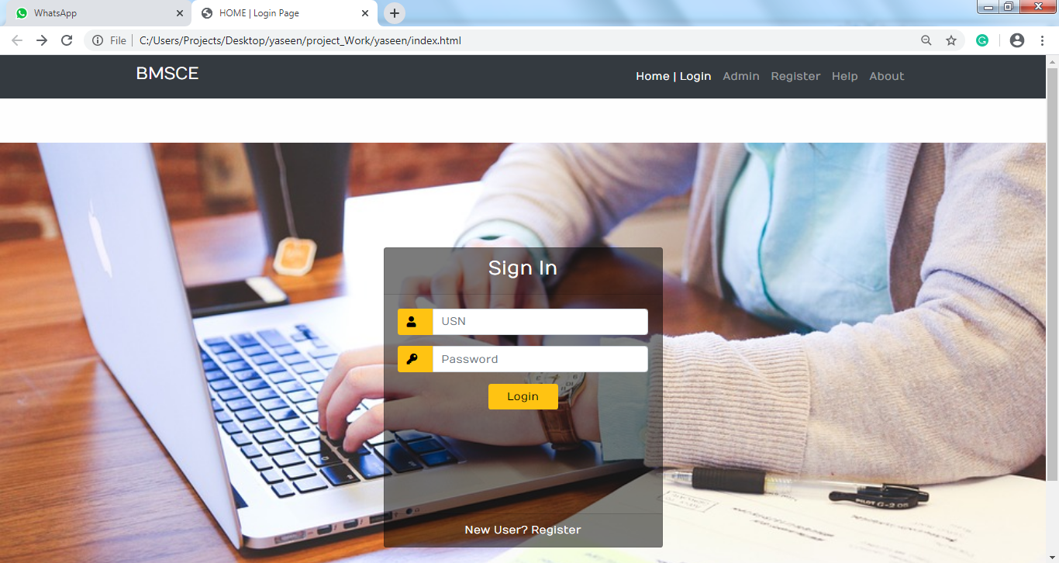

**Fig.1 Login Screen**

* 1. **Registration page:**

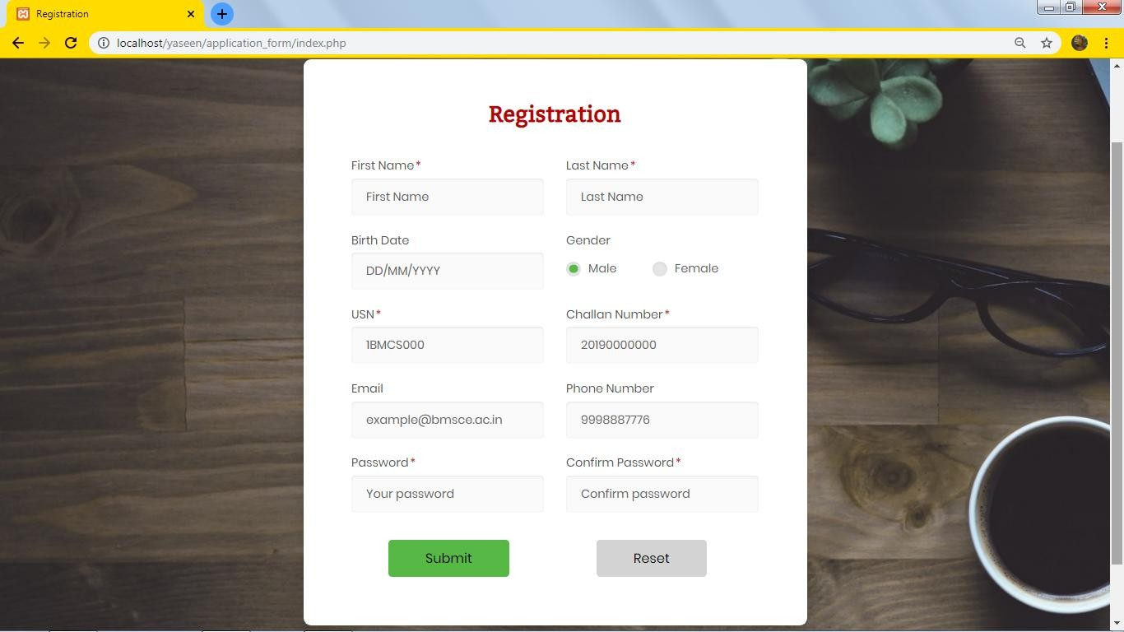

**Fig.2 Registration**

* 1. 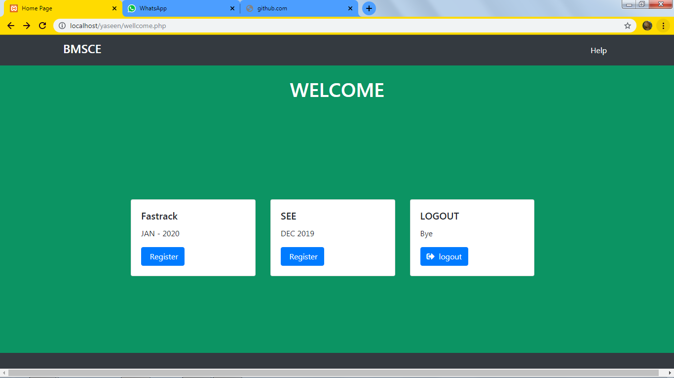 **Home Screen:**

**Fig.3 Home Screen**

* 1. **Department Select Page:**

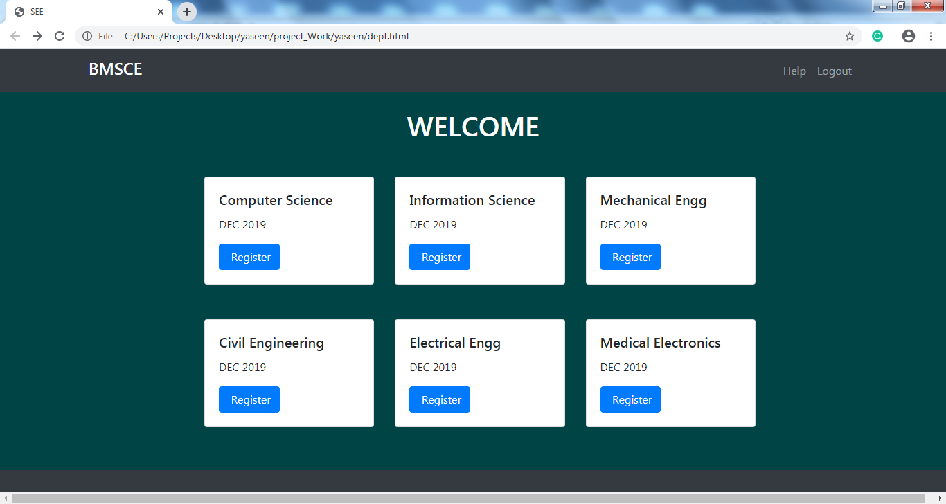

**Fig.4 Department Selection Page**

**3.5 Computer Science Department Page:**

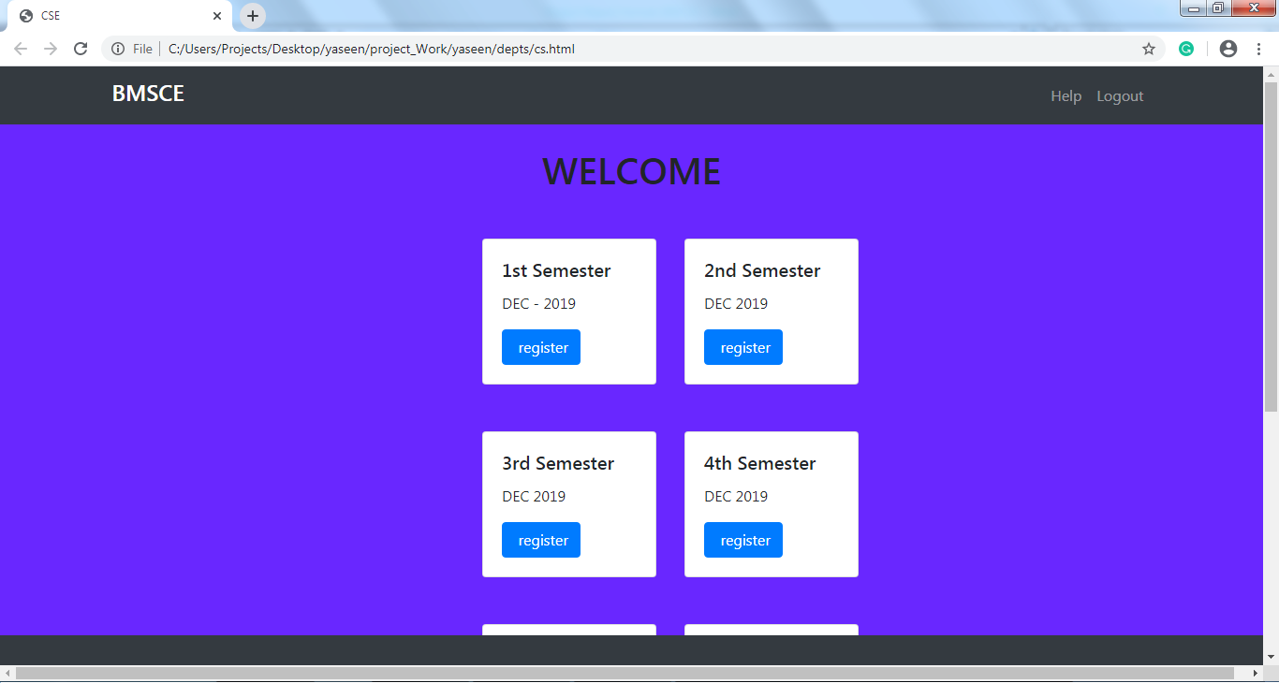

**Fig.5 CSE Semester Selection Page**

* 1. **Subject Selection Page:**

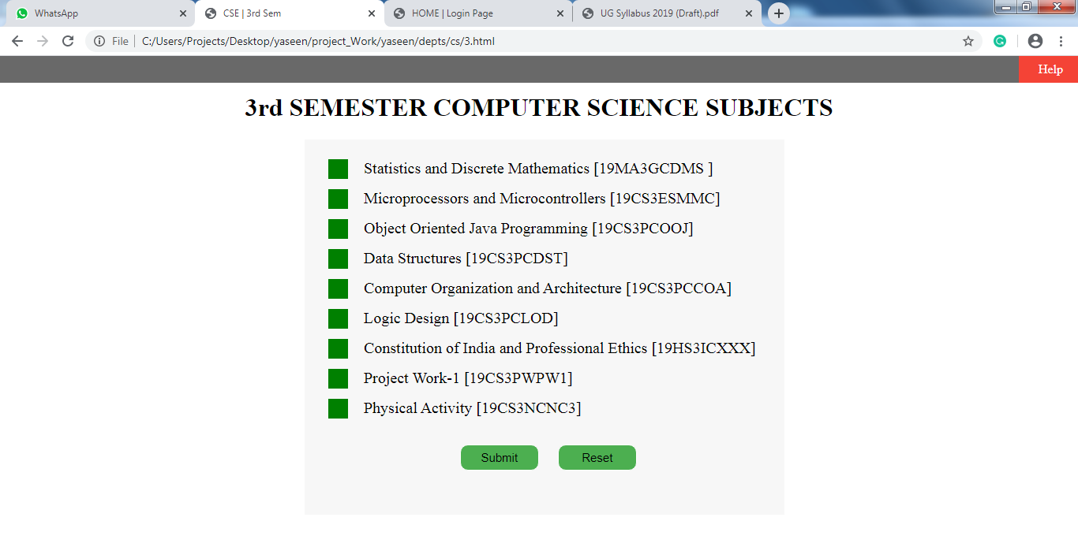

**Fig.6 Subject Selection Page**

**3.7 Admin Home Screen:**

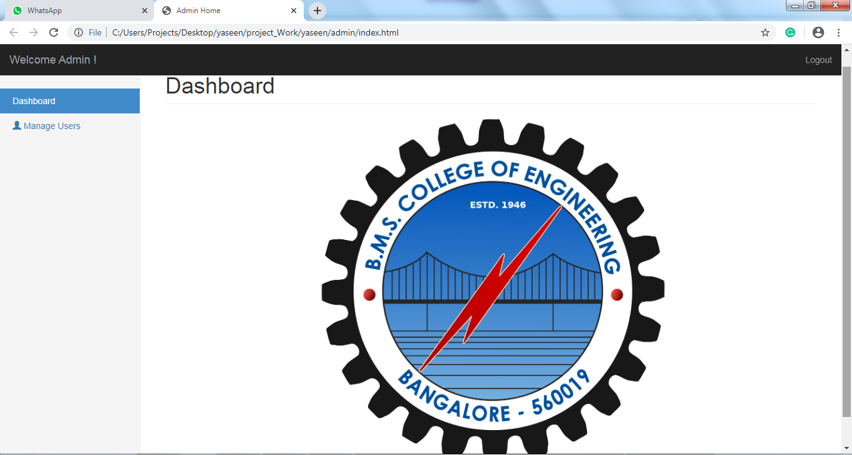

**Fig.6 Admin Home Screen**

**3.8 Admin Panel:**