Q: What is the Compliance Dashboard?

A: This is the place where the US and Canada employees can view their pending Documents, Trainings and Timesheets, whichever of the above 3 are applicable to their location.

Q: How to Navigate to the Compliance DashBoard?

A: There are two ways of navigating to the Compliance dashboard.

1. Clicking the “Take Action” button on the Compliance card in infyme home.

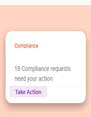

1. Clicking “View Details” on the Compliance card present on the top right corner of Official tab under Profile. 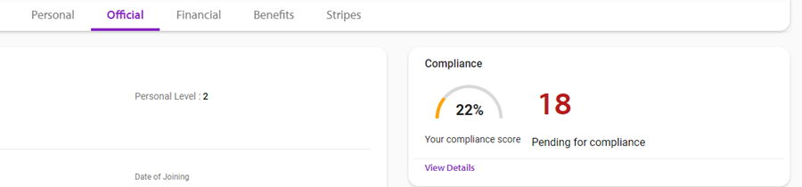

Q: Why is there a “For the submission of timesheets and acknowledgement of documents, please ensure VPN connection..” band at the top of the Compliance Dashboard Page?

A: This is added because Some of the “click here” links to complete the pending actions can be accessed through the intranet only and require VPN enablement.

Q: How to I increase my Compliance Score?

A: By clicking the click here link next to the pending items, you will be taken to the corresponding page, viz TimeIt for timesheets, Harmony for documents or Lex for Trainings. After completing the item, you can come back to the compliance dashboard and refresh, your increased score will be reflected in the dashboard.

Q: After submitting my timesheet, the score change isn’t immediately reflected in the Compliance Dashboard. Why is this?

A: Due to certain constraints, the timesheet score change will not be immediately reflected. However, it will be reflected in 15 minutes.

Q: What are the Score Card Parameters displayed on the top right corner of the Dashboard?

A: This card has information about the significance of your compliance score and the benefits you achieve by maintaining a high compliance score.

Q: How should my compliance dashboard look if I have completed all my compliances?

A: It should look as shown below. 100% overall score and 100% score in all the individual categories.

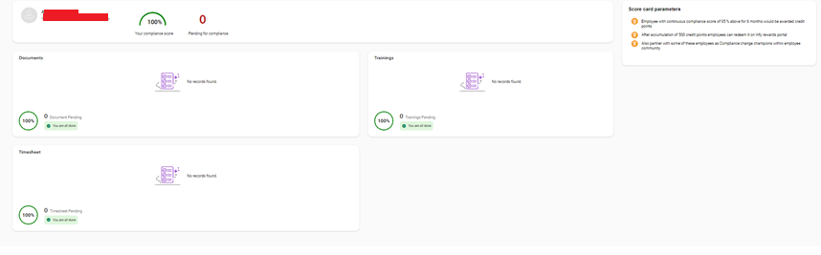

Q : What if I have no pending compliances in one or more category?

A: If you have no trainings pending, You will see 0 Trainings pending as shown in the below screenshot.

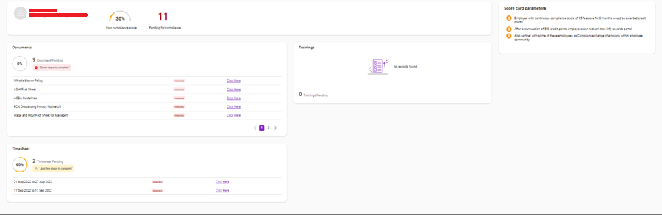

Q: How is the overall score calculated?

A: The overall score is the average of the categories for which the user has compliances. For example, in the above screenshot, overall score = (Documents score + Timesheet score)/2. For a user who has compliances in all 3 categories, overall = sum of 3 scores/3.

Q: What if no compliances have been assigned to me?

A: Your overall score will be N/a and you will see 0 pending in each individual card.

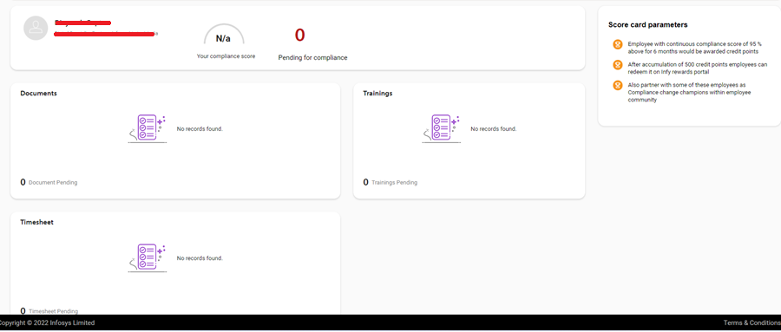

Q: How is my documents score calculated?

A: You will be assigned a fixed number of documents/policy compliances for your entire tenure at Infosys. So your score will be calculated as (number of completed document/policy compliances)*100/ total number.

Q: How is my trainings score calculated?

A: Your trainings score is calculated for every service anniversary. There are recurrent trainings which will be reassigned to you annually/ biannually. Ie. These will be reassigned, and not added to the total number of trainings that you have. Suppose, you had a total of 8 trainings to complete, out of which 1 was recurrent, and you completed only that in that year, your score = completed/total = (1/8) *100.

If in the next year, this recurrent training was assigned again, your score =0/8 . Note that the completion level of the recurrent training is reset, while the total remains unchanged.

Q: How is my timesheet Score calculated?

A: Timesheet score is calculated based on 2 cycles per year.

Cycle 1: April 1 to September 30.

Cyce 2: October 1 to March 31.

Total is calculated as the number of completed weeks from the start of cycle till current date.

Score = Number of Submitted TimeSheets*100/ Total number of weeks till now.

Q: In which cycle will I see the pending timesheet or the last week of a cycle, say from 25 Sep 2022 to 1 Oct 2022?

A:The timesheet for any week will be appearing under pending compliances in the subsequent week. Therefore, the timesheet for 25 Sep 2022 to 1 Oct 2022 will be appearing in the October cycle only.

Q: What do the colors of the piechart signify?

A: Color of the piecharts signify the level of completion. Also the messages vary according to the score.

For individual category cards:

|  |  |  |  |
| --- | --- | --- | --- |
| Score | piechart | message and color |  |
| 100 | green | you are all done, green | |
| >=75 | green | You are almost done, green | |
| 25-75 | orange | Just few steps to complete, yellow | |
| 0-25 | orange | Some steps to complete, red | |

For overall card,

|  |  |
| --- | --- |
| overall score | Piechart Color |
| <=50 | orange |
| >50 | green |

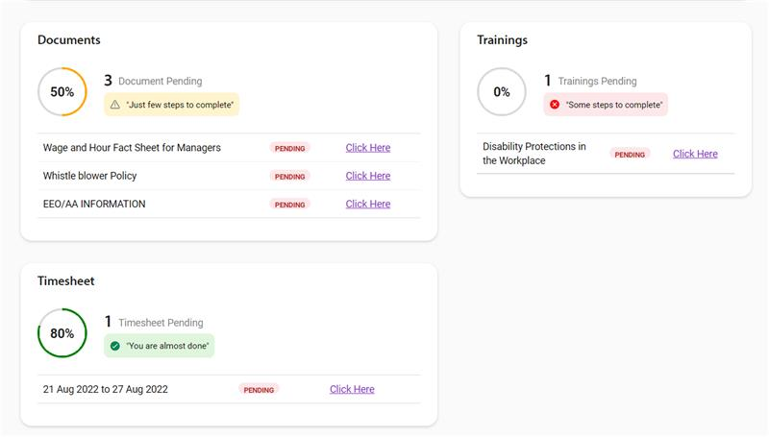

Q: What happens if the end of a cycle falls on a Tuesday (eg: Sep 30, 2025), and a pending Timesheet record was added to Inbay on that day?

A: That timesheet will be a part of the current cycle (ie April 1 – Sep 30) .

This is because, the timesheet on Sep 30 is for the week 21 Sep to 28 Sep