**What is Segmentation**

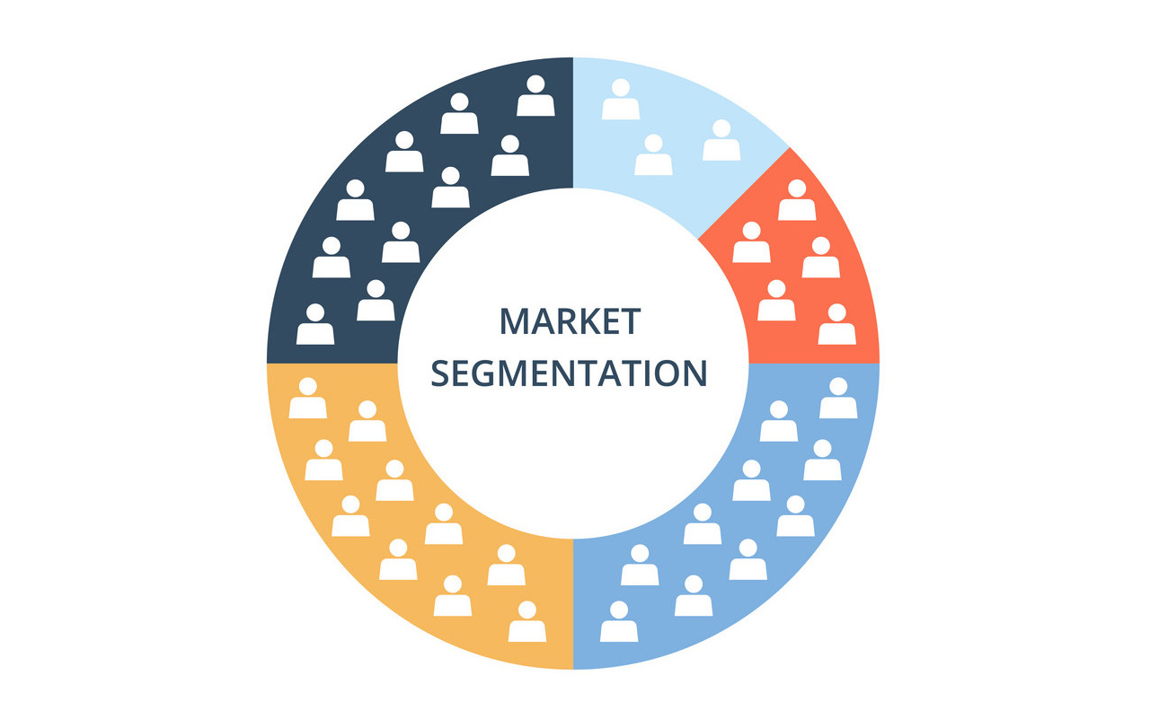

Market Segmentation is the process of identifying different segments of the competetive market and dividing a broad customer base into many subgroups.

Market segmentation is the customer oriented marketing process and it can be applied to different types of markets.

While segmenting the market researchers will look for shared characteristics such as commong interest, need and similar lifestyles

Thus market segmentation assumes the different market segments requires different marketing startegies as the different customer are targeted through promotion, prices, offers.

By dividing the market into different segments, Marketers can have better understanding of the different customer needs which enables them to plan or create the company’s strategies or activities more accurately to the individual or group of people’s liking.

Market segmentation helps the bussiness to meet there customer satisfaction or requirements

It also allow different bussiness to evaluate the competitors’ weaknesses and strengths. This way, businesses can discover different business opportunities in markets which were not served well.

Customer segmentation enables marketers or businesses to incorporate systematic approach for planning ahead for the future, this leads to better making use of marketing resourses resulting in development of targeted marketing programme.

Marketeres uses segementation to prioritize the specific targeted audiences, if the segementation shows customer liking and needs so that marketers can allocate the resourses and interest in profitable way.

Through market segmentation can provide better services to the customers, design customer oriented products thus increasing the profit of businesses.

**WHY SEGMENTATION**

Some of the businesses may not be in a position to satisfy most of their customers. It may prove difficult to meet the requirements of each individual customer. People do not have same choices , so rarely does one product completely satisfy everyone.Many companies arw leaving old undifferentiated type of marketing and adopting target marketing to satisfy customer requirements.In this strategy Market is divided into segments and then develop products or services in these segments, which helps marketers or businesses to effevtively plan or create marketing startegies according to the customer or different geographic needs.

Market segmentation allows the marketers or businesses to market the right product at the right time and at the right place, it helps the businesses or organization to better understand the customer , thus organization can reach a large audiences and effective market the right products at the right place which increases sales of the organization.

Market Segmentation helps marketers or businesses to incorporate appropriate or efficient marketing strategies and provide promotional schemes according to the tastes and liking of individuals customers of a particular market segment.

Example A male model look out of place in the advertisement promoting female products. The marketers should be able to relate products to target segments.\

Market segmentation allows the customer to have a clear view of what to buy and not to buy. Example Rado watch will have no takers from low- income segments and can be focused on premium segments

Market segmentation helps businesses to be more efficient in terms of money, time and resourses

Market segmentation allows businesses to divide homogenous market into clearly identified segments and helps in identifying appropriate marketing programme and strategies in particular segments.

It helps in identifying less satisfied segements and concentrate on them

It makes the business marketing effort more effecient and economic through better matching of the customer needs ,targeted marketing communication which results in enhanced profit of the business , better opportunities in share markets and gain more customers

