Cryptography and Network Security Tutorial Task – 2

Amogh Karhadkar 1BM18CS014

Cryptool comes with a visualisation tool data structures, hashing, graphs, cryptography and much more. The name of the visualisation tool is Animal tool. We can start the tool by clicking on Indiv. Procedures and then selecting Visualisation of Algorithms. It will further give you options on the cipher, here we select Vigenere cipher. Animal tool comes with a default key and plaintext which we can be visualised.

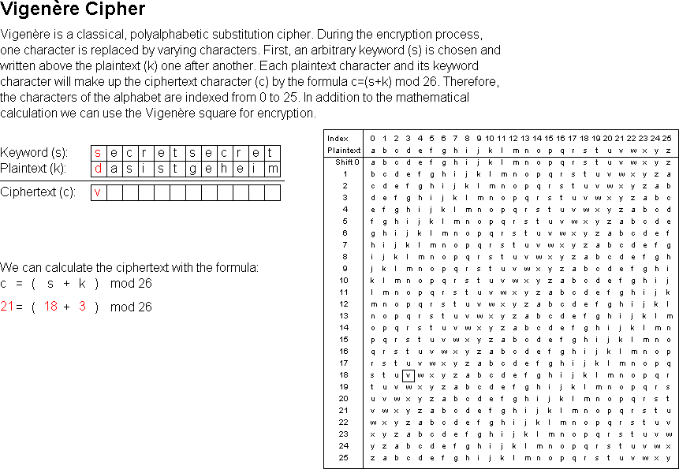The image on the right shows the visualisation which has been given to us by default. Key and plaintext both are shown along with the ciphertext. The visualisation also shows how the key is being used with plaintext to get the ciphertext. After the complete visualisation has been done the complete ciphertext is obtained. Vigenere cipher uses a table to convert the plaintext to ciphertext.

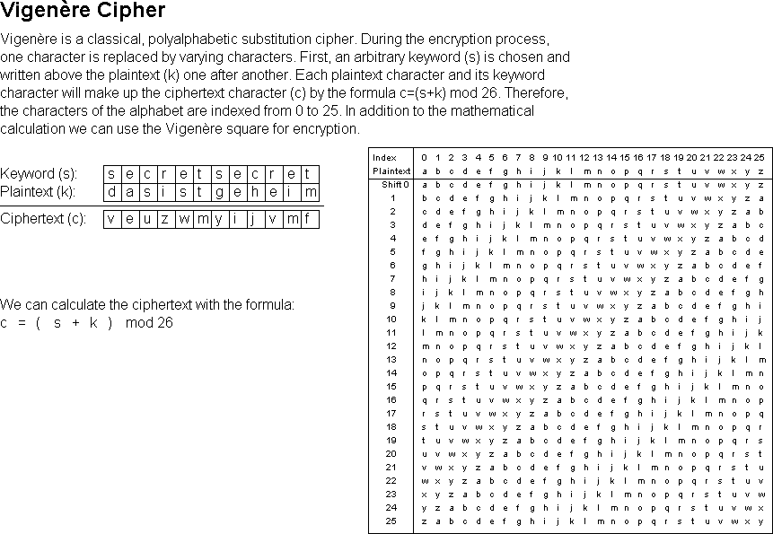The image on the left shows the completed visualisation and how each character of key and plaintext is used to generate the ciphertext.

During the animation we can also change the speed of the animation, we can pause and play forward or backward as we see fit.

It also gives options to view pseudocode, variables, drawing window etc. The whole animation can be controlled by a controller that is open in a different window.

# Using a different Plaintext

We now want to see how the ciphertext differs with different plaintext. To do this we click on new in the Animal controller panel and this click generate. A new window pops up asking us to choose what we want to do from a vast range of choices, we choose Cryptography and search for Vigenere cipher and double click on it. A new window shows up where we can configure our key and plaintext in Primitives tab. We change the plaintext and hit the Start button at the Bottom right corner of the window. As soon as we hit the start button the animation window pops up. We click on play button to start the animation and then we can control the speed and then we can play forwards or backwards.

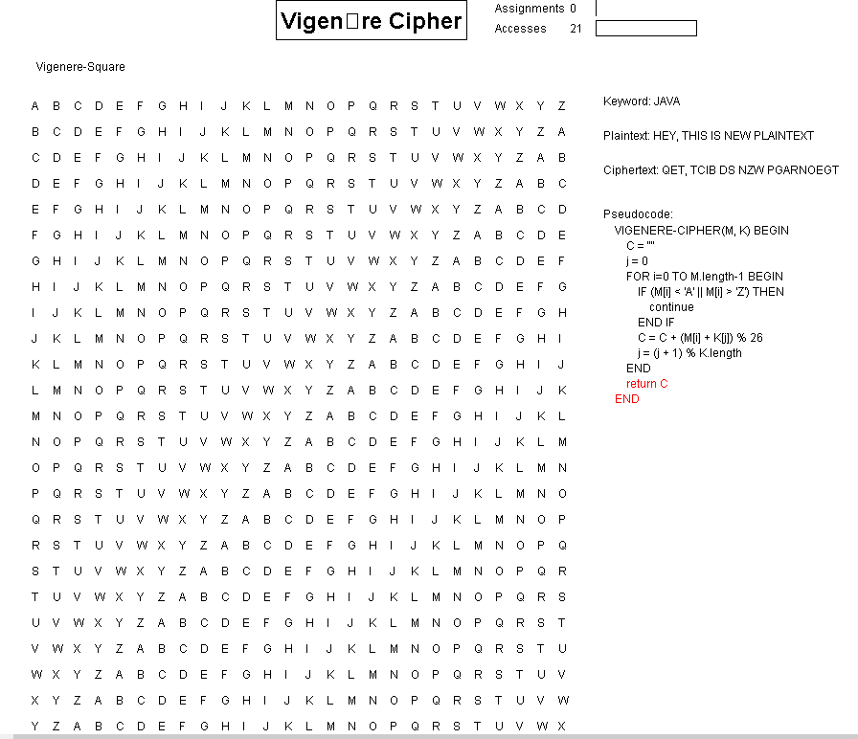

# Using different Plaintext and a different key

In the Primitives tab we can change the value of key as we changed the value of plaintext. After changing value of the key we can start the animation.

