**CNS Tutorial Assignment -2**

**1BM19CS401 ARBAZ AHMED**

**Encrypt analysis using Animal tool**

**Task 1: With default value of input and key, observe and do the analysis at 3 different time intervals**

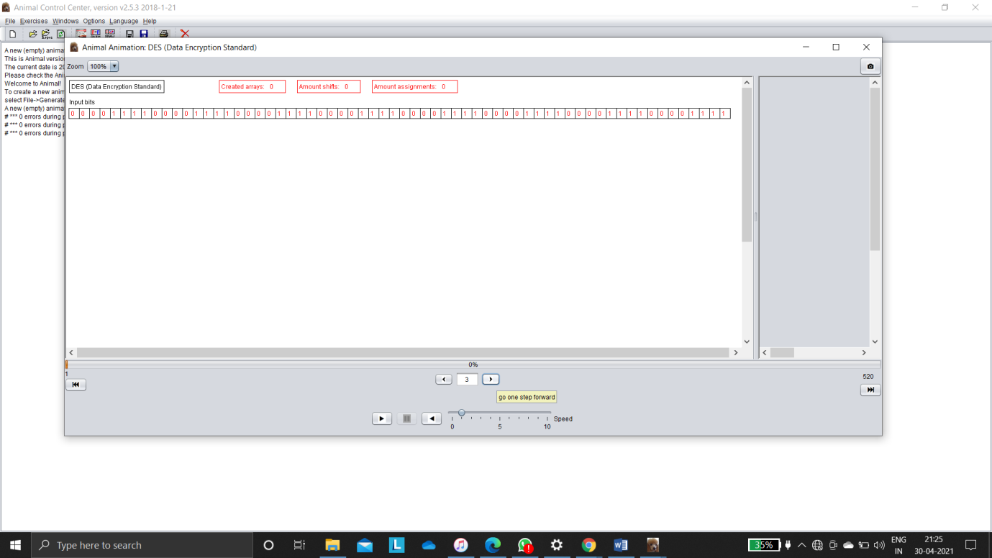

Above we are using DES encrypt analysis using animal tool all are beginning 4 1’s and 0’s

Input Permutation

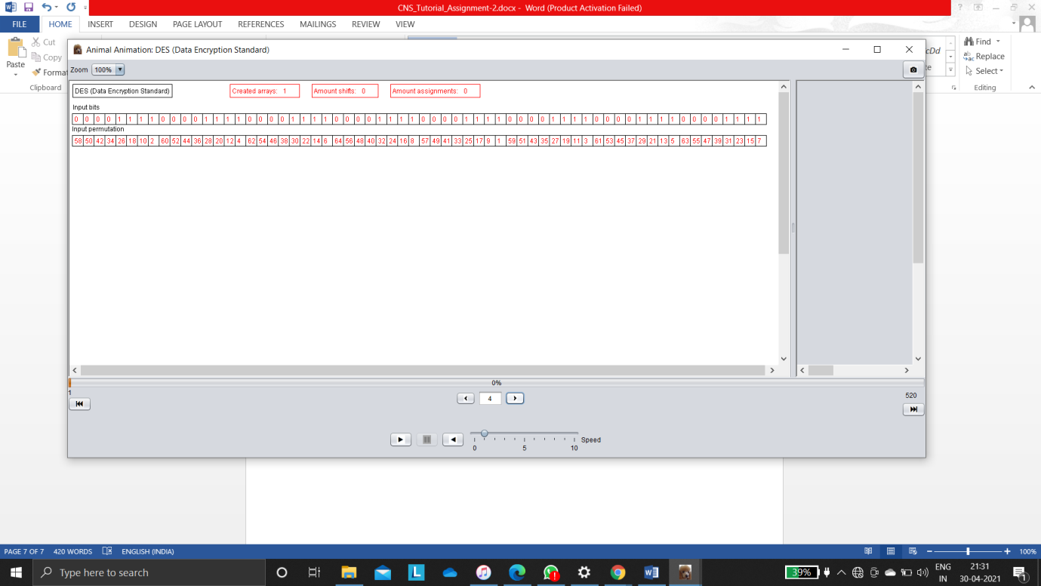

above if you see the the input bits are corresponding input permutations.

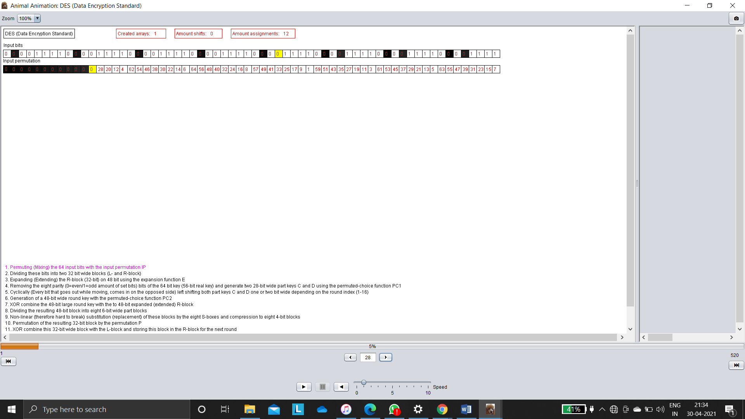

Above absorb that how input permutations are changed input bits in random way they are then every analysis based on input permutations are changing their value to 0 and above the input bits also changing reflecting with block shading and next changing bit will be shaded with yellow colour.

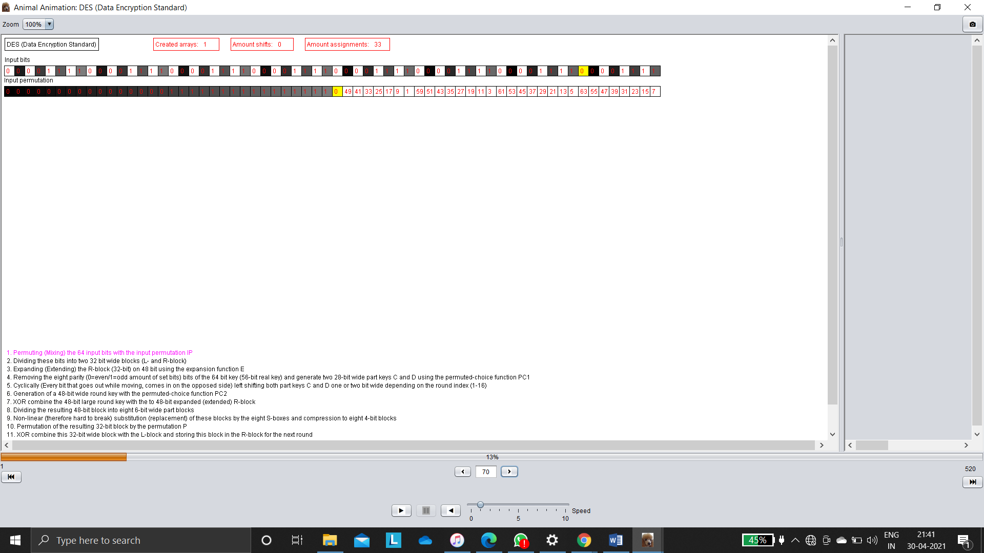

Above absorb that input permutations are changed at 0to 1 after 16 bit

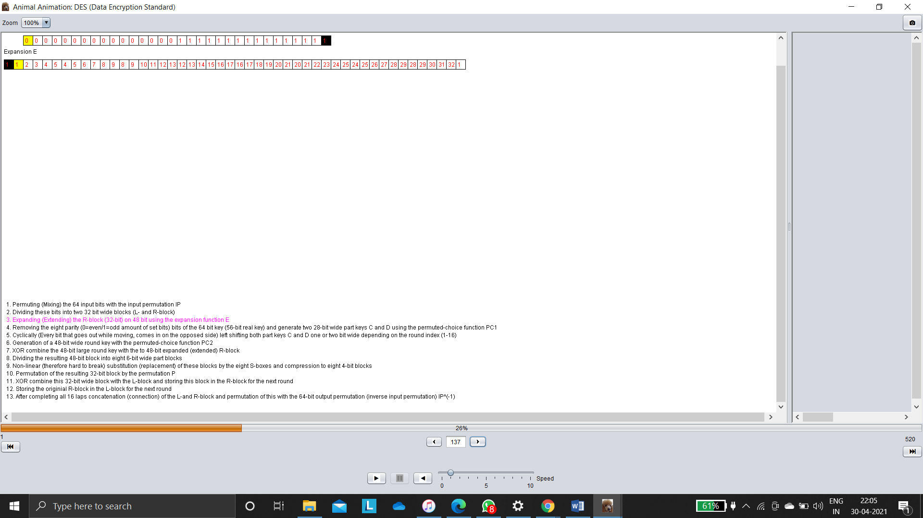

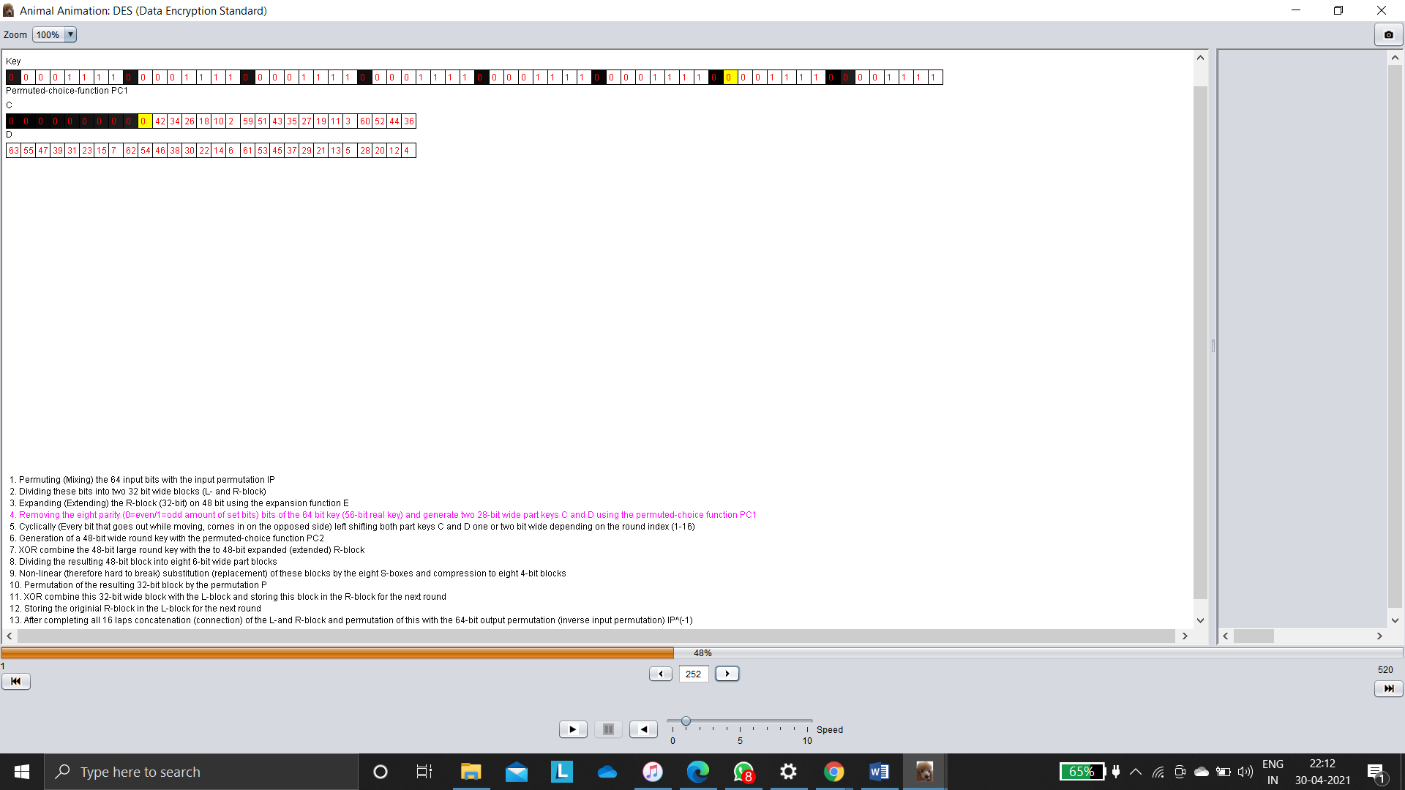

**Decrypt analysis using Animal tool**

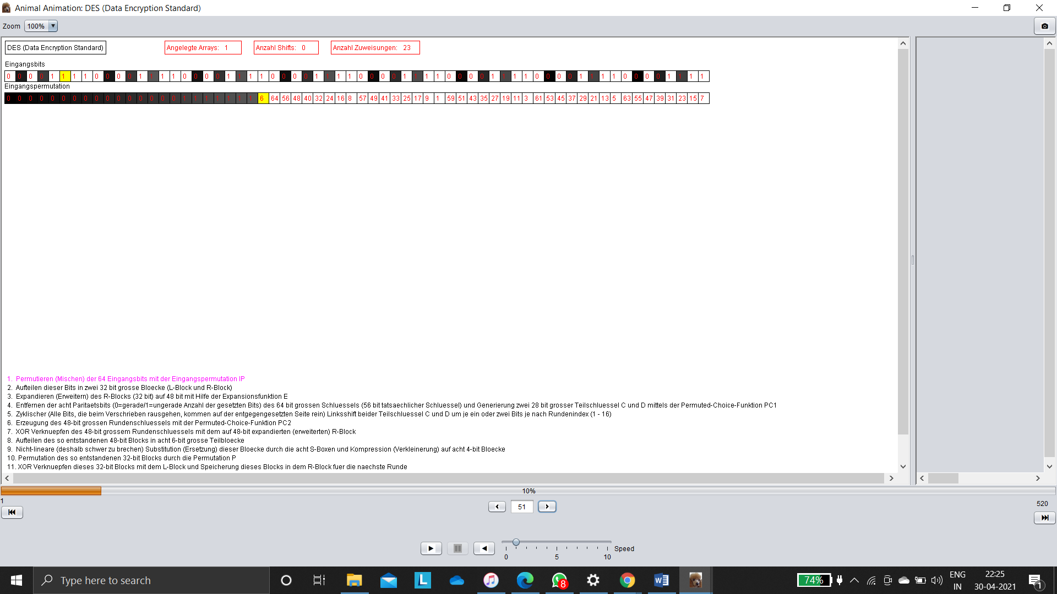

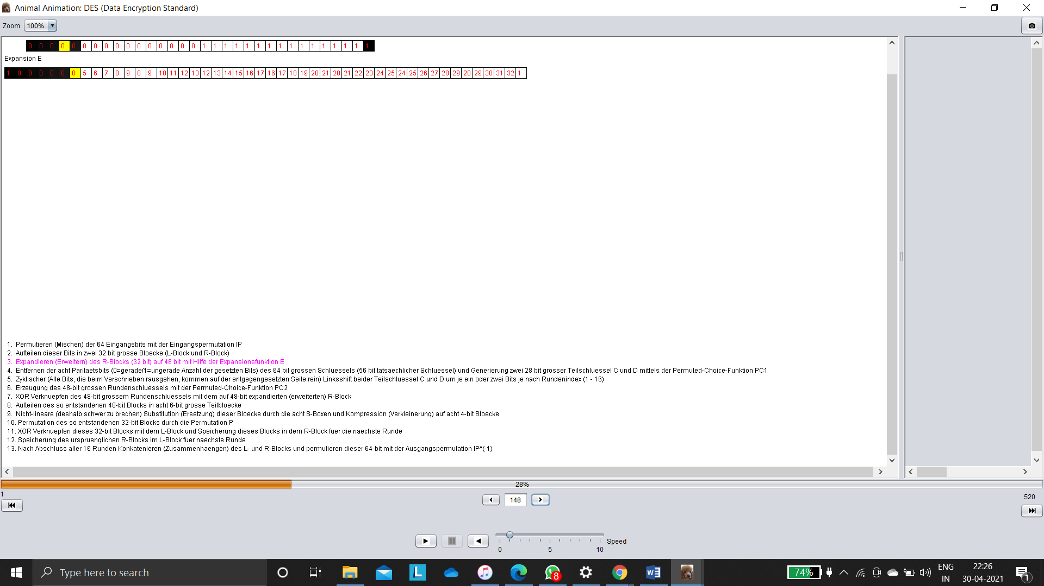

**Task 2: With default value of input and changing only the key, observe and do the analysis at the same 3 time intervals.**

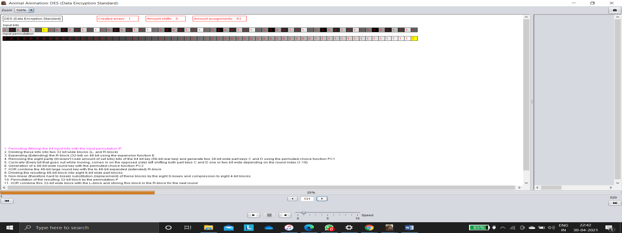

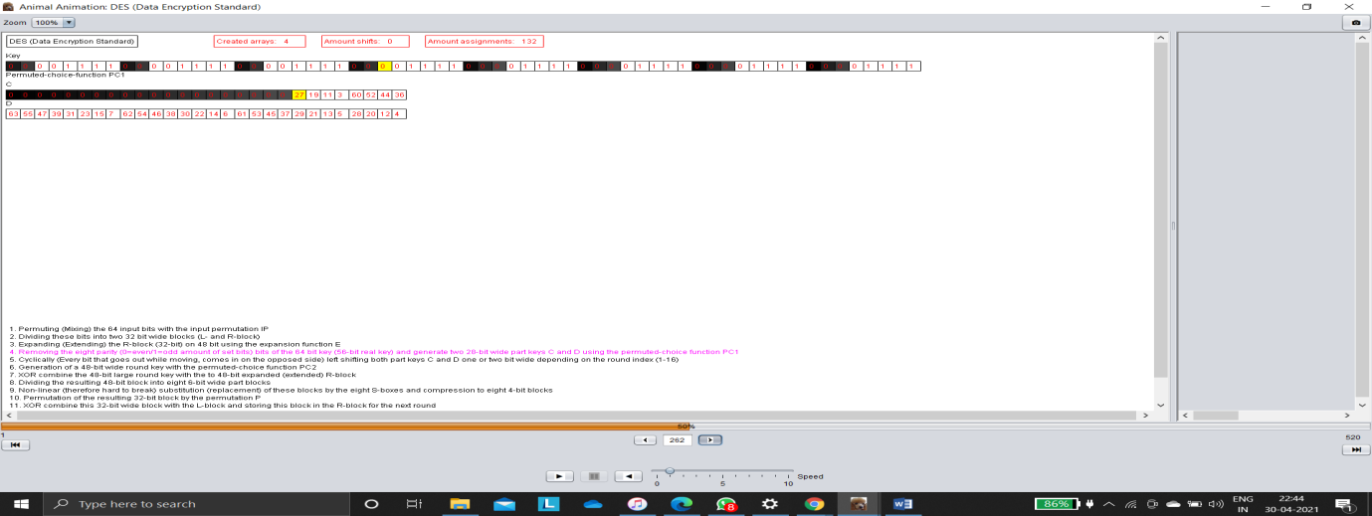

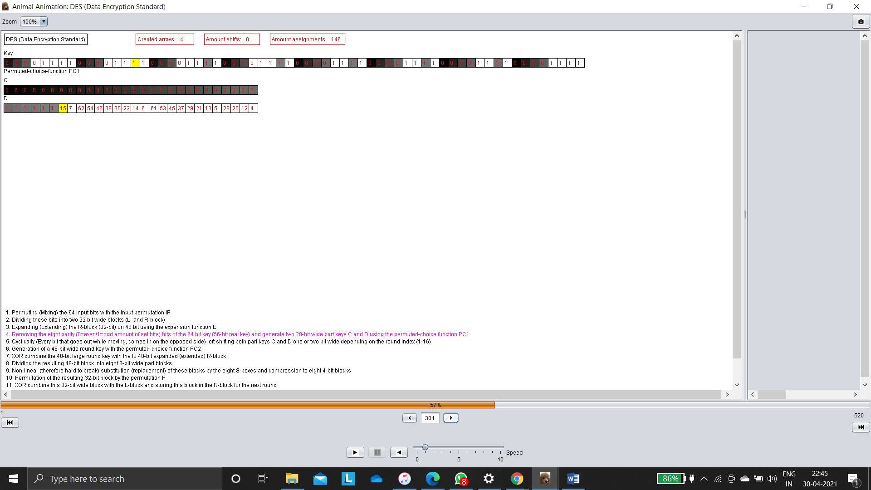

**Task 3: Changing the input as well as the key, observe and do the analysis at the same 3 time intervals.**

