**CNS Tutorial Assignment -2**

**1BM19CS401 ARBAZ AHMED**

**Encrypt analysis using Animal tool**

**Task 1: With default value of input and key, observe and do the analysis at 3 different time intervals**

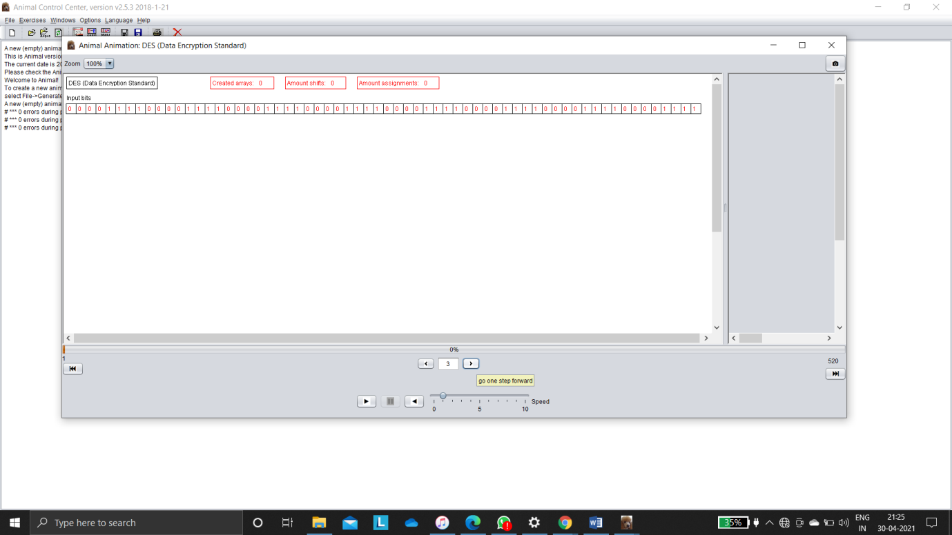

Above we are using DES encrypt analysis using animal tool all are beginning 4 1’s and 0’s

Input Permutation

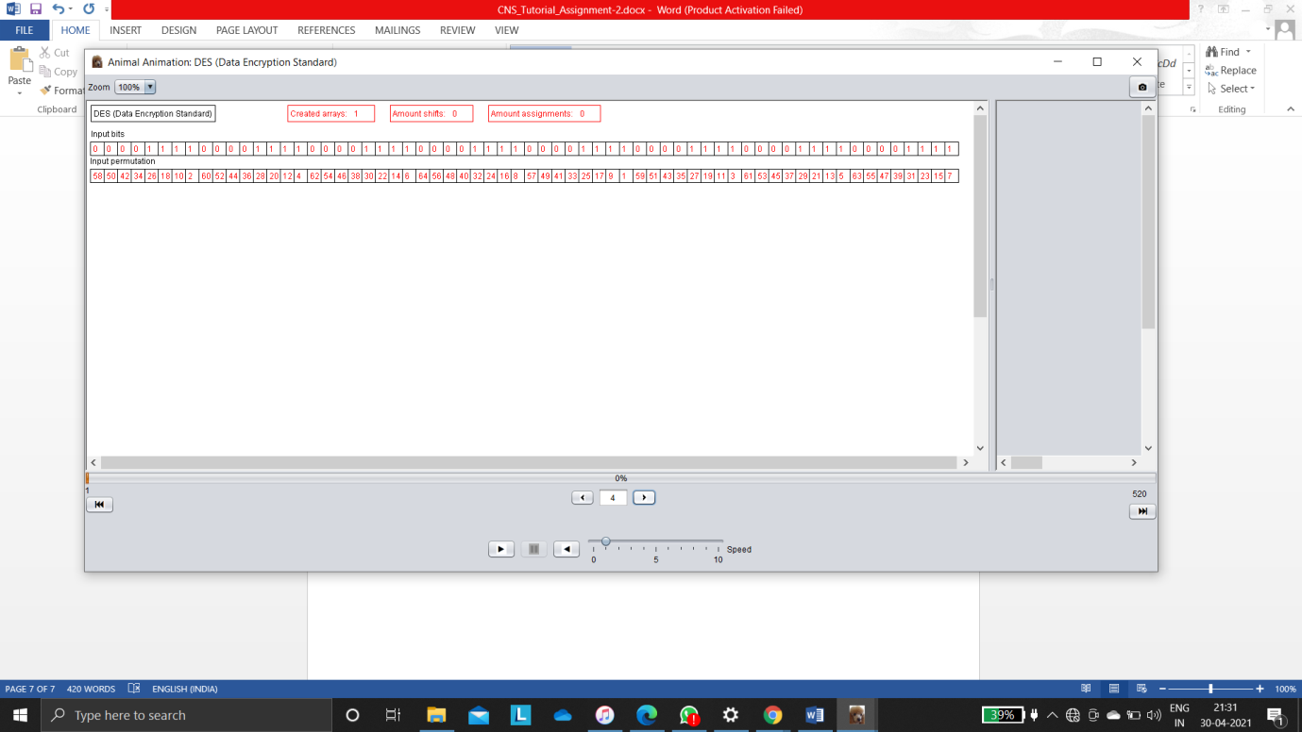 changed input bits in random way they are then every analysis based on input permutations are changing their value to 0 and above the input bits also changing reflecting with block shading and next changing bit will be shaded with yellow colour.

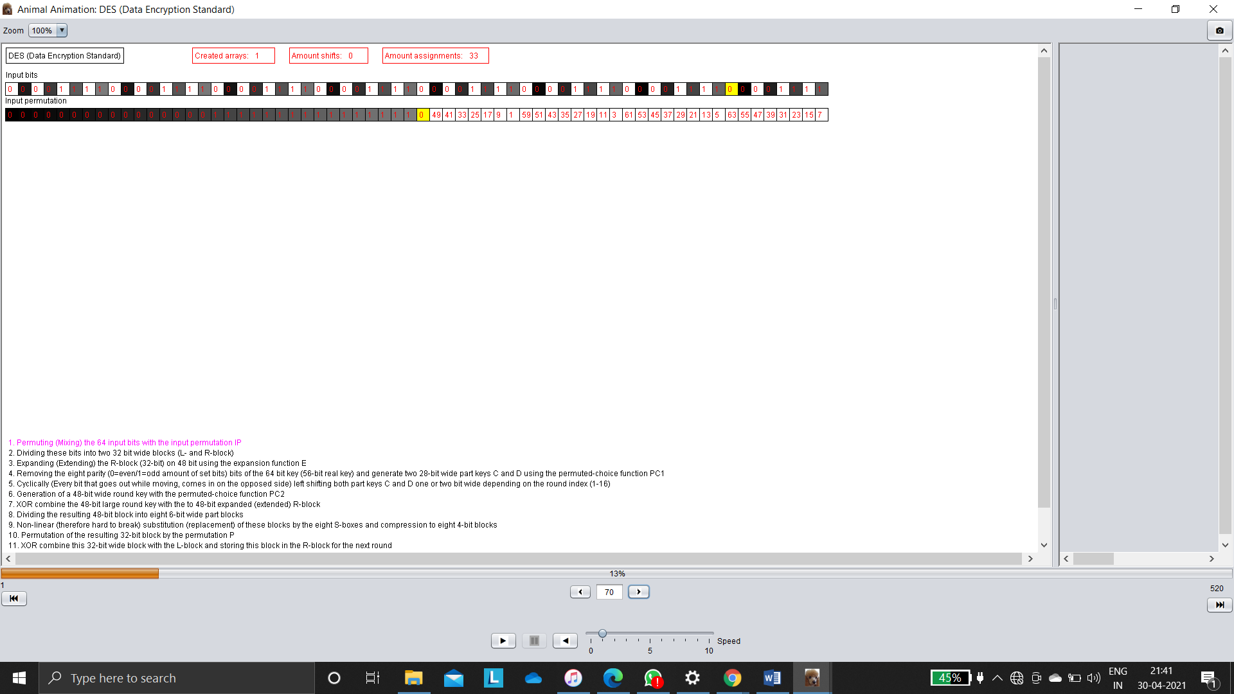

Above absorb that input permutations are changed at 0to 1 after 16 bit

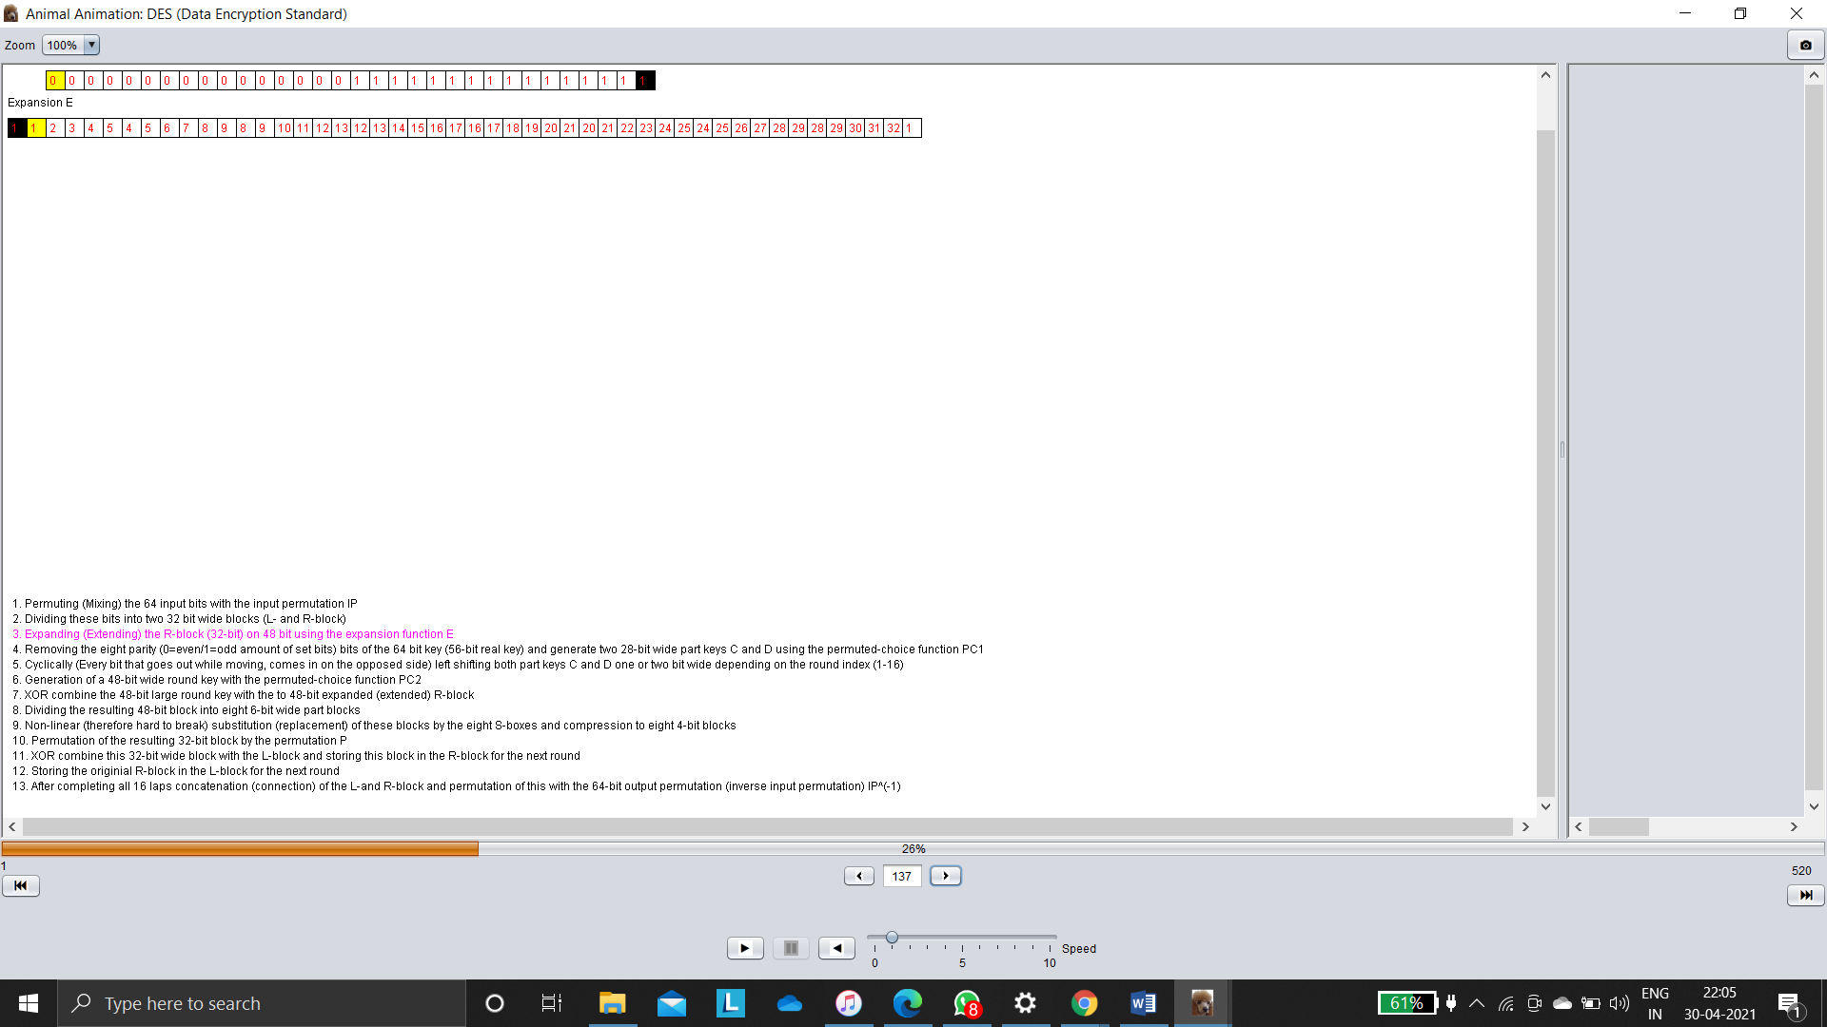

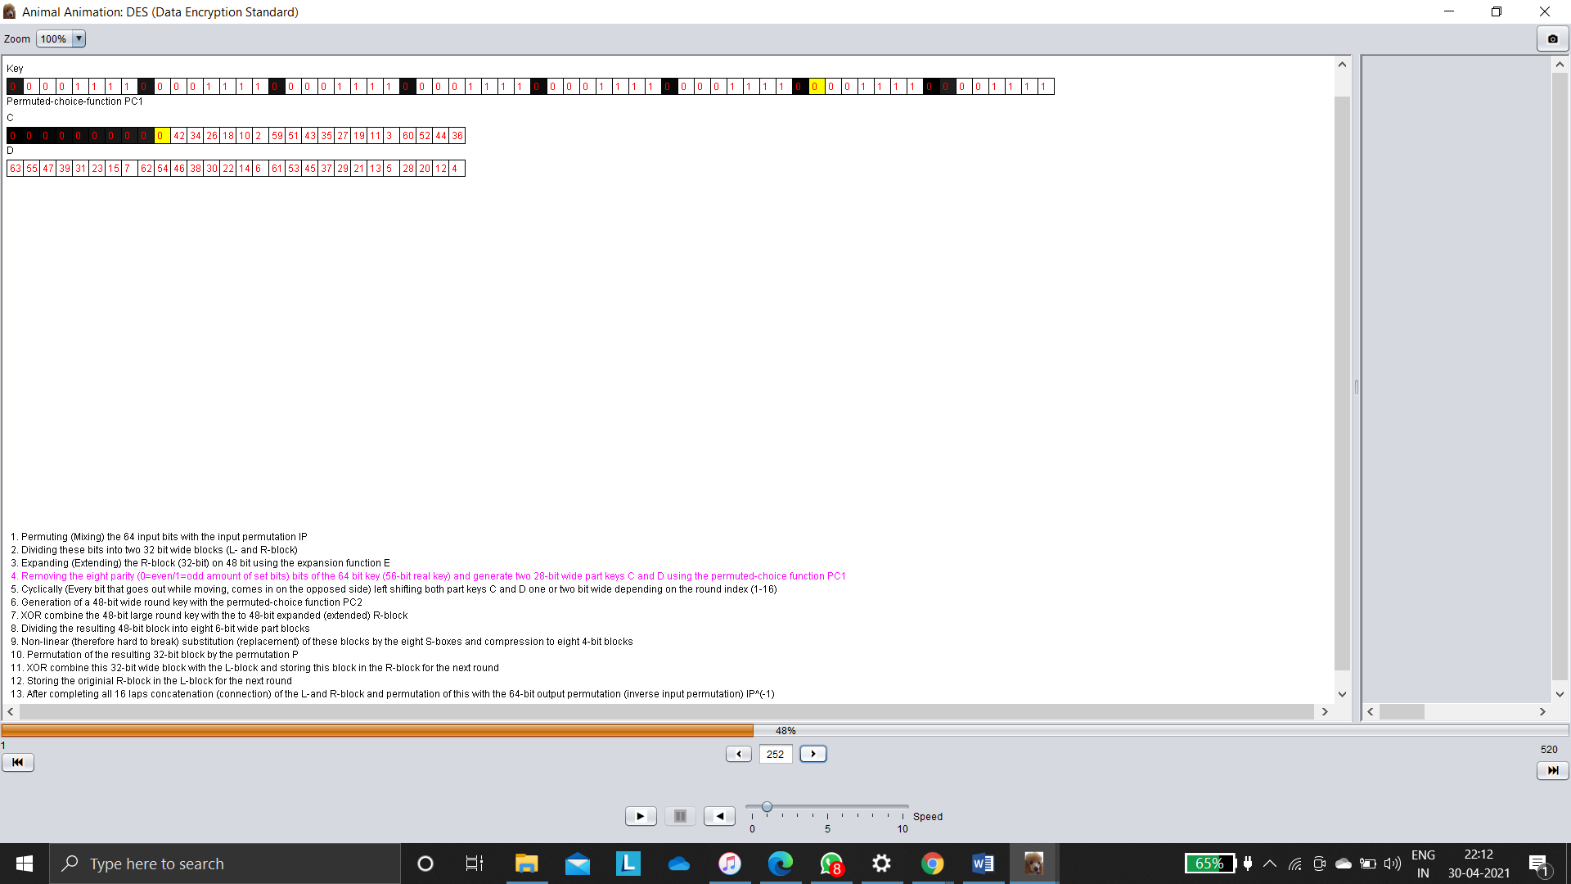

**Decrypt analysis using Animal tool**

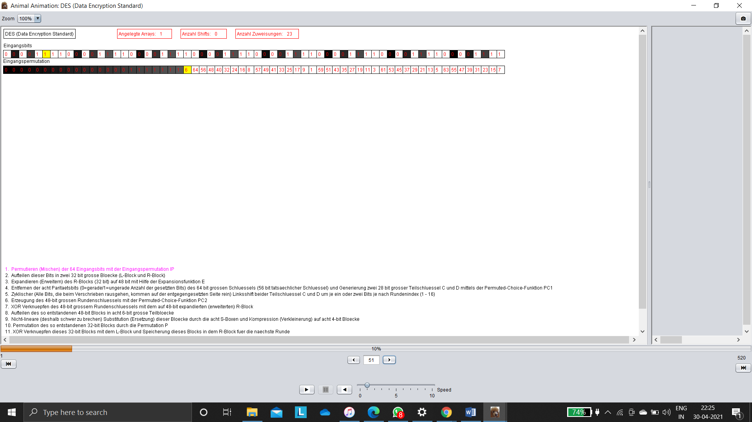

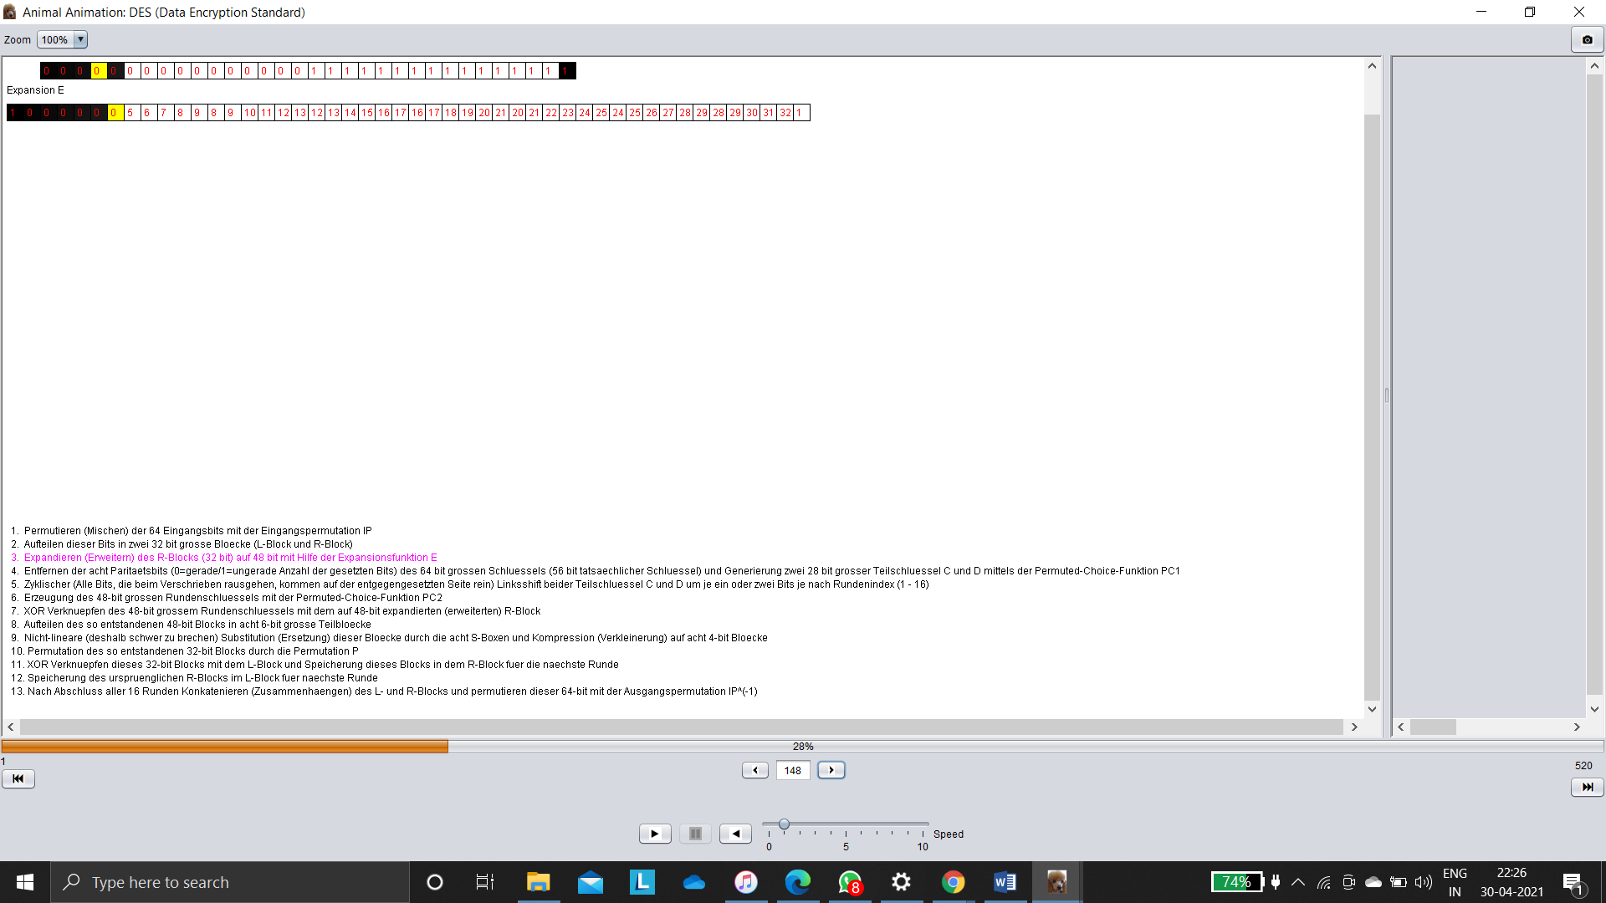

**Task 2: With default value of input and changing only the key, observe and do the analysis at the same 3 time intervals.**

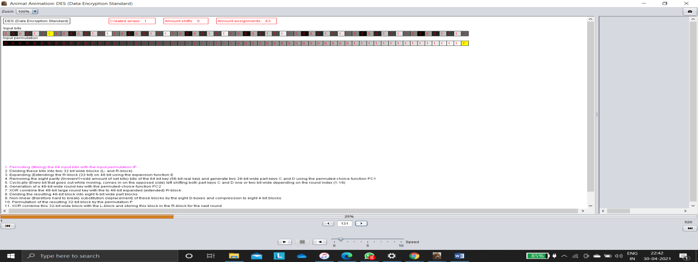

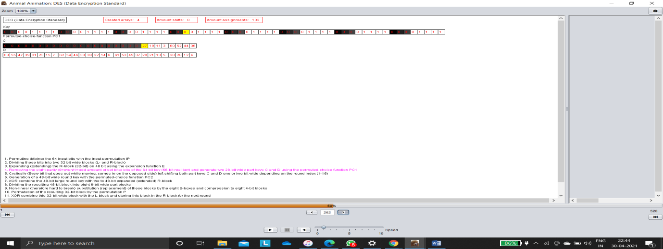

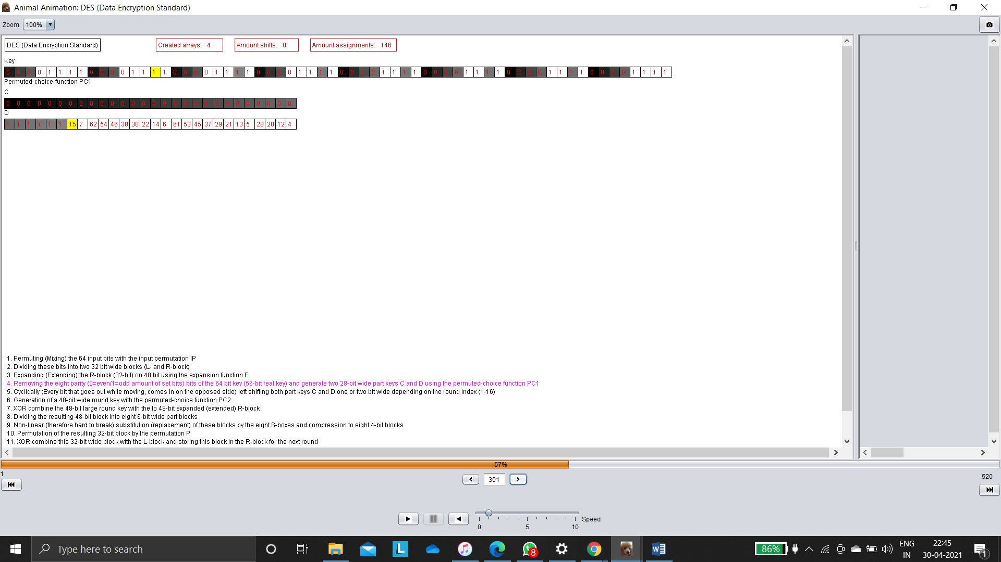

**Task 3: Changing the input as well as the key, observe and do the analysis at the same 3 time intervals.**

