**CNS TUTORIALS ASSIGNMENT - CRYPTOOL**

**Arbaz Ahmed**

**1BM19CS401**

**Encrypt/Decrypt Single line using Cryptool**

1.Encryption Single line using CrypTool

Step1:click on new empty file

Step2:write single word

Step3:go to Encrypy/Decrypt option in that select Symmetric(modern)

Step4:Select DES (ECB) and click on Encrypt

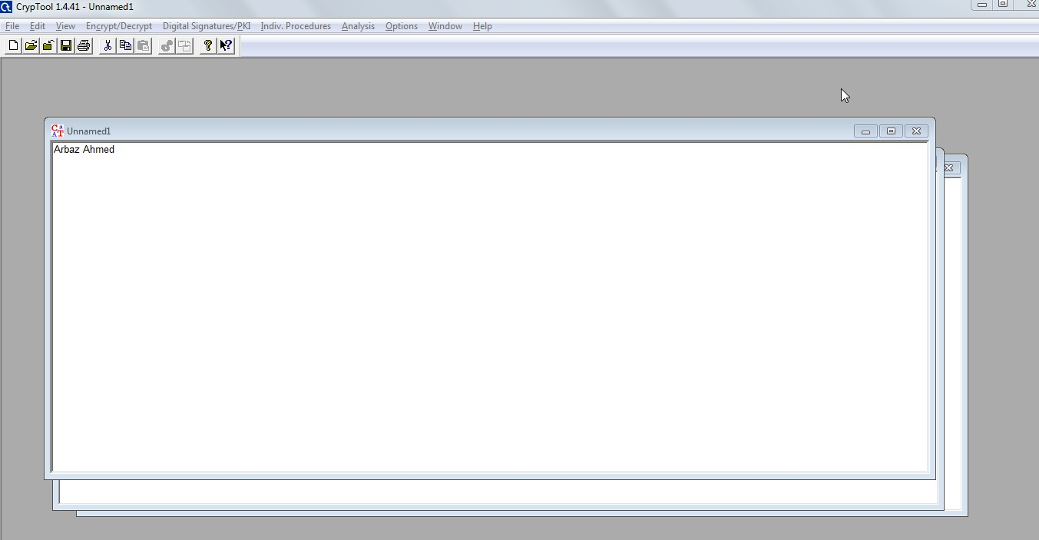

Above we have created File with single line text

**Encrypt with default Key**

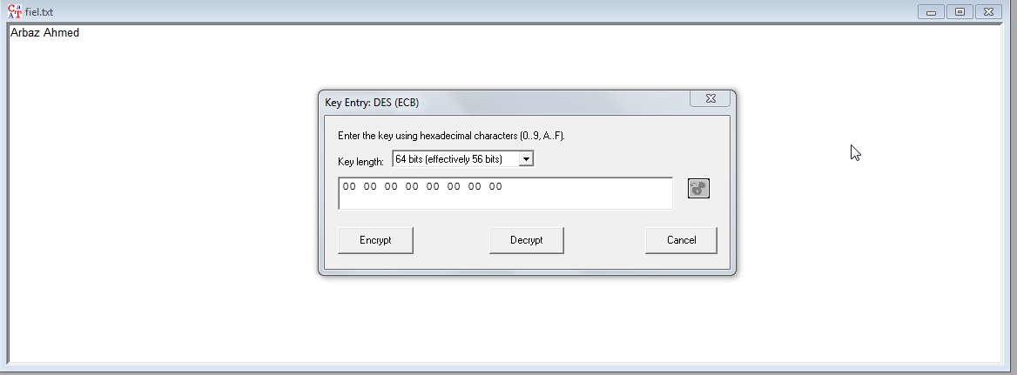

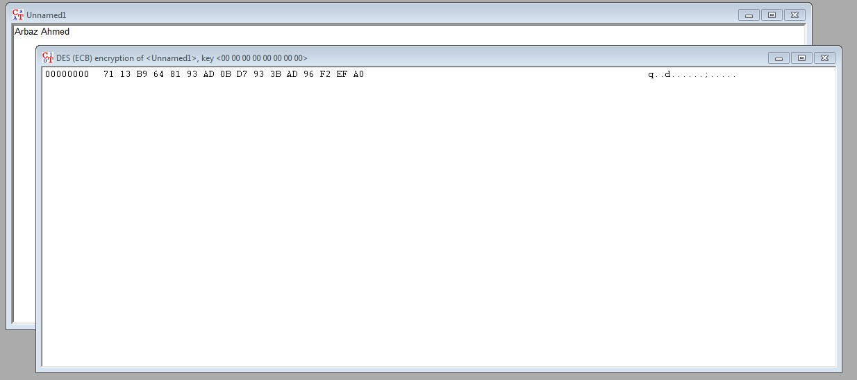

**2.Decryption Single line using CrypTool**

Step1:Open folder which file do you want decrypt

Step2:open file

Step3:go to Encrypy/Decrypt option in that select Symmetric(modern)

Step5:Select DES (ECB) and click on Decrypt option

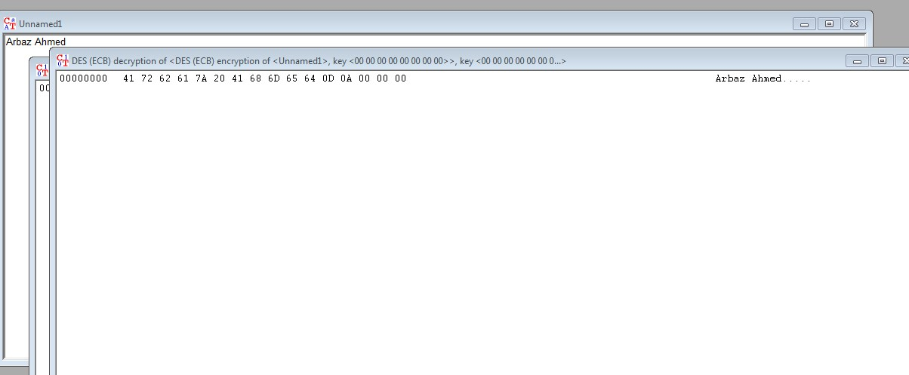

**Encrypt/Decrypt Single Word**

1.Encryption Single line using CrypTool

Step1:click on new empty file

Step2:write single word

Step3:go to Encrypy/Decrypt option in that select Symmetric(modern)

Step5:Select DES (ECB) and click on Encrypt

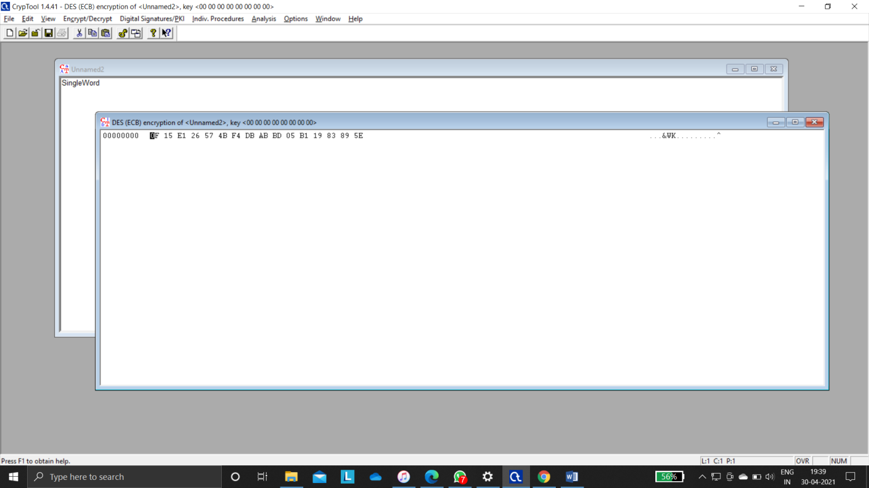

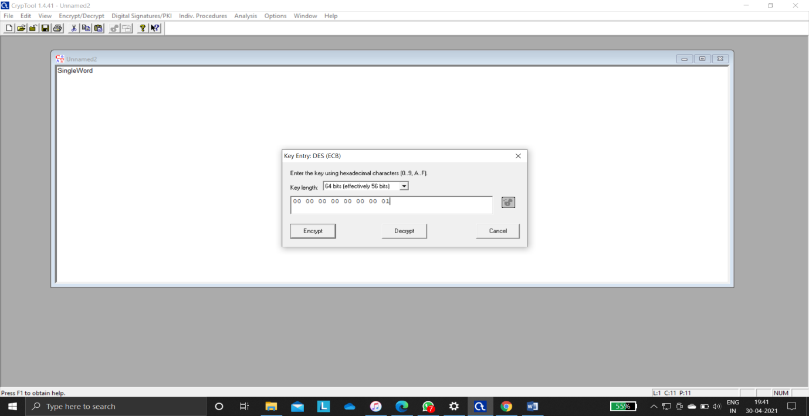

Above we are encrypted single word using crypt tool using key size will be 56 bits out of 64 bits without changing in the key bits.

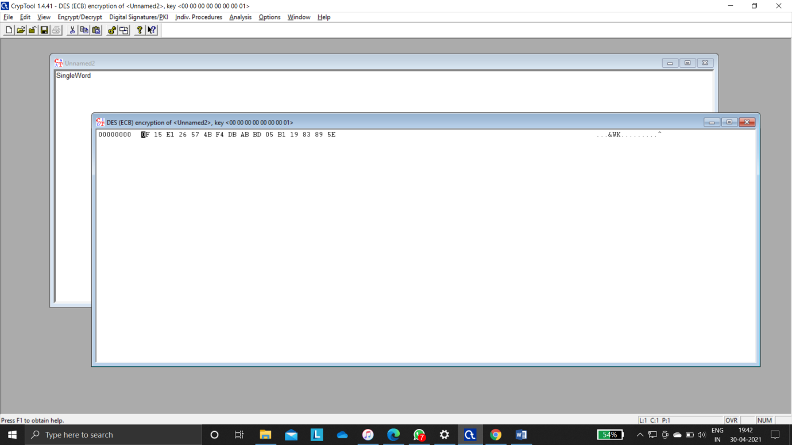

Above we have encrypted single line using crypt tool using key size will be 56 bits out of 64 bits with changing 1 bit but there is no change in encryption in the key bits

**Decryption Single word using CrypTool**

Step1:Open folder which file do you want decrypt

Step2:open file

Step3:go to Encrypy/Decrypt option in that select Symmetric(modern)

Step5:Select DES (ECB) and click on Decrypt option

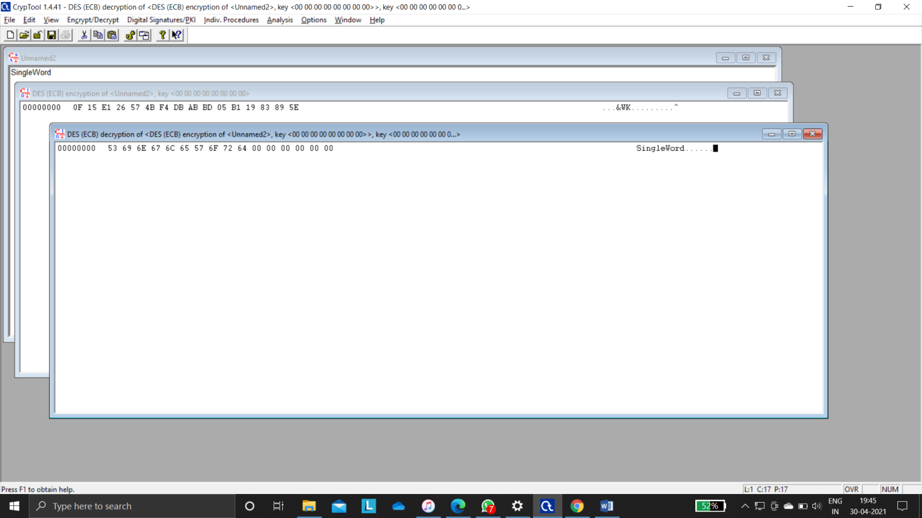

**Encrypt/Decrypt Paragraph**

1.Encryption Single line using CrypTool

Step1:click on new empty file

Step2:write single paragraph

Step3:go to Encrypy/Decrypt option in that select Symmetric(modern)

Step5:Select DES (ECB) and click on Encrypt

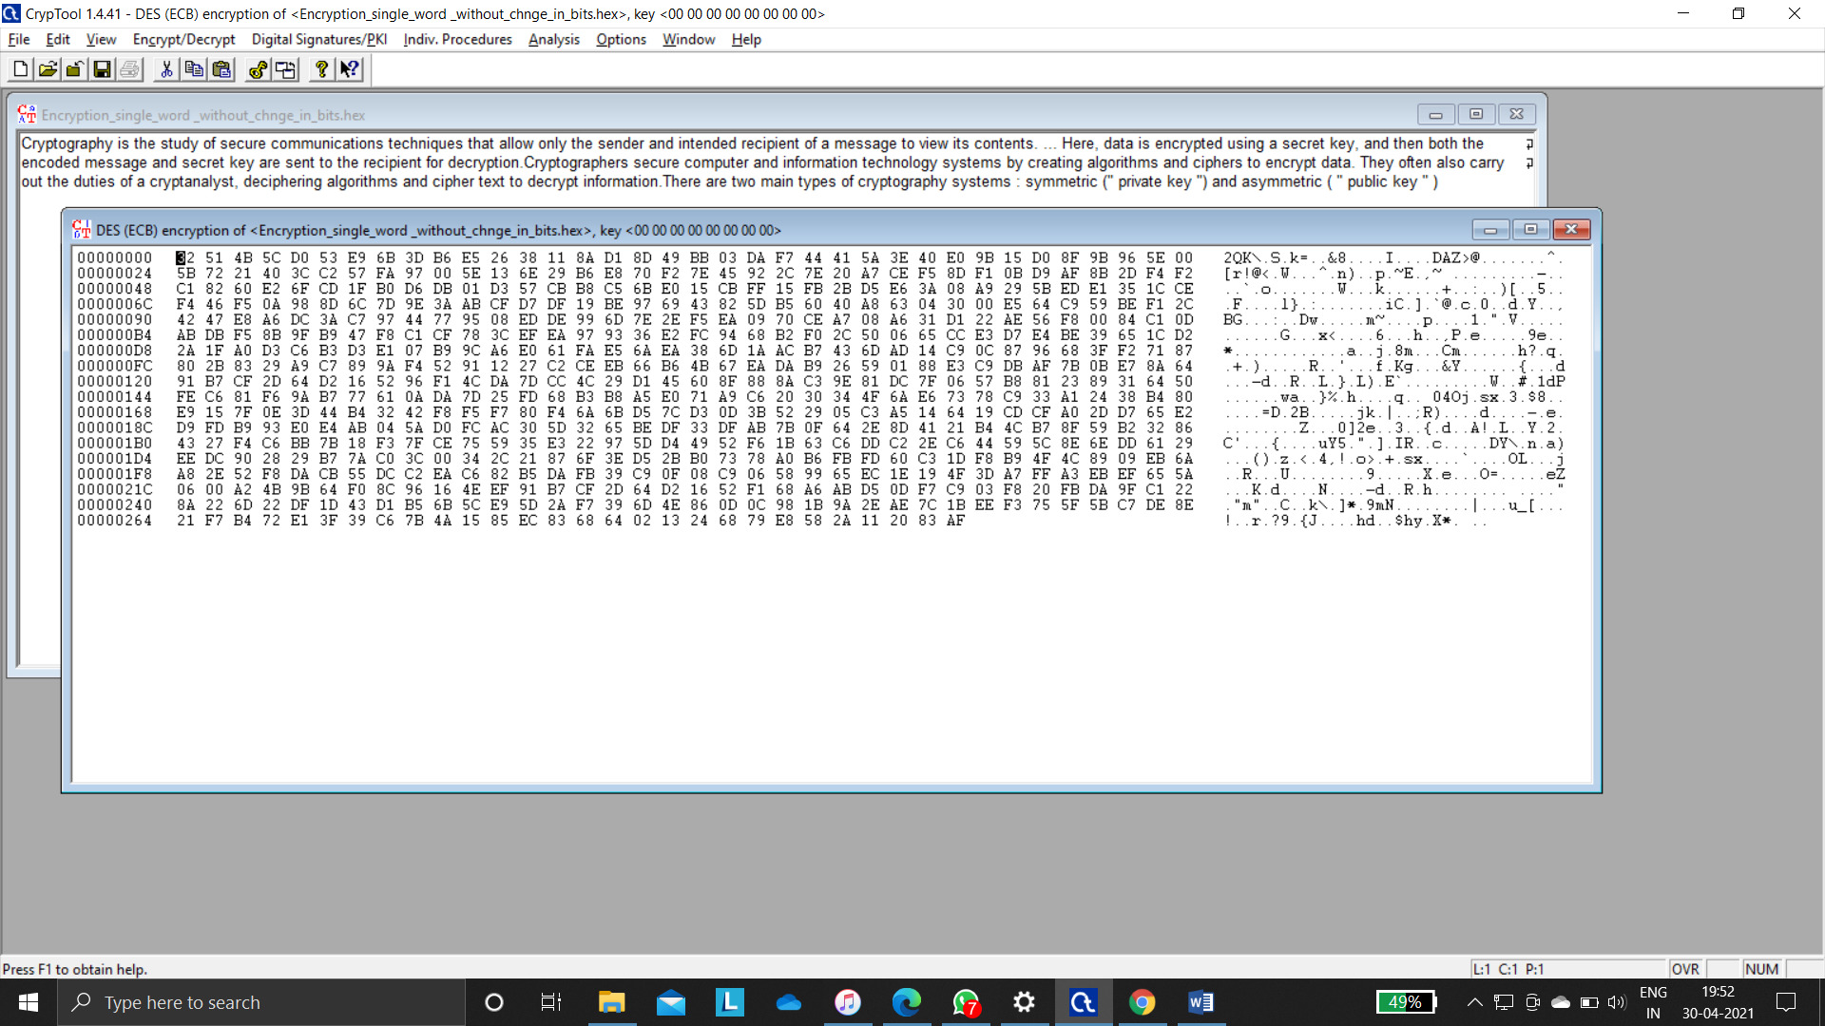

Above we are encrypted single word using crypt tool using key size will be 56 bits out of 64 bits without changing in the key bits.

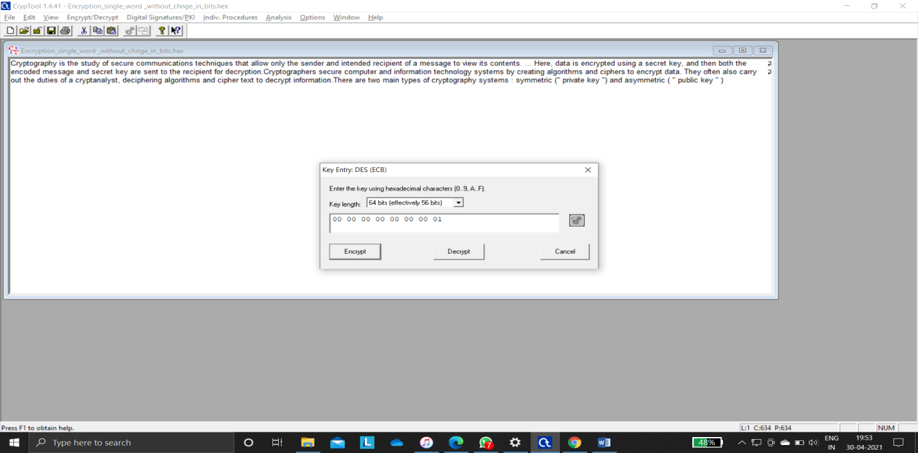



Above we are encrypted single word using crypt tool using key size will be 56 bits out of 64 bits with changing 1 bit in the key bits.

Decryption Para using CrypTool

Step1:Open folder which file do you want decrypt

Step2:open file

Step3:go to Encrypy/Decrypt option in that select Symmetric(modern)

Step5:Select DES (ECB) and click on Decrypt option

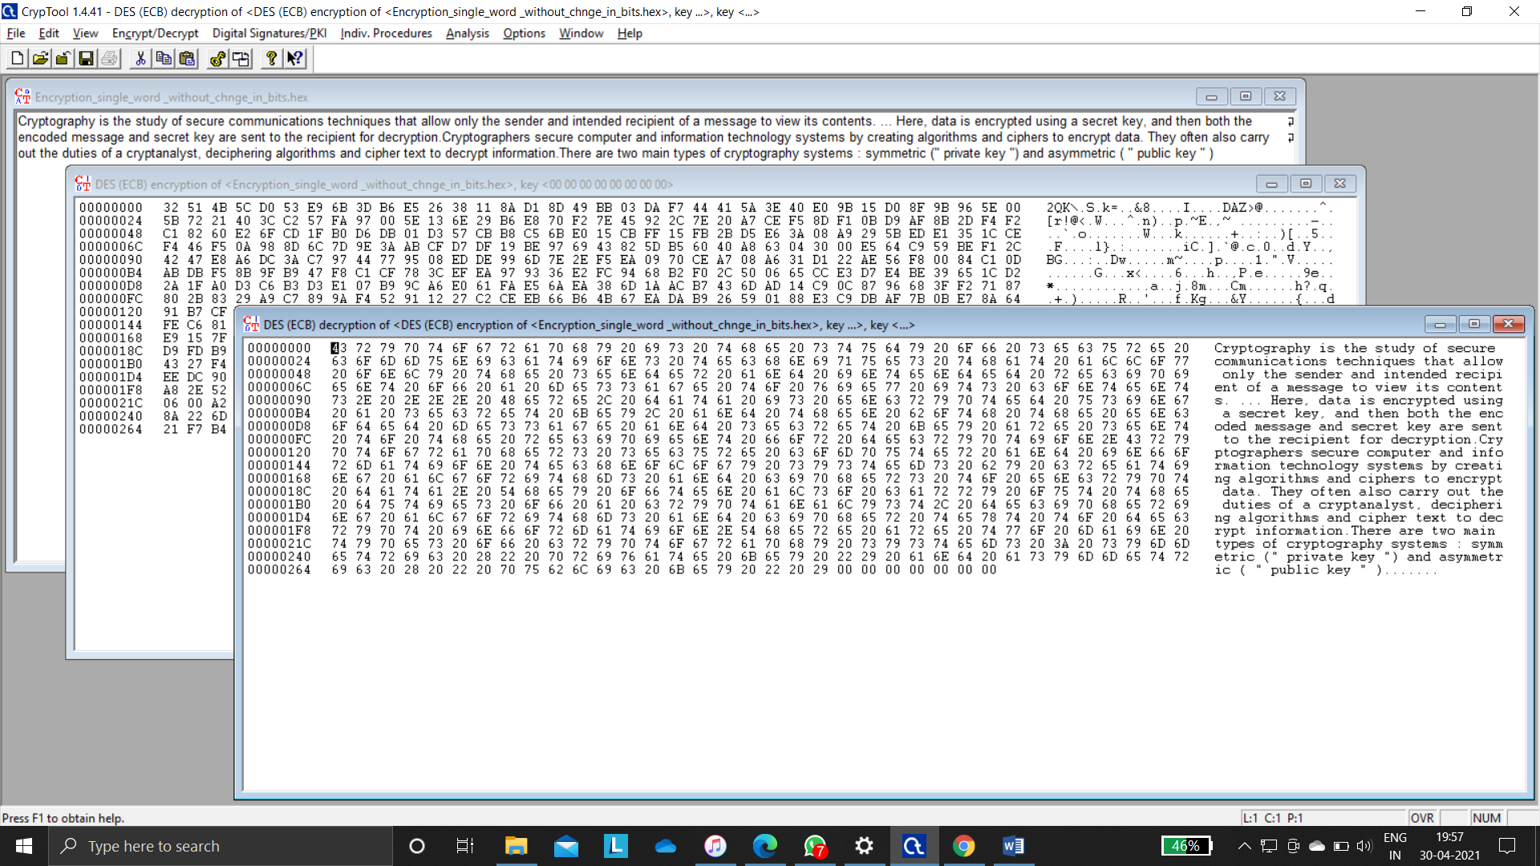

**Changing more than 2 bits in encrytion**

Step1:Open folder which file do you want decrypt

Step2:open file

Step3:go to Encrypy/Decrypt option in that select Symmetric(modern)

Step5:Select DES (ECB) change key bits and click on Encrypt option

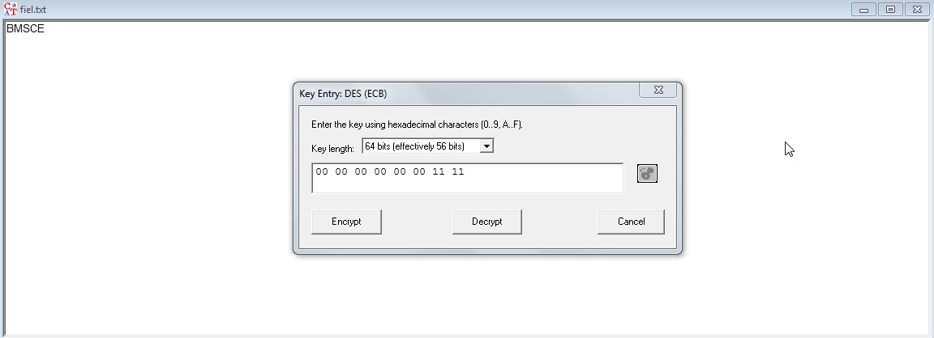

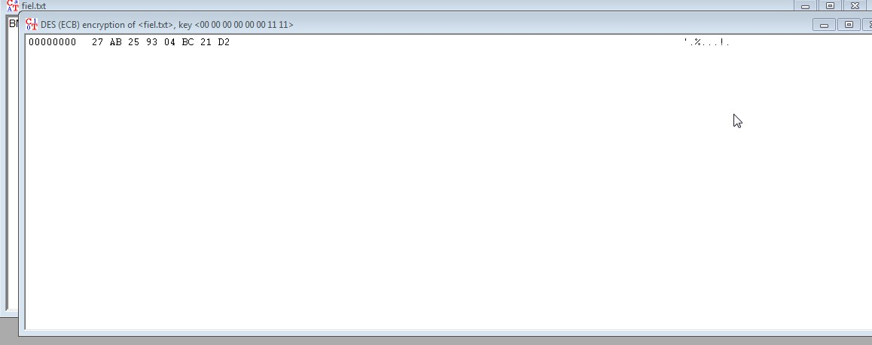

**Decrypting after changing Keys**

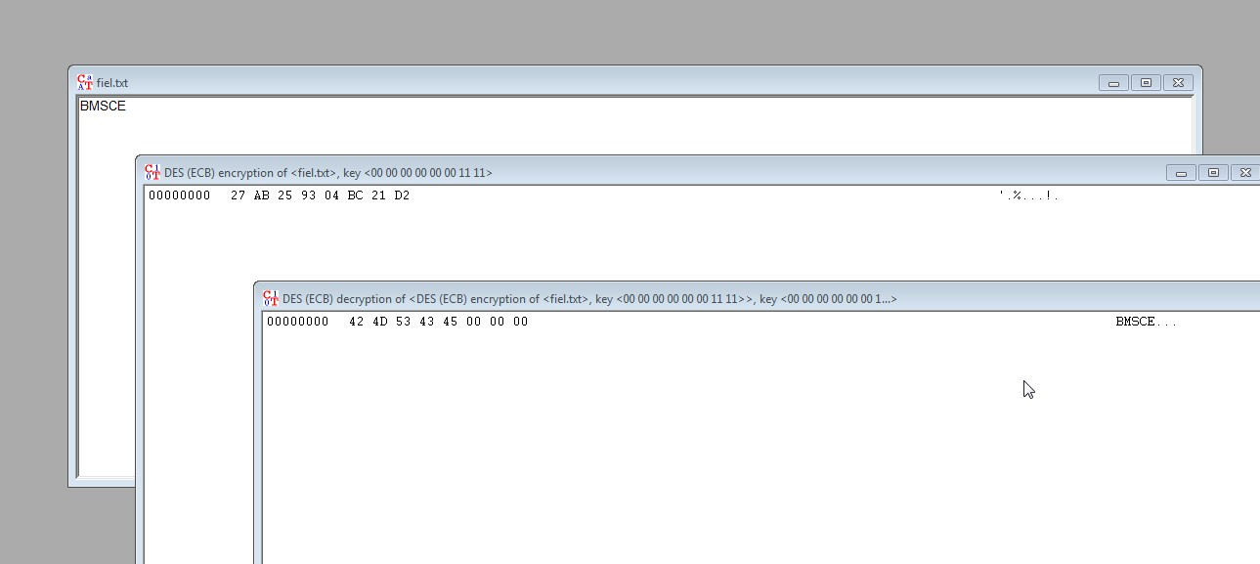

**Paragraph encrypting with changing 4 bits**

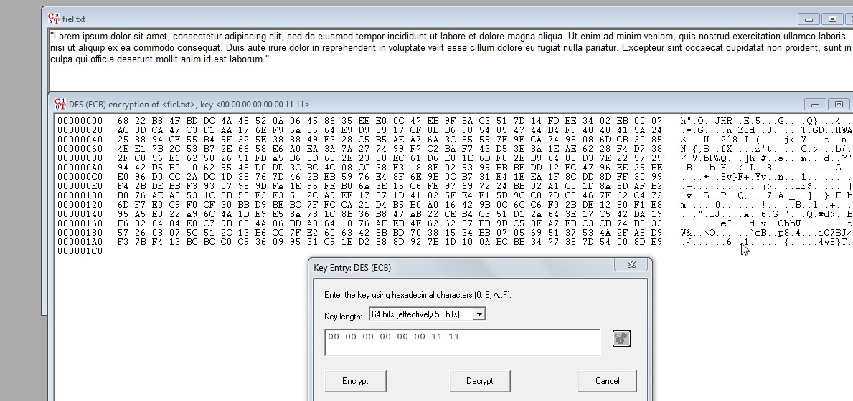

**Paragraph decrypting with changing 4 bits**

