Hi there,

I need assistance on a QUICK project which entails delivering combined title packages to our Computershare Client.

FYI:  I will be sending an email to all in production advising that the below method will be used for ALL Computershare files going forward but need assistance in getting those delivered in the pipeline ASAP.

Attached, you will find a list of files that are currently open/clear to close.

* Please note - if title has not yet been sent, please do not complete the above.
* If all documents listed are not available - DO NOT COMBINE THE PACKAGE.  NOTE THE ATTACHED AS PENDING (If tax statement, CPL, or pre-CD are not available)  The package sent must be the full five documents.

PROCESS:

* Open the file
* Highlight the Commitment, CPL, wire instruction, pre-CD, and tax statement ( All docs should be available, and no changes are needed)
* Combined the docs into a package (FYI ) the documents will go in the correct order when combined
  + Result File Name:  Combined Commitment Package
  + Document Type: Commitment
  + Description: Combined Commitment Package

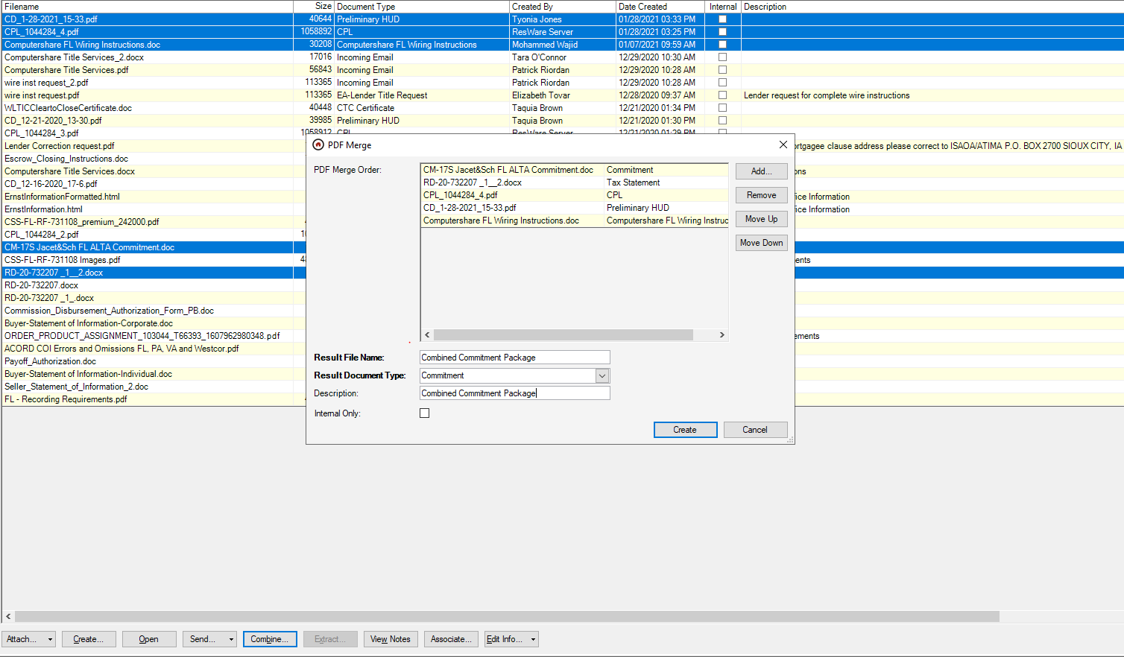

Upon created, go to the action 3186 - Deliver Approved Commitment.  UNDO Completed and RECOMPLETE the action.

The title delivery email will populate.  Remove ALL docs EXCEPT the Combined Commitment Package.

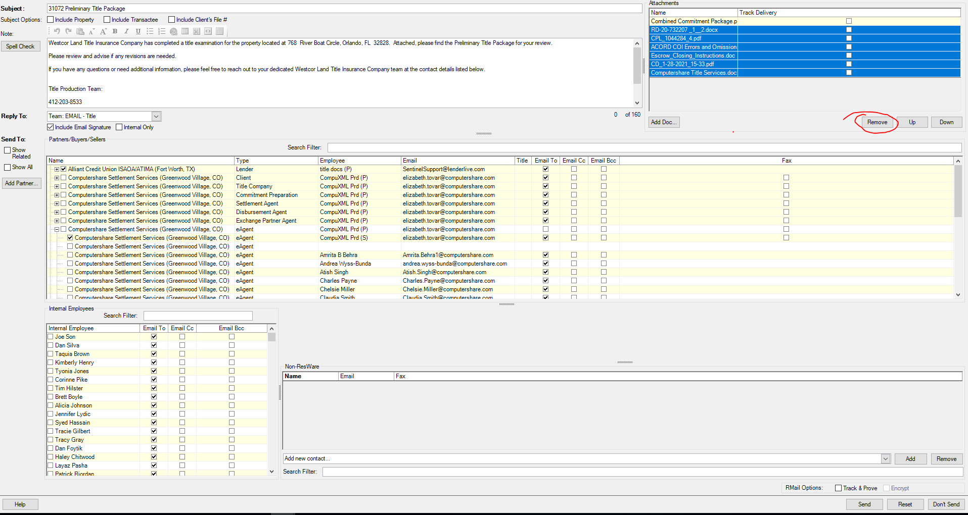

Send the email.

I completed the first one on the attached list.

Please let me know if there are any questions or if further clarification is needed.

 If possible, please have the team work on this for the remainder of the day until complete.