**Solution:-**

Follow the below following steps:

- Start Hive services and ensure that Hive daemons are running in your Hadoop Cluster

- Use HiveQL to create a table with same column names as given in csv file

- Load the csv file in Hive table - Execute the HiveQL query to get the desired results

**1. Problem Solution:-**

1.1 Create Hive Table Using ‘create table’ hive command to create the Hive table for your dataset:

**hive> create table nyse5 (exchange_data String,stock_symbol String,stock_date String,stock_price_open double, stock_price_high double, stock_price_low double, stock_price_close double, stock_volume double, stock_price_adj_close double) row format delimited fields terminated by "," stored as textfile location '/user/arbazmoham18edu/Input/nyse_stocks';**

1.2 Load Data to Hive Table:

Use the below Command.

**hive> load data local inpath '/home/arbazmoham18edu/Input/NYSE_daily_prices_Q.csv' into table nyse5;**

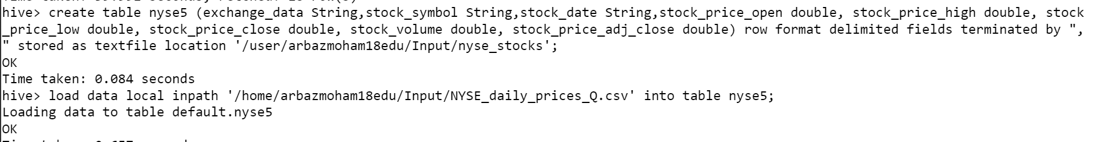

**1.3 Calculate the Covariance**

Use the following query to calculate the covariance between stocks.

**hive> select a.STOCK_SYMBOL, b.STOCK_SYMBOL, month(a.STOCK_DATE), (AVG(a.STOCK_PRICE_HIGH*b.STOCK_PRICE_HIGH) -(AVG(a.STOCK_PRICE_HIGH)*AVG(b.STOCK_PRICE_HIGH))) from nyse5 a join nyse5 b on a.STOCK_DATE=b.STOCK_DATE where a.STOCK_SYMBOL<b.STOCK_SYMBOL and year(a.STOCK_DATE)=2008 group by a.STOCK_SYMBOL, b.STOCK_SYMBOL, month(a.STOCK_DATE);**



**Final Output:-**

