

Tribhuvan University
Faculty of Humanities and Social Science

“Patient Record Management System”
A Project Proposal

Submitted to
Department of Computer Application
Kathmandu College Of Central State

In partial fulfilment of the requirements for Bachelor’s Degree in
Computer Application
Submitted by:
Arbin Maharjan
Praful Shrestha



Tribhuvan University
Faculty of Humanities and Social Sciences
Kathmandu College Of Central State
Supervisor’s Recommendation

I hereby recommend that this project prepared under my supervision by Arbin Maharjan and Praful Shrestha entitled “Patient Record Management System” in partial fulfilment of the requirements for the degree of Bachelor’s in Computer Application is recommended for the final evaluation.

SIGNATURE
Name:
SUPERVISOR
Academic Designation: Coordinator
Department: Humanities (BCA)
Address: Soalteemode, Kathmandu

Tribhuvan University
Faculty of Humanities and Social Sciences
Kathmandu College Of Central State
LETTER OF APPROVAL

This is to certify that this project by Arbin Maharjan and Praful Shrestha entitled “Patient Record Management System” in partial fulfilment of the requirements for the degree of Bachelor’s in Computer Application has been evaluated. In our opinion it is satisfactory in the scope and quality as a project for the required degree.
SIGNATURE of Supervisor  Er. Rajat Upreti  Soalteemode,Kathmandu | SIGNATURE of HOD/ Coordinator  Er. Subhash Belbase  Soalteemode,Kathmandu
SIGNATURE of Internal Examiner | SIGNATURE of External Examiner

TABLE OF CONTENTS

Contents
Chapter 1 2
1.1 Introduction 2
1.2 Problem Statement 3
1.3 Objectives 3
1.5 Outline of the Project 4

Chapter 2 Literature Review 5

Chapter 3 Methodology 6
3.1.1 Functional Requirements 6
3.1.2 Non-Functional Requirements 6
a) Technical Feasibility 7
b) Economical Feasibility 7
c) Operational Feasibility 7
3.1.4 Tools 7
3.2 System Design 8
3.3 Project Shceduling 13
4 References 14

Chapter 1

1.1 Introduction
A Pharmacy is a place where medical drugs are prepared or sold. The scope of pharmacy practice includes more traditional roles such as compounding and dispensing medication on the order of physicians, and It also includes more modern services related to patient care, clinical services, reviewing medication for safety and drug information. The patient information is very crucial and need to be managed properly.

Patients Records Management System is a fully-fledged system which is aimed at enabling Medical Centres to keep track of all the patients’ records and be accessed with ease. This helped to improve ways in which services were rendered to patients by increasing efficiency.

XYZ Patient Record Management System is designed to automate the pharmacy workflow. It is responsible for performing tasks like maintaining doctor and patient information, information about patients prescriptions, adding and removing doctors and patient and information on medical drugs stock. XYZ Patient Record Management System is mainly designed so that administrator can manage all the information about patient, their medical history, prescriptions and to manage medicine related information.

1.2 Problem Statement
The problem many medical centres are facing is using the manual process to provide health services, use of cards, files to track records of continuing patients and set up records for new patients in the hospital. This process has many inconsistencies and inconveniences like patients losing their health cards or their files being misplaced. Therefore an automated system helps to keep track of patient’s records and medical bills making it easy to determine the state of new and continuing patients.

1.3 Objectives
The main objectives of this project are:
- To design a user-friendly system that will capture, store and retrieve the stores records.
    - To develop a secured store system which can access storage with a huge amount of data.
    - To manage patient information

1.4 Scope and limitation

Scope
The study focuses on designing a Patients Records Management System that was used by many medical Centres in keeping track of their patient’s records.

Limitation
    - Require internet to access service
    - No alert when there is shortage of medicines

1.5 Outline of the Project
The main motive of designing this project is to manage information about medical drugs and other related information; so that people are up-to-date about their medical prescription and the availability of our services.

Chapter 2 Literature Review

2.0 Introduction
This chapter covers how the current process was carried out and findings that is reviewed from different sources such as eBooks, online journals, newspapers, magazines and the internet. It shows brief on what other studies worked on and how their system works. The chapter presents various systems used by hospitals to automate the process. Various literatures from various studies on the types of hospital management systems they operated their advantages, how they manage and how effective it brings the organization in use. Literature review published information in a particular subject area, and sometimes information in a particular subject within a certain period of time.

2.1 Description of the current system
Accessing patient’s files and records at Medical Centres are manually in all the departments, making it very labour intensive and ineffective. This process involves very large amounts of data, thus consuming a lot of time. The cause of data retrieval, loss of information results since the nurse or the person involve in data search dealt with very many files for different years. This was actually cumbersome and extremely hectic. This trend was good to be dealt out with for better services to the patients in hospitals. This process had so many inconsistencies and inconveniences like patients losing their health cards or their files being misplaced. Therefore an automated system helps to keep track of patient’s records and medical bills making it easy to determine the state of new and continuing patients.

The following are some of the reasons why the manual files storage should not be used in the hospital.

The current process of attending to patients has a number of problems including the following:
- High possibility of losing patients previous records and files due to misplacement, disasters occurrences like fit breaks.
- It is time wasting e.g., in terms of capturing, analysing and verifying details about patients, scheduling and making of their appointments.
3. It faced a possibility of many human errors caused by doctors in their prescription due to fatigue.
4. It is expensive due to high administrative costs incurred in terms of high stationary costs, printing patient’s cards, data entry and capture, data analysis and cleaning for storage purposes.

Chapter 3 Methodology
We are going to use waterfall methodology while building the website. This project have specific documentation, fixed requirements and well understood technology so in order to build this system, water fall methodology can be used.
The Waterfall model was the first process model to be introduced. It is very simple to use in comparison to all other models. It follows the approach of waterfall just as name suggests. In waterfall model each phases must be completed before moving on to next phase.
3.1 Requirement Analysis
The ‘Pharmacy Management System’ helps the people to get information on availability of medical drugs and availability of doctors as well.
    - Add and display doctor information
    - Add and display drugs information
    - Add and display patient information.
    - Add and display employee information

3.1.1 Functional Requirements

- The system shall allow the Administrator to check the user and employee information.
- The system shall allow the Administrator to delete the record of employee, doctor and patient.
- The system shall allow the Administrator to add and the drugs information.

3.1.2 Non-Functional Requirements

- The system shall be available any time.
- The system shall be secured and shall maintain privacy
- The system shall perform smoothly with good response.
- The system shall be reliable for the user.

3.1.3 Feasibility Study
A feasibility study is an evaluation and analysis of a project or system that somebody has proposed.
Following feasibilities were studied before building the system to see if the system could be build with exact requirement in required time.

Technical Feasibility

- To design this system, it uses existing technologies like VSC(Visual Studio Code) and MYSQL server so there is no technical hurdle to build this system.

- Economical Feasibility

- The system only uses open-source software due to which no extra hardware or software is required. So, there is no recurring cost than just the internet connection

Operational Feasibility

- The system is user-friendly as it only uses simple technologies to design

3.1.4 Tools

- Front end
- HTML
- CSS
- JavaScript

- Back end
- PHP
- MySQL

3.2 System Design

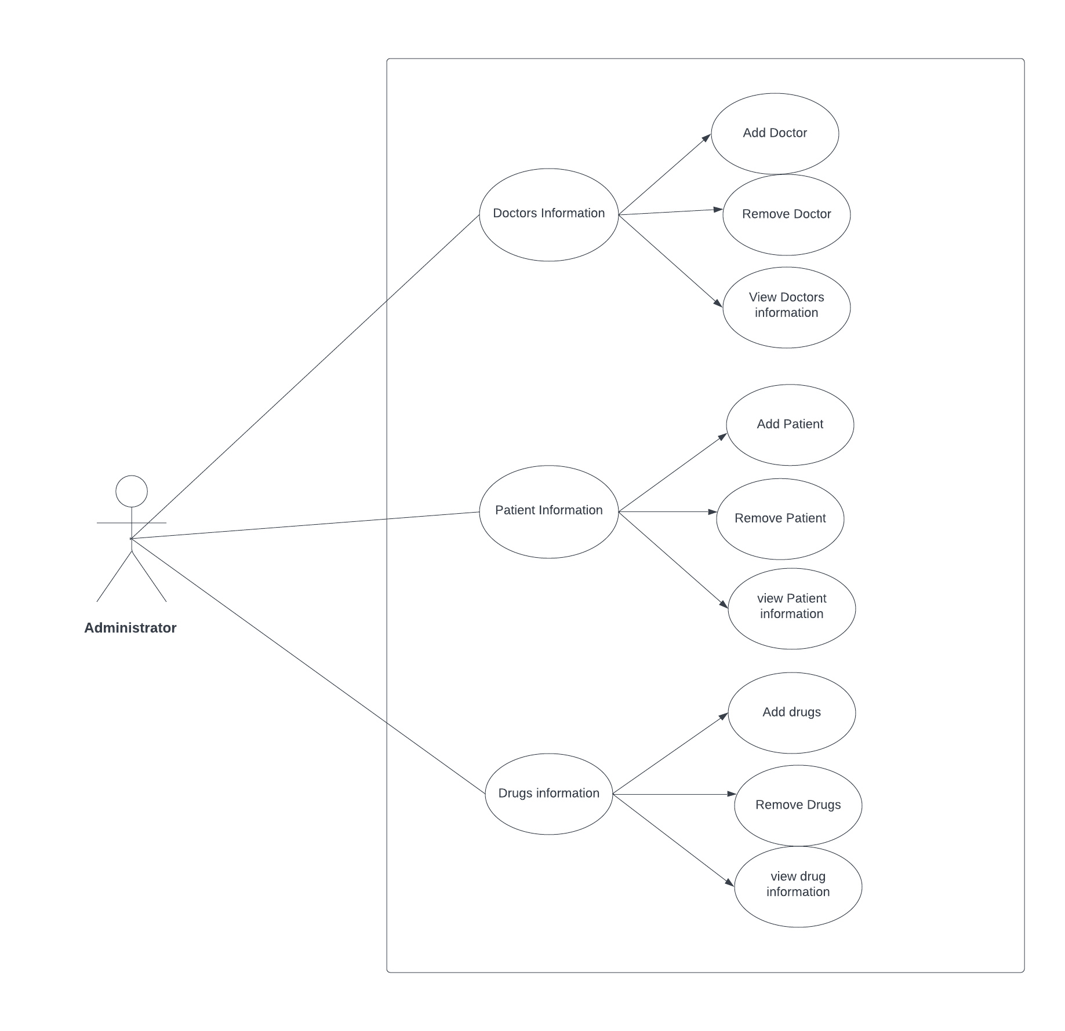
Figure: Use case diagram

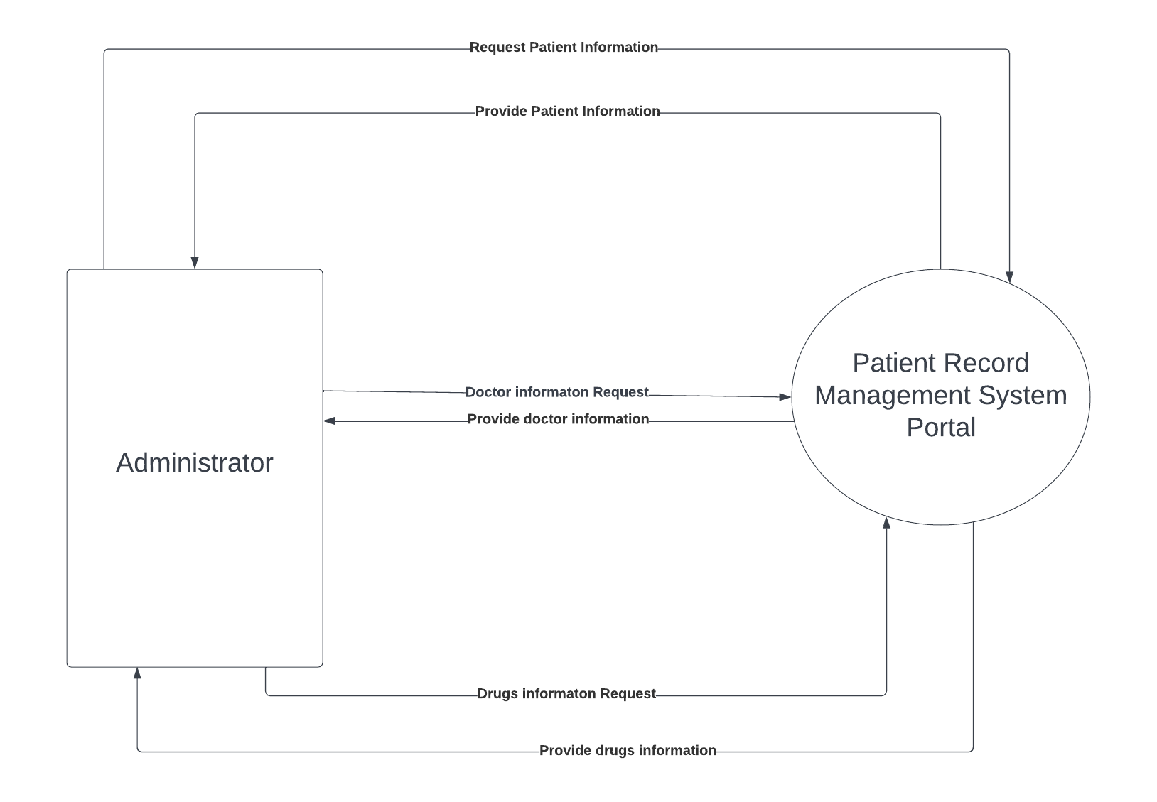
Figure: Context Diagram

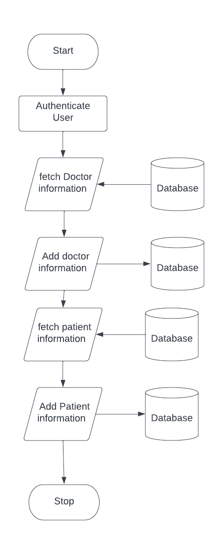

Figure: System Flow Chart

Chapter 4: Implementation and Testing

4.1 Implementation
The software Design Description has been used as input in the implementation process. The actual implementation has been done using PHP. PHP has been used to interact with the backend database.

4.1.1 Tools Used
The front-end and back-end tools used in the system are mentioned below:

Front-end Tools

HTML:
HTML stand for Hyper Text Markup Language is a Mark up language which is used to make the layout of the websites. It is the barebone of the websites and only provide plain layout and structure of the websites. It allows web users to create and structure sections, paragraphs, and links using elements, tags, and attributes.
CSS:
Cascading Style Sheets, fondly referred to as CSS, is a simple design language intended to simplify the process of making web pages presentable. Where HTML is a barebone and structure of the websites CSS is the thing that makes the websites presentable, neat and clean. It is basically styling of the websites after html is applied. Using CSS, user can control the colour of the text, the style of fonts, the spacing between paragraphs, how columns are sized and laid out, what background images or colours are used, layout designs, variations in display for different devices and screen sizes as well as a variety of other effects.
JavaScript:
JavaScript is a dynamic programming language that's used for web development, in web applications, for game development, and lots more. It allows us to implement dynamic features on web pages that cannot be done with only HTML and CSS. Without JavaScript, all we would have on the web would be HTML and CSS. These alone limit our to a few web page implementations. 90% (if not more) of the webpages would be static, and only have the dynamic changes like animations that CSS provides. JavaScript is a dynamic programming language that supports Math calculations, allows to dynamically add HTML contents to the DOM, creates dynamic style declarations, fetches contents from another website, and lots more.

- Back-end Tools

PHP:
PHP (recursive acronym for PHP: Hypertext Pre-processor) is a widely-used open source general-purpose scripting language that is especially suited for web development and can be embedded into HTML. PHP is mostly used for making web servers. It runs on the browser and is also capable of running in the command line. PHP is platform-independent. User don't have to have a particular OS to use it because it runs on every platform, whether it's Mac, Windows, or Linux. You can easily connect PHP to all Databases, relational and non-relational. So it can connect in no time to MySQL, Postgress, MongoDB, or any other database.
MySQL:
MYSQL is a Relational Database Management System(RDBMS) developed by Oracle that is based on Structured Query Language(SQL). A database is a structured collection of data. It may be anything from a simple shopping list to a picture gallery or a place to hold the vast amounts of information in a corporate network. In particular, a relational database is a digital store collecting data and organizing it according to the relational model. In this model, tables consist of rows and columns, and relationships between data elements all follow a strict logical structure. An RDBMS is simply the set of software tools used to actually implement, manage, and query such a database.

4.1.2 Implementation Details of Models

There are many SDLC models which are available to use. Among those various available models we used Waterfall model for developing the system. It is a traditional SDLC model which follows the continuous flow of execution of phases. It works just like a waterfall, once the phrase is executed there is no looking back.

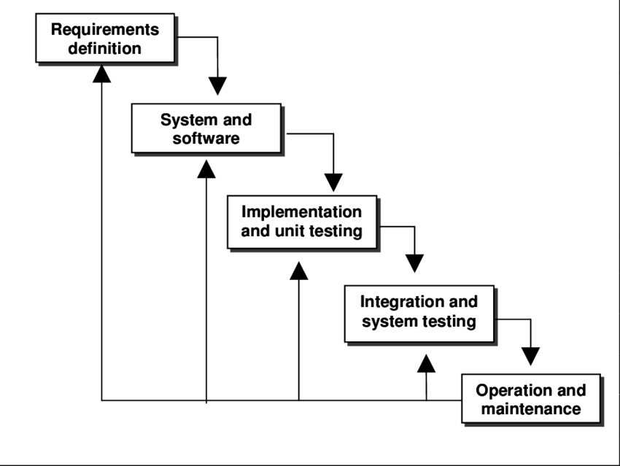

Figure: Waterfall Model of Software Development

4 References
Bibliography
[1 a School of pharmacy, 1992.[online].Available:]
http://www.pharmacy.cuhk.edu.hk/1/about-us/pharmacy/
[2 altexsoft,2007.[online].Available]
http://www.pharmacy.cuhk.edu.hk/1/about-us/pharmacy/

