**TRIBHUVAN UNIVERSITY**

**INSTITUTE OF ENGINEERING**

**Lab Sheet #12**

**PURWANCHAL CAMPUS**

DHARAN-8

**Submitted by:** **Submitted to:**

Name: **Arbind Kumar Mehta** Department of

Roll No: **PUR075BCT017** Electronics & Computer

Faculty: BCT Engineering

Group: I/I ‘A’

Date: ….......................... Checked by: ……………………….

**Title:**

Write A FORTRAN Program (WAFP) to display “Welcome to Fortran Language”. **Code:**

! A fortran95 program for G95

! By WQY

program welcome

implicit none

write(*,*) "Welcome to fortran language!"

end

**Output (Compilation, Debugging and Testing):**

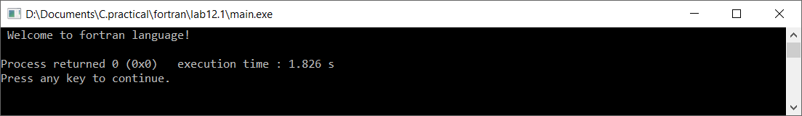

**Title:**

Write a FORTRAN program to read three integers of same width using I format specifier.

**Code:**

!reading three integer of same width

program main

integer a,b,c

write(*,*),"Enter three integer(width=1) to be stored:"

read(*,101),a,b,c

write(*,102),"You have entered:",a,',',b,'and',c

101 Format(I1,I1,I1)

102 Format(A18,I1,A1,I1,A3,I1)

End

**Output (Compilation, Debugging and Testing)**

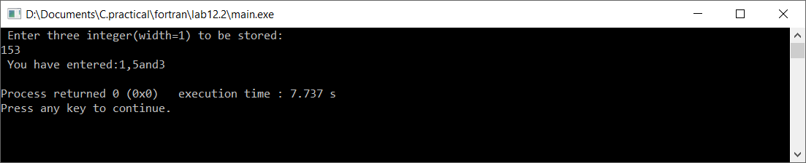

**Title:**

WAFP to read two real numbers in fractional form and display their sum in exponential form.

**Code:**

!program to find sum

program sum1

real a,b,su1

write(*,*)'Enter two real number:'

read(*,*)a,b

su1=a+b

write(*,*)'The sum of ',a,' and ',b,' is ',su1

end program

**Output (Compilation, Debugging and Testing):**

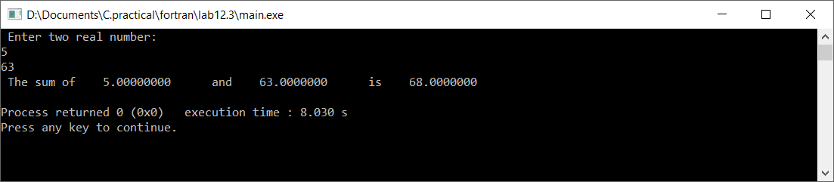

**Title:**

WAFP to read sex code (1: for male & 2: for female) from user and display corresponding sex using computed GOTO statement)

**Code:**

!computed GOTO

program main

integer s

write(*,*)"Press 1 for male and 2 for female and 3 for undefined:"

read(*,*),s

GO TO(100, 101,102),s

100 write(*,*)"Congratulation!!! you are male."

stop

101 write(*,*)"Congratulation!!! you are female."

stop

102 write(*,*)"Sorry!!! you are sex is undefined."

stop

end program

**Output (Compilation, Debugging and Testing):**

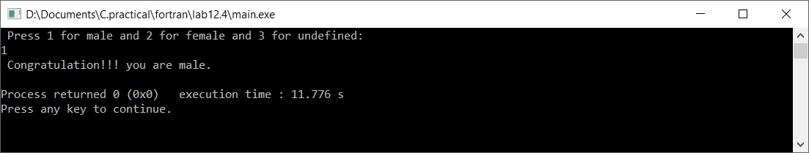

**Title:**

WAFP to read a number from keyboard and display whether it is positive, negative or zero

**Code:**

!comparing numbers

program main

real n

write(*,*)'Enter a number:'

read(*,*)n

if(n)100,101,102

100 write(*,*)'You have entered negative number.'

stop

101 write(*,*)'You have entered Zero.'

stop

102 print *,'You have entered positive number.' !x>y .and. x<y is also valid

stop

end program

**Output (Compilation, Debugging and Testing):**

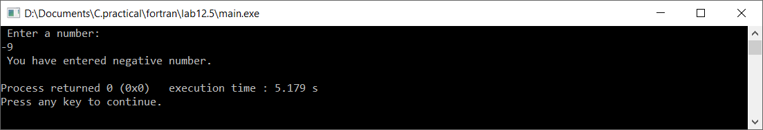

**Title:**

WAFP to find factorial of a number.

**Code:**

!factrioal

program main

integer n,f,i

f=1

write(*,*)'Enter number:'

read(*,*)n

do i=1,n

f=f*i

enddo

write(*,*)"The factrioal of",n,"is",f

end program

**Output (Compilation, Debugging and Testing):**

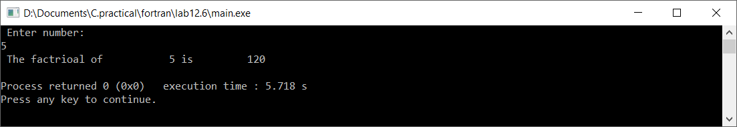

**Title:**

WAFP to find greatest among five numbers stored in an array.

**Code:**

!using array

program main

implicit none

integer a(5),i,j

integer ma

data(a(i),i=1,5)/20,-50,110,0,13/

write(*,*)'The array is:'

do i=1,5

write(*,*)a(i)

end do

ma=a(1)

do j=1,5

if(ma.lt.a(j)) then !we can also use '>'or'<' , power=**

ma=a(j)

endif

end do

write(*,*)'The greatest number is:',ma

end program main

**Output (Compilation, Debugging and Testing):**

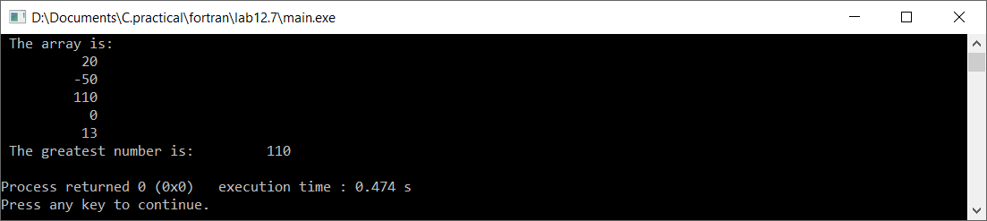

**Title:**

WAFP to read marks of 10 students in a subject and display top three marks.

**Code:**

!recording student marks

program main

integer i,j,m(10),temp

write(*,*),'Enter the marks of each student:'

do i=1,10

read(*,*)m(i)

enddo

write(*,*)'You have entered:'

do i=1,10

write(*,*),m(i)

end do

do i=1,9

do j=i+1,10

if(m(i).lt.m(j)) then

temp=m(i)

m(i)=m(j)

m(j)=temp

end if

end do

end do

write(*,*),'The top three marks is:',(m(i),i=1,3)

end program

**Output (Compilation, Debugging and Testing):**

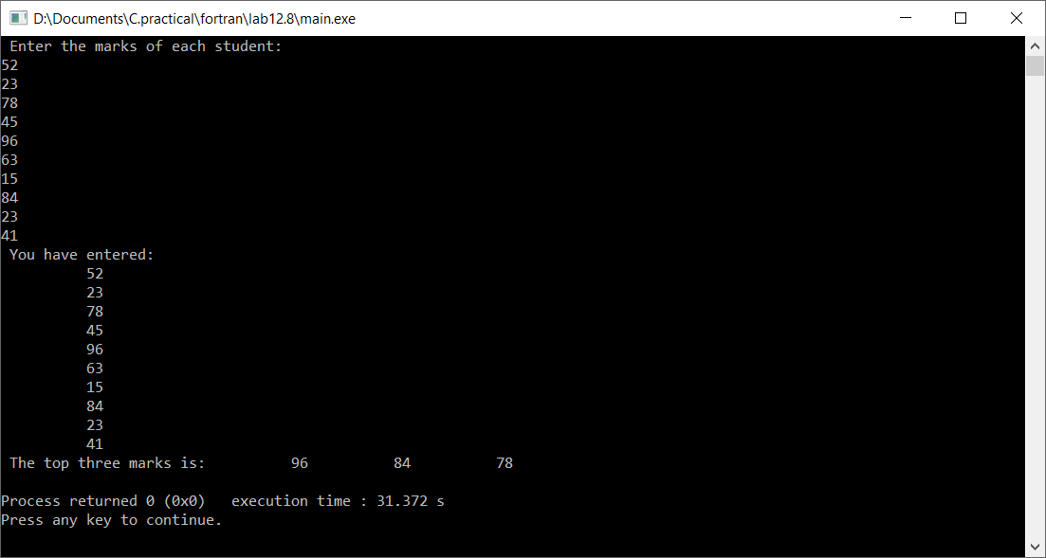

**Title:**

WAFP to read two matrix of size 3X3 and display the sum matrix. Also display the transpose of the first matrix.

**Code:**

!matrix addition

program matrix

integer m1(3,3),m2(3,3),m(3,3)

write(*,*)'Enter the element of first matrix:'

do i=1,3

read(*,*),(m1(i,j),j=1,3)

enddo

write(*,*)'Enter the element of second matrix:'

do i=1,3

read(*,*),(m2(i,j),j=1,3)

enddo

do i=1,3

do j=1,3

m(i,j)=m1(i,j)+m2(i,j)

end do

end do

write(*,*)'The sum of matrix is::'

do i=1,3

write(*,*),(m(i,j),j=1,3)

enddo

end program

**Output (Compilation, Debugging and Testing):**



