**TRIBHUVAN UNIVERSITY**

**INSTITUTE OF ENGINEERING**

**Lab Sheet #5**

**PURWANCHAL CAMPUS**

DHARAN-8

**Submitted by:** **Submitted to:**

Name: **Arbind Kumar Mehta** Department of

Roll No: **PUR075BCT017** Electronics & Computer

Faculty: BCT Engineering

Group: I/I ‘A’

Date: ….......................... Checked by: ……………………….

**Title:**

Write a program to find sum as Y of the following series excluding prime numbers in the series.

Y = 1 +1/ 1!+22/ 2!+32 /3!+ ⋯+ 102/10!

**Objective:**

* To understand the programming using Loop & nested loop Statements (for, while, do-while)

**Problem Analysis:**

Based on problem, it is required to define three integer variable and a float variable. Different operation should performed using user defined function.

|  |  |  |
| --- | --- | --- |
| **Input variables** | **Output variables** | **Necessary header files/functions/macros** |
| n,i(int type) | Y(float type) | stdio.h  coino.h  scanf()  printf()  math.h  isprime()  fact() |

**Algorithm:**

1. Start
2. Define variables: n,i,Y

for(i=1;i<=10;i++)

{

if(isprime(i)==0)

{

Y=Y+(pow(i,2)/fact(i));

}

}

1. Print:Y
2. Stop

**Flowchart:**

Start

Define variable: i=1,Y

If(i<10)

If(isprime=0)

Y=Y+(pow(i,2)/fact(i)); i++

Print:Y

End

**Code:**

#include <stdio.h>

#include <stdlib.h>

#include <math.h>

int fact(int n)

{

if(n==1||n==0)

return 1;

else

return(n*fact(n-1));

}

int isprime(int n)

{

int i,flag=0;

for(i=2;i<=n/2;i++)

{

if(n%i==0)

flag=1;

}

if(flag==1||n==1||n==2)

return 0;

else

return 1;

}

int main()

{

int n,i;

float Y=1.00;

for(i=1;i<=10;i++)

{

if(isprime(i)==0)

{

Y=Y+(pow(i,2)/fact(i));

}

}

printf("Y=%.3f",Y);

return 0;

}

**Output (Compilation, Debugging and Testing):**

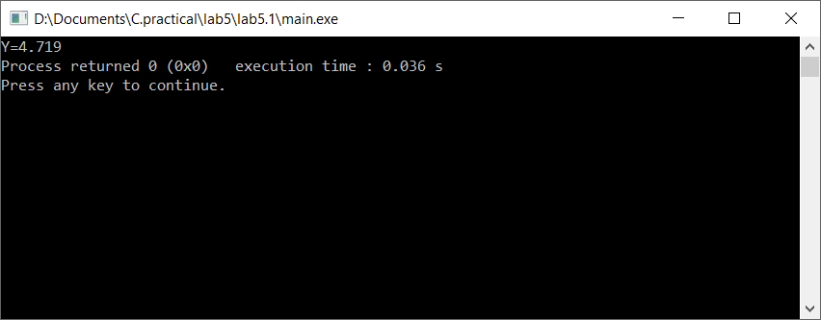

**Discussion & Conclusion:**

In this lab of C programming, based on the focused objective(s) to understand about C data types with formatted input/output functions with user defined functions.

**Title:**

Write a program to input two integer numbers and display the sum of even numbers between these two input numbers.

**Objective:**

* To understand the programming using Loop & nested loop Statements (for, while, do-while)

**Problem Analysis:**

Based on problem, it is required to define four integer variable. Different operation should performed using if statement and for loop.

|  |  |  |
| --- | --- | --- |
| **Input variables** | **Output variables** | **Necessary header files/functions/macros** |
| n1,n2,i,j(int type) | sum(int type) | stdio.h  coino.h  scanf()  printf() |

**Algorithm:**

1. Start
2. Define variables: n1,n2,i,j,sum=0,
3. Read n1,n2

if(n1>n2)

{i=n2;

j=n1;}

else

{

i=n1;

j=n2;

}

for(i;i<=j;i++)

{

if(i%2==0)

sum=sum+i;

}

1. Print: sum
2. Stop

**Flowchart:**

Start

Define variable:i,j,sum=0,n1,n2

Read: n1,n2

If(n1>n2)

i=n2;j=n1

i=n1;j=n2

If(i<n/2)

If(i%2=0)

sum=sum+i;

i++

Print:sum

End

**Code:**

#include <stdio.h>

#include <stdlib.h>

int main()

{

int n1,n2,i,j,sum=0;

printf("Enter the range of number:\n");

scanf("%d%d",&n1,&n2);

if(n1>n2) //Assigning smaller to i & greater to j

{i=n2;

j=n1;}

else

{

i=n1;

j=n2;

}

printf("The sum of even number between %d and %d is:",i,j);

for(i;i<=j;i++)

{

if(i%2==0)

sum=sum+i;

}

printf("%d",sum);

return 0;

}

**Output (Compilation, Debugging and Testing):**

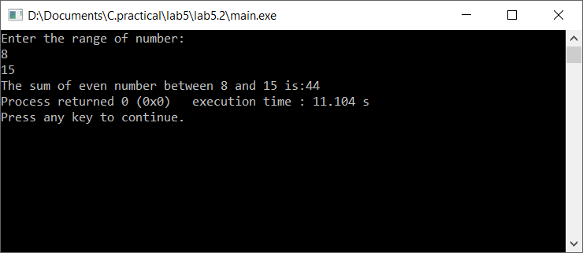

**Discussion & Conclusion:**

In this lab of C programming, based on the focused objective(s) to understand about C data types with formatted input/output functions with if statement and for loop.

**Title:**

Write a program to find GCD (greates common divisor or HCF) and LCM (least common multiple) of two numbers.

**Objective:**

* To understand the programming using Loop & nested loop Statements (for, while, do-while) and if statement in C.

**Problem Analysis:**

Based on problem, it is required to define ten integer variable. Different operation should performed using if statement and for loop.

|  |  |  |
| --- | --- | --- |
| **Input variables** | **Output variables** | **Necessary header files/functions/macros** |
| n1,n2,i,j,k,x,f1,f2(int type) | gdc,lcm (int type) | stdio.h  coino.h  scanf()  printf() |

**Algorithm:**

1. Start
2. Define variables: n1,n2,i,j,k,x,f1,f2,gdc=0,lcm=1
3. Read n1,n2

if(n2>n1)

i=n2;

else

i=n1;

for(j=2;j<=i;j++)

{

if(n1%j==0&&n2%j==0)

gdc=j;

}

printf("GDC is=> %d\n",gdc);

if(gdc!=0)

lcm=(n1*n2)/gdc;

else

lcm=n1*n2;

1. Print: lcm,gdc
2. Stop

**Flowchart:**

Start

Define variable: n1,n2,i,j,k,x,f1,f2,gdc=0,lcm=1

Read: n1,n2

If(n1>n2)

i=n1

i=n2,j=2

If(j<i)

If(n1%j=0&n2%j=0)

gdc=j

j++

If(gdc!=0)

lcm=(n1*n2)/gdc

A

A

lcm=n1*n2

Print:lcm,gdc

End

**Code:**

#include <stdio.h>

#include <stdlib.h>

void factor(int i) //calculating facctors of number

{ int k=2;

printf("Factors of %d are=>",i);

{ while(i>=2)

{

if(i%k==0)

{

i=i/k;

printf("%d\t",k);

}

else

k++;

}

}

}

int main()

{

int i,j,n1,n2,x,k=2;

int gdc=0,lcm=1,f1,f2,g;

printf("Enter two number whose GCD and LCM is to be found:\n");

scanf("%d%d",&n1,&n2);

if(n2>n1) //assigining greater number to i

i=n2;

else

i=n1;

for(j=2;j<=i;j++)

{

if(n1%j==0&&n2%j==0) //GDC or HCF

gdc=j;

}

printf("GDC is=> %d\n",gdc);

if(gdc!=0)

lcm=(n1*n2)/gdc;

else

lcm=n1*n2;

printf("LCM is=> %d\n",lcm); //lcm=(n1*n2)/gdc

factor(n1);

printf("\n");

factor(n2);

return 0;

}

**Output (Compilation, Debugging and Testing):**

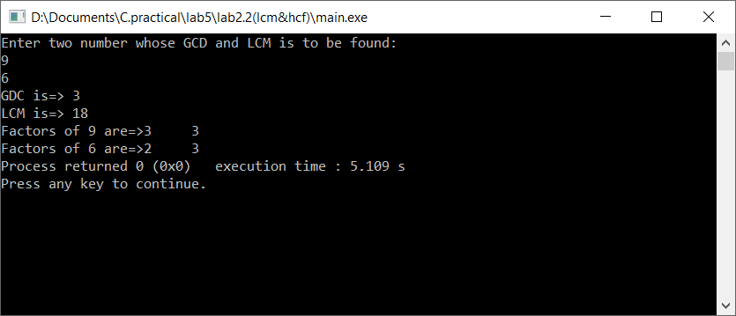

**Discussion & Conclusion:**

In this lab of C programming, based on the focused objective(s) to understand about C data types with formatted input/output functions with if statement and for loop.

**Title:**

Write a program to display Fibonacci series of last term up to 30.

**Objective:**

* To understand the programming using Loop & nested loop Statements (for, while, do-while) and if statement in C.

**Problem Analysis:**

Based on problem, it is required to define three integer variable. Different operation should performed using if statement and for loop.

|  |  |  |
| --- | --- | --- |
| **Input variables** | **Output variables** | **Necessary header files/functions/macros** |
| n1,n2,i(int type) | nx (int type) | stdio.h  coino.h  scanf()  printf()  define n 30 |

**Algorithm:**

1. Start
2. Define variables: n1,n2,i,nx

for(i=0;i<n;i++)

{

nx=n1+n2;

n1=n2;

n2=nx;

print: nx

}

1. Stop

**Flowchart:**

Start

Define variable: n1=-1,n2=1,i=0,nx

If(i<n)

nx=n1+n2;n1=n2;n2=nx;

Print:nx

i++

End

**Code:**

#include <stdio.h>

#include <stdlib.h>

#define n 30

int main()

{

int i,n1=-1,n2=1,nx; //to start from 1 assign n1=0

for(i=0;i<n;i++)

{

nx=n1+n2;

n1=n2;

n2=nx;

printf("%d\t",nx);

}

return 0;

}

**Output (Compilation, Debugging and Testing):**

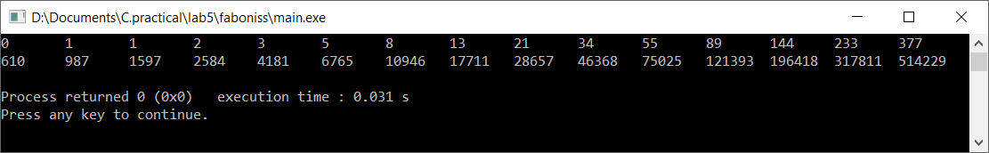

**Discussion & Conclusion:**

In this lab of C programming, based on the focused objective(s) to understand about C data types with formatted input/output functions with if statement and for loop.

**Title:**

Write a program to display the flag of Nepal using symbolic/HEX character in C.

**Objective:**

* To understand the programming using Loop & nested loop Statements (for, while, do-while) and if statement in C.

**Problem Analysis:**

Based on problem, it is required to define two integer variable. Different operation should performed using if statement and for loop.

|  |  |
| --- | --- |
| **Input variables** | **Necessary header files/functions/macros** |
| i,j(int type) | stdio.h  coino.h  printf() |

**Algorithm:**

1. Start
2. Define variables: i,j

for(i=0;i<=8;i++)

{

for(j=0;j<=i;j++)

print:*

print:\n

}

for(i=0;i<=10;i++)

{

for(j=0;j<=i;j++)

print: *

print:\n

}

1. Stop

**Flowchart:**

Start

Define variable: I=0,j=0

If(i<8)

If(j<i)

Print:*

J++

Print:\n

i++

End

**Code:**

#include <stdio.h>

#include <stdlib.h>

int main()

{

int i,j;

for(i=0;i<=8;i++)

{

for(j=0;j<=i;j++)

printf("*");

printf("\n");

}

for(i=0;i<=10;i++)

{

for(j=0;j<=i;j++)

printf("*");

printf("\n");

}

return 0;

}

**Output (Compilation, Debugging and Testing):**

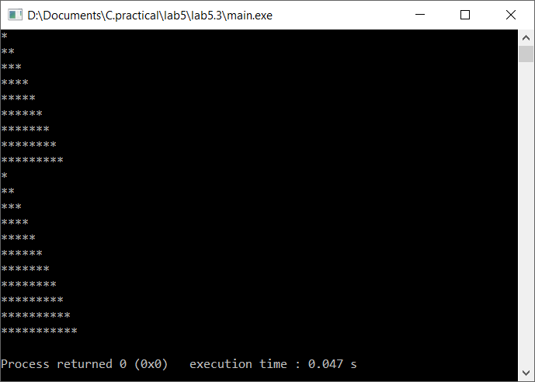

**Discussion & Conclusion:**

In this lab of C programming, based on the focused objective(s) to understand about C data types with formatted input/output functions with if statement and for loop.

**Title:**

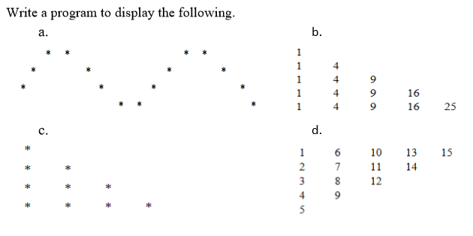

**Objective:**

* To understand the programming using Loop & nested loop Statements (for, while, do-while) and if statement in C.

**Problem Analysis:**

Based on problem, it is required to define different according to need integer variable. Different operation should performed using if statement and for loop.

|  |  |
| --- | --- |
| **Input variables** | **Necessary header files/functions/macros** |
| i,j(int type) | stdio.h  coino.h  printf() |

**Algorithm:**

1. Start
2. Define variables: i,j

for(i=1;i<=4;i++)

{

for(j=1;j<=16;j++)

{

if(j==5-i||j==4+i||j==13-i||j==12+i)

print:*

else

print:

}

Print:\n

}

1. Stop

**Flowchart:**

Start

Define variable: I=1,j=1

If(i<=4)

If(j<16)

if(j==5-i||j==4+i||j==13-i||j==12+i)

Print: *

Print:_

J++

Print:\n

i++

End

**Code(a.):**

#include <stdio.h>

#include <stdlib.h>

int main()

{

int i,j;

for(i=1;i<=4;i++)

{

for(j=1;j<=16;j++)

{

if(j==5-i||j==4+i||j==13-i||j==12+i)

printf(" *");

else

printf(" ");

}

printf("\n");

}

return 0;

}

**Output (Compilation, Debugging and Testing):**

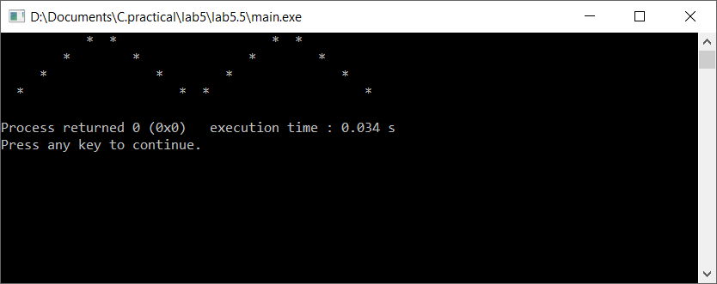

**Code(b.):**

#include <stdio.h>

#include <stdlib.h>

int main()

{ int i,j;

for(i=1;i<=5;i++)

{

for(j=1;j<=i;j++)

{

printf("%d\t",(j*j));

}

printf("\n");

}

return 0;

}

**Output (Compilation, Debugging and Testing):**

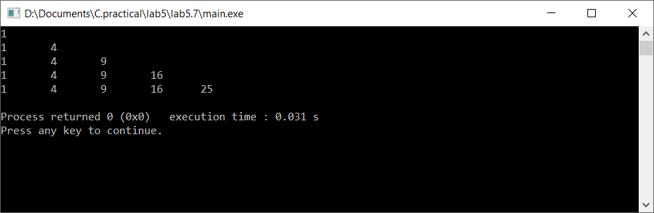

**Code(c.):**

#include <stdio.h>

#include <stdlib.h>

int main()

{

int j,i;

for(i=1;i<=4;i++)

{

for(j=0;j<i;j++)

{

printf("* ");

}

printf("\n");

}

return 0;

}

**Output (Compilation, Debugging and Testing):**

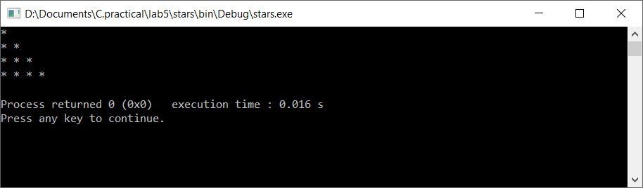

**Code(d.):**

#include <stdio.h>

#include <stdlib.h>

int main()

{

int i,j,k,x;

for(i=1;i<=5;i++)

{

printf("%d\t",i);

k=i;

x=5;

for(j=5-i;j>=1;j--)

{

k=k+x;

printf("%d\t",k);

x--;

}

printf("\n");

}

return 0;

}

**Output (Compilation, Debugging and Testing):**

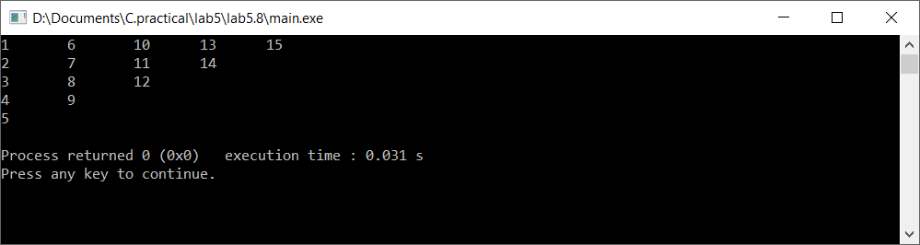

**Discussion & Conclusion:**

In this lab of C programming, based on the focused objective(s) to understand about C data types with formatted input/output functions with if statement and for loop.

***