LAWPD - CIAM Migration | System Architecture
Auth0 Bulk User Migration
System Design Specification

Prepared for: Client Review
Classification: Confidential
Version: 2.0 - Final
Go-Live: 23 November 2026 | 2M Users - Big Bang

1. Executive Summary
This document describes the technical design of the Auth0 Bulk User Migration Pipeline - a production-grade system built to migrate 2 million LADWP user accounts from Oracle OUD/OAM into Auth0, with full auditability and the ability to resume from any point of interruption.
The pipeline is built on BullMQ (a Redis-backed job queue) and operates strictly within Auth0 hard platform limits: a 500 KB file size cap per import job and a maximum of two concurrent import jobs per tenant. User records are read from a Redis List, batched into size-bounded JSON files, and imported in parallel via the Auth0 Management API. Failed users are retried individually up to a configurable threshold; users exhausting all retries are written to manual-review.xlsx for human intervention.
A Redis-backed checkpoint ensures the pipeline resumes exactly where it stopped after any crash, deployment, or intentional pause - no data is re-processed and no in-progress work is lost.
[OK] Safe to re-run at any time. The checkpoint ensures already-completed batches are skipped. Resuming after a crash or stop picks up exactly where the migration left off.

2. Auth0 API Constraints
The following limits are enforced by the Auth0 platform and are hard constraints - not configurable without an explicit quota increase request to Auth0 Support. Every architectural decision in this system traces back to one or more of these boundaries.
Constraint | Limit | Design Response
Maximum file size per import job | 500 KB | Chunks are sized to <= 480 KB, leaving a 20 KB buffer for JSON serialisation overhead across platforms.
Concurrent import jobs per tenant | 2 (default) | Worker concurrency is controlled by MAX_CONCURRENT_AUTH0_JOBS. Changing the env var is the only action needed when Auth0 raises the limit.
Job completion timeout | 2 hours | Status poller caps at 240 attempts x 30 s = 120 min. Jobs that do not complete have their users escalated to the retry queue.
Job data TTL (auto-deleted by Auth0) | 24 hours | Status polling must complete before data expires. In practice the 2-hour cap means this is never reached.
Per-user retry threshold | 3 (configurable) | After 3 failed attempts a user record is written to manual-review.xlsx for human intervention.

3. System Architecture
The pipeline is organised as three co-operating BullMQ queues - Import, Status, and Retry - each processed by dedicated worker processes. The orchestrator reads user data from Redis, chunks it, and enqueues it. Workers are the only components that communicate with the Auth0 API.

3.1 Main Migration Flow
On startup the orchestrator checks Redis for an existing checkpoint. If one is found, already-processed chunk IDs are loaded and excluded from the queue - the run resumes from the point of interruption. On a fresh run the orchestrator streams all users from the Redis source List using LRANGE in batches of 500, validates each record (skipping rows missing an email address), and writes size-bounded chunks to disk as JSON files.
Each chunk is enqueued as a BullMQ job using its chunkId as the job ID - making duplicate enqueues idempotent. Workers POST the chunk to Auth0, store the resulting Auth0 job ID in Redis, and add a delayed status polling job to the Status Queue.
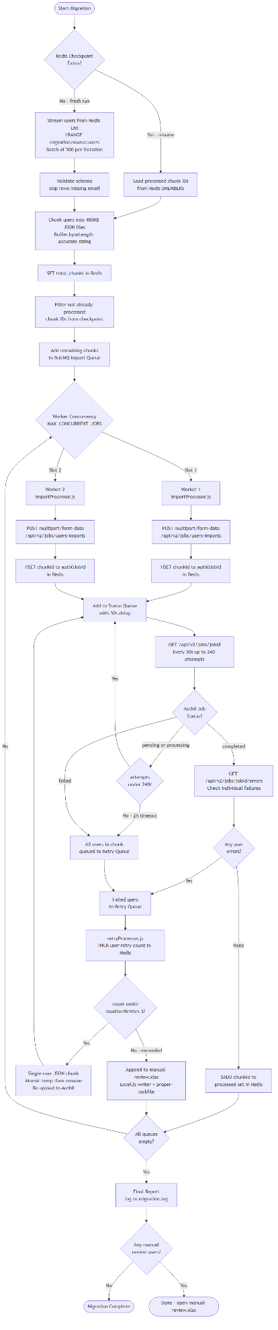
Fig. 1 - Complete pipeline: source streaming, chunking, parallel import, status polling, and failure escalation

3.2 Concurrent Job Sequencing
Two import workers operate in parallel, controlled by a single environment variable. When Auth0 raises your tenant concurrent job limit, only that value changes - no code is deployed. A worker slot is freed only when the Auth0 job it submitted has fully resolved (completed, failed, or timed out), so concurrency is tracked at the Auth0 job level rather than the HTTP request level.
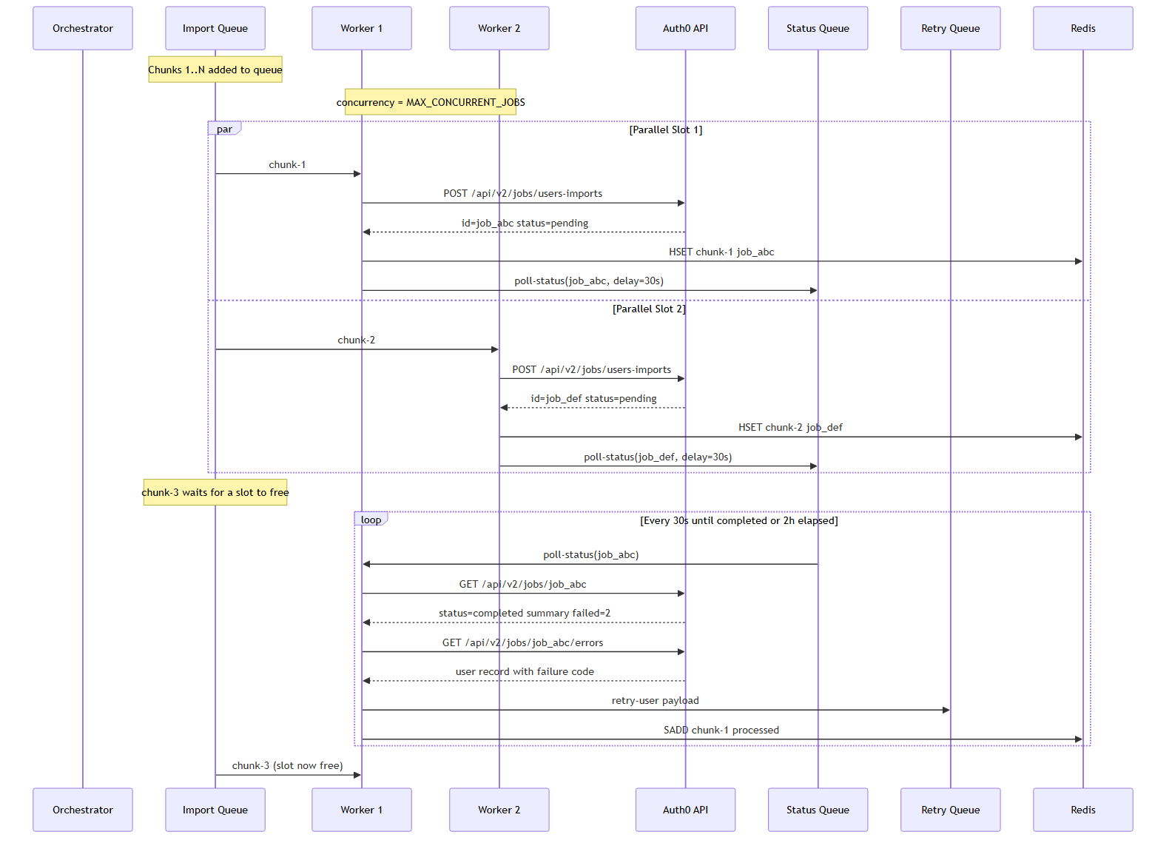
Fig. 2 - Workers run in parallel; a slot frees only when the Auth0 job fully resolves

3.3 Failure and Retry Escalation
Three failure categories all funnel into the same Retry Queue, so retry logic is centralised in a single processor. The retry processor handles both transient and permanent failures by checking the per-user attempt counter before deciding whether to re-submit or escalate to manual review.
When a user is escalated to manual review, the record is appended to manual-review.xlsx using proper-lockfile for mutual exclusion between concurrent retry workers and an atomic write pattern (write to a .tmp file, then rename) so the file is never in a half-written state.
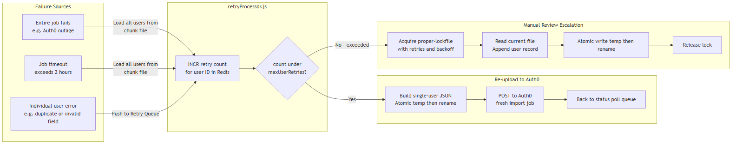
Fig. 3 - All failure paths converge on the Retry Queue; manual review is the terminal escalation after 3 attempts

3.4 Checkpoint and Resume Model
Every processed chunk ID is stored in a Redis SET immediately on completion. On any restart - planned or crash - the orchestrator loads the set and skips matching chunks. BullMQ queue state in Redis provides a second recovery layer: jobs active at the time of a crash are automatically re-queued by BullMQ stall detection.
Six Redis keys collectively represent the full pipeline state: processed_chunks (SET of completed chunk IDs), auth0_jobs (HASH of chunkId to Auth0 job ID), per-user retry counts (STRING), migration status (STRING), total chunk count (STRING), and source list read offset (STRING).
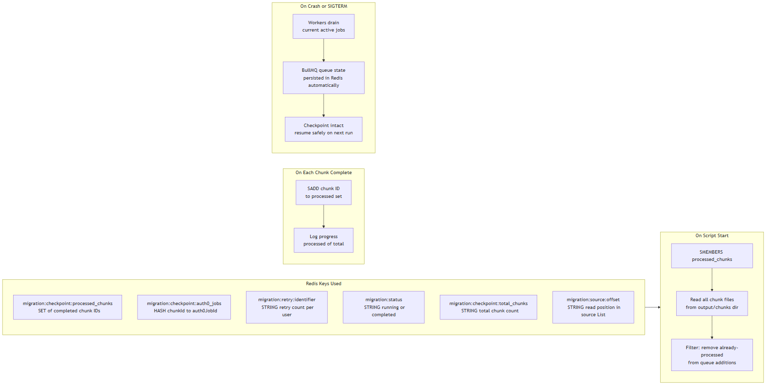
Fig. 4 - Redis checkpoint enables safe resume; BullMQ queue state provides in-flight job recovery

4. Technology Stack
Dependencies are deliberately minimal - every package listed below earns its place and has no simpler alternative that satisfies the requirement.
Package | Version | Role | Rationale
bullmq | ^5.0 | Job queue and worker orchestration | Redis-backed, built-in concurrency control, exponential backoff. BullMQ is the active successor to Bull (v4 is end-of-life). Auth0 batch import maps precisely to its producer-worker model.
ioredis | ^5.3 | Redis client and checkpoint store | Required by BullMQ. Used directly for checkpoint operations via atomic SADD, SMEMBERS, HSET. maxRetriesPerRequest: null is mandatory for BullMQ compatibility.
exceljs | ^4.4 | Excel writer for manual review output | Writes manual-review.xlsx for users who failed all retries. Excel means the ops team opens it directly without any conversion step.
axios | ^1.6 | Auth0 Management API HTTP calls | Used directly instead of the Auth0 Node SDK because bulk import requires multipart/form-data with a file stream.
form-data | ^4.0 | Multipart form builder | Attaches the JSON chunk as a readable file stream. Provides getHeaders() to set the correct Content-Type boundary automatically.
proper-lockfile | ^4.1 | File-level mutual exclusion | Prevents concurrent retry workers from corrupting manual-review.xlsx. Works correctly on Windows unlike flock-based alternatives.
winston | ^3.11 | Structured logging | JSON-formatted logs to file plus human-readable console output. Parseable by Datadog, ELK, and CloudWatch out of the box.
uuid | ^9.0 | Chunk ID generation | Each chunk needs a stable unique ID for checkpoint tracking, Redis keys, and the Auth0 external_id field for end-to-end traceability.

5. Key Design Decisions
1 | Redis for checkpoint, not a file  Redis is already required by BullMQ, so using it for checkpointing adds zero new infrastructure. A Redis SET gives O(1) membership checks and atomic SADD operations - a file-based checkpoint would require locking on every write from every worker.  Risk: Redis loss equals checkpoint loss. Required mitigation: run Redis with AOF persistence (appendonly yes, appendfsync everysec) and a replica or Sentinel.

2 | Disk-based chunk files, not in-memory arrays  Chunks are written to output/chunks/ before upload. This enables: safe resume without re-reading from Redis, re-read of chunk contents when a whole job fails, and no memory pressure from holding all chunks simultaneously. Each chunk is <= 480 KB, so disk I/O cost is negligible.

3 | Polling, not webhooks  Auth0 POST /api/v2/jobs/users-imports does not support completion webhooks - polling is the only option. The status worker adds a delayed BullMQ job that re-polls every 30 seconds, capped at 240 attempts (2 hours). All polling logic lives inside the queue with no leaked setInterval handles.

4 | Retry at user level, not chunk level  When a job completes with partial failures, re-uploading the entire chunk would risk duplicating already-imported users. The design calls GET /api/v2/jobs/{id}/errors to extract only the failed user records and retries them individually as single-record imports. This eliminates upsert ambiguity entirely.

5 | Atomic writes for manual-review.xlsx  Two mechanisms combined: proper-lockfile for mutual exclusion between concurrent retry workers, and ExcelJS writes to a .tmp file then fs.renameSync() for an atomic swap. The Excel file is never in a half-written, unreadable state even if a worker crashes mid-write.

6 | Concurrency as a runtime environment variable  BullMQ Worker concurrency reads from MAX_CONCURRENT_AUTH0_JOBS. When Auth0 raises your tenant concurrent job limit, only the environment variable changes - no code deployment required. The operational team can tune throughput without involving engineering.

6. Risks and Mitigations
Risk | Severity | Mitigation
Redis is a single point of failure. If Redis fails mid-migration, BullMQ loses queue state and the checkpoint becomes inaccessible. | HIGH | Enable AOF persistence (appendonly yes, appendfsync everysec). Run Redis Sentinel or Cluster. Do not use ephemeral Redis for this migration.
30-second poll interval introduces latency between a job completing and the next chunk uploading. | LOW | Configurable via STATUS_POLL_INTERVAL_MS. Reduce for higher throughput, but monitor Auth0 Management API rate limits on the status endpoint.
Windows atomic rename is not truly atomic. Renaming over an existing file requires delete-then-rename, leaving a brief window where the file is absent. | LOW | Under proper-lockfile only one process is ever in this window. A crash during the delete leaves the file absent until the next write - acceptable for a manual review log.
If the Redis source offset key is lost without the chunk checkpoint, re-chunking from offset 0 may produce duplicate chunk files on disk. | MEDIUM | Use --fresh flag only intentionally - it resets both the checkpoint and the source offset atomically at startup. Never delete Redis keys manually mid-migration.

