# WEATHER STATION

# OBJECTIVE

# To design a mobile weather station which can monitor temperature,pressure,humidity and rainfall reliably

1. Improve efficiency
2. To bring error free, scientific measurement of rain
3. Document the design and implementation procedures
4. Provide other planning guidance and procedure

# MOTIVATION BEHIND THE PROJECT

Mobile weather station gain greater and greater importance around the world. We only get weather of a countable cities in the world. So we wish to know about the data of remote places also. Weather stations have helped to take the precautionary measures against the destructive rains, winds,severe high or low temperature, diseases and pests. The use of weather stations helps to cope with the frost and high temperature in summer. The knowledge of pressure and humidity enable us to know about precipitation and climate change. The rain gauge here gives the data of rain per hour, so that we can know about the intensity of rain. These all data using one setup

Nevertheless, what we have hope to do is not only giving a temperature sensor. We would like to build up pressure,humidityand rainfall measurement.

We hope that the product constructed can relieve much difficulties in climate change sensing and help in research activities. We envisage this product can truly reach the objectives with the rapid popularization.

# ABSTRACT

A weather station is a device that collect data related to the weather conditions and environment such as temperature ,pressure ,humidity,precipitation ,wind direction,wind speed using many different sensors. In this project we would like to develop a mobile weather station .The final product would include the following three features .

1. Temperature monitor
2. Pressure monitor
3. Humidity monitor
4. Rain fall monitor

Unlike ordinary methods, the data stores in the free online database called Google Firebase.

We can monitor the data anytime, anywhere using Android application.

# WORKING OF THE PROJECT

The apparatus containing all the sensors such as DHT 11 , BMP 180 , Tipping bucket, to sense these attributes and microcontroller and power supply unit are mounted in rigid upright stick.

1. Rainfall

Here we use tipping bucket mechanism. The rainfall will cause the bucket to tip and this will excite a switch. This pulses are counted and the value of rainfall is recorded in the online database in every 60 minutes.

1. Temperature, Humidity

DHT 11 sensor will monitor the temperature and humidity and give it to the MCU. This data is send to the online databaseevery time

1. Temperature, Pressure

BMP 180 sensor will monitor the temperature and pressure and give it to the MCU. This data is also send to the online databaseevery time. The microcontroller controls the flow of data.

These uploaded data are shown to the user using Android application which shows the data from the sensors.

**LITERATURE SURVEY**

We did the analysis of data from the various sensors used here. The dimensions of tipping bucker also analyzed. Analyzed about various aspects of product including stability, reliability, efficiency, center of gravity, etc.

**NEED OF THE PROJECT**

We can only able to know about different weather attributes such as temperature ,pressure ,humidity ,precipitation ,wind direction ,wind speed only about countable number of places. Also they are not much accurate. It may be different from the location. We can’t know about the exact data about a place. This Mobile Weather Station gives us the weather reports of it’s location. It also stores it in online database. So we can loose it. We can see the live data using smartphone directly. The data are error free.

**BLOCKDIAGRAM**

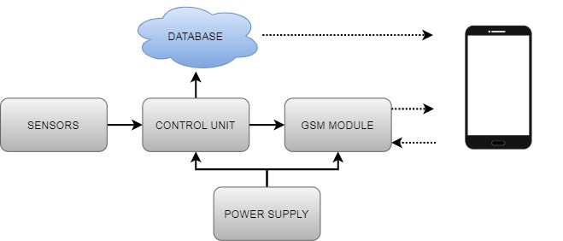

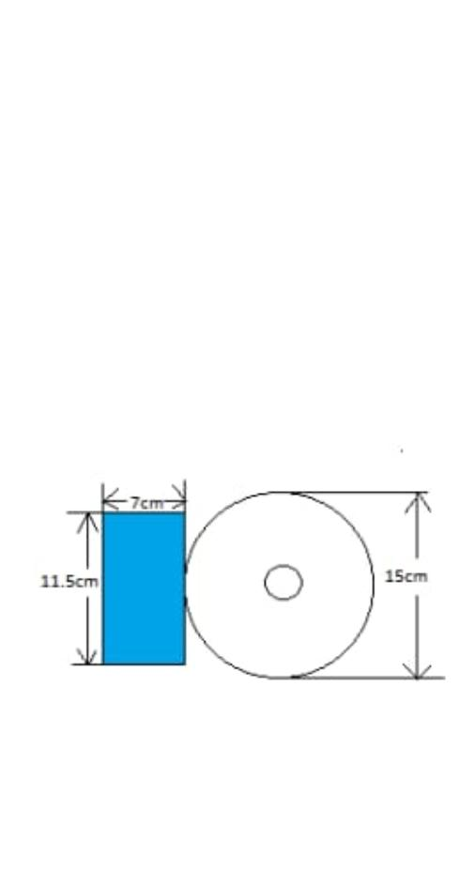**FRONT VIEWTOP VIEW**

Figure 2

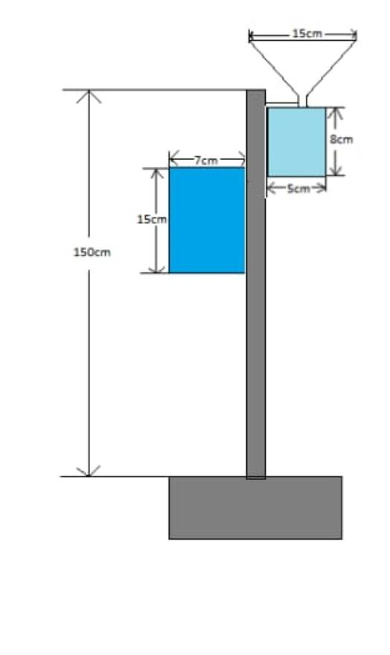

**COMPONENTS**

1. ESP8266/ WROOM 8266

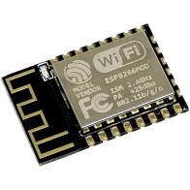

* 1. Programmable Wi-Fi module.
  2. USB-TTL included, plug & play.
  3. 10 GPIOs D0-D10, PWM functionality, IIC and SPI communication, 1-Wire and ADC A0 etc. All in one board.
  4. Wi-Fi networking (can be used as access point and/or station, host a web server), connect to internet to fetch or upload data.
  5. Event-driven API for network applications.
  6. PCB antenna.

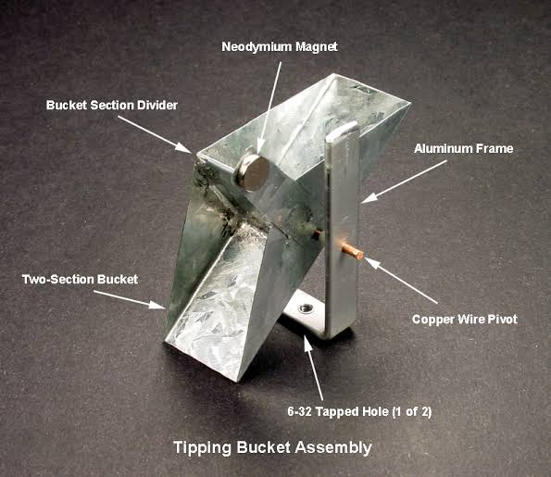2. Tipping Bucket

Figure 1

1. Tipps when 12 drops of water pass through it

1. High sensitivity
2. Uses electrical contact excitation

3 . BMP 180

1. 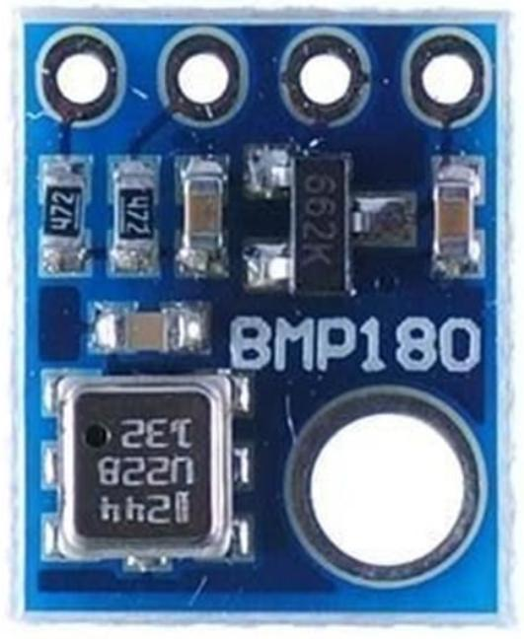 Operating  voltage : 1.3V – 3.6V
2. Input voltage : 3.3V to 5.5V
3. Peak current : 1000uA
4. Consumes 0.1uA standby
5. Maximum voltage at SDA , SCL : VCC + 0.3V
6. Operating temperature: -40ºC to +80ºC
7. Pressure range:300 to 1100hPa
8. High relative accuracy of ±0.12hPa
9. Pressure conversion time: 5ms

**GOOGLE FIREBASE**

Google Firebase is a Google-backed application development software that enables developers to develop iOS, Android and web apps.  Firebase provides tools for tracking analytics, reporting and fixing app crashes, creating marketing and product experiment.Real-time database is where the data is stored. The Firebase Real-time Database is a cloud-hosted NoSQL database that enables data to be stored and synced between users in real time. The data is synced across all clients in real time and is still available when an app goes offline.

**APPLICATION**

The user can see the current temperature, pressure, humidity, rainfall data

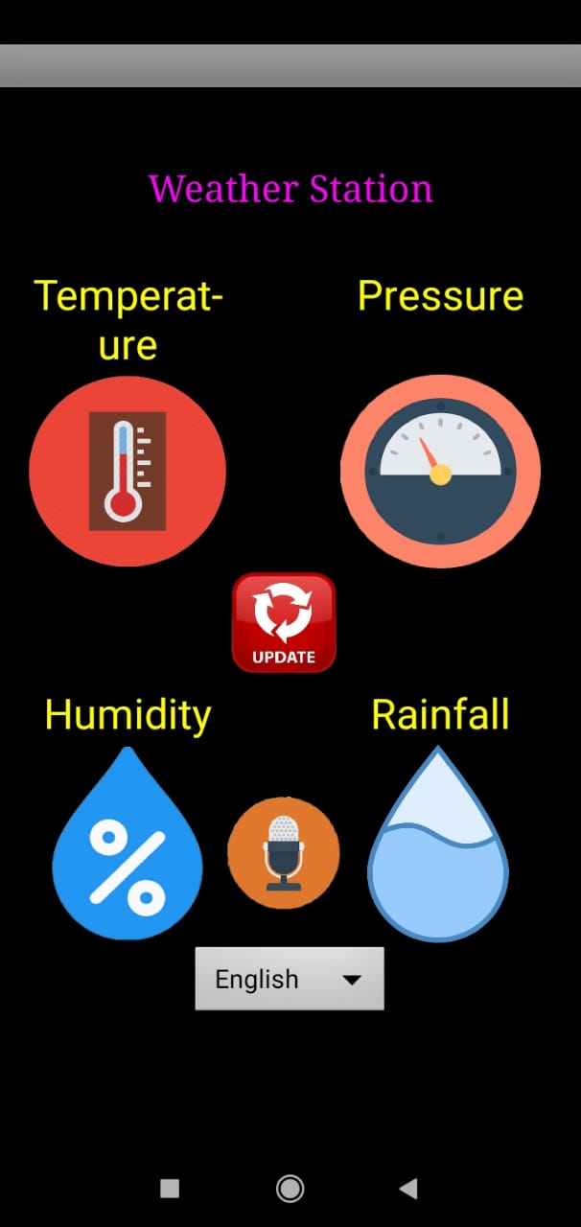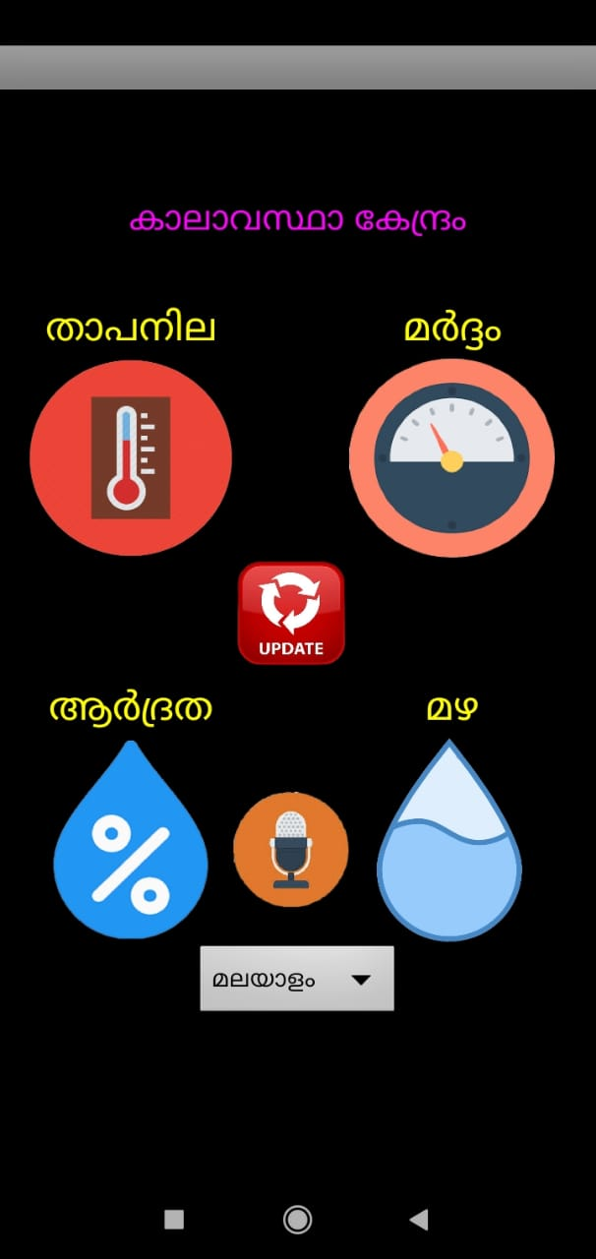

# CONCLUSION

Our objective of the project is to make an efficient weather station. No matter how much researches we have done to assist the implementation of whole project, many obstacles still appears during the progress made.

**SUGGESTIONS FOR FUTURE WORK**

We can include more sensors and reduce the size if the product. We may can use more compact sensors and use water proof materials. We can also use low weight material.

**REFERENCE**

<http://www.iwmi.cgiar.org/resources/mobile-weather-stations/>

<https://www.allaboutcircuits.com/projects/build-a-wireless-tipping-bucket-rain-gauge-part-1assembling-the-base/>

<https://www.instructables.com/id/Interfacing-BMP-180-Barometric-Pressure-Sensor-and/>

<https://www.instructables.com/id/How-to-interface-Humidity-and-Temperature-DTH11-Se/>

<https://components101.com/dht11-temperature-sensor>

<https://components101.com/sensors/bmp180-atmospheric-pressure-sensor>

<https://lastminuteengineers.com/esp8266-nodemcu-arduino-tutorial/>

<https://firebase.google.com/>

**WORKING VIDEO**

**https://drive.google.com/file/d/1WU2QF1LjfvB0rmKmmoqs2IfeJEQI0lNr/view?usp=drivesdk**