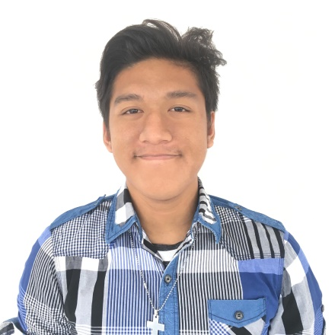 ERCHIL B. AMAD

Villa Apura Visayan Village Tagum City, Davao Del Norte

+639303772046

Arbiterchil@gmail.com

**OBJECTIVE:**

To join an organization where I can apply my knowledge and skills in personnel and attain an elevated level of performance.

**PERSONAL INFORMATION**

**Age:** 20

**Date of Birth:** December 21, 1998

**Gender:**  Male

**Civil Status:** Single

**Nationality:** Filipino

**Religion:** Roman Catholic

**CERTIFICATES, SEMINAR AND TRAINING EXPERIENCES**

* Computer Hardware Servicing NCII
* Server and Network Fundamentals Seminar

**QUALIFICATIONS**

* Willing to gain more knowledge
* Dedicated and Hardworking Individual

**SKILLS**

* Javascript
* Java
* Android Studio
* CSS3
* Firebase
* HTML5
* SQL Server

**EDUCATIONAL BACKGROUND**

**Tertiary: UNIVERSITY OF MINDANAO TAGUM COLLEGE**

**Bachelor of Science in Information Technology**

Bolton Street, Davao City

2015 – 2019

**Secondary: LETRAN DE DAVAO INC. HIGHSCHOOL**

Jollibee Drive Thru,Sobrecarey Street.

2011 – 2015

**Elementary: MAGUGPO PILOT IMELDA ELEMENTARY SCHOOL**

Sobrecarey Street.

2005 - 2011

I hereby certify that the above statements are true and correct to the best of my knowledge and belief.

**ERCHIL B. AMAD**

Applicant