CST8285: Web Programming
Student name: Arbutha Durairaj
Student No:041156799
Section :321
Assignment:1

Validating index.html File
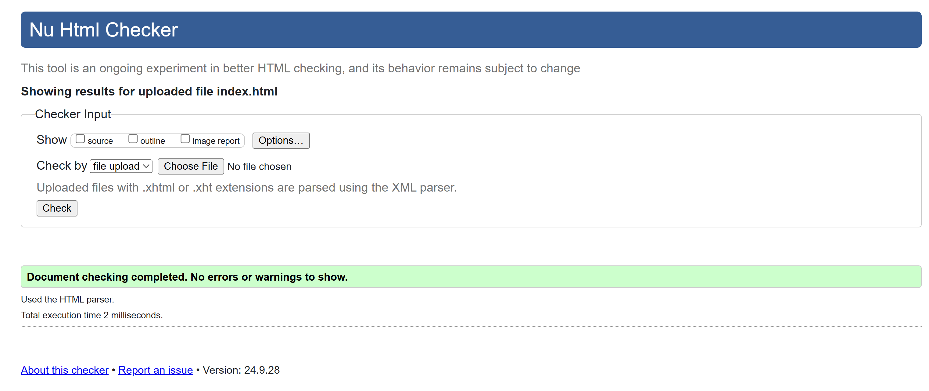

Validating contact.html File
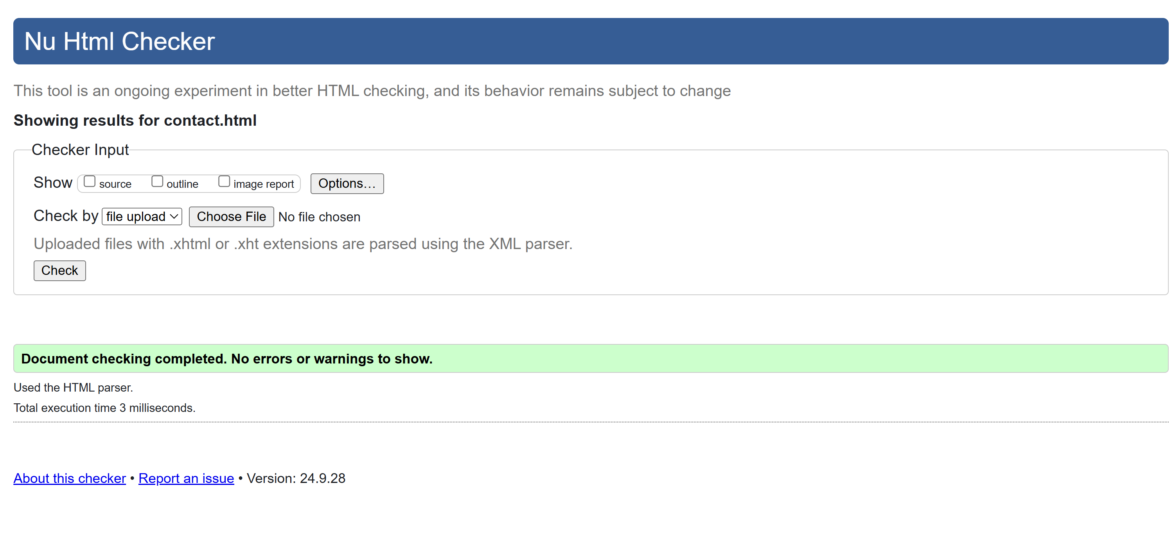
Validating projects.html File
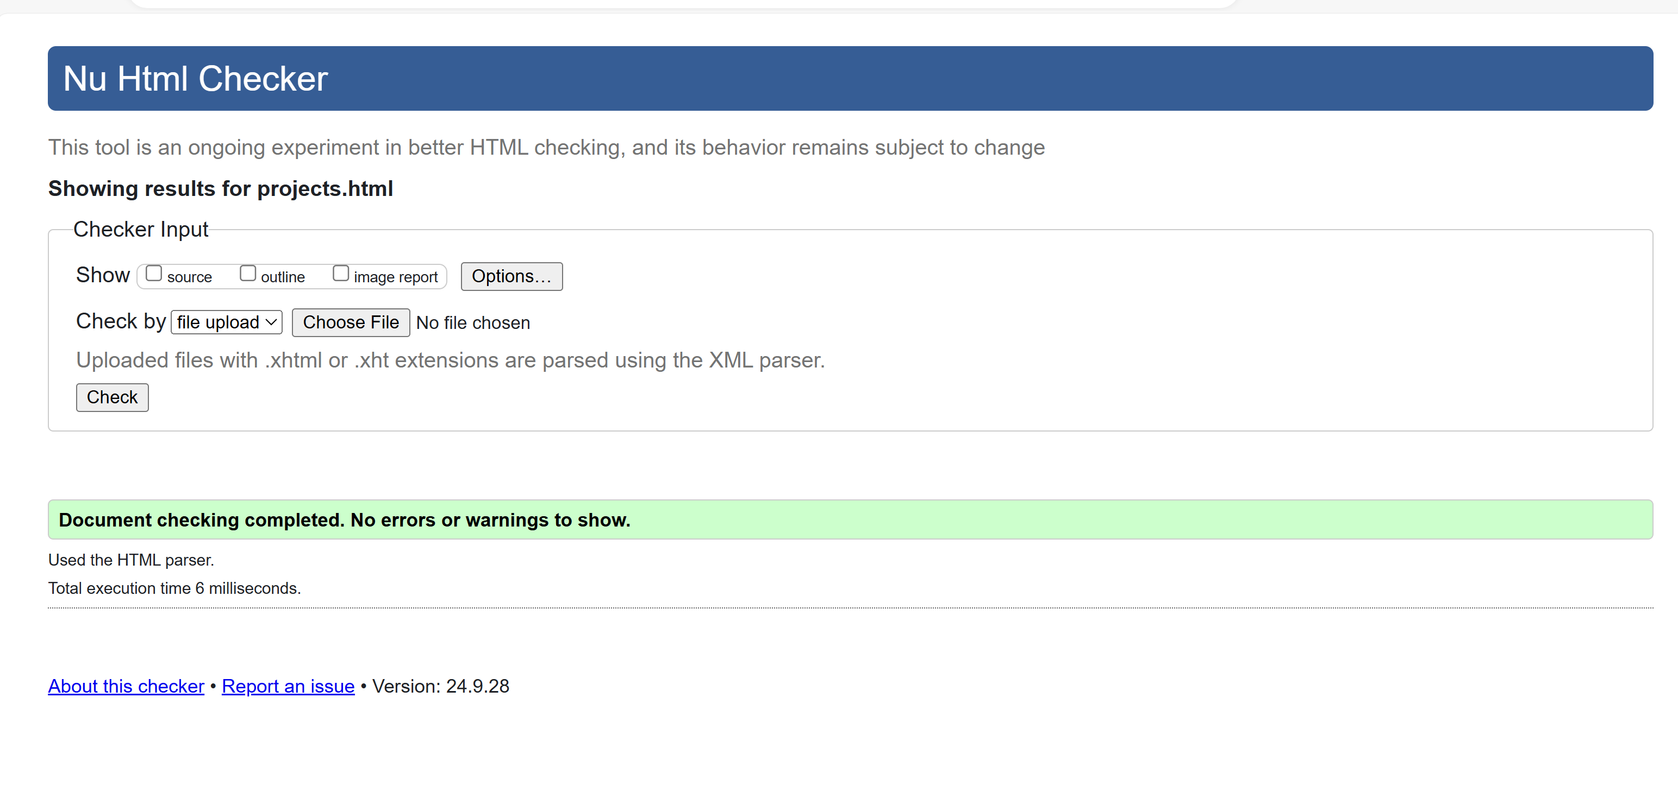

Validating resume.html File
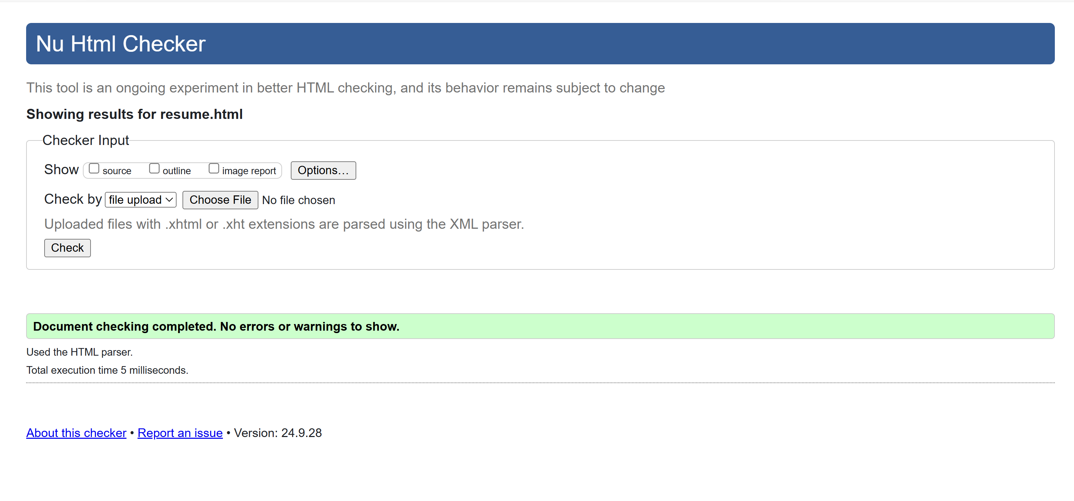

Validating index.css File
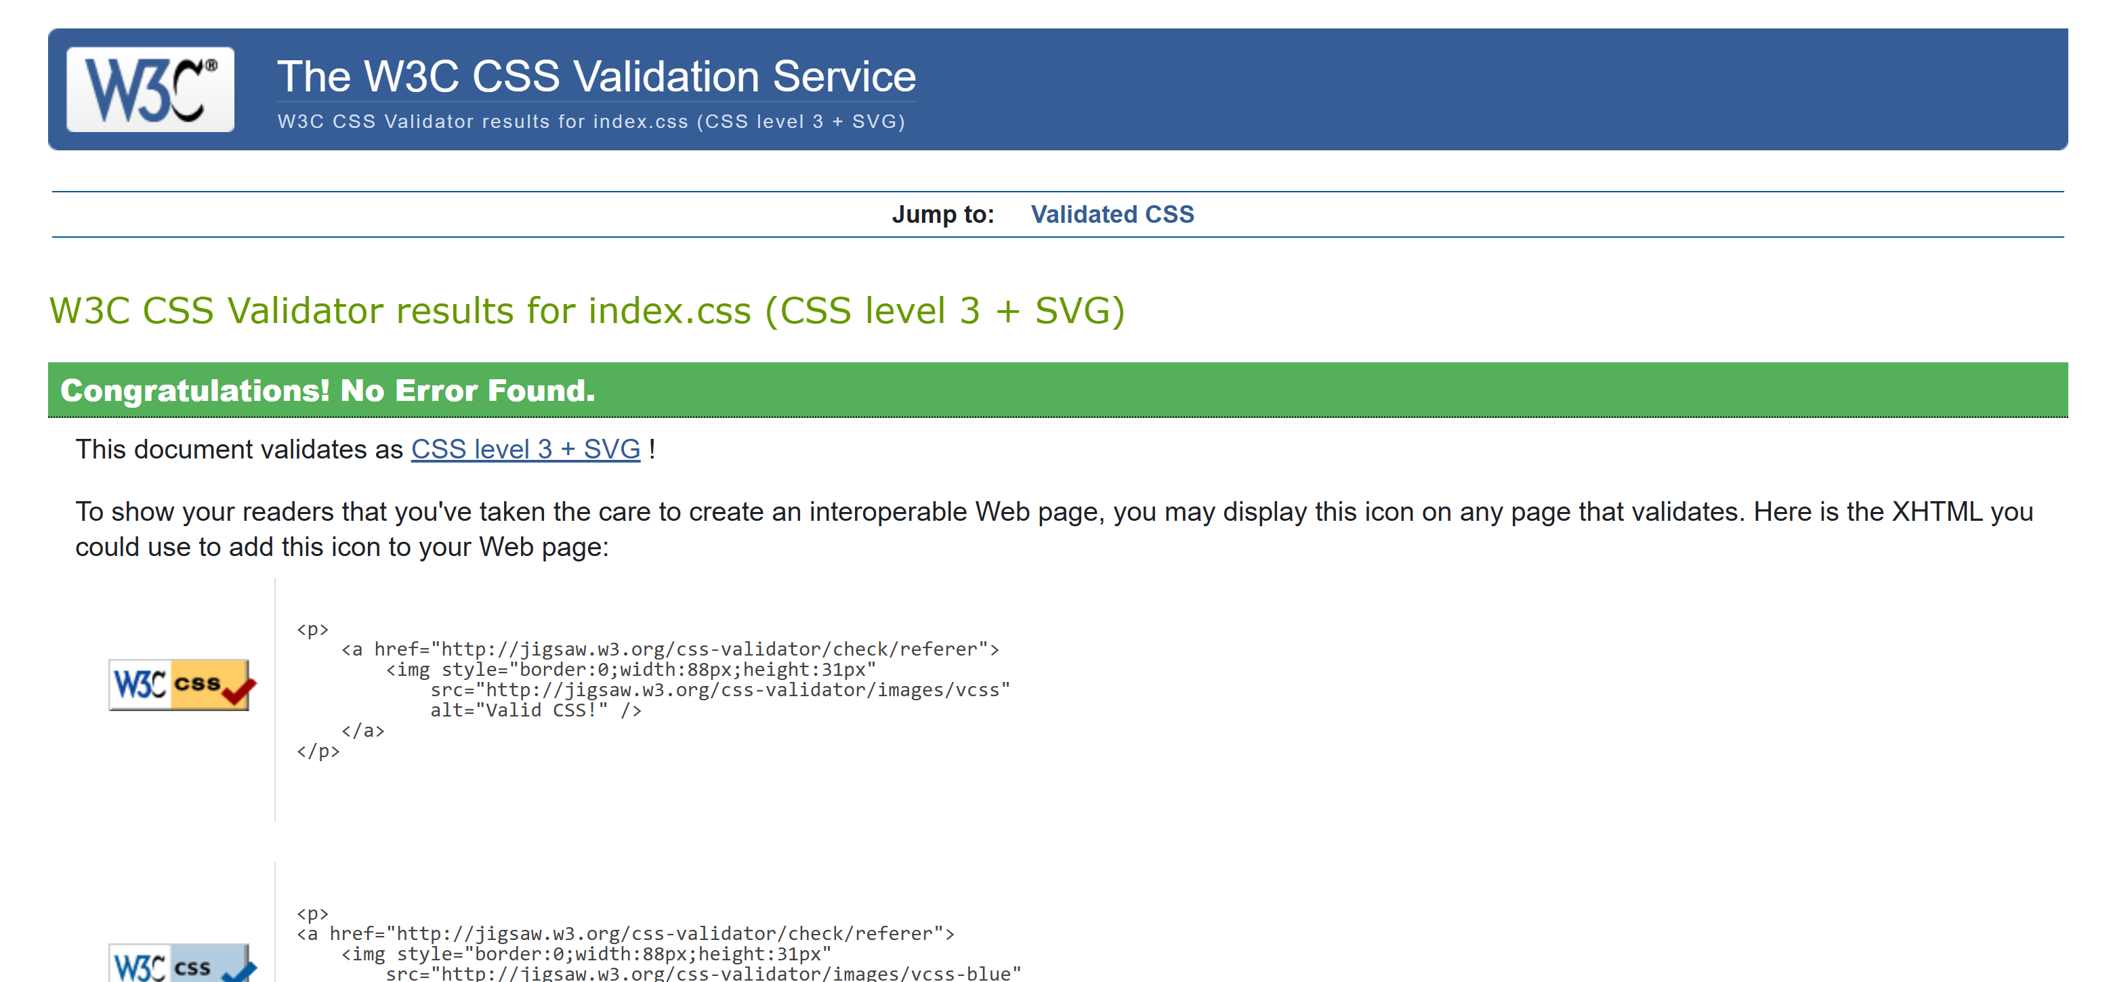

Validating form.css File
