

***Software Engineering Project Report***

**Project Title:** **e-ATM**

**Submitted to: Mohammad Zavid Parvez**

**Date of Submission: 30/03/2020**

**Course: CSE470**

**Section: 05**

**Semester: Spring 2020**

**Group Number:05**

**Group Name: Arctic-Wolves**

**Group Members:**

|  |  |
| --- | --- |
| **Student ID** | **Student Name** |
| 18101617 | Aninda Sadman |
| 17101250 | Syed Nafis Fuad |

***Introduction***

Our selected topic is e-ATM which is a website for people to perform transactions online. As such people need not go to nearby ATM booths for depositing or withdrawing money anytime whenever they wish. This will eliminate the occurrences of any sort of spread of germs. Recently there is the danger imposed by the virus Coronavirus which spreads through physical interactions. This way the people can stay safe and do their bank transactions properly at the click of a button through our website. Also there is the flexibility of checking one’s account at any time and the people can smoothly do their bank related activities properly from home with care. Normally there is a rush or line at ATM booths. In this way we can tackle death-threatening diseases like Coronavirus and also perform transactions of bank carefully. And it is also suited for any bank of our country since they will sync combinedly online and thus the people will be benefited the most from this project.

***Motivation***

We choose this topic because we were shaken by the Coronavirus crisis of the whole world and wished to do something in this regard for our country. Recently all the banks even the ATM booths have been closed for the sake of reducing human interactions to stop the spread of Coronavirus. Nowadays everything is available online and we can order anything staying from home. But the only thing missing is the banking facility in our country. So we wished to introduce it to the mass public ultimately helping humanity. And websites are easily accessible nowadays with the vast access of internet across Bangladesh. So people can log in and check their account info details with the help of our website. Thus we will have reached every nook and corner of the country to spread our helping hands to the mass people. That is the least we are able to do during this risky situation and also in the process we are reducing the number of ways the disease can spread for ATM booth usage.

***Methodology***

For our project, we have followed the V-model in processing and in communication we used the Agile method of Scrum development. So we get hold of the requirements and specification at first with no scope of further change. Then we implement testing for each phase of development and progress systematically finishing every step one after another. So the final draft of the software took more time than usual but in every single phase we moved only after it was validated after evaluation. For decision-making on different steps, we used to hold meetings every week with sample stakeholders, end-users, testers and developers. Our website will be live after completion fully with constant requirements fulfilled. However, the development team worked remotely and communicating through online platforms every now and then in the case of facing any sort of bug which was bound to happen. When a part of a website is made/changed there will be Integration Testing which will bring out the flaws and feedback and thus the pull request is not accepted firsthand. Every phase of the development had to go though thorough verification and so comparatively the website was slow to build.

***System Description***

**Brief Description**

We implemented our website with the help of MySQL as database, Javascript frameworks as backend, AWS for cloud storage and as frontend we used HTML, CSS, Embedded JS. For Communication we used project management tools and for productive handling of project we used Slack and Trello. The idea is pretty simple but the impact it will put on the undergoing crisis of the country is tremendous. For showcasing our works, we used Use-Case diagram and UML Class diagram which is shown below.

**Use-Case Diagram**

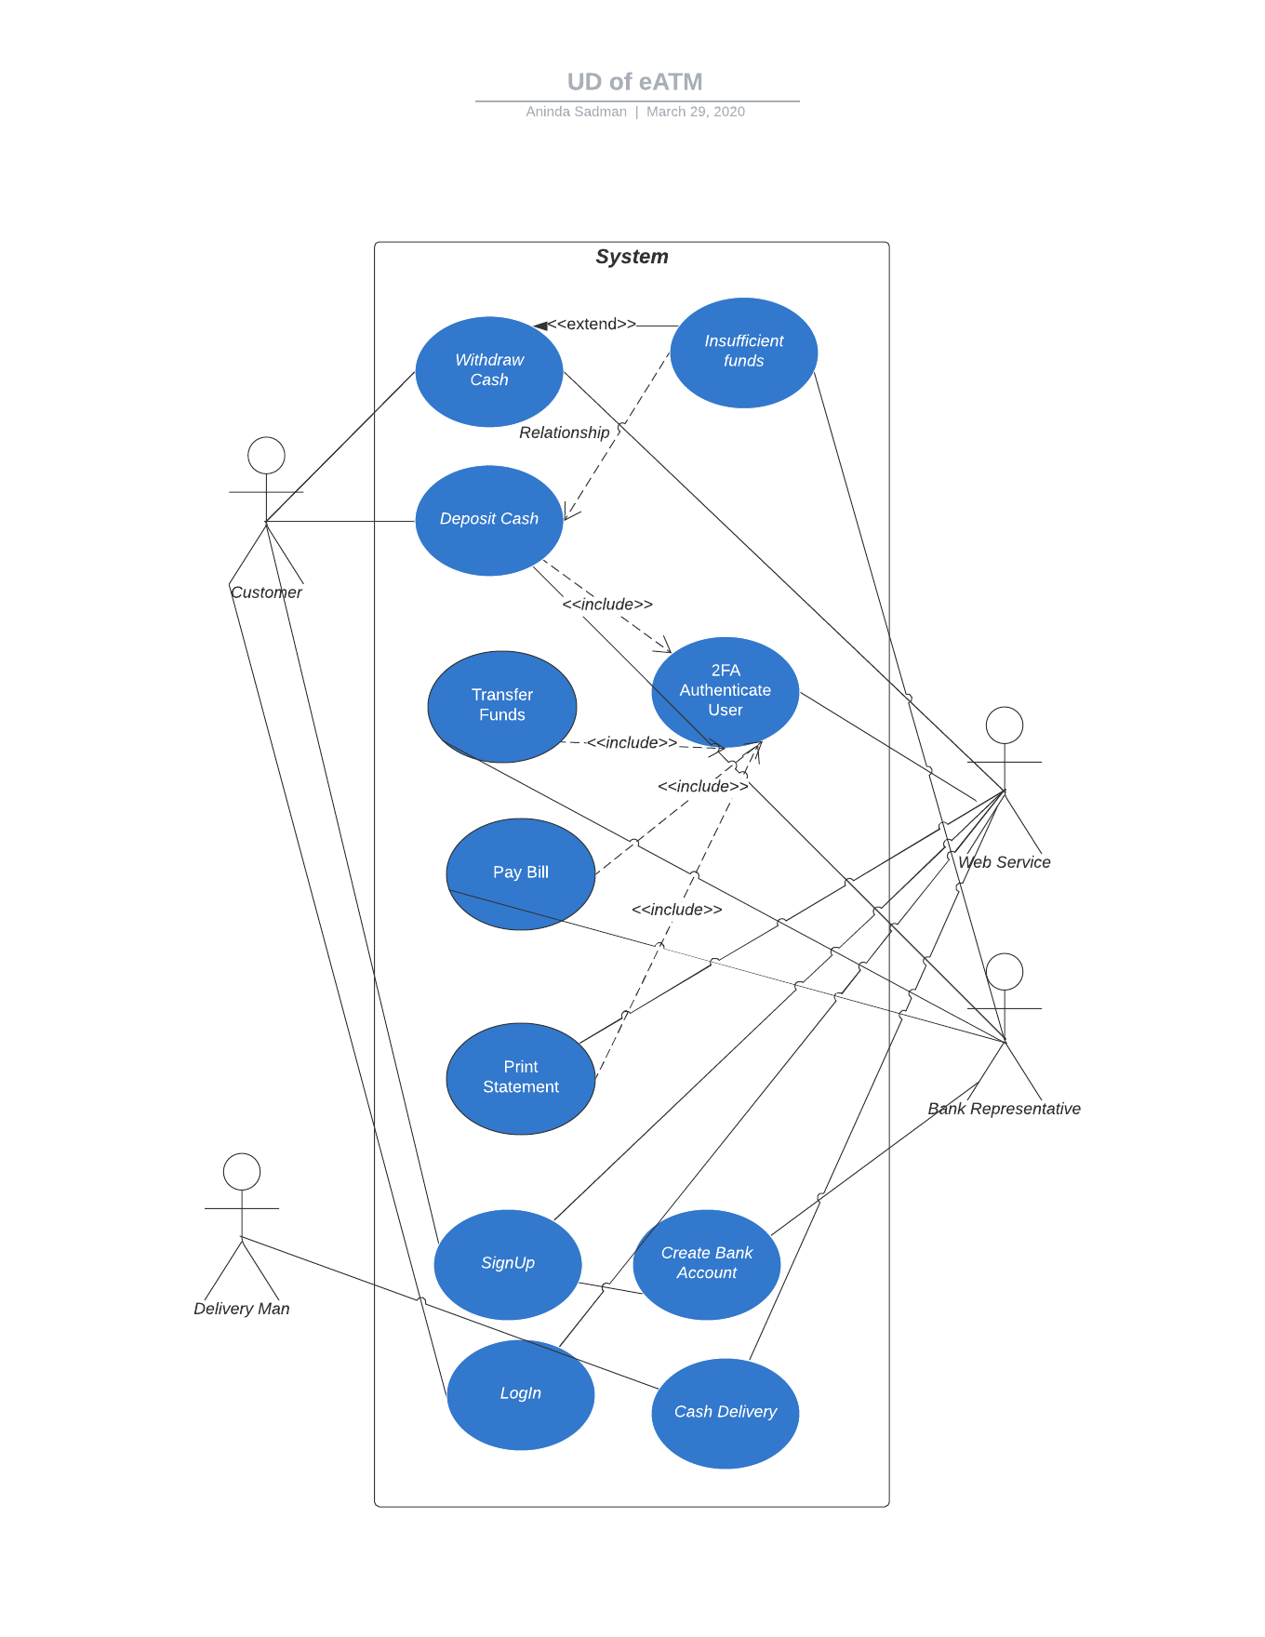

**UML Class Diagram**

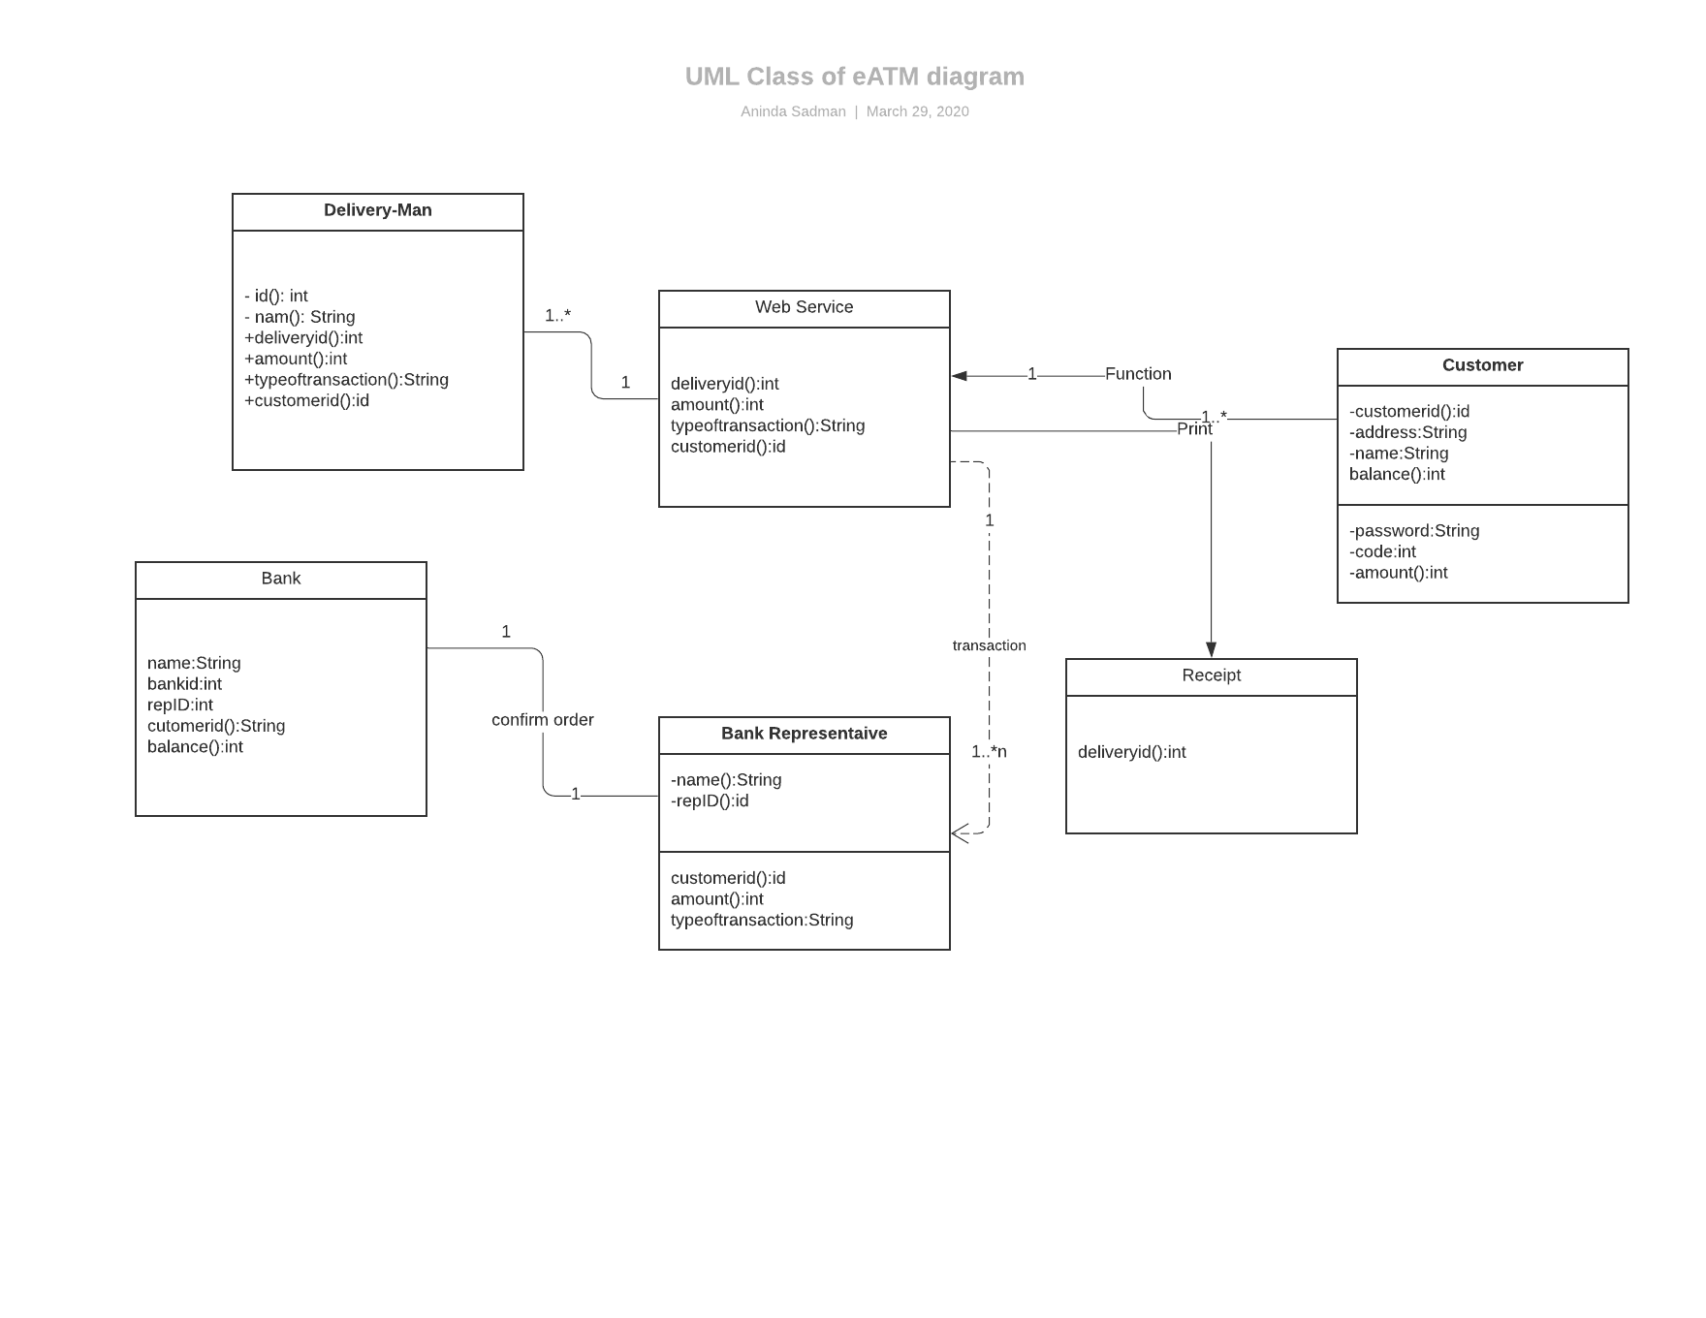

***Software Cost Estimation***

**Function Point**

For our project, the function points are shown below:

|  |  |
| --- | --- |
| Number of inputs | 15 |
| Number of outputs | 36 |
| Number of queries | 30 |
| Number of files | 16 |
| Number of interfaces | 4 |
|  |  |

Finding Raw FP from the data table above:

|  |  |  |  |  |  |
| --- | --- | --- | --- | --- | --- |
| Functional Units | Total Number | Low | Average | High | Total |
| Inputs | 15 | 6*3 | 5*4 | 4*6 | 62 |

|  |  |  |  |  |  |
| --- | --- | --- | --- | --- | --- |
| Outputs | 36 | 15*4 | 15*4 | 6*4 | 144 |
| Queries | 30 | 12*3 | 9*4 | 9*6 | 126 |
| Files | 16 | 7*7 | 6*10 | 3*15 | 154 |
| Interfaces | 4 | 1*5 | 2*7 | 1*10 | 29 |

Count Total: 515

Here,

RawFP=515 and CAV = 1

Now,

*F P* = *RawF P ×* (0*.*65 + 0*.*01 *× CAV* )

*=* 515 *×* (0*.*65 + 0*.*01 *×* 1)

= 339.9

So Function Point of our Project is 339.9

**COCOMO model**

From the Basic COCOMO Method, we know that,

|  |  |  |  |  |
| --- | --- | --- | --- | --- |
| Software Project | *ab* | *bb* | *cb*c | *db* |
| Organic | 2.4 | 1.05 | 2.5 | 0.38 |

|  |  |  |  |  |
| --- | --- | --- | --- | --- |
| Semi-detached | 3.0 | 1.12 | 2.5 | 0.35 |
| Embedded | 3.6 | 1.20 | 2.5 | 0.32 |

We have used some HTML,CSS,EJS for front end, Javascript in the back-end and SQL in database so the total lines of codes is:

JS=33*30=990

HTML/CSS=32*39=1248

SQL=29*18.5=537

Total=990+1248+537=2775

So the **KLOC** is 2775/1000 = 2.78.

Effort Estimation

*E* = *ab ×* (*KLOCbb* ) *Person – months*

*=2.4*2.78^1.05*

*=7.02 Person-months*

Duration Estimation

*D* = *cb ×* (*Edb* ) *Months*

=2.5*7.02^0.38

=5.24 months

Person Estimation

*P* = *E ÷ D Persons*

= 7.02/5.24

=1.34 persons

=2 persons

***Project Scheduling***

**CPM**

|  |  |  |  |
| --- | --- | --- | --- |
| Task | Duration (Days) | Staff Required | Precedence |
| Planning(A) | 10 | 2 |  |
| Database Handle(B) | 3 | 2 | Planning |
| Frontend  Design(C) | 5 | 2 | Planning |
| Backend  Coding(D) | 7 | 2 | Frontend+database |
| Testing(E) | 2 | 2 | backend |
| Documentation  (F) | 1 | 2 | testing |

Now lets create CPM diagram.

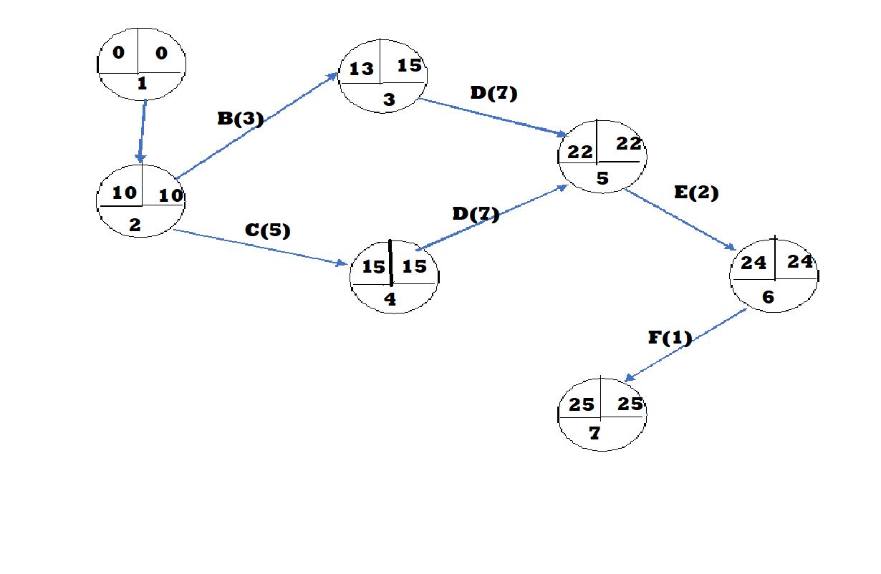

|  |  |  |  |  |  |  |  |
| --- | --- | --- | --- | --- | --- | --- | --- |
| Task | Duration | ES | EF | LS | LF | Slack Time | Critical |
| Planning | 10 | 0 | 10 | 0 | 10 | 0 | Y |

|  |  |  |  |  |  |  |  |
| --- | --- | --- | --- | --- | --- | --- | --- |
| Database handle | 3 | 10 | 13 | 12 | 15 | 2 | N |
| Front-end Design | 5 | 10 | 15 | 10 | 15 | 0 | Y |
| Backend  Coding | 7 | 15 | 22 | 15 | 22 | 0 | Y |
| Testing | 2 | 22 | 24 | 22 | 24 | 0 | Y |
| Documentation | 1 | 24 | 25 | 24 | 25 | 0 | Y |

We can notice that every task except database handling is Critical. Total time taken is 25 days with 2 group members.

**Gantt Chart**

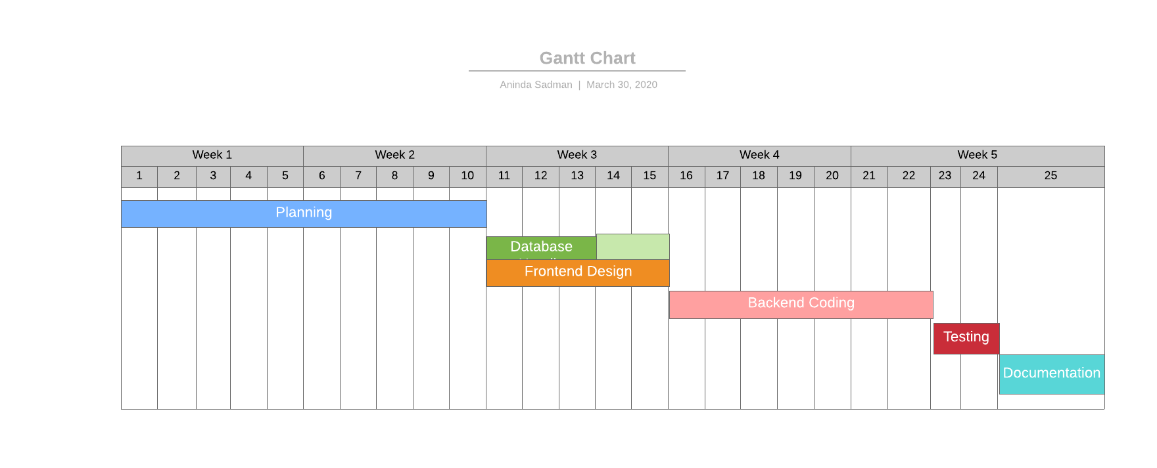

**Stuff Utilization**

Stuff utilization= (2*10+3*2+5*2+7*2+2*2+2*1)/((10+5+7+2+1)*2)

=50/56

=0.89/89.3%

**References:** None used