Tangible-Holographic Sketch

{placeholders} @ {placeholders}

# Abstract

Augmented reality and Virtual reality techniques are long term to exploit the idea of Tangible-holographic, which are digital contents that can provide tangible feedback to users. In this paper, we present a novel 3D modeling interface base on AR and fabrication techniques, to explore some new-raised ideas and problem in the design space of *Tangible*-holographic interface.

***Note***: I think the most focus of discussion is on the section of *[*Secondary proxy*], [*Physical proxy update*], and [*Relationship between tangibles*] ( you can click the cross-link. The intro is not well-written yet.*

# Introduction

Traditional 3D model design process contains steps of creating or importing digital model, create physical-prototype, redesign the digital-model.

As the aspect of digital model creation, they are usually finished by modeler using keyboard and mouse, with 2D monitors. But the dimensional gap between the 3D model and 2D input and output device limited the productivity of the modeler. An inherit 3D working space is much friendly in the term of user interaction.

An proper physical proxy will help the modeler to understand their working load better, and helps them to improve. Even more, a large group of 3D modeler insist to working with traditional form of clay to model, and using 3D scanner to finish their digital design. But the physical sculpting ability needs professional training, and are extremely bad at global changes such as copy-paste, change in the scale of the model.

Another trend recently is just the inverse direction, where people using quick fabrication techniques like 3D printing to create the physical prototype in fast and easy manner. The built physical prototype helps them to understand the potential physical flaws in the design, and also allows them to observe the 3D model by using their hands: the best 3D input device.

Furthermore, the modeler starts to repeat this process and doing their design iteratively.

Recently, many people use 3D printing for the prototype since it is a faster and cheaper approach to create real world object from given 3D model. In this process, most of the prototype will be treated as waste. The longer the design process and the more changes required, the more waste will be produced.

Our goal is to change the process of iterative design by introducing ours system that allows the user to see the digital changes they made for model directly in their physical prototype, and, using their physical prototype as the proxy to help their digital design. And we use the fast 3D printing technique to re-fabricate the physical prototype when the changes have made the physical prototype outdated and or proper to use as the proxy. We believe that our system can significantly reduce the amount of waste prototypes and achieve more accurate quicker design process for 3D model creation and editing task.

Our system allows the user to see the changes of an object dynamically through the display

# Related Work

3D printing and fabrication technology are rapidly gaining ground in the modern world. Encore: 3D printed augmentation of everyday objects with printed-over, affixed and interlocked attachments [11] explores 3D-printing attachments to existing objects rather than 3D-printing entire objects from scratch. Attachment techniques are discussed, but it doesn't touch upon modelling interfaces for such attachments, which is our focus in this paper.

Since a physical object is part of the design process by the definition of the problem, it seems fitting to make use of augmented reality. Augmented reality sketching interfaces have been explored in the literature. Second Surface [7] is an augmented reality system where users can draw on top of their physical surroundings, using a tablet with a touchscreen as a physical proxy— the drawn objects can be placed in 3D space, but seeing as the physical proxy is flat, they are typically not 3D objects themselves.

Hybrid Virtual Environment 3D (Hyve-3D) [8] is another augmented reality sketching interface using a tablet, where the 2D drawing planes either follow the tablet in 6DOF, or follow the position but ignore the rotation (allowing work in parallel planes).

More tangible interfaces for modelling have been explored; in Sculpting By Numbers [10], the goal is to use augmented reality to guide the sculpting of physical objects— a 3D model of the object can be projected onto the sculpting material, with various forms of guidance that indicate how it must be deformed to match the 3D model.

On-air gesture-based approaches have also been explored. Cavepainting [13] is an immersive medium that uses the 3D equivalent of 2D brush strokes to create artistic 3D sketches, and Drawing on Air [12] is an input technique for drawing 3D curves in 3D space. However, the problem of achieving sufficient control while drawing on thin air remains challenging, and we attempt to mitigate that by introducing a physical proxy that acts as a reference point rather than a drawing surface.

# System design

In current design processes there are constraints in the 3D space. By using modeling software, the models that the user is working on is displayed through the computer screen. To operate on the model, the user has to rotate the scene to look at the model from different angles. While some designers want to have a tangible model to operate one, they will chose other materials to simulate the real model. Most models nowadays are created by clay. But in this approach the user is not able receive a updated tangible model in real-time.

The problem with this design processes is that there is no REAL-TIME tangible feedback. We introduce 3D printing into the design process so after each iteration of design, the user can print the model with a 3D printer and use it as the new model. With this approach the user can use the 3D printed object as the new tangible model for further design.

In order for the user to know how their model will look like before the 3D print happens, we use holographic display to show the user the updated model in real-time. After the user operate on the model itself, the new parts which include the extension of the existed object will be displayed. Also through the display of the VR headset we can achieve stronger depth cue display.

## Digital content overlay

The digital contents are overlay with the physical proxy using an AR headset in user’s perspective, the content is depth aligned with stereoscopic cue.

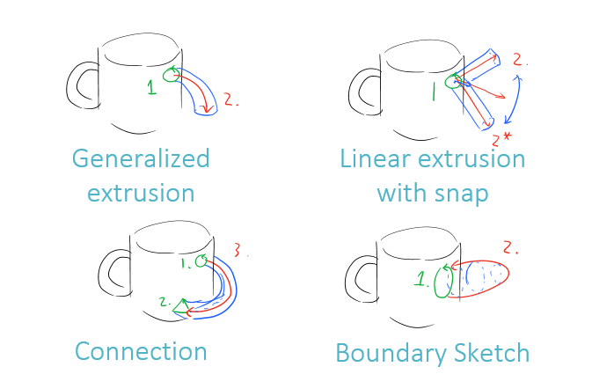

In the figure, we use black stroke to visualize physical object. And overlays the digital contents (colored strokes) among the physical model.

## Surface sketching

The user is able to draw spatial curves directly on the physical proxy’s surface, just like any other 2D sketching based approach (green strokes in the figure). And, they can *only* draw the curves on a physical surface by *default*. This operation is triggered by physical pressure sensor mounted on the stylus tip. This restriction ensures that the curve they illustrated are high-quality curves instead of the typical result you get from un-constrained on-air drawing inputs, e.g. [ref]. The artist will always receive tangible feedback will working with this type of spatial sketch, maximizing their skills trained in 2D case.

## Re-sketching

We also allow the artist to re-sketch the surface curves they already drawn, the connected 3D volumes will also be update in real-time. This behavior gives them the flexibility to modify the details shape of the model after their first touch, and enables them to illustrate the global structure of their design at the early stage, instead of diving into details.

## Stylus on-air dragging

To take advantage of the 3D input space, we also allow the user the draw free-form spatial curve in mid-air. This type of drawing are lack of tangible feedback and reference frame, will usually result in inaccurate form, but it is useful to illustrate the ideas and structures.

## Modeling operations

Instead drawing the boundary, which are typically ambiguous to restrict the 3D model, we design our system to build totally solid 3D volumes instead of curve networks. Like the atomic operations showed in the figure, these operations are commonly used in existed modeling software, we hope our user to adopt this paradigm in a quick training session,

## Digital sculpting

Instead of constructive model strategy, the digital sculpting tools are also popular among artist, especially for creating high-detailed realistic looking objects (e.g. human face). The digital sculpting techniques should also have benefited from the direct physical proxy.

## Secondary proxy

Our system encourages user to use a secondary physical proxy as a *working surface*, which serves as an *ruler* to helps the user draws curves aligned or certain constraints. The tangible feedback and stylus fraction also helps the user to get more accurate result.

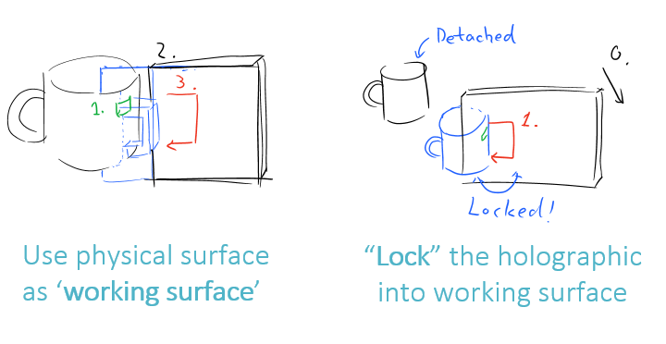

One issue for use the secondary proxy is how to maintain the relationship the two proxy, our system allows two state for user to operate : lock and unlock.

By default, any secondary physical proxies are *UNLOCKED* from the digital content user is working on. When the user tries to use it as a working space and helps they to draw, they aligns the object with the primary physical object, and an VOICE COMMAND are used to trigger the LOCK state, as the user should be busy with both of their hands. The LOCK state locks the digital content to the secondary physical proxy, instead of the primary one. This helps the user to free the hand which are previously holding the primary proxy. The secondary physical proxy are essentially an TANGIBLE WORKING SPACE. After the user’s editing with the secondary proxy, the users can SHAKE the model or use the VOICE to unlock the digital model, which automatically returns to the primary proxy.

## Physical proxy update

The physical proxy will becomes more and more in-accurate along with the user’s editing, the user can request and PROXY-UPDATE by VOICE, which sends the digital model to 3D-printer, and re-fabricate the model in minutes (in hours for now). The updated model will serves are an more accurate proxy for the user to working on.

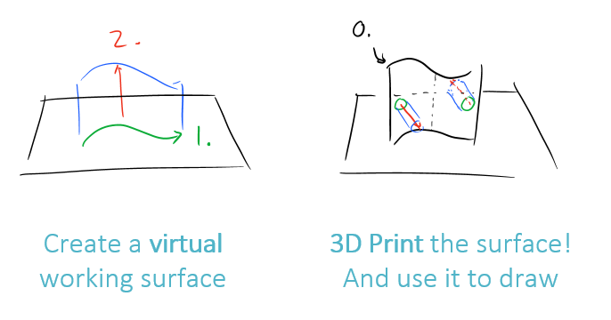

One thing to note is this update process should follows the user’s intention instead of always happens automatically, as the update of physical proxy brings the accurate representation, but it also brings CONSTRAINT to operation on certain space in the real world. Like the space between cups handle are hard to operate after the handle are made physical, but the user does have more freedom to work on that area before the physical update. But the system could detect the mismatch and made SUGGESTION for user about when to update their proxy.

## Relationship between tangibles

As showed in the Secondary proxy and proxy update session, the tangible object does helps, but it also brings physical constraint to each other. Like the case when we wish to operate on the cross-section plane of the mug, which modifies its radius (of the cylinder shape), the user uses an physical plane as the working space, the physical proxy cannot actually cut into the mug. Our system will also needs to “VIRTIALIZE” the physical proxies on certain tasks, to help resolves this issue.

# Algorithm

## Model representation

Constructive solid geometry with Triangle meshes. Bounding volume hierarchy for accelerated spatial search.

## Surface Sketching

Project to UV space, and apply all the editing with the xyz-uv pairs. And all common 2D geometry operations.

## Re-sketching

Not implemented yet.

## Path extrusion

Transform the base patch with rigid transform on the extrusion path.

## Hull extrusion

Not implemented yet.

## Proxy mismatch detection

Not implemented yet.

# Implementation

## Apertures

## Hardware setup

Our initial idea requires a virtual reality headset that have the ability to display and track objects on its own, and a Bluetooth pen that have buttons on it to perform different operations. Due to financial limitations, we set up our tracking device to by using a combination of three different hardware parts: the motion detection Kinect to keep track of the objects to display; the VICON system to keep track of every object in the working environment; the virtual reality headset to display the view of the scene and the dynamic changes that occurs for the user. The pen was simulated by using a pen object and a Bluetooth wearable click device (???) to perform clicks that represent different operations.

|  |  |
| --- | --- |
| Idea apertures | Testing platform |

## 3.1. Virtual reality headset

The virtual reality (VR) headset is used to display the rendering of the scene and the objects for the users. During the setup process, we need to make sure the direction the user’s glaze direction is aligned with the direction tracked through VICON. The display on the VR headset uses two different screens to achieve perspective display.

## 3.2. spatial tracked stylus, with attached buttons

The Bluetooth wearable click device is used to simulate a button that would enable the pen to change mode. In our implementation there is two different operations: draw and extrusion.

3.3. motion capture system

The VICON system is a motion capture system that allows us to keep track of all the objects in the working environment. In our experiment we place markers on all the objects we use: the object to operate on, the pen use to draw extrusion and the VR headset that is combined with the Kinect. The VICON system will keep track of the objects and the pen, which will return the position data of all the markers and the position of center of the object in (????) form.

## Software interface

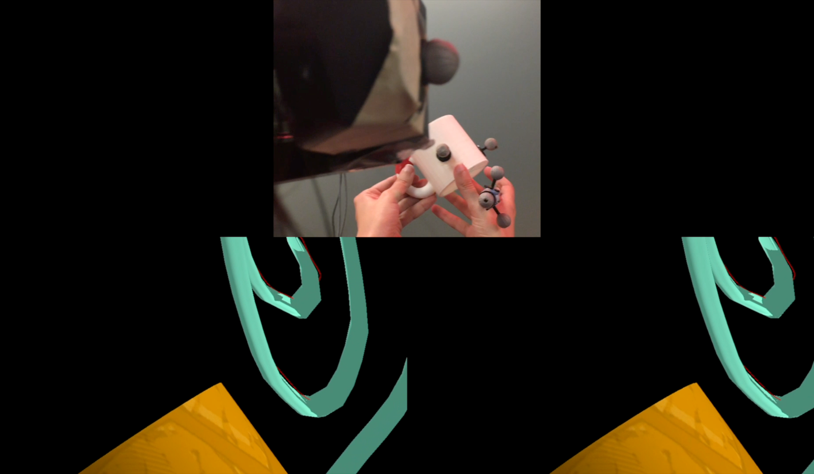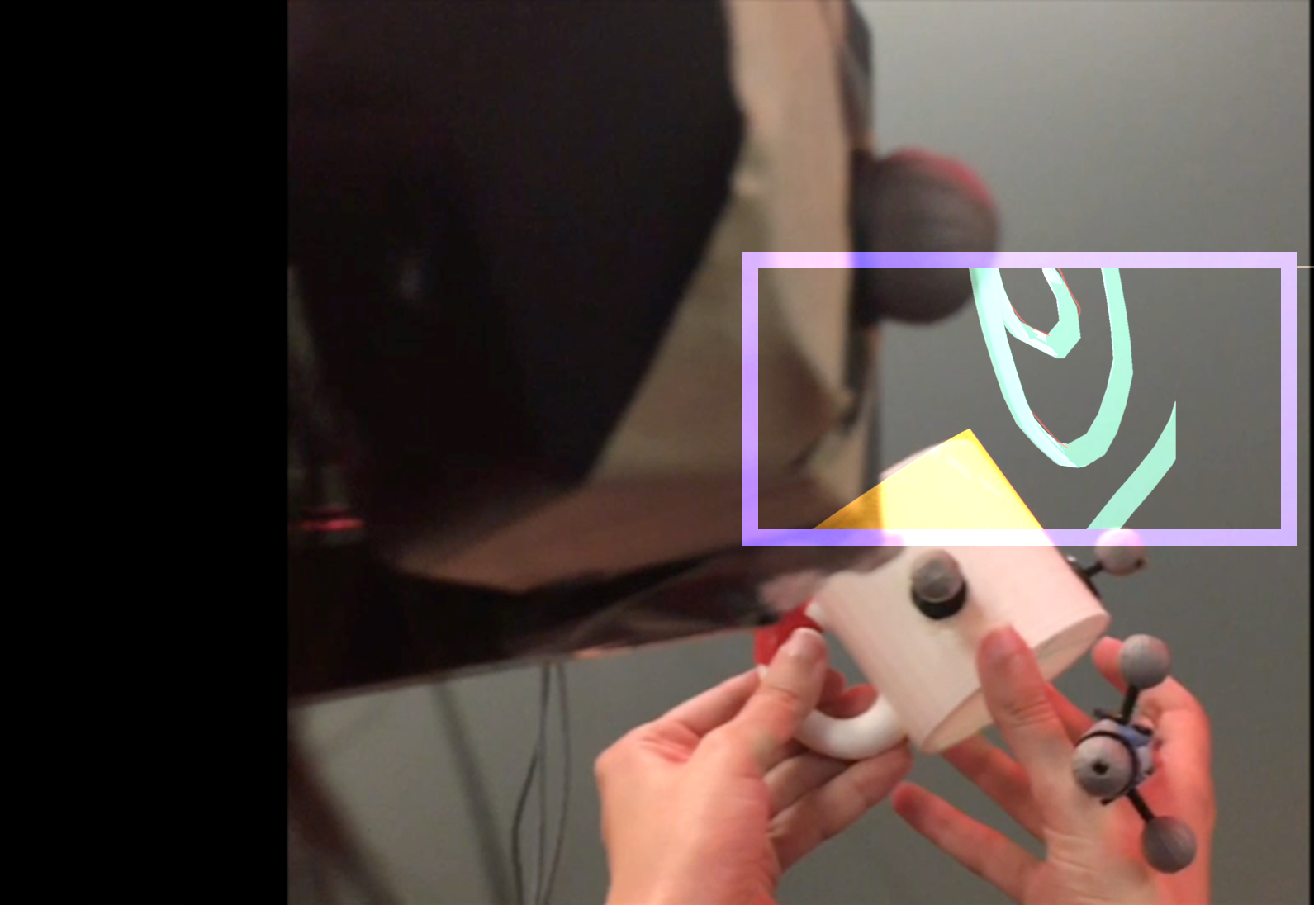

Figure. Over-shoulder view of our system, User-view of our system

Our software system ware implemented to shows the stereoscopic visuals that are aligned with physical objects. Besides, few system cues are also showed.

# Evaluation

Our system is still WIP. We test our system on certain pilots, which shows our current implementation are useable, and they agree the ability to operate their modeling process in 3D space align with the physical proxies helps.

# Conclusion

[TODO]

# Bibliography

1. Sheng, J., Balakrishnan, R. and Singh, K., 2006, November. An interface for virtual 3D sculpting via physical proxy. In *GRAPHITE*(Vol. 6, pp. 213-220).
2. Rivers, A., Adams, A. and Durand, F., 2012. Sculpting by numbers. ACM Transactions on Graphics (TOG), 31(6), p.157.
3. Bae, S.H., Balakrishnan, R. and Singh, K., 2008, October. ILoveSketch: as-natural-as-possible sketching system for creating 3d curve models. In *Proceedings of the 21st annual ACM symposium on User interface software and technology* (pp. 151-160). ACM.
4. Igarashi, T., Matsuoka, S. and Tanaka, H., 2007, August. Teddy: a sketching interface for 3D freeform design. In *Acm siggraph 2007 courses*(p. 21). ACM.
5. De Araùjo, B.R., Casiez, G. and Jorge, J.A., 2012, May. Mockup builder: direct 3D modeling on and above the surface in a continuous interaction space. In *Proceedings of Graphics Interface 2012*(pp. 173-180). Canadian Information Processing Society.
6. Chen, X.A., Coros, S., Mankoff, J. and Hudson, S.E., 2015, November. Encore: 3D printed augmentation of everyday objects with printed-over, affixed and interlocked attachments. In *Proceedings of the 28th Annual ACM Symposium on User Interface Software & Technology* (pp. 73-82). ACM.
7. Kasahara, S., Heun, V., Lee, A.S. and Ishii, H., 2012, November. Second surface: multi-user spatial collaboration system based on augmented reality. In *SIGGRAPH Asia 2012 Emerging Technologies (p. 20)*. ACM.
8. Dorta, T., Kinayoglu, G. and Hoffmann, M., 2014, July. Hyve-3D: a new embodied interface for immersive collaborative 3D sketching. In *ACM SIGGRAPH 2014 Studio* (p. 37). ACM.
9. Xin, M., Sharlin, E. and Sousa, M.C., 2008, October. Napkin sketch: handheld mixed reality 3D sketching. In *Proceedings of the 2008 ACM symposium on Virtual reality software and technology* (pp. 223-226). ACM.
10. Alec Rivers, Andrew Adams, and Frédo Durand. 2012. Sculpting by numbers. ACM Trans. Graph.31, 6, Article 157 (November 2012), 7 pages.
11. Xiang 'Anthony' Chen, Stelian Coros, Jennifer Mankoff, and Scott E. Hudson. 2015. Encore: 3D printed augmentation of everyday objects with printed-over, affixed and interlocked attachments. In *ACM SIGGRAPH 2015 Posters* (SIGGRAPH '15). ACM, New York, NY, USA, Article 3 , 1 page.
12. Keefe, Daniel F., Robert C. Zeleznik, and David H. Laidlaw. "Drawing on air: Input techniques for controlled 3D line illustration." Visualization and Computer Graphics, IEEE Transactions on 13.5 (2007): 1067-1081.
13. Keefe, Daniel F., et al. "CavePainting: a fully immersive 3D artistic medium and interactive experience." Proceedings of the 2001 symposium on Interactive 3D graphics. ACM, 2001.