***Approach Profile Workflow***

ArcGIS for Aviation: Airports

|  |  |
| --- | --- |
|  |  |
|  |  |
|  |  |

**Table of Contents**

Aero Profiler Workflow 3

Data Preparation 3

Create OIS Approach Surface 3

Create Profile JSON 5

Create OIS/DEM Heatmap (optional) 6

Create Contours 7

Create Elevation Bands 7

Create Obstacle Confidence interval 8

Publish – Local ArcGIS Server 8

Publish – ArcGIS for Organizations 10

Web Application Configuration 10

# Approach Profiler Workflow

This document provides workflow steps for configuring the ArcGIS for Aviation: Airports Aero Profiler JavaScript web application. The workflow is divided into Data Preparation and Web Application configuration sections. This workflow was designed with using sample data so the name will differ from your data.

## Prerequisites

* **Ensure your RunwayCenterline, Obstacles and DTM/DEM are in a Projected Coordinate System and the unit of measure is the same for the XY and Z coordinate systems (i.e. Meters).**
* **Ensure your RunwayCenterline data has a text field called RWYDESG that contains the designators (this not applicable you are using the Airports datamodel)**
* **Ensure the Digital Terrain/Elevation model encompasses the approach surfaces for the runway you want shown in the profile.**

### Create OIS Approach Surface

This part of the workflow outlines how to use the Obstruction Identification Surfaces (OIS) tool available within the ArcGIS for Aviation extension. The OIS tool creates surfaces based on several specifications within the aeronautical industry. The parameters for each surface specification are configurable should a different value be needed. The steps below will create an FAA FAR Part 77 Precision Instrument Runway OIS. For more information on the OIS toolset, see the [Creating obstruction identification surfaces for runways](http://resources.arcgis.com/en/help/main/10.2/0104/010400000343000000.htm#GUID-FE9F7C0F-5C25-487F-A168-119C1F8D8277) help topic.

1. Open a new ArcMap map document.
2. On the main menu, click **Customize** > **Toolbars** > **Aviation Airports**.
3. Add the following layers to your MXD: RunwayCenterline, Obstacles, DEM
4. Ensure the **RunwayCenterline** layer is checked in the table of contents.
5. Right-click the **RunwayCenterline** layer and click **Selection** > **Select All.**
6. Click the **Obstruction Identification Surfaces** button Obstruction Identification Surfaces on the ***Aviation Airports*** toolbar to open the ***Obstruction Identification Surfaces*** window.
7. Click the **Specification** drop-down arrow and choose your specification (i.e. FAA Part 77)
8. Click the **Input Runway** drop-down arrow and choose **RunwayCenterline**.
9. Click the **Output Type** drop-down arrow and choose **Multipatch Features**.
10. Click the ellipsis (...) next to the **Output Path** text box and browse to the geodatabase where the Multipatch will be created.

Note: You must double click on the geodatabase to open it before naming the output Multipatch feature class.

1. Type a name  in the **Name** text box. Click **Save**. (Click OK if a warning message appears)
2. In the Obstruction Identification Surfaces tool, typethe value for for the **Airport Reference Elevation** if it is required.
3. Below is an example of settings used to create the OIS surface:

|  |
| --- |
|  |

1. Click the Advanced tab.
2. Uncheck all the surfaces except for the Approach Surfaces. Leave all other defaults.

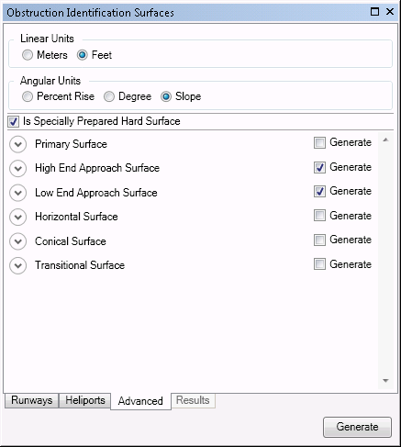`

1. Click **Generate**.
2. Once the tool is complete, the Results tab will activate and show the tool results.
3. To close the Obstruction Identification Surfaces tool, click the X in the upper right corner of the dialog.
4. Do not close ArcMap.

### Create Profile JSON

This section describes the steps to calculate the JSON of the OIS surface including the runway centerline and elevation model.

1. In the ArcCatalog pane, navigate to the same folder where the ArcMap document is located.

Open the “Approach Profile Tools” toolbox and double click on the model tool called “Add JSON fields”.

1. From the Standard toolbar, click the Python button  to launch the Python command window.
2. In the python command window, copy and paste the following Python code block:

import arcpyproduction.aviation as aero

mxd = arcpy.mapping.MapDocument("CURRENT")

lyrs = arcpy.mapping.ListLayers(mxd)

lyrLine = lyrOIS = lyrdemRaster = ""

for lyr in lyrs:

if lyr.name == "RunwayCenterline":

lyrLine = lyr

elif lyr.name == "OIS":

lyrOIS = lyr

elif lyr.name == "DEM":

lyrdemRaster = lyr

elif lyr.name == "ObstaclePoint":

lyrObstacle = lyr

# Generate the profile JSON

aero.airports.GenerateOISProfileJSON(lyrLine, lyrOIS, lyrdemRaster, 30, lyrObstacle)

1. Once the python code is pasted in the Python window, press the Enter on your keyboard.
2. When the processing complete, open the attribute table of the OIS Multipatch feature class and ensure that the fields you added previously (ProfileJSON, ObstacleJSON, NAME) are populated.

Note: you may have to close and re-open the attribute table to verify the populated attribute.

1. Close the Python window.

### Create OIS outline

This section describes the procedure to generate an outline of the OIS

1. Open the GP tool called Minimum Bounding Geometry which is located in the Data Management toolbox under the Feature toolset.
2. Set following parameters:
   1. OIS multipatch as the Input Feature
   2. Set the Output feature class to your current database and name is OIS_Outline
   3. Geometry Type to Convex Hull and click OK

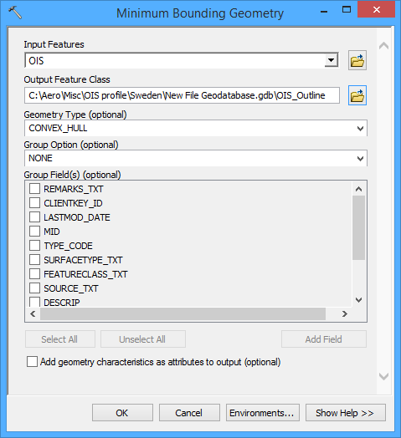

### Create OIS/DEM Heatmap

This section describes the procedure to generate a heatmap that will highlight the difference in elevation between the OIS surface and the ground

1. Open the “Approach Profile Tools” toolbox and open the Convert Multipatch to Raster GP and set the OIS as the input multipatch and set the output raster to your database and name it. Set an appropriate cell size for your out raster and click OK.
2. Open the “Approach Profile Tools” toolbox and open the Minus tool.
3. Set the raster output from Step 1 as the first raster then set the DEM as the second raster and set the output.
4. Apply and appropriate color ramp.

### Create Contours

This section describes the procedure to create contour lines for the extent of your OIS approach surface

1. Run the Clip geoprocessing tool in the Data Management toolbox in the Raster toolset under the Raster Processing tooldet to clip the DEM raster to the OIS Multipatch layer.
   1. Double-click on the Clip geoprocessing tool to launch the tool.
   2. Drag and drop the DEM layer into the Input Raster parameter.
   3. Drag and drop the OIS_Outline layer into the Output Extent (optional) parameter.
   4. Browse to your geodatabase for the Output Raster Dataset parameter and type: DEM into the Name box. Click Save.
   5. Check the box for the parameters “Use Input Features for clipping geometry”
   6. Click OK to run the Clip geoprocessing tool.

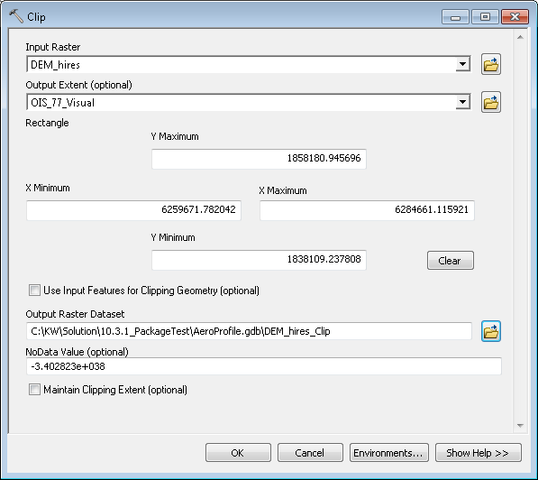

1. Open the Contour GP tool in the Spatial Analyst toolbox in the Surface toolset
2. Fill in the following parameters:
   1. Input Raster: DEM that was previously clipped in step 1
   2. Output Polyline: Name of you output contour feature class
   3. Contour Interval: 10
   4. Leave rest of setting the default and click OK

### Create Elevation Bands

This section describes the procedure to generate elevation bands along the approach surface.

1. Open the Convert Multipatch to Raster GP and set the OIS as the imput multipatch and set the output raster to your database and name it and click OK
2. Open the Contour GP tool in the Spatial Analyst toolbox in the Surface toolset
3. Fill in the following parameters:
   1. Input Raster: Raster that was previously clipped in step 1
   2. Output Polyline: Name of you output contour feature class
   3. Contour Interval: 10
   4. Leave rest of setting the default and click OK

### Create Obstacle Accuracy polygon

This section describes the procedure to generate the buffers of the obstacles that represent the horizontal confidence interval

1. Open the Buffer GP in the Analysis toolbox in the Proximity toolset
2. Set the following parameters and click OK:
   1. Input: Obstacle
   2. Output: ObstacleAccuracy
   3. Distance: Field –HorizAcc_Val
   4. Method: Geodesic

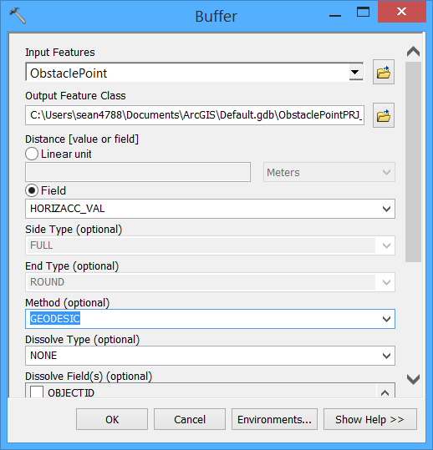

### 

### Publish to your ArcGIS Online for Organization account

Now all the data processing is done you are ready to publish to ArcGIS Server for consumption by the web application. Ensure you are signed into ArcGIS Online in ArcMap before continuing on this section.

1. In ArcMap go to File🡪Share As and select Service

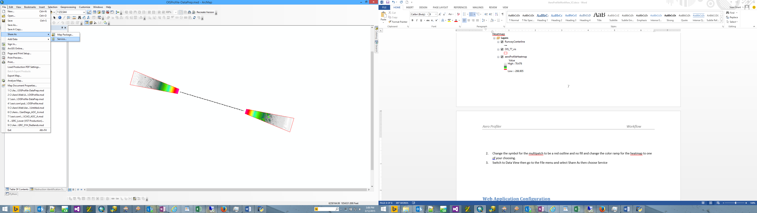

1. Choose Publish a service then click Next

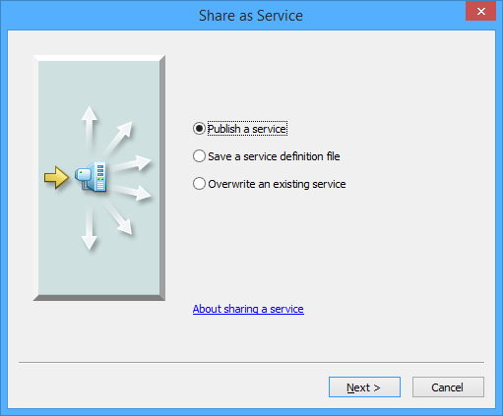

1. Choose your connection to your ArcGIS Hosted services and name the service then click Next

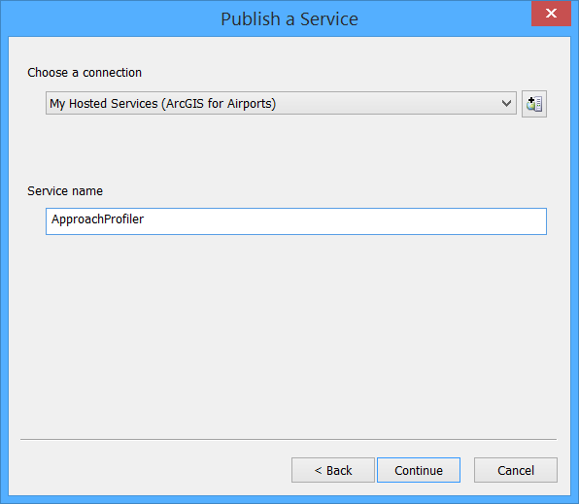

1. Change the capabilities to include feature access

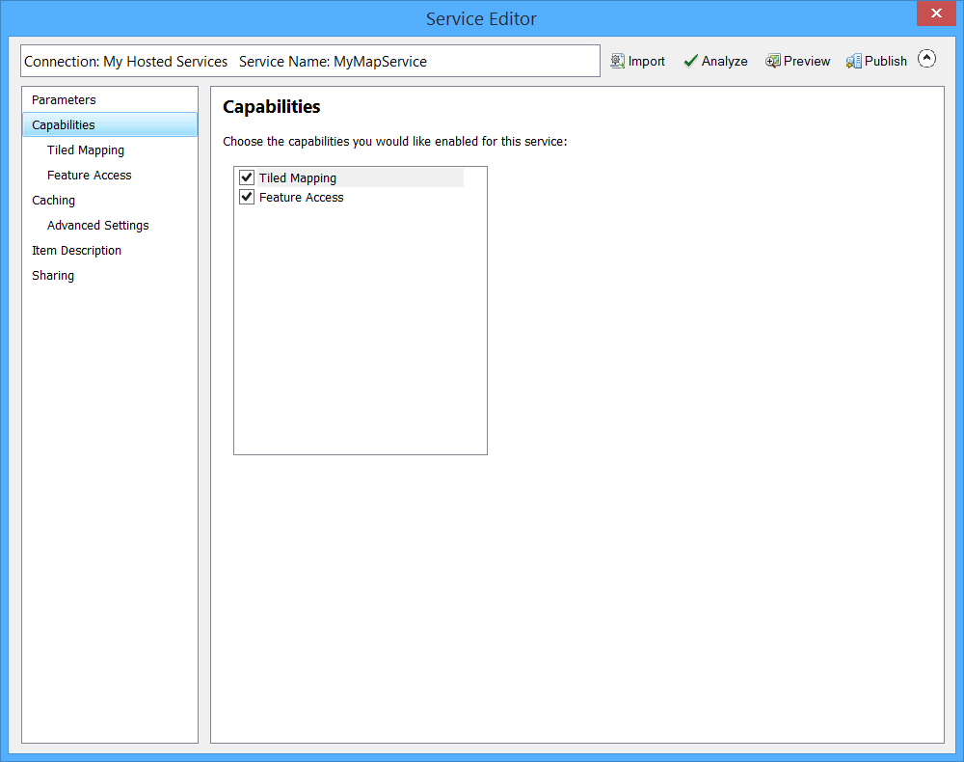

1. Set an appropriate cache levels (i.e. Metropolitan Area 🡪 Town).
2. Update the required field in the item description
3. On the Sharing section, share the data with your organization.
4. Once you are ready to publish your data, click the Publish button and resolve any errors in analyze window
5. Once the service is published you are ready to configure your web map and application.

## Web Application Configuration

This section will discuss what you need to do to setup the Approach Profiler application on an HTTP server and to modify that application to look at content hosted in your ArcGIS Online for Organization account. In here you will create a Web Map and a Web Application that the Approach Profiler JavaScript application will point to

Approach Profiler Setup – GitHub

1. Go to <https://github.com/esri> and log in with your github account
2. Once you are logged in search for “**aviation-approach-profiler**”
3. Once you find the repository, click the link that say “Download as ZIP” (Alternatively you can branch and get a local copy)
4. Once you have downloaded the repository, copy it to your HTTP server and extract it.

ArcGIS Online for Organization – Web Map

1. Log into your ArcGIS for Organization account and go to the My Content section
2. In the My Content section, create a new Web Map.
3. In your new web map, search for layers within your organization and add the service you published earlier
4. Organize the layer so that the heatmap is on the bottom and save.
5. Optional you can configure the pop-ups of the layer you want the Identify tool to interrogate.

ArcGIS Online for Organization – Web Application

1. Go to <https://developers.arcgis.com/en/> and log into your ArcGIS for Organization account
2. Click the button Register New Application to create a blank application

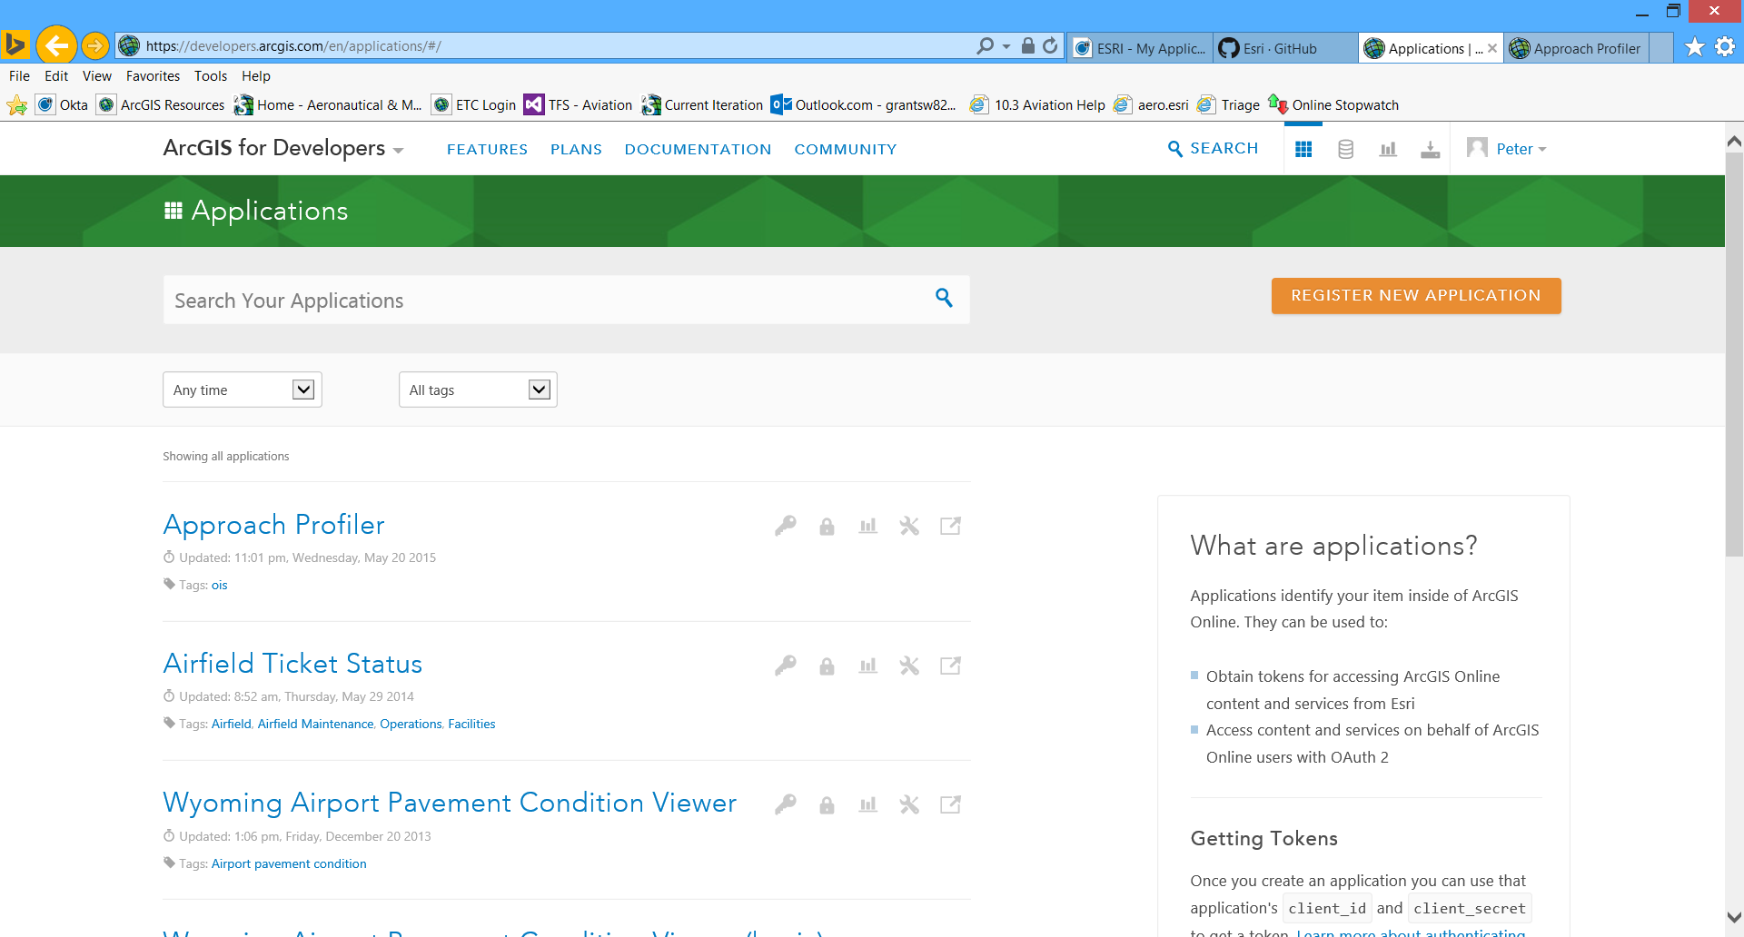

1. Fill in the New Application Details and click Register New Application

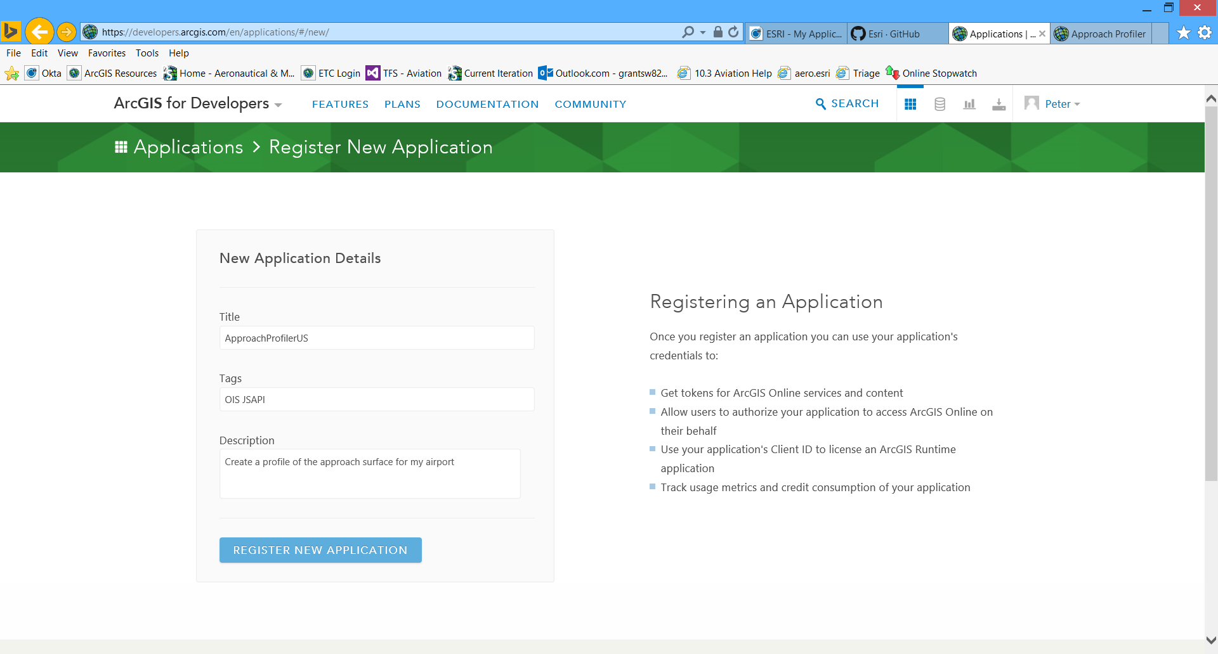

1. Once the application is registered, click the button to Edit Application Details
2. In the Settings tab, enter in the URL for your web application and click Update

## JavaScript Application Configuration

This section will discuss what you need to do to configure the Approach Profiler to look at content hosted in your ArcGIS Online for Organization account. In here you will modify the layer names and point the web application to your services that are hosted in the ArcGIS for Organization account.

1. Go to the location where you downloaded and extracted the web app from GitHub.
2. Navigate to the **js** folder and open the file called **config.js** in your Javascript editor or a text editor.
3. Go to line 28 where it asks for the **AGOLOrgUrl** and copy/paste your Org account URL.
4. Go to line 32 and 33 and copy/paste the Id’s of the web app and web map that was created in the Web Application Configuration.
5. Go to line 240 and change the name of the model to match the OIS surfaces that you want to show (i.e. annex14, far77, faa18b, annex15).
6. Go to line 243 and change the name and Label for the surface. The Label is the name that will be displayed in the actual web application.
7. For lines 248-267 replace the value for “name:” with the name of the layers in your web map for the corresponding feature.
8. Lines 280-310 are for a second OIS that is displayed. If you have more than one OIS specification that you want to show then adjust this as necessary. If there are more than 2 types then copy lines 280-313 then paste after 313.
9. If you wish to change the name that is displayed at the top of the app then change the value on line 41.