**Oriented Imagery Catalog**

**RieglRiPROCESS_CSV OICType**

**Introduction**:

The RieglRiPROCESS_CSV OICType allows users to ingest data generated by the Riegl RiProcess software. The OIC Type allows the user to specify the location of the images, the CSV metadata file, type of images and SRS of the input data.

**Installation & Usage**:

To use this OIType follow these instructions.

1. Copy the following files to c:\Image_Mgmt_Workflows\OrientedImagery\Types\

* RieglRiPROCESS_CSV.oictype
* RieglRiPROCESS_CSV.py

1. Start Pro.
2. Create a new Oriented Imagery Catalog. (SRS should be **GCS Hong Kong 1980**)
3. Add Images to the OIC using the RieglRiPROCESS_CSV OICType
4. It is recommended to create two OICs, one for panoramic images and one for the individual cameras. See below for detailed info.

**Input Data**:

The input data consists of metadata files and images to ingest. The images are of two types, a stitched 360 degree panoramic images or the individual cameras. The image format has to be in JPG format. The Naming convention of the CSV files is important as well. Below is the sample metadata file.

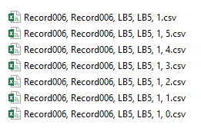

The first file ending in ‘1.csv’ corresponds to the panoramic images. The other files ending in ‘1, 0.csv’ to ‘1, 5.csv’ correspond to the individual images that make up the stitched images.

The stitched images also have to be organized in a particular folder structure. The program assumes the below folder structure to ingest that data.

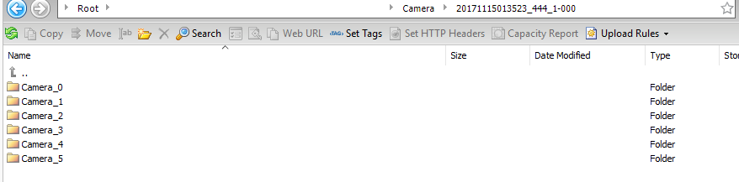

**Add panoramic imagery**:

1. Create a new OIC. (As in step 3 above in Installation and Usage above.)
2. Select Add Images to Oriented Imagery Catalog.
3. Select the newly created OIC.
4. For Input type pick RieglRiPROCESS_CSV
5. Enter the Parameters for the following.

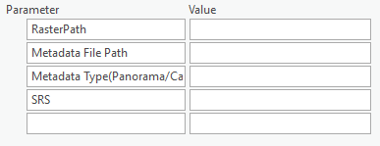

**Raster Path** : http://<yourbucket>.s3.amazonaws.com/HongKong/Panorama/20171115013523_444_1-000/

**Metadata File Path**:

d:\HK\Record006\Record006, Record006, LB5, LB5, 1.csv

Note: If copy pasting the path, remove any quotation marks.

**Metadata Type(Panorama/Camera)**:

Panorama

Tip: Copy the required value from the Parameter column to the Value column.

**SRS**: 2326

This is the WKID value for GCS Hong Kong 1980

1. Enter Default values.
   1. Oriented Imagery Type = Bubble
   2. Horizontal Field of View = 360
   3. Vertical Field of View = 180
   4. Average Height (m) = 3
   5. Near Distance = 3
   6. Far Distance = 30

NOTE: For all values use the Check box below to set as default. This will write the values to the OIC properties file and leave the fields in the blank as these values will be common to all the records added. These fields can be hidden before publishing to reduce the size of the published feature service.

1. Click on run to start the add process.

**Add single camera imagery**:

To add data for the single frame, the code makes certain assumptions based on the input data. Please read instructions carefully.

1. Create a new OIC. (As in step 3 above in Installation and Usage above.)
2. Select Add Images to Oriented Imagery Catalog.
3. Select the newly created OIC.
4. For Input type pick RieglRiPROCESS_CSV
5. Enter the Parameters for the following.

**Raster Path** : http://<yourbucket>.s3.amazonaws.com/HongKong/Camera/20171115013523_444_1-000/

NOTE: In this folder you should have the files organized by camera in the respective camera folders as shown Input data.

**Metadata File Path**:

**d:\HK\Record006\Record006, Record006, LB5, LB5, 1, 0.csv**

Note: For the single frame metadata files, give the file that ends in 0 as input. The program will automatically search for the other metadata files for the remaining cameras and use it to add data.

**Metadata Type(Panorama/Camera)**:

Camera

Tip: Copy the required value from the Parameter column to the Value column.

**SRS**: 2326

This is the WKID value for GCS Hong Kong 1980

1. Enter Default values.
   1. Oriented Imagery Type = Inspection
   2. Horizontal Field of View = 72
   3. Vertical Field of View = 90
   4. Average Height (m) = 3
   5. Near Distance = 3
   6. Far Distance = 30

NOTE: For all values use the Check box below to set as default. This will write the values to the OIC properties file and leave the fields in the blank as these values will be common to all the records added. These fields can be hidden before publishing to reduce the size of the published feature service.

1. Click on run to start the add process.

**Sample Hongkong Data**

To ingest the sample Hongkong data repeat the add data several times for each metadata file.

For the Sample Hongkong data this is the metadata to image folder mapping that is used.

|  |  |
| --- | --- |
| Input File | Imager Folders (Camera and Panoramic) |
| "Record006, Record006, LB5, LB5, 1.csv" | 20171115013523_444_1-000/ |
| "Record007, Record007, LB5, LB5, 1.csv" | 20171115013814_414_1-000/ |
| "Record014, Record014, LB5, LB5, 1.csv" | 20171115020425_640_1-000/ |
| "Record015, Record015, LB5, LB5, 1.csv" | 20171115020759_039_1-000/ |
| "Record016, Record016, LB5, LB5, 1.csv" | 20171115021125_987_1-000/ |
| "Record017, Record017, LB5, LB5, 1.csv" | 20171115021419_434_1-000/ |

**Steps after Add Data**:

Once all the data has been added to the OIC, Follow these steps. For detailed info regarding each step refer to the user document in c:\Image_Mgmt_Workflows\OrientedImagery\Documentation.

1. Run Create Coverage Features
2. Run Create Coverage Map
3. Run Analyse Oriented Imagery Catalog
4. Run Publish Oriented Imagery Catalog