**Oriented Imagery Catalog**

**Sanborn OICType**

**Introduction**:

The Sanborn OICType uses the exterior orientation parameter file & camera file to ingest data into an OIC. The user also needs to specify the raster path and if need a suffix, prefix and average elevation.

**Installation & Usage**:

To use this OIType follow these instructions.

1. Copy the following files to c:\Image_Mgmt_Workflows\OrientedImagery\Types\

* sanborn.oictype
* sanborn.py

1. Start Pro.
2. Create a new Oriented Imagery Catalog.
3. Add Images to the OIC using the Sanborn OICType
4. See below for detailed info.

**Input Data**:

There are two main components to the input data. The first is the path to the actual imagery. The second is the folder of the metadata files (EO and camera files.) The EO and camera files have to be in the same folder and have to end in the following:

EO File : *_EO.txt

Camera File : _Camera.txt

Sample EO File:

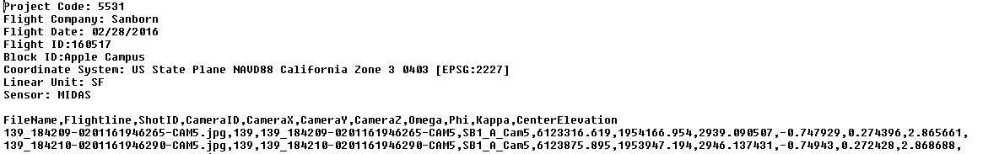

Sample Camera File:



**Add data**:

1. Create a new OIC.
2. Select Add Images to Oriented Imagery Catalog.
3. Select the newly created OIC.
4. For Input type pick Sanborn
5. Pick a DEM to use for this data. This is optional and can be skipped if not needed.
6. Enter the Parameters for the following.

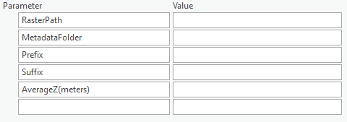

**Raster Path** :

http://<yourbucket>.s3.amazonaws.com/Sanborn/Santa_Clara_Apple_Campus

You can also enter a local folder path.

**Metadata Folder**:

Enter the folder path where the *_EO.txt and *_Camera.txt files are stored.

Note: If copy pasting the path, remove any quotation marks and trailing spaces and the slash (‘\’ ) at the end of the path.

**Prefix**:

The prefix works with the shotid field to create a fully qualified file name. In this case the prefix will be left blank.

**Suffix**:

The suffix works with the ShotID field to create a fully qualified file name.A typical suffix would be the file extension. Since the ShotID field is being used a file extension should be specified. Example, ShotID = 139_184209-0201161946265-CAM5

Suffix = .jpg

Filename would then be 139_184209-0201161946265-CAM5.jpg

**AverageZ (meters)**:

The Average elevation that needs to be specified for the area of interest.

1. Enter Default values.
   1. Oriented Imagery Type = Terrestrial
   2. NOTE: For all values use the Check box below to set as default. This will write the values to the OIC properties file and leave the fields in the blank as these values will be common to all the records added. These fields can be hidden before publishing to reduce the size of the published feature service.
2. Click on run to start the add process.

**Steps after Add Data**:

Once all the data has been added to the OIC, Follow these steps. For detailed info regarding each step refer to the user document in c:\Image_Mgmt_Workflows\OrientedImagery\Documentation.

1. Run Create Coverage Features
2. Run Create Coverage Map
3. Run Analyse Oriented Imagery Catalog
4. Run Publish Oriented Imagery Catalog