Documentation for Front End for Question Bank Admin View:

Skill Based Test:

User:

* A new user can request for a Skill Based Assessment test from the CaramelIT Academy page.
* The user will get an option to enter up to 5 skills and his level of expertise (beginner, intermediate, expert) in each.

Admin:

* The admin can log in to the question bank and go to the dashboard.
* In the dashboard, he/she can view the options for a Skill Assessment or a Course Assessment or Question Bank.

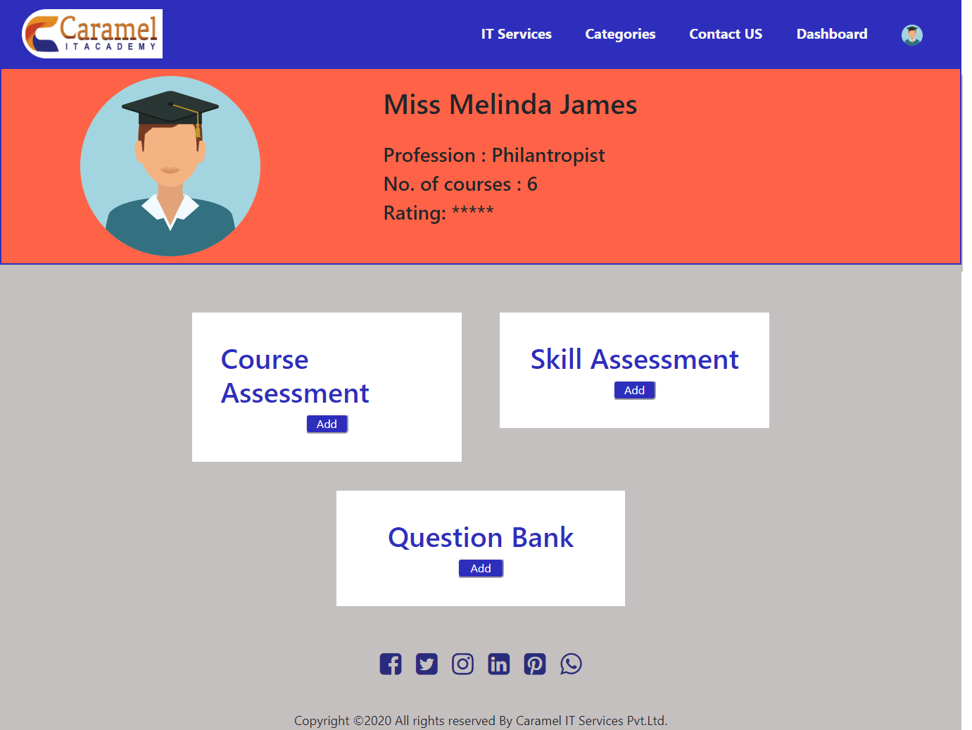

* The admin can then go to the add Skill Assessment option. There they can enter the User ID, what skills the test has to be conducted on, the level of questions (beginner, intermediate, expertise) and number of questions for MCQ type.

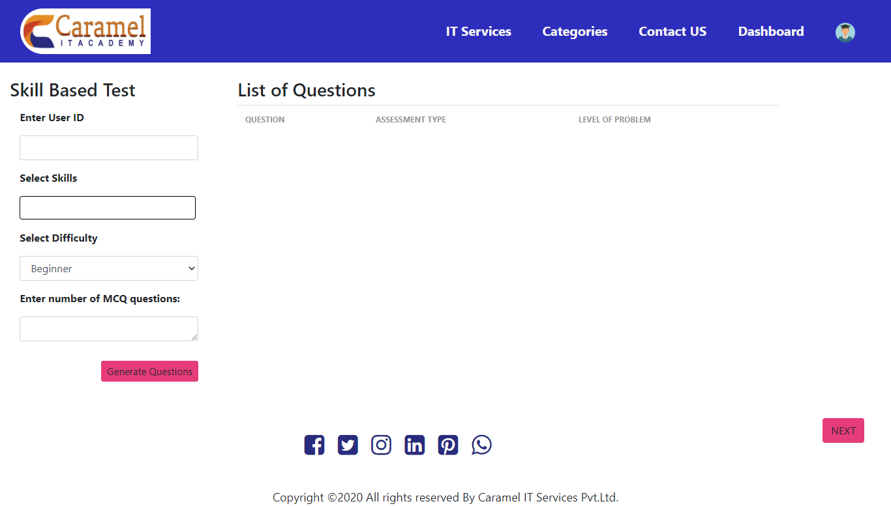

* Depending upon the above details, a list of questions will be displayed which have been chosen from the question bank by an AI/ML Recommendation system.
* The input to the AI/ML Recommendation system will in JSON format and will consist of the above details (topics, level of expertise, type of questions and the number of questions for each type, time limit of test, total score of test).

The output will also be in JSON format and will consist of all the questions chosen and will also be giving 10 extra generic questions

* Once the questions have been generated, the admin can click next.
* On navigating to the next page, the admin can schedule the test by entering the user Email-ID, time and date within which the user can give the test.

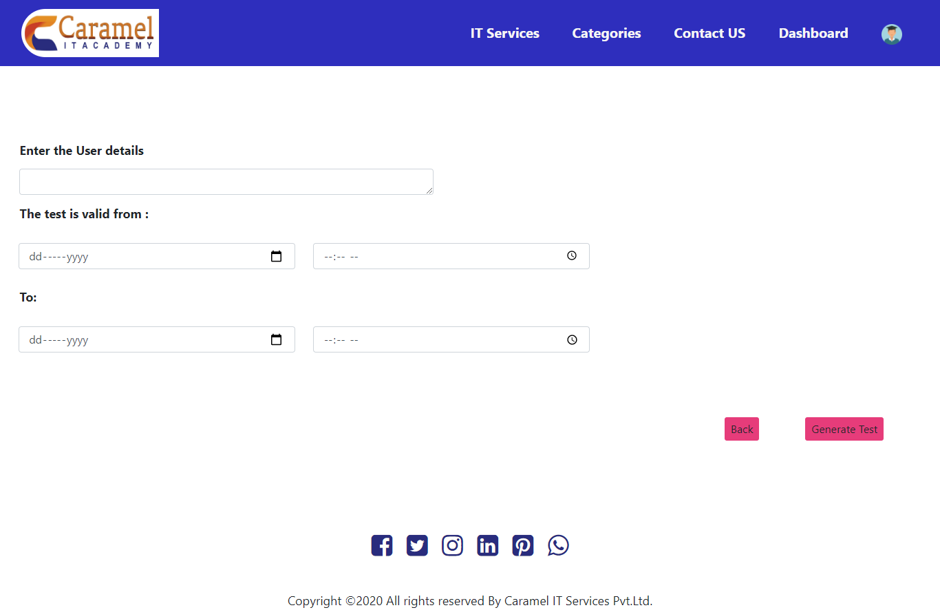

* On clicking ‘Generate Test’, the test is created and the user receives an email link for the test.

User:

* The user is alerted about the scheduled test and can then take the test.

Course Based Test:

User:

* The user may request for a test at the completion of a module in the course or the course itself.

Admin:

* The admin can log in to the question bank and go to the dashboard.
* In the dashboard, he/she can view the options for a Skill Assessment or a Course Assessment or Question Bank.



* The admin can go to the add Course Assessment option. There the admin can enter the user ID, course name, the module, the level of questions (beginner, intermediate, expertise), the type of questions (eg. MCQs, short answer questions) and number of questions for each type.

On entering the type of questions and pressing submit, an option to fill in the number of questions for that type will be shown.

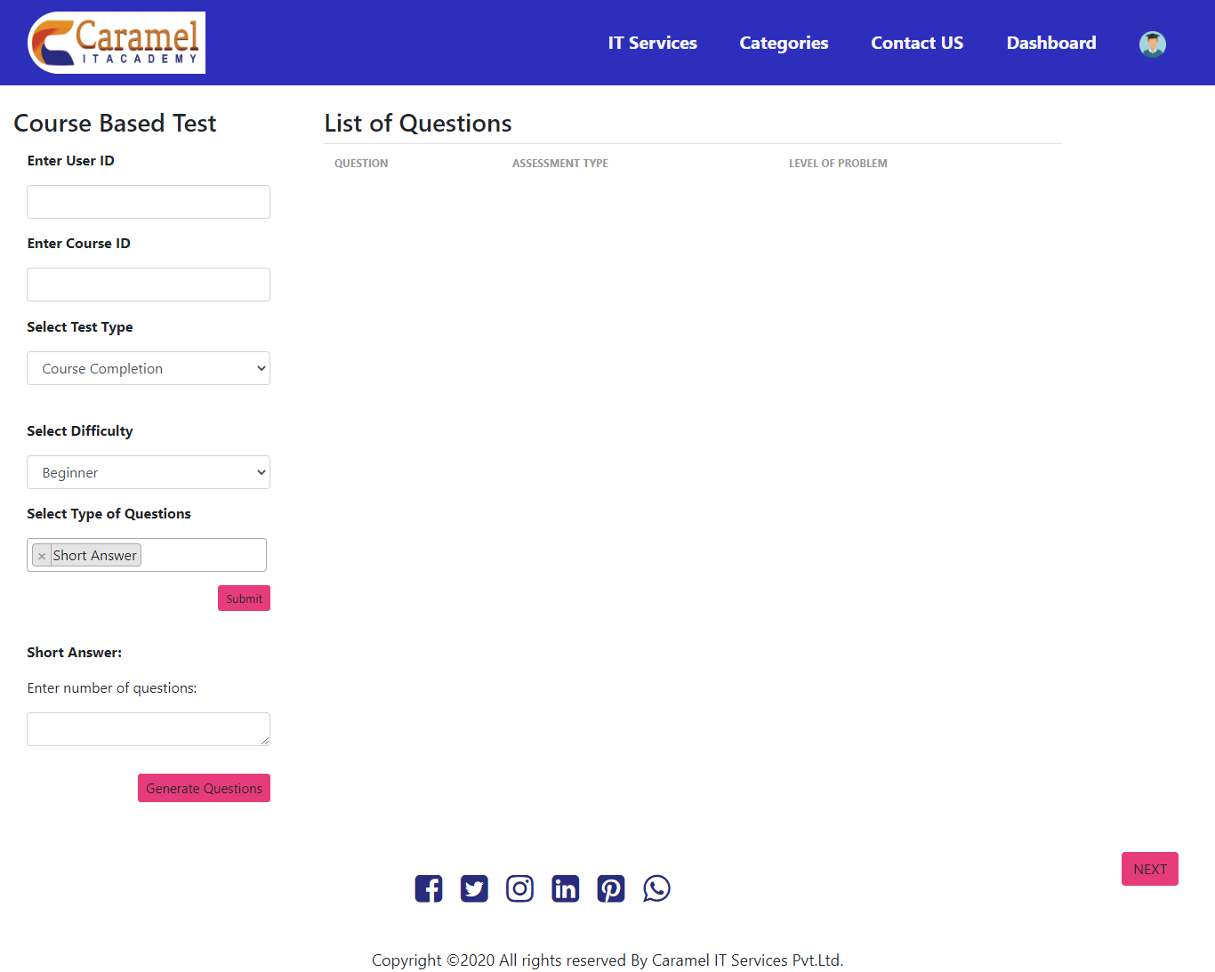

* Depending upon the above details, a list of questions will be displayed which have been chosen from the question bank by an AI/ML Recommendation system.
* The input to the AI/ML Recommendation system will in JSON format and will consist of the above details (topics, level of expertise, type of questions and the number of questions for each type, time limit of test, total score of test).

The output will also be in JSON format and will consist of all the questions chosen.

* Once the questions have been generated, the admin can click next.



* On navigating to the next page, the admin can schedule the test by entering the user Email-ID, time and date within which the user can give the test.

User:

* The user is alerted about the scheduled test and can then take the test.

Question Bank:

* The Question Bank allows the admin to enter any new question to the existing repository of questions.

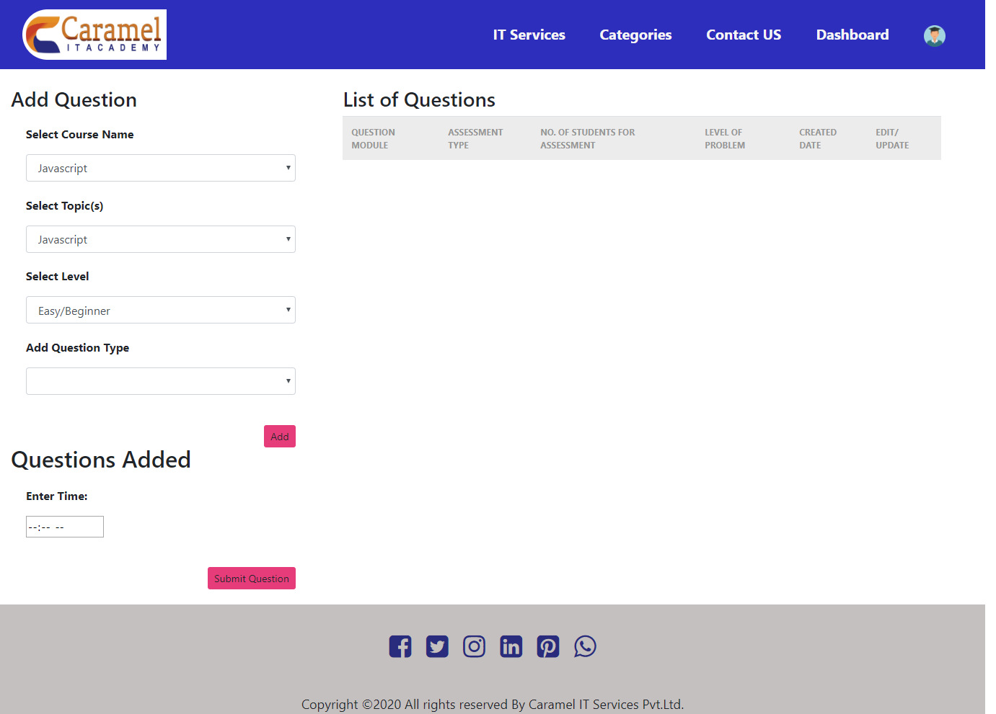

* The admin can enter the Course Name, Topic Name, the level of difficulty (beginner, intermediate, expert) and the type of question (MCQ. Subjective, true/false) he/she wants to enter.
* The questions added in one session are listed under Questions Added in the left side column.
* The right side column displays all the questions currently existing in the Question Bank.
* For MCQ Questions:

The admin can enter the question and the four options.

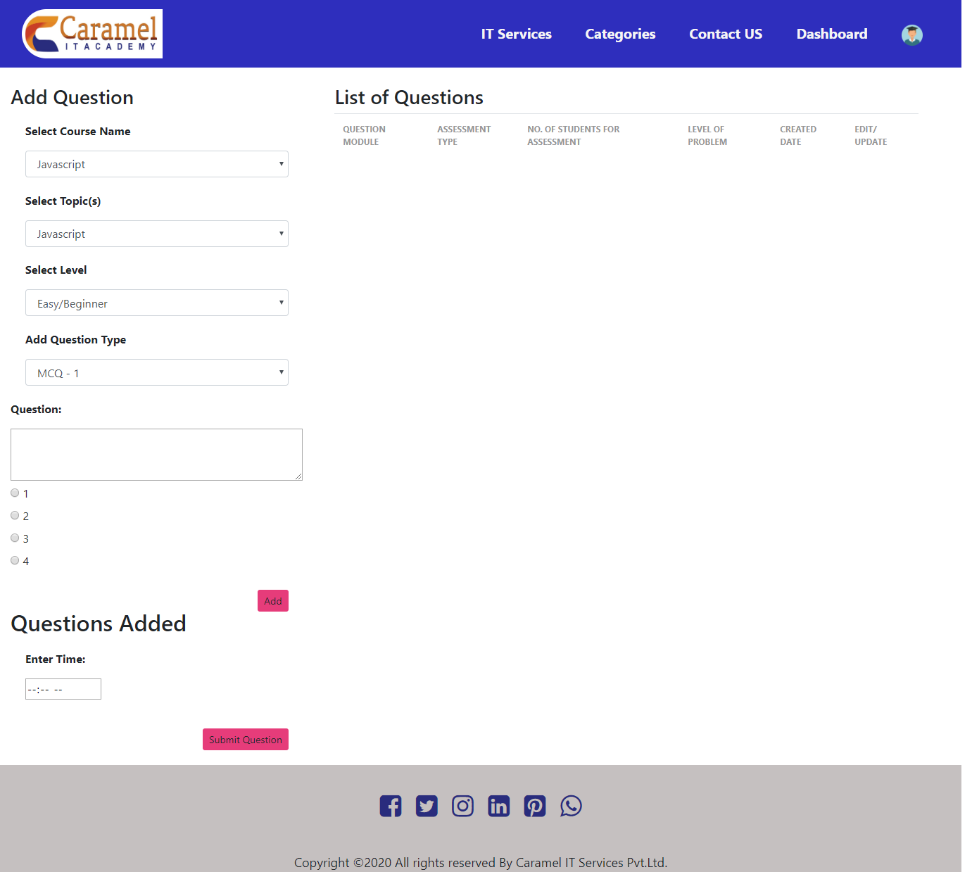

* For Subjective Questions:

The admin can enter the question and answer in the space provided.

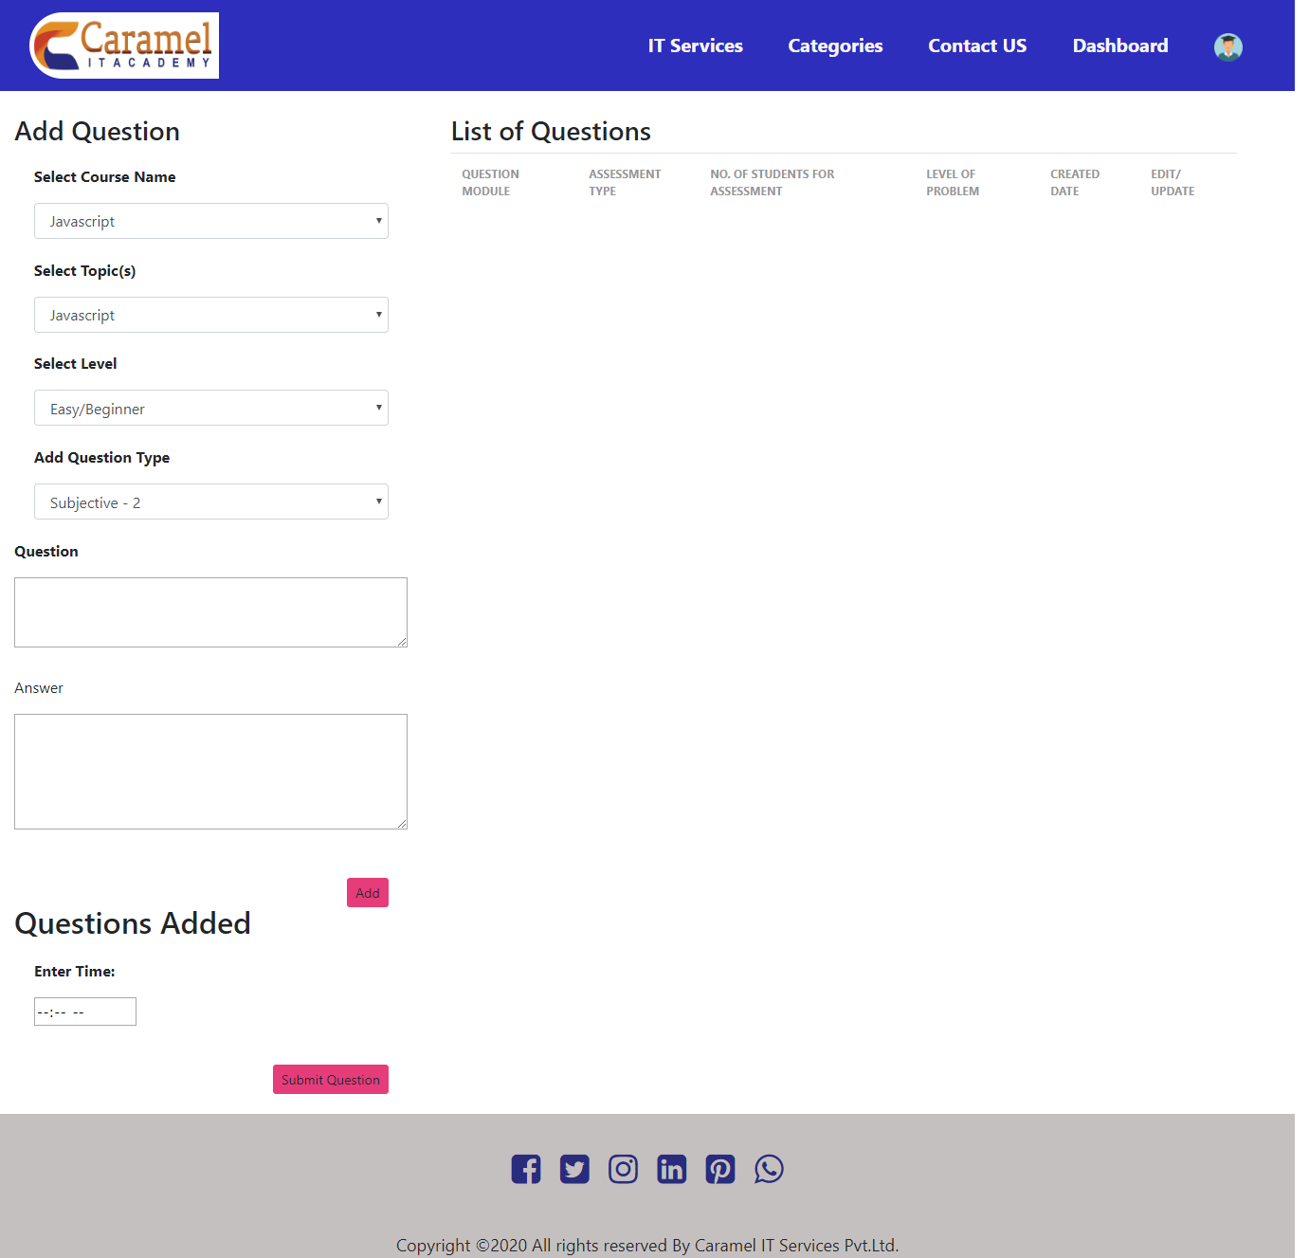

* For True/False Questions:

The admin can enter the question and the true and false option.

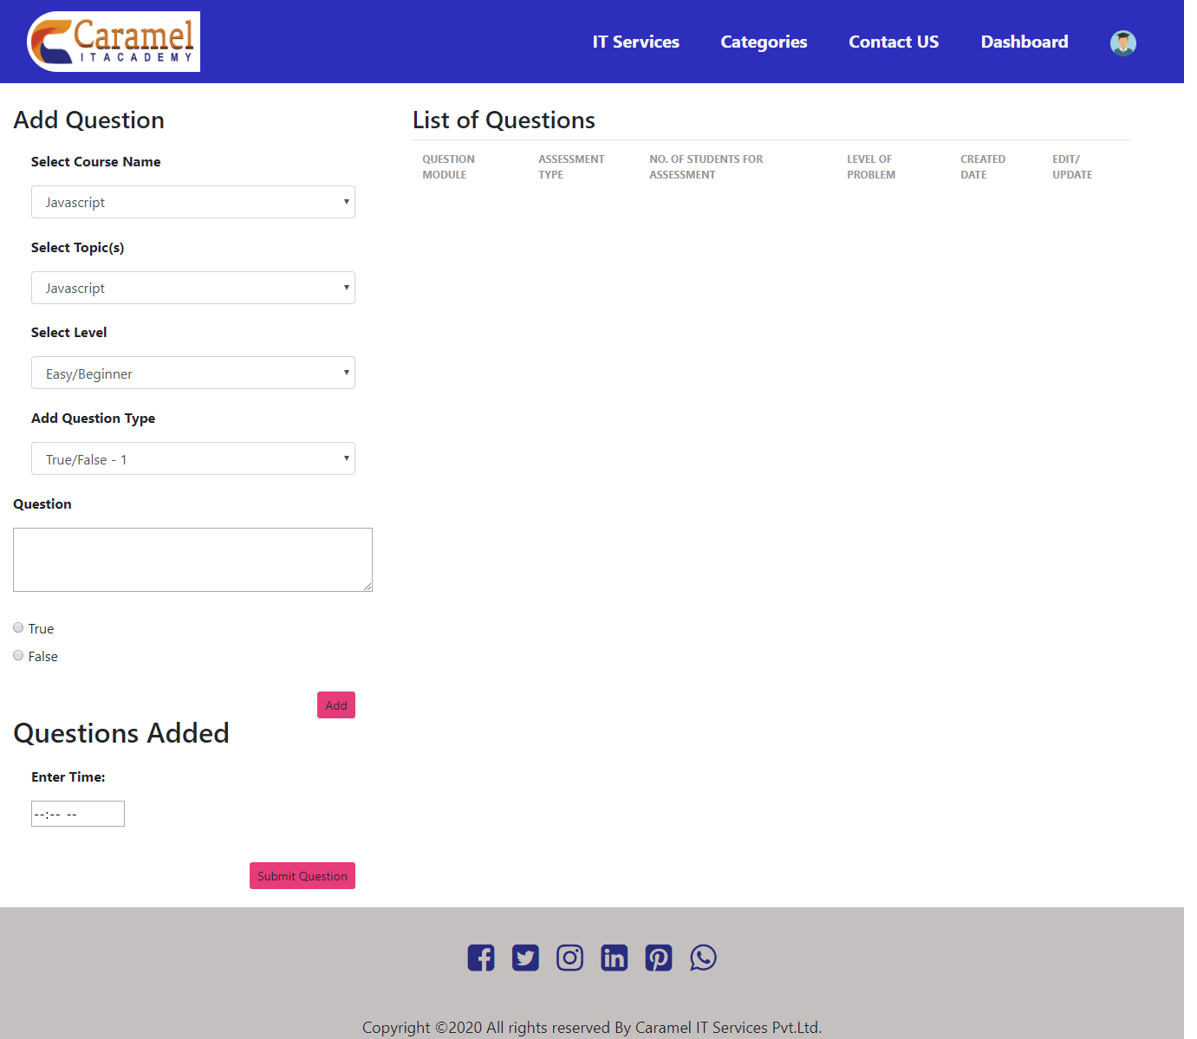

**Integration Documentation for AI/ML Models**

**Caramel IT**

The models developed for the usage in the Caramel IT Academy Website are as follows-

**1.QB_Skills_Based_Test**

**2.QB_Course_Modules_Based_Assignment_Model**

**3.QB_Course_Completion_Assignment_Model**

**4.QB_SubProgram_Completion_Test_Model**

**5.CA_Score_Based_Other_Recommended_Courses_Model**

**6.CA_User_Search_Based_Course_Recommendation_Model**

**7.CA_Other_Recommended_Courses_Model**

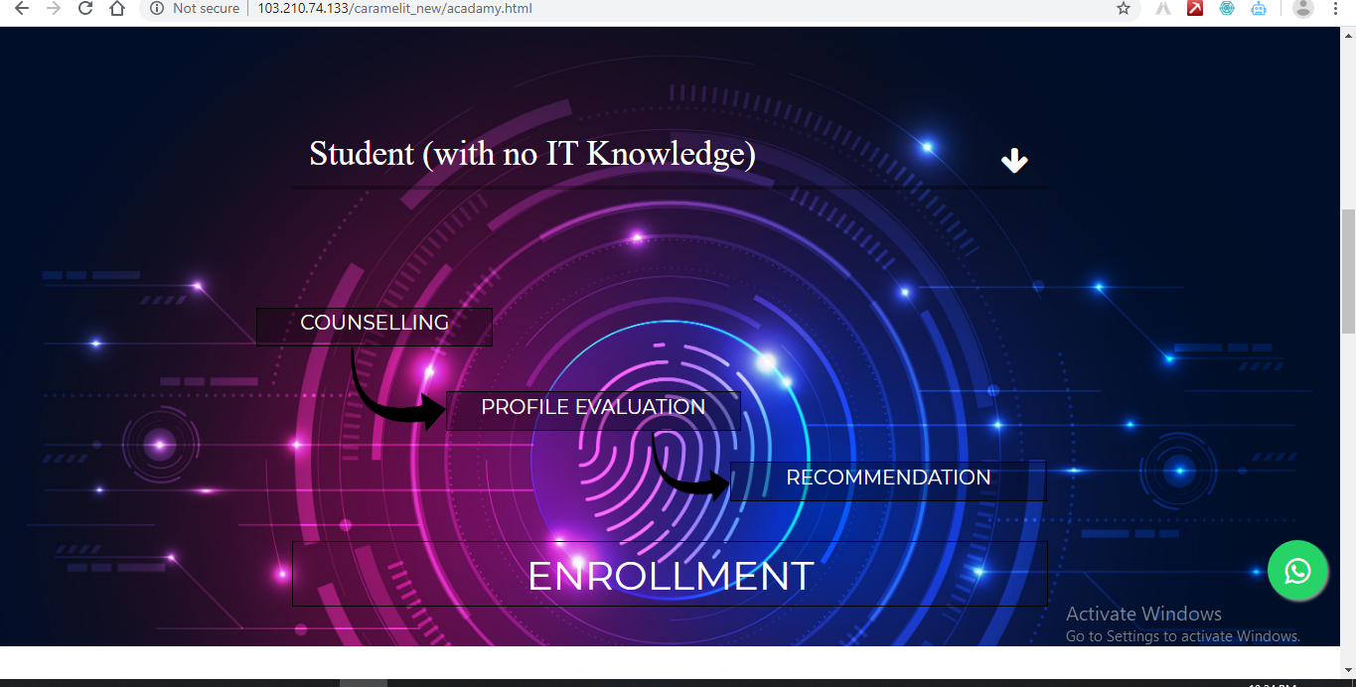

**1. QB_Skills_Based_Test-**

will run when User is prompted on the Counselling button. The model is aimed for generation of unique question id’s based on the skills entered by the User and also for some defined generic questions as well.

**2. CA_Score_Based_Other_Recommended_Courses_Model-**

Based on the score given to it from the question paper generated by the above mentioned model, when prompted on the recommendation part, based on the type of User and the skills and the scores of the User, some courses will be recommended to him at a discounted price as he gave the test itself.

**3. CA_User_Search_Based_Course_Recommendation_Model**

If the user does not want to give a test and get a recommendation, he can directly search in the search bar of what course he wants and on the basis of that some results will be filtered out.He can choose any course he wants but it will not be available at a discounted price.Similar to the one on Udemy*.

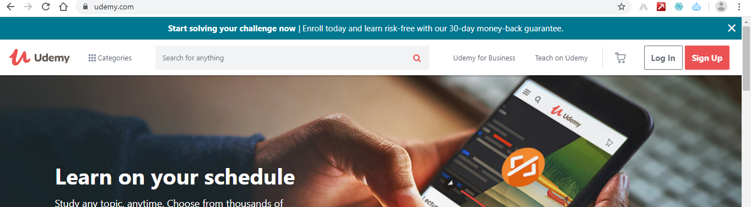

**4.CA_Other_Recommended_Courses_Model**

When the user clicks on some course he would be given some courses in the bottom Carousel which may garner his interest. Also this model can be applied to in variation as a **frequently b ought together Model.**Similar to the one like Udemy*

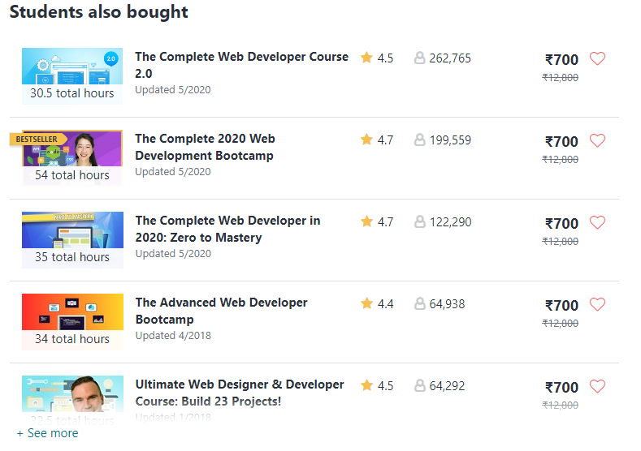

**5. QB_Course_Modules_Based_Assignment_Model**

If the user is enrolled in some course, and is on a particular subsection then after the end of the subsection, the questions particular to that subsection of that particular course will be generated.

**6.QB_Course_Completion_Assignment_Model**

Similar to the above model, at the end of the course one final exam will be generated containing both mcq’s and short answer questions which will be of that particular course.

**7.QB_Subprogram_Completion_Test_Model**

Similar to the above model, at the end of the course one final exam will be generated containing both mcq’s and short answer questions which will be of the master subprogram which will contain a variety of sub courses.

Outputs given by these models are in JSON Formats-

For all the models prefixed with QB-output are the question id’s

For all the models prefixed with CA-output are the course id’s

*As UI’s for these models are being developed some mock screenshots are being used for explanation