
IT342-Section
SYSTEMS INTEGRATION AND ARCHITECTURE 1

FUNCTIONAL REQUIREMENTS SPECIFICATION (FRS)

Project Title: User Registration & Authentication
Prepared By: Cambal, Michael Raymund B.
Date of Submission: 1/30/2026
Version: 1

Table of Contents
1. Introduction 3
1.1. Purpose 3
1.2. Scope 3
1.3. Definitions, Acronyms, and Abbreviations 3
2. Overall Description 3
2.1. System Perspective 3
2.2. User Classes and Characteristics 3
2.3. Operating Environment 3
2.4. Assumptions and Dependencies 3
3. System Features and Functional Requirements 3
3.1. Feature 1: 3
3.2. Feature 2: 3
4. Non-Functional Requirements 3
5. System Models (Diagrams) 4
5.1. ERD 4
5.2. Use Case Diagram 4
5.3. Activity Diagram 4
5.4. Class Diagram 4
5.5. Sequence Diagram 4
6. Appendices 4

Introduction

Purpose
The Authentication System's goal is to give users a safe and dependable method of registering, logging in, accessing protected resources, and logging out. The purpose of this document is to help developers, testers, and project evaluators comprehend the system's needs and functionality.

Scope
- Allow users to create accounts.
- Allow users to log in using credentials.
- Restrict access to protected pages for unauthenticated users.
- Allow users to log out securely.

Definitions, Acronyms, and Abbreviations
List and define important terms used in this document.
Term / Acronym | Definition
SRS | Software Requirement Specification
User | An individual who signs up and accesses the system
Registration | The procedure for establishing a new account
Login | The procedure for verifying a user's registration
Logout | How a user session is terminated
Dashboard | Only verified users can see the protected page.

Overall Description

System Perspective
Operating as a stand-alone module, the Authentication System is in charge of user validation, session state maintenance, and resource access management.

User Classes and Characteristics
User Class | Characteristics / Privileges
Guest | able to sign up and try to log in. unable to access pages that are protected.
User | A user can browse their profile or dashboard, log out, and access restricted pages.

Operating Environment
• The user's mobile device or web browser.
• The authentication logic is handled by the backend server.
• A database to safely store user credentials.

Assumptions and Dependencies
• Users will supply accurate and legitimate credentials.
• Passwords will be safely kept and encrypted.
• The system stores user data in a running database.

System Features and Functional Requirements
Describe each major feature of the system and its functional requirements.

Feature 1: User Registration
Description: To access protected pages, users must first register an account.
Functional Conditions:
- Users provide their password, email address, and username.
- Input is verified by the system, and duplicate accounts are avoided.
- Before being stored, passwords are safely hashed.

Feature 2: Profile / Dashboard Access
Description: Users who have successfully authenticated can access their dashboard or profile.
Functional Conditions:
- Protected pages are only accessible by authenticated users.
- Attempts by unauthorized users to gain access are forwarded to the login page.

Feature 2: User Logout
Description: Users can safely end their session.
Functional Requirements:
- The user session or token is invalidated upon logout.
- The user is taken to the login screen.

Feature 2: User Login
Description: To access protected sites, registered users must log in.
Functional Conditions:
- Users input their password and email address.
- Credentials are verified by the system.
- An error is raised by invalid credentials, allowing for a retry.

Non-Functional Requirements
Specify system quality attributes such as performance, security, usability, reliability, etc.
• Performance: Users must be authenticated by the system in two to three seconds.
• Security: Encrypting passwords and preventing session hijacking are essential.
• Usability: Registration and login forms are straightforward and easy to understand.
• Reliability: The system needs to be accessible 99 percent of the time.
• Maintainability: Modular code makes upgrades and repairs simple.

System Models (Diagrams)
Insert the necessary diagrams for the system:

ERD
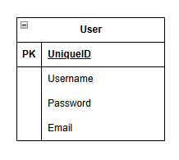
Insert ERD here

Use Case Diagram
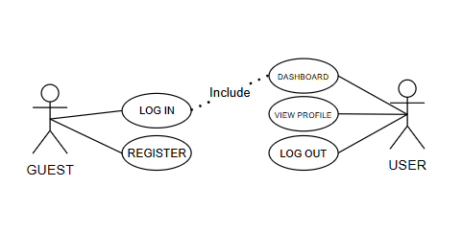
Insert ERD here

Activity Diagram
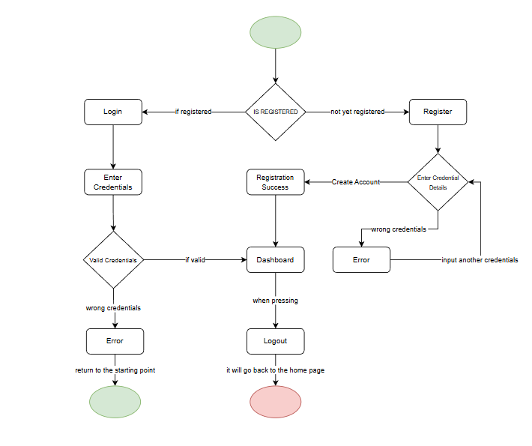
Insert ERD here

Class Diagram
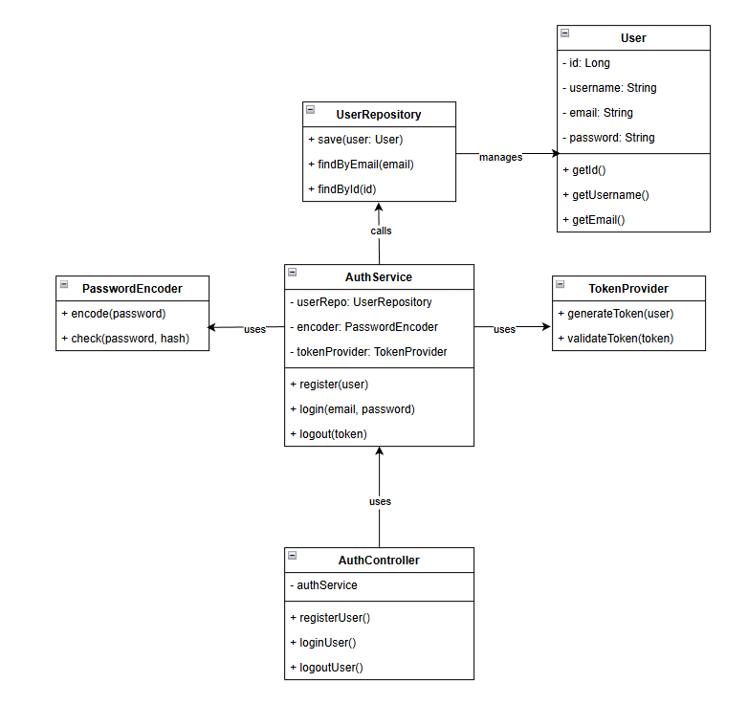
Insert ERD here

Sequence Diagram
Insert ERD here
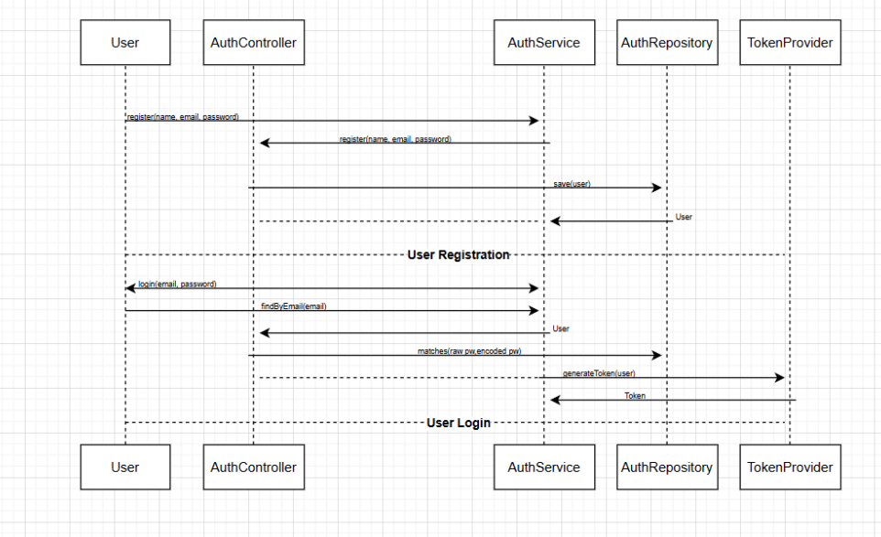

Appendices
Include any additional information, references, or support materials.

