How to configure and use the countdown template

What you’ll need

Two ArcGIS.com web maps:

* Overview web map
  + To be displayed at a smaller scale.
  + This map must contain the points (content layer) represented in the template’s list view.
  + Popups for the content layer will be displayed in the left hand panel.
* Close up (or large scale) web map
  + To be displayed at a larger scale.
  + Provides a close up view of an individual content layer feature’s area.
  + Currently, popups for the close up map will not be honored.
  + Close up map may contain multiple layers, but can also just contain a base map layer.

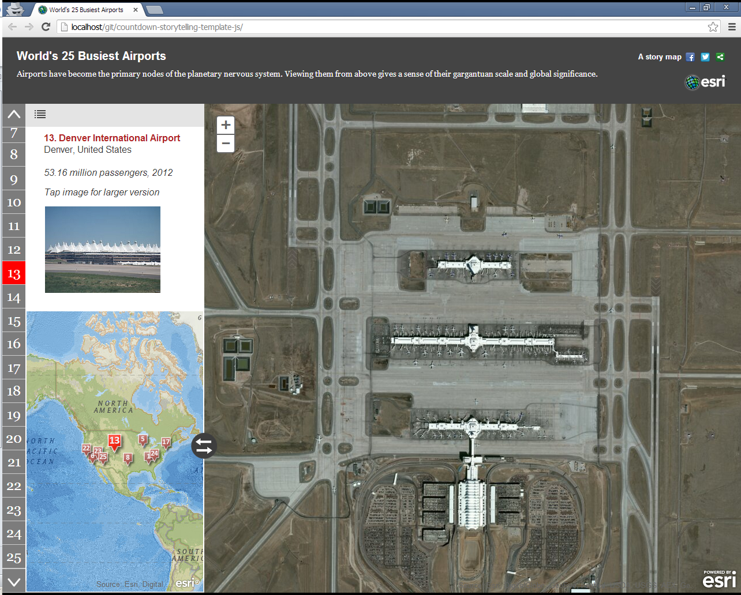

Popup display

Overview map w/ content layer

Close up map

Notes:

* By design, these two maps can swap positions. And in fact, the overview map initially appears on the right, not the left (as pictured here).
* Please author and save both of the above web maps under your account.
* Don’t forget to publish your maps and give them “Everyone” access!
* Currently, template does not support FeatureService-based layers as content layer, so you must upload your content data either as CSV or shapefile.
* A sample content layer CSV has been supplied (*sample data/BigAirports.csv*).

Configuration

1. Download application files and deploy in a web server directory (or virtual directory).
2. Open config.js and supply:

|  |  |
| --- | --- |
| webmap_largescale | Web map id for close up web map |
| webmap_overview | Web map id for overview web map |
| contentLayer | Name of the overview map’s content layer as it appears in the ArcGIS.com viewer TOC. |
| fieldName_Rank | Field name in the content layer to be used for rank. Must be integer values. |
| fieldName_Name | Designates the name of the content feature. |
| fieldName_Level | (optional) Field containing integer values. For each feature, specifies zoom level at which large scale map should be displayed. If this field isn’t specified, the app will simply use the defaultLargeScaleZoomLevel setting below. |
| initialZoomLevel | Zoom level at which to display the overview map initially |
| initialZoomLevelWide | Initial zoom level for overview map when app window has a wider aspect ratio |
| defaultLargeScaleZoomLevel | Zoom level at which to present the large scale map whenever a feature is selected. |
| showIntro | Indicates whether to show the intro screen at start-up. |
| popupHeight | How much vertical space (in pixels) should be allotted for the popup display in the left hand pane. At the moment, this cannot be calculated automatically. |
| popupLeftMargin | How much white space (in pixels) should be inserted in the left margin of the popup view. |



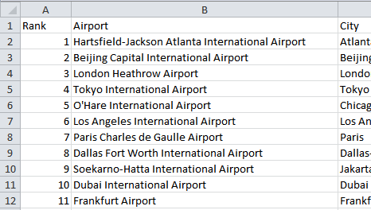

popupLeftMargin

popupHeight

fieldname_Rank