Project Report

Speech Emotion Recognition with HuBERT and Hand-crafted Features:
Does Cross-Attention Fusion Help?
A controlled, speaker-independent comparison of MFCC, prosody and self-supervised speech features on RAVDESS and CREMA-D

Submitted by
JATIN KUSHWAHA – 2024EEB1211
PRANAY SHEKHAR – 2024EEB1231

Abstract
Speech emotion recognition (SER) aims to identify the emotion expressed in a spoken utterance. Recent work often combines a pretrained self-supervised speech model with hand-crafted acoustic features and reports gains from attention-based fusion. In this project we tested that idea under a strict, speaker-independent protocol. We built four experiments on two acted English datasets, RAVDESS (24 speakers, 6 folds) and CREMA-D (91 speakers, 5 folds), using six emotion classes: E1, MFCC statistics with an SVM and a Random Forest; E2, frozen HuBERT features pooled over time with a small MLP; E3, frame-level concatenation of HuBERT, MFCC and prosody; and E4, a two-stage bidirectional cross-attention model, together with a parameter-matched self-attention control and a HuBERT-only frame model. All hyper-parameters were chosen on validation speakers only, and every test fold was predicted once from a saved checkpoint.
The simplest HuBERT model, E2, was the most accurate (macro-F1 0.762 ± 0.054 on RAVDESS and 0.713 ± 0.030 on CREMA-D) and was best in 9 of the 11 folds. Cross-attention fusion (E4) reached 0.723 ± 0.061 and 0.674 ± 0.023 and did not consistently improve on concatenation, on the self-attention control or on HuBERT alone; on CREMA-D it was below concatenation in all five folds. Ablations showed that HuBERT carries almost all of the useful information, while MFCC and prosody, although informative on their own, add little once HuBERT is present. The results apply to two acted English corpora and a small number of folds, and no claim of significance or cross-corpus generalisation is made.
Keywords: speech emotion recognition, HuBERT, MFCC, prosody, feature fusion, cross-attention, speaker-independent evaluation

Contents
Abstract 2
Contents 3
1. Introduction 5
2. Problem Statement and Objectives 5
2.1 Problem statement 5
2.2 Objectives 5
2.3 Scope 6
3. Background and Theoretical Concepts 6
3.1 Acoustic features 6
3.2 HuBERT 6
3.3 Temporal pooling and layer weighting 6
3.4 Attention and cross-attention 7
3.5 Classical classifiers 7
3.6 Evaluation metrics 7
4. Datasets and Preprocessing 7
4.1 Datasets 7
4.2 Speaker-independent splits 8
4.3 Audio preprocessing 8
4.4 Feature extraction 9
5. Overall Methodology 9
6. Experimental Models 10
6.1 E1 – MFCC statistics with SVM and Random Forest 10
6.2 E2 – Frozen HuBERT with temporal pooling 10
6.3 E3 – Frame-level concatenation 11
6.4 E4 – Bidirectional cross-attention fusion 11
6.5 Control models and comparators 11
7. Implementation Details 12
7.1 Software and hardware 12
7.2 Training configuration 12
7.3 Reproducibility and integrity checks 12
8. Experimental Results and Comparison 13
8.1 Overall results 13
8.2 E1 versus E2: the value of HuBERT 14
8.3 E3: contribution of each feature stream 14
8.4 E4: cross-attention versus the other models 15
8.5 Per-class results 16
8.6 Confusion matrices 17
8.7 Computational cost 18
9. Discussion and Observations 18
9.1 The strongest model is not the most sophisticated one 18
9.2 Why did fusion not help? 18
9.3 Why is pooled HuBERT better than frame-level HuBERT? 19
9.4 Relation to the reference paper 19
9.5 Lessons from the process 19
10. Limitations 19
11. Conclusion and Future Scope 20
11.1 Conclusion 20
11.2 Future scope 20
References 20
Appendix: Project repository 21

1. Introduction
Speech carries information beyond its words. The way something is said, through pitch, loudness, timing and voice quality, often signals the speaker's emotional state. Speech emotion recognition (SER) is the task of predicting that state automatically from audio. It is relevant to areas such as human–computer interaction, call-centre analytics and assistive technology, but it is also difficult: emotions are expressed differently by different people, several emotions share similar acoustic cues, and labelled datasets are small.
Classical SER systems describe each utterance with hand-crafted features, mainly spectral features such as MFCCs and prosodic features such as the fundamental frequency (F0) and energy, and then use a conventional classifier. More recent systems use representations from large self-supervised speech models such as HuBERT, which are trained on hundreds of hours of unlabelled speech and transfer well to many downstream tasks. A natural next step, explored in several papers, is to fuse both kinds of features, often with attention mechanisms that let one feature stream select relevant parts of another.
Our project was motivated by one such paper, HuMP-CAT by Zhao et al. [1], which combines HuBERT, MFCC and prosodic features through cross-attention. We used it as a reference for the idea of cross-attention fusion. We did not reproduce that paper: our datasets, our evaluation protocol and the details of our architecture differ, and we did not perform any cross-lingual evaluation. Instead, we asked a narrower question that can be answered carefully with the data and hardware available to us: under a strict speaker-independent protocol, does fusion, and cross-attention in particular, actually improve on a well-tuned model that uses HuBERT alone?
To answer this, we built the project in stages, from a classical baseline (E1) through pooled HuBERT (E2) and frame-level concatenation (E3) to cross-attention fusion (E4). Each stage was validated before the next one was started, and every decision, run and interruption was recorded in an experiment log.

2. Problem Statement and Objectives

2.1 Problem statement
Given a short recording of acted speech, classify it into one of six emotions (neutral, happy, sad, angry, fearful, disgust) for speakers that were never seen during training, and determine whether combining HuBERT with hand-crafted acoustic features through concatenation or cross-attention improves on HuBERT alone.

2.2 Objectives
- Build a reproducible SER pipeline with speaker-independent cross-validation on RAVDESS and CREMA-D.
- Establish a classical baseline with MFCC statistics and an SVM / Random Forest (E1).
- Measure how much a frozen self-supervised representation (HuBERT) adds over the baseline (E2).
- Test frame-level fusion of HuBERT, MFCC and prosody by concatenation, and measure the contribution of each feature stream through ablations (E3).
- Test bidirectional cross-attention fusion against concatenation, a parameter-matched self-attention control and a HuBERT-only frame model under the same hyper-parameter search (E4).
- Compare accuracy, per-class behaviour and computational cost, and report the limitations honestly.

2.3 Scope
The study covers two acted English datasets and six emotion classes. HuBERT is used as a frozen feature extractor; it is not fine-tuned. The work stops at E4. A follow-up diagnostic study (called the G-study) was designed to explain why the pooled model performed best, but it was cancelled by a scope decision and was not carried out (Section 11).

3. Background and Theoretical Concepts

3.1 Acoustic features
MFCC. Mel-frequency cepstral coefficients summarise the short-time spectral envelope. Each 25 ms frame is windowed, its power spectrum is passed through a mel-scaled filter bank, the logarithm is taken and a discrete cosine transform keeps the first coefficients. We use 13 coefficients (including log-energy) plus their first and second time derivatives (Δ and ΔΔ), giving 39 values per 20 ms frame.
Prosody. Prosodic features describe intonation and loudness. We extract four values per frame: F0 in semitones, a binary voicing flag, a periodicity value in [0, 1] and frame energy in dB. F0 is estimated with Praat's autocorrelation method. In addition, the 103 utterance-level DisVoice prosody statistics used by the reference paper were computed and tested as a separate ablation.

3.2 HuBERT
HuBERT (Hidden-Unit BERT) [2] is a self-supervised speech model. During pre-training, parts of the input are masked and the model learns to predict cluster labels of the masked frames, which forces it to learn acoustic and linguistic structure without any human labels. We use the base model (facebook/hubert-base-ls960, 94.4 M parameters, trained on LibriSpeech). For each 20 ms frame it provides 13 hidden states of 768 dimensions: the Transformer input (index 0) and the outputs of its 12 Transformer layers. Different layers capture different information, so choosing or combining layers matters [3].

3.3 Temporal pooling and layer weighting
Utterances have different lengths, but a classifier needs a fixed-size input. The simplest solution is to pool over time. For a sequence of frame vectors x₁ … x_T we use the mean and the standard deviation:
μ = (1/T) Σₜ xₜ , σ = √( (1/T) Σₜ (xₜ − μ)² ) , u = [ μ ; σ ] | (1)

When several HuBERT layers are combined, E2 can learn a softmax-weighted sum of the (standardised) layer vectors, where the weights aₗ are trained together with the classifier:
x = Σₗ softmax(a)ₗ · xₗ , l = 0 … 12 | (2)

3.4 Attention and cross-attention
Attention computes, for every query vector, a weighted average of value vectors, where the weights depend on the similarity between the query and the keys [4]:
Attention(Q, K, V) = softmax( Q Kᵀ / √dₖ ) V | (3)

Here Q is a learned linear projection of the query sequence, K and V are learned linear projections of the context sequence, and dₖ is the dimension of each attention head (32 in our models). In self-attention the queries, keys and values all come from the same sequence. In cross-attention the queries come from one feature stream (for example HuBERT frames) and the keys and values from another (for example MFCC/prosody frames), so each HuBERT frame can select which acoustic frames are relevant to it. Multi-head attention runs several such attention functions in parallel. We implemented attention explicitly, with masking of padded frames, so that the same code is shared by E4 and its control model.

3.5 Classical classifiers
The SVM with an RBF kernel finds a maximum-margin decision boundary in a high-dimensional feature space, with hyper-parameters C (penalty for margin violations) and γ (kernel width). The Random Forest averages the predictions of many decision trees grown on bootstrap samples with random feature subsets. Both are standard baselines for features of moderate dimension.

3.6 Evaluation metrics
Because the classes are not perfectly balanced, accuracy alone can be misleading. Our primary metric is the macro-averaged F1 score, which gives every class the same weight. We also report unweighted accuracy (UA, the mean of per-class recalls), accuracy and macro precision. With Pᶜ and Rᶜ the precision and recall of class c, and C = 6 classes:
F1ᶜ = 2 Pᶜ Rᶜ / (Pᶜ + Rᶜ) , Macro-F1 = (1/C) Σ꜀ F1ᶜ , UA = (1/C) Σ꜀ Rᶜ | (4)

4. Datasets and Preprocessing

4.1 Datasets
We used two publicly available acted English emotion datasets. RAVDESS [5] contains recordings by 24 professional actors speaking two fixed sentences. Its speech part has eight emotions; we removed calm and surprised to keep the six emotions shared with CREMA-D, which leaves 1,056 recordings. CREMA-D [6] contains recordings by 91 actors and covers exactly the six emotions used here. One CREMA-D file was silent and was excluded, leaving 7,441 recordings. Table 1 summarises the data and Figure 1 shows the class distribution. RAVDESS neutral has half as many recordings as the other classes, and CREMA-D neutral is also slightly smaller, which is why all models use class weights computed from the training data.
Table 1: Datasets used in the project.
 | RAVDESS (speech) | CREMA-D
Speakers | 24 actors | 91 actors
Recordings used | 1,056 (of 1,440; calm and surprised removed) | 7,441 (1 silent file removed)
Per class | neutral 96; other five classes 192 each | neutral 1,087; sad 1,270; others 1,271 each
Original sampling rate | 48 kHz | 16 kHz
Median length after trimming | 91 frames (≈ 1.8 s) | 118 frames (≈ 2.4 s)
Cross-validation | 6 folds | 5 folds
Per fold: train / val / test | 704 / 176 / 176 recordings; 16 / 4 / 4 speakers | ≈ 4,740 / 1,190 / 1,490 recordings; 58 / 15 / 18 speakers
Licence | CC BY-NC-SA 4.0 | ODbL

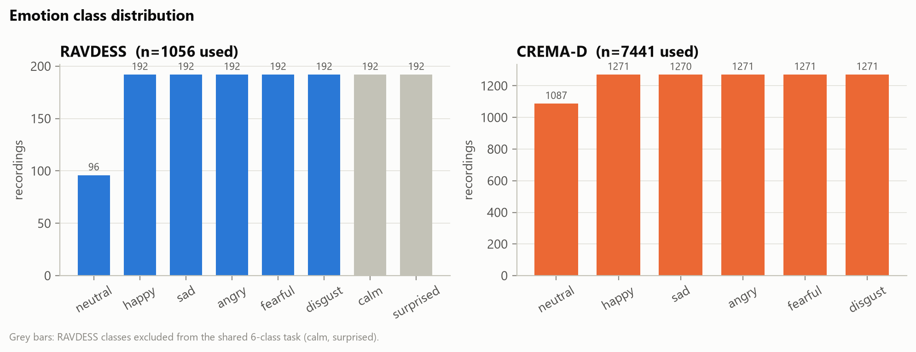
Figure 1: Emotion class distribution. Grey RAVDESS classes (calm, surprised) are not part of the six-class task.

4.2 Speaker-independent splits
In a speaker-independent evaluation, no speaker appears in more than one of the training, validation and test partitions of a fold. This matters because a model can otherwise learn to recognise voices instead of emotions. Each fold uses three disjoint speaker groups (Table 1): the training speakers fit everything that is learned, including scalers and class weights; the validation speakers are used only for choosing hyper-parameters and for early stopping; and the test speakers are predicted once, after the choice has been saved to disk. The split files were created once, checked with SHA-256 hashes and never regenerated.

4.3 Audio preprocessing
- Decode to mono and resample to 16 kHz (the rate HuBERT was trained on).
- Trim leading and trailing silence (30 dB below the peak, 50 ms margin); for RAVDESS this reduced the mean duration from 3.72 s to 1.95 s while removing a negligible fraction of the signal energy.
- Remove the DC offset and normalise the peak amplitude, so that recording gain does not act as a cue.
- Compute all frame-level features on one shared 20 ms grid (25 ms windows), so that MFCC, prosody and HuBERT frames are exactly aligned.

4.4 Feature extraction
Table 2 lists the feature streams. Features were extracted once and stored in a cache that all experiments read. One implementation decision is worth noting: the first F0 tracker we tried (pYIN) found no voiced frames at all in 10.3 % of CREMA-D recordings, and these failures were concentrated in quiet classes such as disgust and sad. Because such a class-dependent error could leak label information into the prosody features, we switched to Praat's autocorrelation tracker (60–800 Hz), which removed the problem.
Table 2: Feature streams.
Stream | Level | Dimension | Details
MFCC | frame (20 ms) | 39 | 13 coefficients + Δ + ΔΔ; 25 ms Hamming window
Prosody | frame (20 ms) | 4 | F0 (semitones), voiced flag, periodicity, energy (dB); Praat, 60–800 Hz
HuBERT-base | frame (20 ms) | 13 × 768 | frozen; stored in fp16; pooled [mean ‖ std] per layer also stored
DisVoice-103 | utterance | 103 | prosody statistics of the reference paper; ablation only

5. Overall Methodology
Figure 2 shows the complete workflow. After preprocessing, three feature streams are extracted. Each experiment uses some of them, and all experiments are evaluated on exactly the same speaker-independent folds.
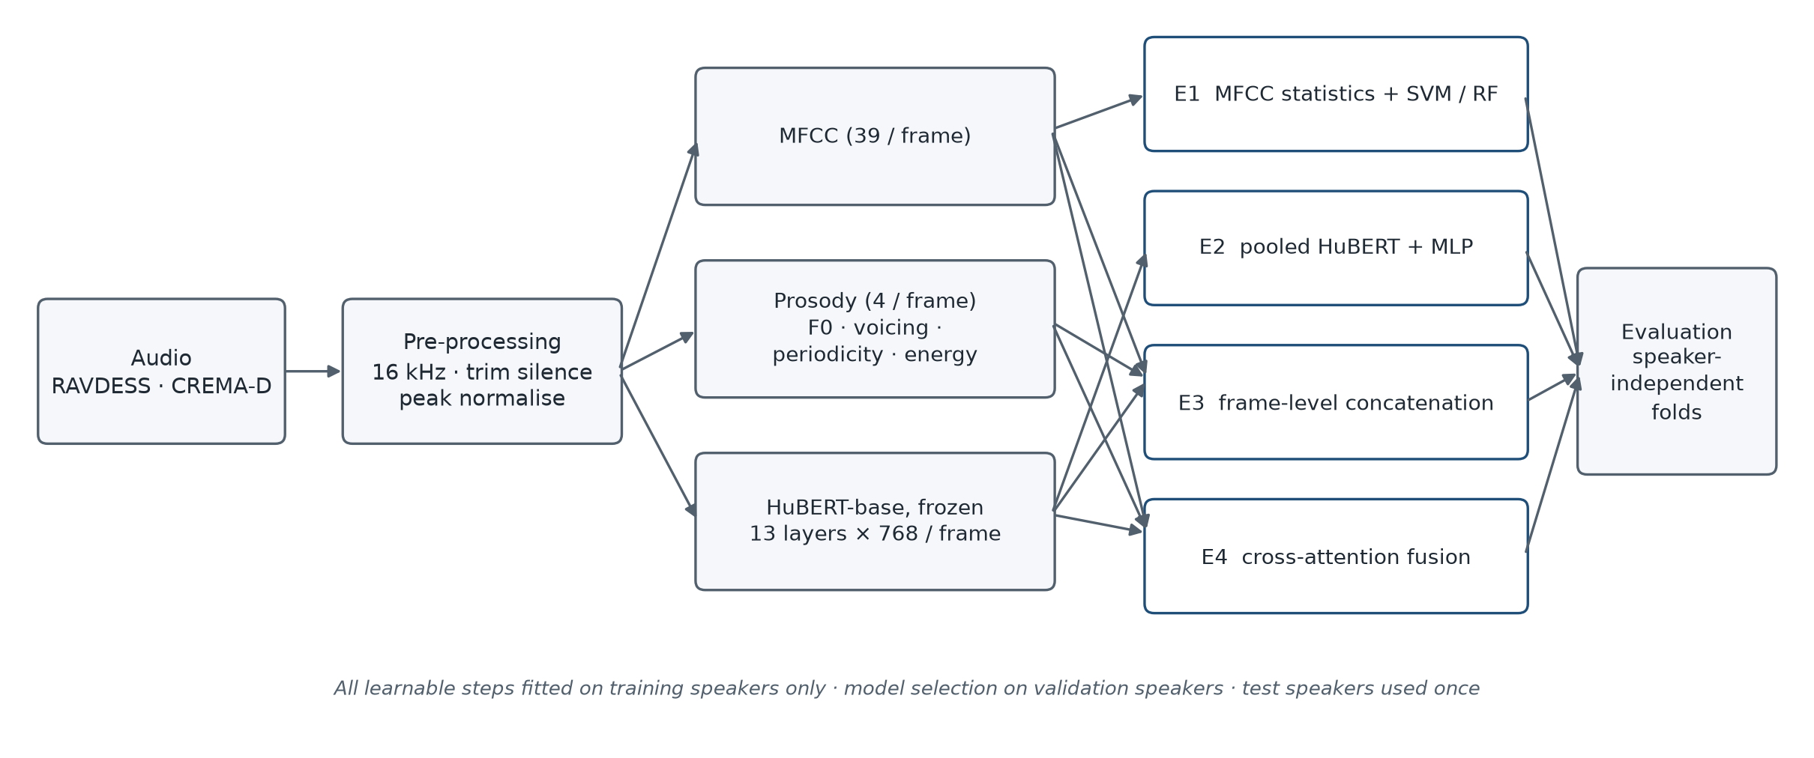
Figure 2: Overall workflow of the project.
The experiments form a progression. Each one adds one idea to the previous one, so that differences between them can be interpreted:
- E1 checks the data pipeline and gives a classical reference point.
- E2 replaces MFCC statistics with pooled HuBERT features.
- E3 keeps the frame-level sequence and adds MFCC and prosody by concatenation.
- E4 replaces concatenation with cross-attention between the streams.
The same evaluation protocol was used throughout:
- Hyper-parameters are selected on validation macro-F1 only, and the selection is written to a file before any test prediction is made.
- Each selected configuration is retrained with three random seeds (0, 1, 2); each trained model is saved, reloaded and then used to predict the test speakers once.
- Results are averaged over seeds within each fold, and the mean ± standard deviation over folds is reported.
- Model comparisons are paired by fold (the same test speakers), with the number of folds in which one model is better. Because there are only 6 and 5 folds, we use exact sign-flip tests only descriptively: the smallest possible p-value is 0.031 (RAVDESS) and 0.062 (CREMA-D), so no comparison can be significant after correction for multiple tests.

6. Experimental Models

6.1 E1 – MFCC statistics with SVM and Random Forest
Each recording's MFCC sequence is turned into a fixed vector in one of three ways: the mean (39 values), mean and standard deviation (78), or functionals (mean, standard deviation and the 10th, 50th and 90th percentiles; 195). The vector is standardised with training statistics and classified by an RBF-SVM or a Random Forest with 300 trees. The aggregation and the classifier settings are chosen together on validation data (36 candidates for the SVM and 12 for the Random Forest).

6.2 E2 – Frozen HuBERT with temporal pooling
E2 pools HuBERT hidden states over time (mean, or mean and standard deviation) and feeds the standardised vector to a one-hidden-layer MLP: z = Dropout(GELU(W₁x + b₁)), logits = W₂z + b₂. The search is done in three stages on validation data: (A) the representation, which is any of the 13 single layers, the concatenation of layers 1 and 9, or a learned weighted sum of all layers, each with two pooling options (30 candidates); (B) the head size, dropout and learning rate (8 candidates); and (C) weighted or unweighted loss (1 candidate). Depending on the selected configuration, the head has between 198,406 and 1,576,454 trainable parameters.
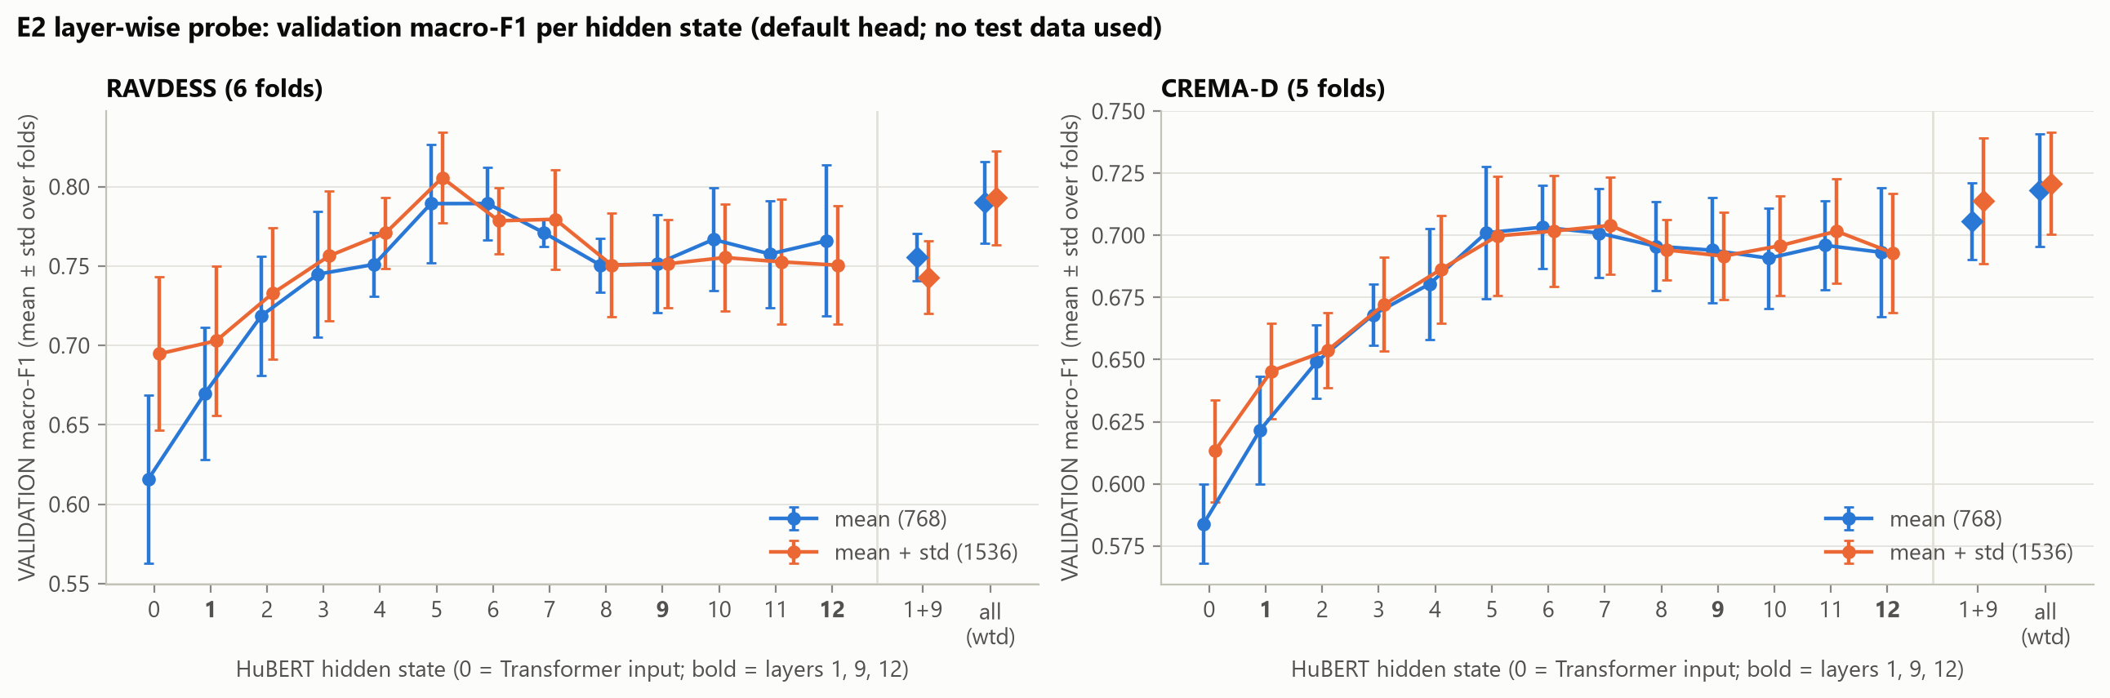
Figure 3: Layer-wise validation macro-F1 of pooled HuBERT features (E2, phase A; no test data used). Middle layers (around 5–7) work best; the learned weighted sum of all layers is strongest on CREMA-D.
Figure 3 shows that middle layers carry the most emotion information on both datasets. On RAVDESS the best single layer beat the learned weighted sum in all six folds, whereas on CREMA-D the weighted sum was equal or better in four of five folds. As a result, E2 ended up using single layers on RAVDESS and mostly multi-layer inputs on CREMA-D.

6.3 E3 – Frame-level concatenation
E3 keeps the time dimension. Each stream (HuBERT, MFCC, prosody) is projected per frame to 128 dimensions with a linear layer, layer normalisation and dropout. The three projections are concatenated, passed through a linear layer with GELU, pooled over real (non-padded) frames with mean and standard deviation, and classified by an MLP. For each fold, one HuBERT layer is used: the best single layer from that fold's own E2 validation results (RAVDESS: 6, 10, 5, 5, 5, 5; CREMA-D: 7, 6, 12, 11, 5). To measure the contribution of each stream, E3 was also trained on every subset of the streams and with the DisVoice features added.

6.4 E4 – Bidirectional cross-attention fusion
E4 (Figure 4) uses the same projections, pooling and classifier as E3, but replaces concatenation with two stages of bidirectional cross-attention. In stage 1, MFCC frames attend to prosody frames and vice versa, and the two results are fused. In stage 2, HuBERT frames attend to this fused acoustic stream and vice versa, followed by a second fusion layer and layer normalisation. The attention blocks use pre-layer-normalisation, 4 heads, a feed-forward size of 256 and masking of padded frames. E4 has 769,286 trainable parameters.
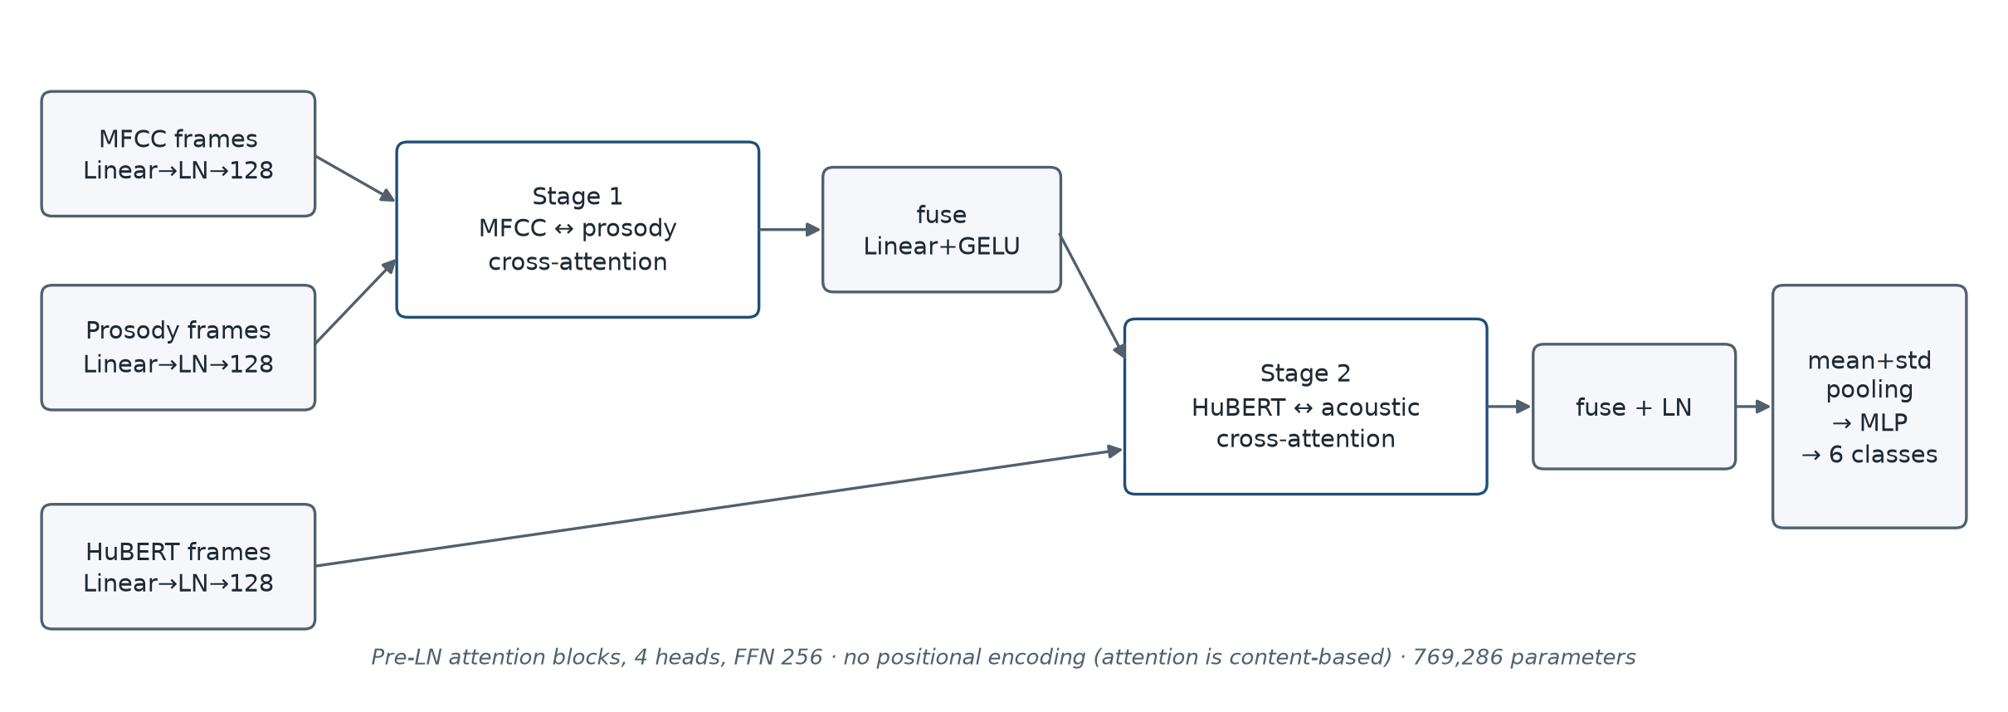
Figure 4: Structure of the E4 cross-attention model.
Important design limitation. Like the self-attention control, E4 has no positional encoding. Its attention weights therefore depend only on the content of the frames: a HuBERT frame cannot specifically prefer the MFCC frame recorded at the same moment. The shared time grid is used only by the frame-wise fusion layers. Our conclusions about E4 apply to this content-based form of cross-attention, not to every possible cross-modal attention design.

6.5 Control models and comparators
A better score for E4 could come either from interaction between the streams or simply from having more attention layers. To separate these, we built a self-attention control: the E3 model with four self-attention blocks after concatenation, with 751,750 parameters (2.3 % fewer than E4). We also trained a HuBERT-only frame model and re-trained the concatenation model, all with the same hyper-parameter search as E4. Finally, three E4 ablations remove prosody, remove MFCC, or replace the first cross-attention stage with concatenation.
Table 3: Models compared in the project.
Model | Input | Temporal treatment | Fusion | Trainable parameters
E1 SVM / RF | MFCC statistics | statistics per recording | — | SVM: support vectors
E2 | HuBERT (selected layer(s)) | pooled before the classifier | — | 198,406 – 1,576,454
HuBERT-only frame model | HuBERT layer L | per-frame projection, pooled after | — | 182,534
E3 concatenation | HuBERT + MFCC + prosody | per-frame, pooled after | concatenation | 221,574
Self-attention control | HuBERT + MFCC + prosody | per-frame, pooled after | concat + 4 self-attention blocks | 751,750
E4 | HuBERT + MFCC + prosody | per-frame, pooled after | 2-stage cross-attention | 769,286

7. Implementation Details

7.1 Software and hardware
The project is written in Python 3.12 with PyTorch 2.14.1 (CUDA 12.6), Hugging Face Transformers 5.22.1 for HuBERT, scikit-learn 1.9.1 for E1, librosa 1.0.0 for MFCC and praat-parselmouth 0.4.7 for F0. All training ran on a laptop with an NVIDIA RTX 3050 (4 GB) and 16 GB of RAM. The code is organised into modules for preprocessing, features, models, training and evaluation, with one script per experimental stage, and a pytest suite of 159 tests.

7.2 Training configuration
Table 4: Training and selection settings.
Setting | E1 | E2 | E3 | E4 and comparators
Classifier / optimiser | RBF-SVM; RF (300 trees) | AdamW, wd 1e-4 | AdamW, wd 1e-4 | AdamW, wd 1e-4
Search space | SVM: C × γ × aggregation; RF: 2 × 2 × aggregation | representation, pooling, head, dropout, lr, loss weighting | dropout {0.2, 0.4} × lr {1e-3, 3e-4} | dropout {0.2, 0.4} × lr {1e-3, 3e-4, 1e-4, 3e-5}
Candidates per fold | 36 (SVM), 12 (RF) | 39 | 4 per tuned model | 8 per tuned model
Batch / max epochs / patience | — | 32 / 50 / 10 | 32 / 50 / 10 | 32 / 150 / 10
Gradient clipping | — | none | norm 1.0 | norm 1.0
Loss | class-balanced | weighted CE (or unweighted, selected) | class-weighted CE | class-weighted CE
Final seeds | SVM 1 (deterministic); RF 3 | 3 | 3 | 3

The E4 learning-rate grid is wider than E3's because, in E3, the self-attention control chose the smallest learning rate in all 11 folds, which suggested it was under-tuned. The wider grid was fixed before any E4 test prediction and was applied equally to E4, the control, concatenation and the HuBERT-only model.

7.3 Reproducibility and integrity checks
- Determinism. Seeds are set before each model is built and deterministic GPU algorithms are enabled, so a run can be repeated exactly. This was confirmed several times: for example, the E4 runs reproduced the earlier E3 runs with identical settings bit for bit.
- Leakage audits. Automated audits re-checked every saved artefact: E2 passed 28/28 checks, E3 36/36 and E4 41/41. Among other things, they confirm that selections were made before test predictions and that every checkpoint re-predicts its saved test predictions exactly.
- Label-permutation controls. Each pipeline was retrained with shuffled training labels; test macro-F1 stayed near chance (0.140–0.187, chance = 0.167), which rules out leakage through the data path.
- Isolation tests. Unit tests replace test-set features with NaN and check that model selection is unchanged.
- Memory handling. HuBERT frames for CREMA-D occupy about 17.6 GB, more than the available RAM. Only the one selected layer is loaded per fold, in chunks. Two CREMA-D runs were interrupted by the host system because memory ran low (once in E3 and once in E4, in both cases while the first CREMA-D data were being loaded and before any further training). They were resumed with unchanged settings under a script that stops a run if available memory falls below 1 GB, and integrity checks confirmed that no completed result had changed.

8. Experimental Results and Comparison

8.1 Overall results
Table 5 gives the test results of all main models and Figure 5 shows the score of every fold. The ranking is the same on both datasets: E2 is clearly best, the frame-level HuBERT models are close to each other and about 0.02–0.04 below E2, and the MFCC baseline is far behind. E2 was the best of the seven main models in 4 of 6 RAVDESS folds and in all 5 CREMA-D folds.
Table 5: Test results (mean ± standard deviation over folds; each fold averaged over 3 seeds). The last four rows use the same 8-candidate search.
Model | RAVDESS macro-F1 | RAVDESS UA | RAVDESS acc. | CREMA-D macro-F1 | CREMA-D UA | CREMA-D acc.
E1 SVM | 0.537 ± 0.059 | 0.543 ± 0.061 | 0.549 ± 0.061 | 0.503 ± 0.021 | 0.509 ± 0.020 | 0.507 ± 0.021
E1 Random Forest | 0.493 ± 0.032 | 0.503 ± 0.039 | 0.512 ± 0.032 | 0.457 ± 0.028 | 0.481 ± 0.023 | 0.478 ± 0.024
E2 pooled HuBERT | 0.762 ± 0.054 | 0.771 ± 0.052 | 0.764 ± 0.057 | 0.713 ± 0.030 | 0.714 ± 0.029 | 0.712 ± 0.029
E3 concatenation | 0.729 ± 0.064 | 0.735 ± 0.061 | 0.737 ± 0.068 | 0.695 ± 0.027 | 0.697 ± 0.026 | 0.694 ± 0.026
HuBERT-only frame | 0.736 ± 0.046 | 0.740 ± 0.047 | 0.745 ± 0.056 | 0.688 ± 0.028 | 0.691 ± 0.026 | 0.688 ± 0.027
Concatenation | 0.726 ± 0.061 | 0.733 ± 0.056 | 0.735 ± 0.065 | 0.694 ± 0.028 | 0.696 ± 0.027 | 0.693 ± 0.028
Self-attn control | 0.730 ± 0.043 | 0.739 ± 0.037 | 0.743 ± 0.052 | 0.686 ± 0.026 | 0.689 ± 0.026 | 0.686 ± 0.026
E4 cross-attention | 0.723 ± 0.061 | 0.729 ± 0.058 | 0.733 ± 0.067 | 0.674 ± 0.023 | 0.676 ± 0.024 | 0.674 ± 0.023

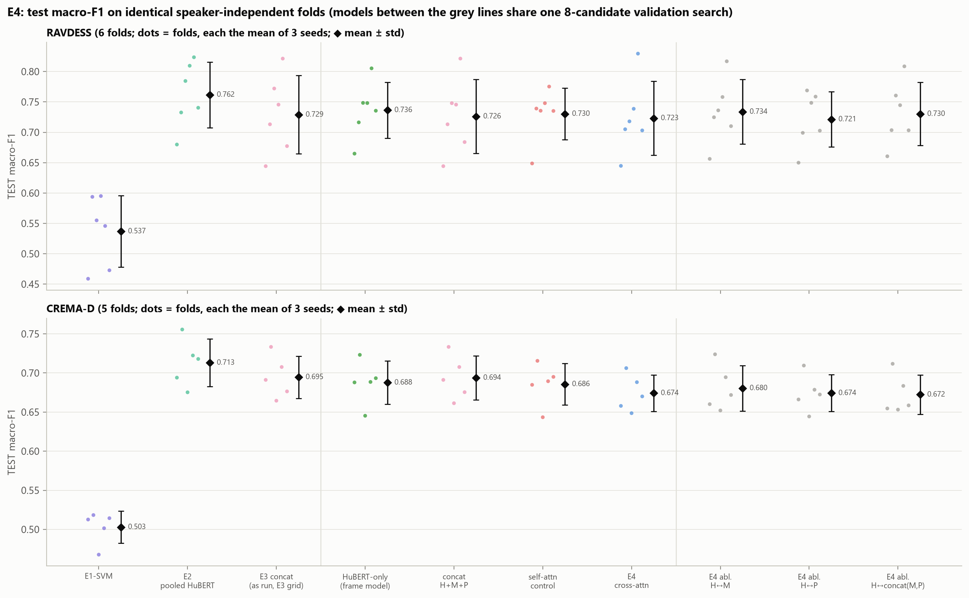
Figure 5: Test macro-F1 per fold (dots, each the mean of 3 seeds) and mean ± standard deviation (diamonds) for all models on identical folds.
Two observations stand out in Figure 5. First, the spread across folds is large on RAVDESS, where each test fold contains only four speakers; differences of 0.01–0.02 between models are therefore smaller than the fold-to-fold variation. Second, adding more structure to the frame-level model, from concatenation to self-attention to cross-attention, does not move the scores upwards.

8.2 E1 versus E2: the value of HuBERT
Replacing MFCC statistics with pooled HuBERT features improved macro-F1 by +0.225 on RAVDESS and +0.210 on CREMA-D, in every fold. The improvement holds for every emotion class (+0.10 to +0.36 F1 per class). The MFCC baseline still performs well above chance, and its errors are mostly between emotions with similar arousal, such as neutral and sad.

8.3 E3: contribution of each feature stream
Table 6 shows the E3 ablations. Removing HuBERT costs 0.18 (RAVDESS) and 0.12 (CREMA-D) macro-F1 in every fold, so HuBERT carries most of the useful information. MFCC and prosody are clearly informative on their own: together they reach 0.549 and 0.577, which is above the E1 SVM. However, once HuBERT is present, adding them changes the result by −0.018 on RAVDESS (worse in all six folds) and +0.010 on CREMA-D (better in four of five folds, which is about the size of seed-to-seed variation). DisVoice-103 did not help consistently.
Table 6: E3 stream ablations (test macro-F1, mean over folds). H = HuBERT, M = MFCC, P = prosody.
Streams | RAVDESS | CREMA-D
H + M + P (E3) | 0.729 | 0.695
H | 0.747 | 0.685
H + M | 0.743 | 0.690
H + P | 0.749 | 0.692
M + P | 0.549 | 0.577
M | 0.482 | 0.546
P | 0.349 | 0.411
H + M + P + DisVoice-103 | 0.734 | 0.691
H + M + P + DisVoice-103 + missingness indicators | 0.721 | 0.683

We also computed Shapley values, which distribute the score of the full model among the three streams by averaging each stream's marginal contribution over all subsets. HuBERT receives 0.364 (RAVDESS) and 0.283 (CREMA-D), MFCC 0.131 and 0.156, and prosody 0.068 and 0.090. These values should be read with care: the MFCC and prosody shares come mostly from subsets that do not contain HuBERT, so they do not mean that these streams add that much to E3. Figure 6 shows the paired per-fold differences behind these numbers.
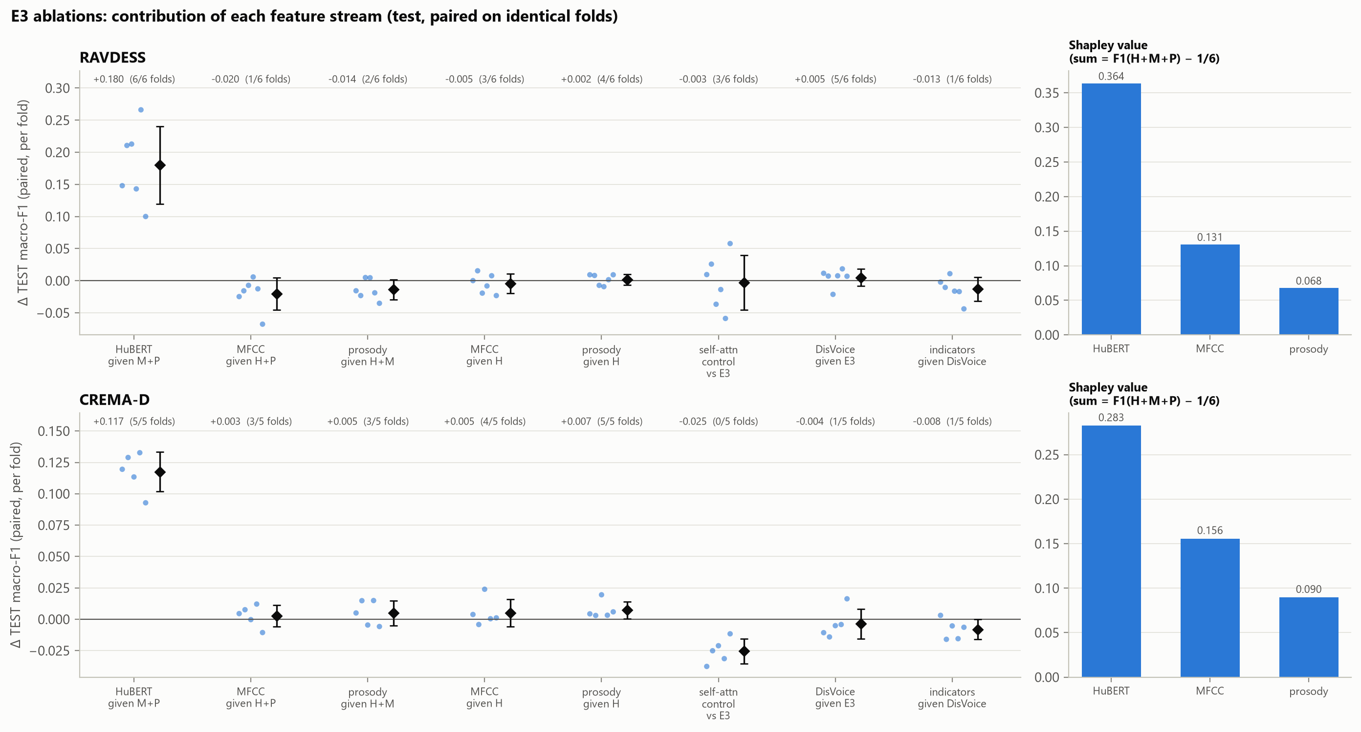
Figure 6: E3 ablations: paired per-fold differences in test macro-F1 (left) and Shapley values per stream (right).

8.4 E4: cross-attention versus the other models
Table 7 summarises the paired comparisons that were fixed before E4 was tested. The rule required E4 to be better on average on both datasets, better in at least 5 of 6 RAVDESS folds and 4 of 5 CREMA-D folds, and better by more than the seed-to-seed variation. None of the three comparisons met this rule; in fact, every average difference is negative. On CREMA-D, E4 was below concatenation in all five folds.
Table 7: Paired differences in test macro-F1 (folds in which E4 is better in brackets).
Comparison | RAVDESS | CREMA-D | Verdict
E4 − concatenation | −0.003 (3/6) | −0.020 (0/5) | no consistent improvement
E4 − self-attention control | −0.007 (1/6) | −0.012 (1/5) | no consistent improvement
E4 − HuBERT-only frame model | −0.013 (1/6) | −0.014 (1/5) | no consistent improvement
E4 − E2 | −0.039 (1/6) | −0.039 (0/5) | —

The ablations of E4 point in the same direction. Removing prosody from E4 slightly improved the score (by 0.011 and 0.006), removing MFCC changed almost nothing, and replacing the first cross-attention stage with concatenation made no consistent difference. With identical inputs, replacing concatenation by cross-attention lowered CREMA-D macro-F1 by 0.021, in all five folds. The self-attention control was not better than concatenation either (+0.004 on RAVDESS, −0.008 on CREMA-D), so extra attention capacity alone did not help. The wider learning-rate grid helped only the control, which had been under-tuned in E3 (+0.016 on CREMA-D).
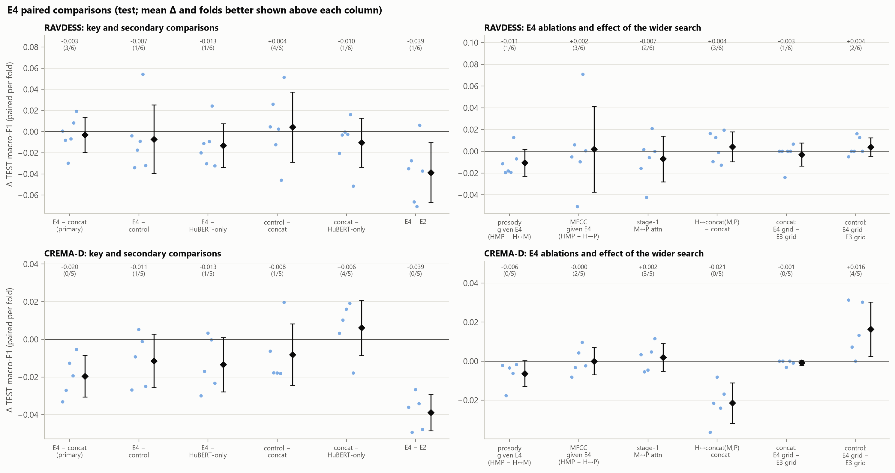
Figure 7: Paired per-fold differences in test macro-F1 for E4 and its comparators (left) and for the E4 ablations and the wider search (right).

8.5 Per-class results
Table 8 compares E2 and E4 for each emotion, and Figure 8 adds precision, recall and the per-fold differences. On CREMA-D, E4 is lower than E2 for every class; the largest drop is for happy (−0.066), which is also the class on which E4 loses against concatenation and the HuBERT-only model in all five folds. On RAVDESS, the gap is concentrated on neutral (−0.100; recall falls from 0.85 to 0.68). The HuBERT-only frame model shows almost the same neutral loss (−0.096), so this loss comes from the frame-level pipeline rather than from fusion.
Table 8: Per-class test F1 of E2 and E4 (mean over folds and seeds).
Class | RAVDESS E2 | RAVDESS E4 | Δ (folds E4 better) | CREMA-D E2 | CREMA-D E4 | Δ (folds E4 better)
neutral | 0.765 | 0.664 | −0.100 (0/6) | 0.781 | 0.749 | −0.032 (1/5)
happy | 0.754 | 0.712 | −0.042 (2/6) | 0.732 | 0.666 | −0.066 (0/5)
sad | 0.655 | 0.628 | −0.027 (2/6) | 0.643 | 0.605 | −0.038 (0/5)
angry | 0.816 | 0.816 | +0.000 (3/6) | 0.807 | 0.779 | −0.028 (0/5)
fearful | 0.734 | 0.704 | −0.030 (1/6) | 0.646 | 0.599 | −0.047 (0/5)
disgust | 0.847 | 0.814 | −0.033 (2/6) | 0.669 | 0.647 | −0.022 (0/5)

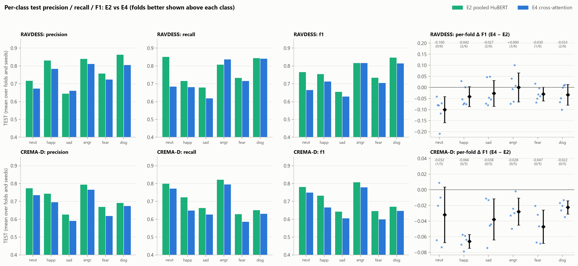
Figure 8: Per-class test precision, recall and F1 for E2 and E4, and per-fold F1 differences (E4 − E2).

8.6 Confusion matrices
Figure 9 shows the confusion matrices of E2 and E4 and their difference. The main confusions are the same for both models and also for the MFCC baseline: fearful is often predicted as sad, and sad, disgust and neutral are confused with one another. These are all lower-arousal or negative emotions. Fusion did not reduce this confusion; on RAVDESS, E4 mainly shifted errors between sad and fearful. On the same test recordings, only E2 was correct for 9.9 % (RAVDESS) and 11.6 % (CREMA-D) of recordings, while only E4 was correct for 6.8 % and 7.8 %. When both models were wrong, they usually predicted the same wrong label.
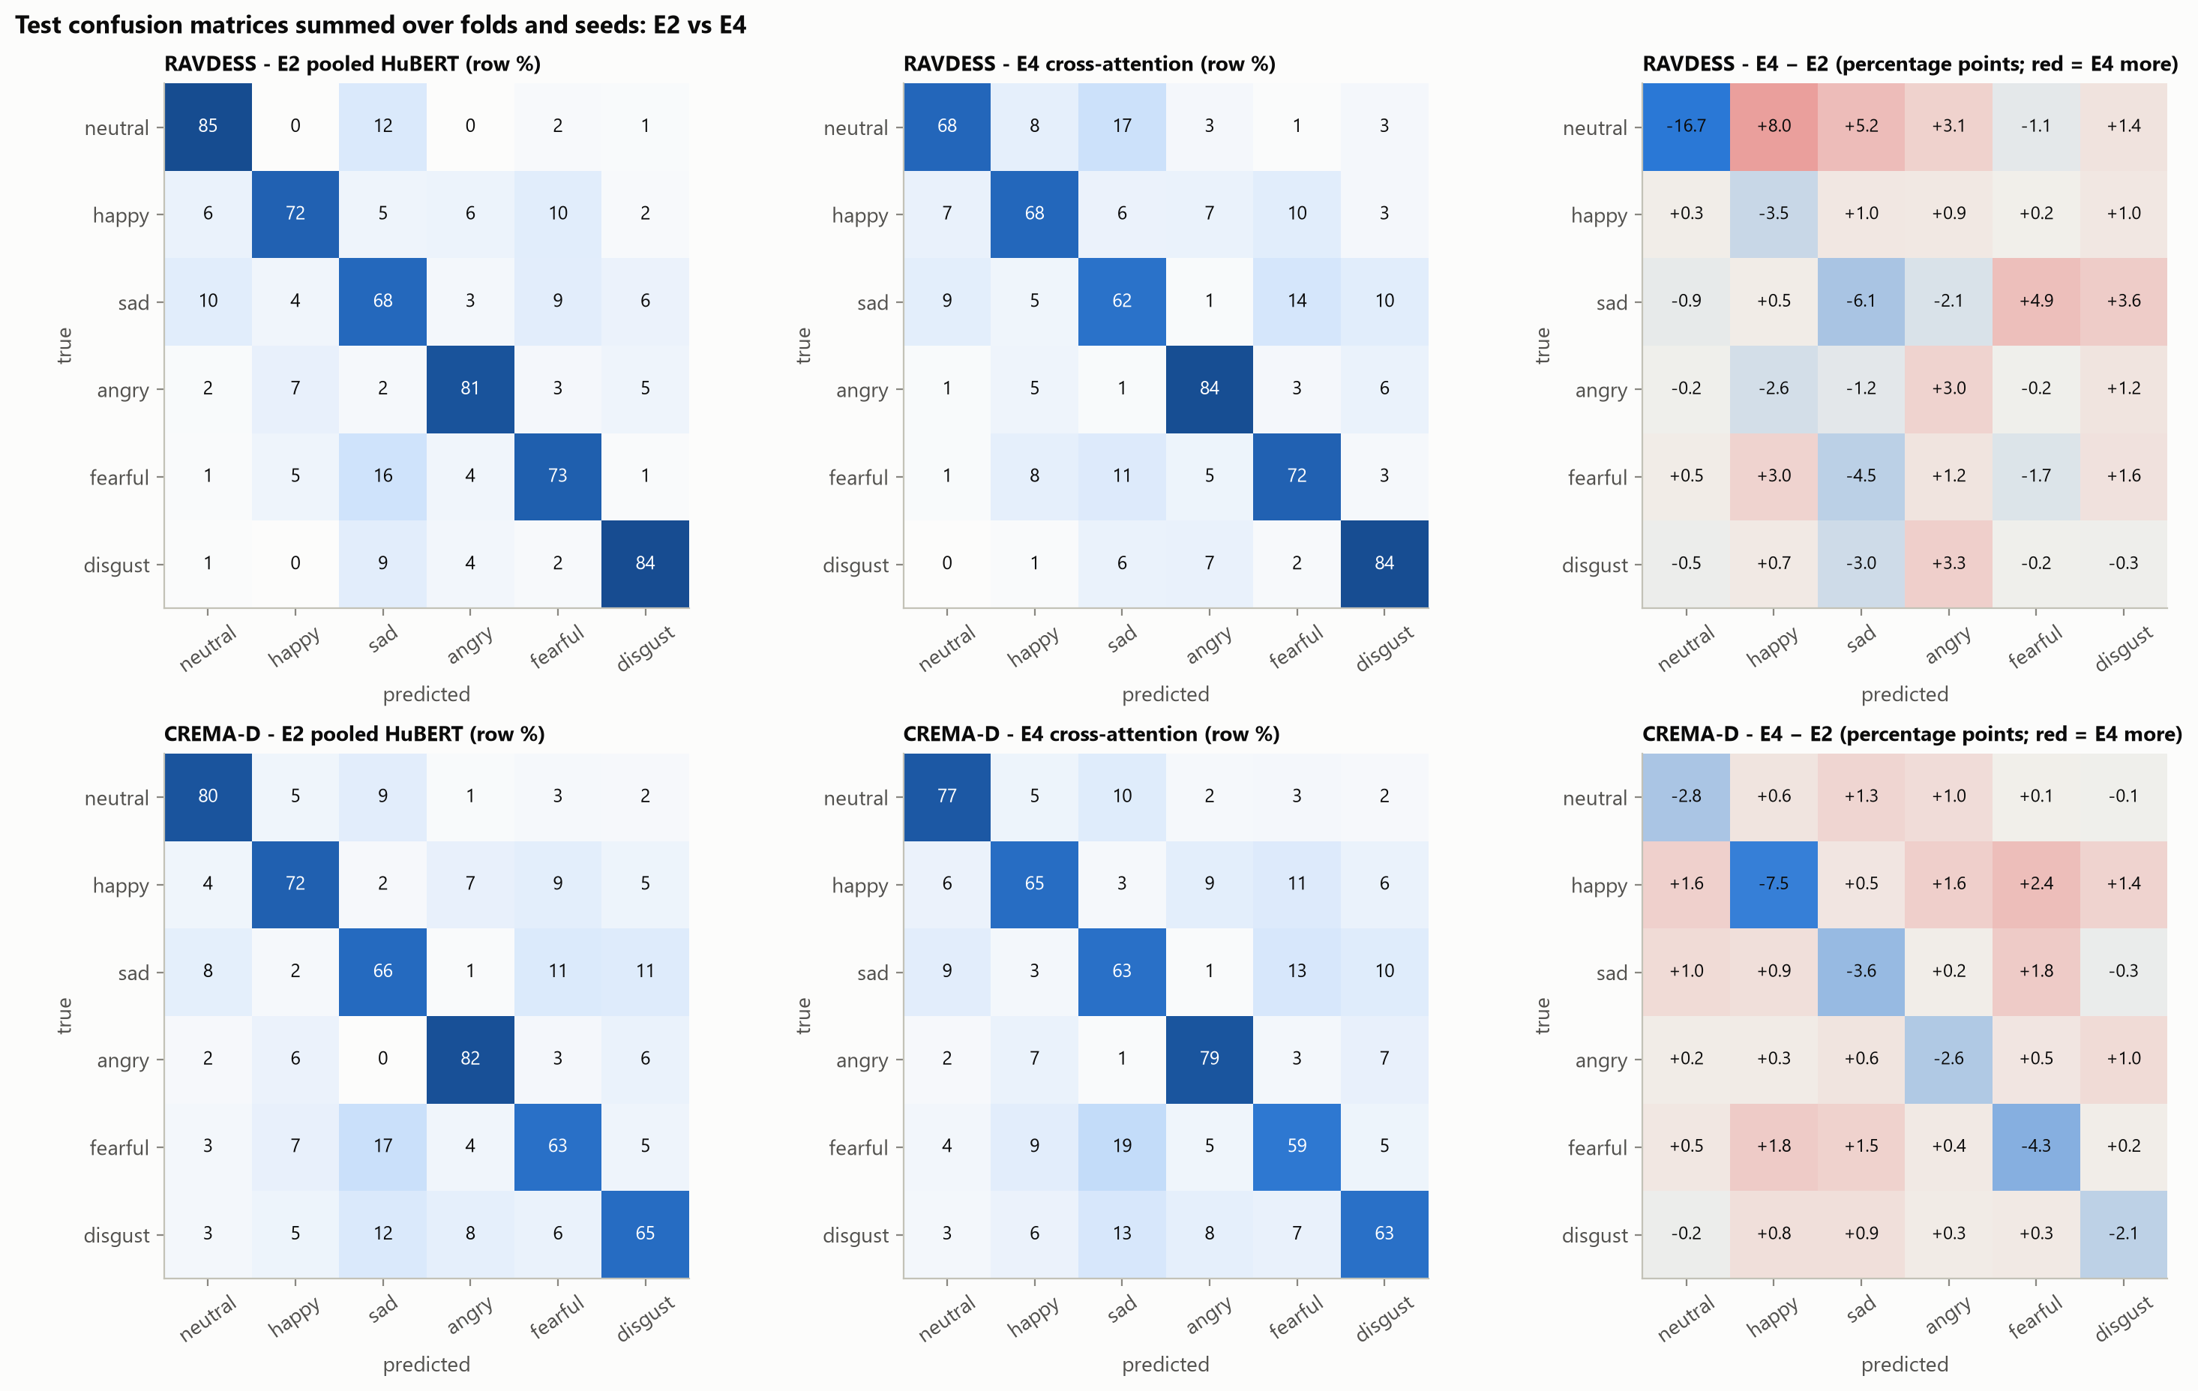
Figure 9: Test confusion matrices (row percentages, summed over folds and seeds) for E2 and E4, and their difference (E4 − E2).

8.7 Computational cost
Table 9 compares the classifier stage of each model. HuBERT feature extraction is shared by E2–E4 and was not timed, so it is not included. E2 is both the most accurate HuBERT model and the cheapest to train. The attention models need about four times the inference time of the frame models without attention, and E4 needs 14 to 22 times the median training time of E2 per run, without any gain in accuracy (Figure 10). In total, all logged training runs of E4 took about 6.7 hours, against about 0.4 hours for E2.
Table 9: Computational cost of the classifier stage (R = RAVDESS, C = CREMA-D).
Model | Parameters | Median training s / run (R / C) | Inference ms / recording (R / C) | GPU peak MiB (R / C)
E1 SVM (CPU) | — | 0.04 / 1.7 | 0.07 / 0.45 | —
E2 | 198 k – 1.58 M | 0.70 / 6.4 | 0.04 / 0.07 | 85 / 759
HuBERT-only frame | 182,534 | 2.8 / 22.9 | 0.05 / 0.05 | 316 / 1,613
Concatenation | 221,574 | 5.3 / 27.0 | 0.07 / 0.06 | 316 / 1,614
Self-attn control | 751,750 | 18.5 / 129.5 | 0.25 / 0.26 | 693 / 2,074
E4 | 769,286 | 15.1 / 91.0 | 0.26 / 0.27 | 715 / 2,098

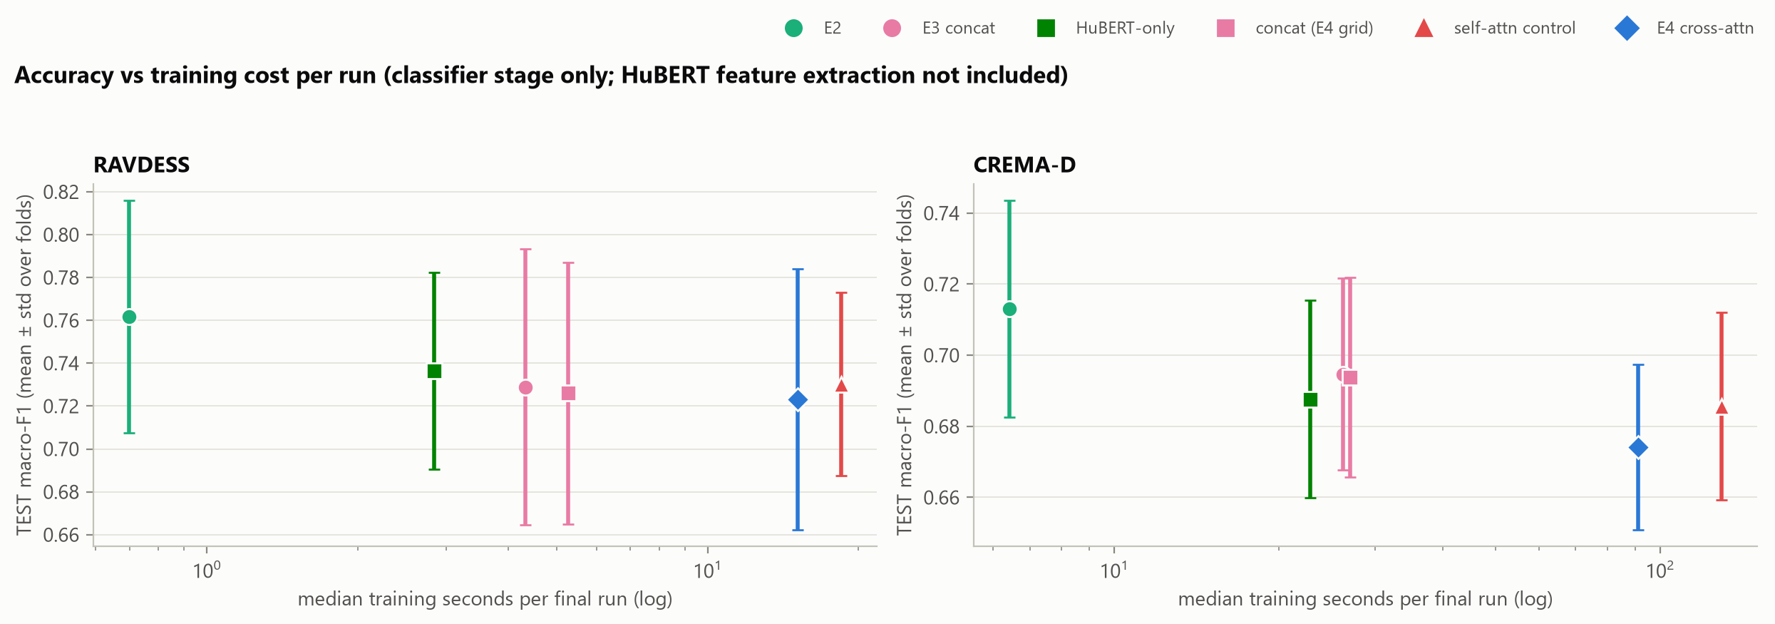
Figure 10: Test macro-F1 against median training time per run (classifier stage only). CREMA-D GPU figures for frame models include the 1.35 GB HuBERT layer held on the GPU.

9. Discussion and Observations

9.1 The strongest model is not the most sophisticated one
The clearest outcome of the project is that the simplest HuBERT model performed best. E2 has no attention, no frame-level modelling and a single hidden layer, yet it outperformed every frame-level model, including the cross-attention model that has the most components and the highest training cost. E4 was also the least stable model across random seeds (mean within-fold standard deviation 0.034 on RAVDESS and 0.012 on CREMA-D, against 0.011 and 0.006 for E2).

9.2 Why did fusion not help?
What we measured: removing HuBERT hurts a lot, while adding MFCC and prosody to HuBERT changes little or makes the model slightly worse; extra self-attention capacity does not help; and cross-attention is below concatenation on CREMA-D. The trained models do use MFCC and prosody: in a supplementary test where these features were swapped between recordings, 10–27 % of predictions changed. They simply do not gain accuracy from them.
Our interpretation: for these six acted emotions, HuBERT already seems to encode most of the spectral and prosodic information that MFCC and prosody provide, so fusion mostly adds redundant inputs. A possible reason why fusion even hurts on RAVDESS is that it has only 704 training recordings per fold, so additional input dimensions may add variance. We did not test this explanation directly.

9.3 Why is pooled HuBERT better than frame-level HuBERT?
We do not know for certain. On RAVDESS, E2 used the same single HuBERT layer as the HuBERT-only frame model in every fold and was still better in all six folds, so the gap is not only about layer choice. Several differences between the two pipelines could contribute: E2 could combine several layers (and did so on CREMA-D); the frame models compress each frame to 128 dimensions with a per-frame normalisation before pooling; the frame models use gradient clipping; E2 searched 39 candidate configurations against 8; and E2 could choose an unweighted loss and a wider head. These are hypotheses. A controlled follow-up study was designed to test them one at a time, but it was not run (Section 11). It is also worth noting that both approaches ignore the order of frames, so the comparison is between two order-free summaries of an utterance rather than between temporal and non-temporal modelling.

9.4 Relation to the reference paper
Our results do not confirm or contradict the gains reported by Zhao et al. [1], because our datasets, protocol and architecture details are different and we did not test cross-lingual transfer. What our results show is narrower: under a strict speaker-independent protocol, with a strong pooled-HuBERT baseline, a capacity-matched control and equal hyper-parameter search, fusion did not improve on HuBERT for these two corpora.

9.5 Lessons from the process
- A strong single-representation baseline is essential before claiming that fusion helps.
- Control models with matched capacity and equal search budgets change the interpretation of results.
- Validation-only selection matters: on RAVDESS, validation scores were 0.02–0.05 higher than test scores, because choosing the best of many candidates on four validation speakers is optimistic.
- Automated audits and determinism checks made it possible to restart interrupted runs safely and to trust that the final numbers were not affected.

10. Limitations
- Data. Only two acted English datasets were used, and RAVDESS contains only two sentences. There is no cross-corpus or cross-lingual evaluation, so the results may not transfer to spontaneous speech.
- Statistics. With 6 and 5 folds, statistical power is low and folds share training speakers, so they are not independent. We report consistency across folds rather than statistical significance.
- Representation. HuBERT-base was used frozen; fine-tuning was not explored. The frame-level models used one HuBERT layer per fold.
- Comparability. E2 and the frame-level models differ in more than one respect (layer combination, search breadth, clipping, loss weighting, bottleneck), so the reason for E2's advantage remains open.
- Tuning. Some selected learning rates lie at the edge of the search grid, and the ablation models reuse the hyper-parameters of the full model instead of being tuned separately.
- Attention design. E4 has no positional encoding, so position-aware cross-attention was not tested.
- Cost measurements. Only the classifier stage was timed; HuBERT feature extraction time was not recorded.

11. Conclusion and Future Scope

11.1 Conclusion
We built and evaluated four speech emotion recognition systems on RAVDESS and CREMA-D using a speaker-independent, validation-only protocol. Frozen HuBERT features improved on MFCC statistics by more than 0.2 macro-F1. However, fusing HuBERT with MFCC and prosody, either by frame-level concatenation or by bidirectional cross-attention, did not improve on HuBERT alone, and a parameter-matched self-attention model did not help either. The best model was the simplest one: pooled HuBERT with a small MLP (0.762 and 0.713 macro-F1). For these datasets, the quality of the speech representation mattered far more than the complexity of the fusion architecture.

11.2 Future scope
The experiments were completed up to E4. A diagnostic study (the G-study) was designed to explain why pooled HuBERT outperforms the frame-level models by changing one factor at a time: multi-layer input, per-frame normalisation and projection size, gradient clipping and search budget. Its implementation passed validation-only reproduction checks, but the study was cancelled by a scope decision and no G-study training or test evaluation was performed. Possible future directions are:
- running the controlled one-factor study described above;
- adding MFCC and prosody statistics to the pooled HuBERT vector of E2, which is a cheaper test of complementarity;
- testing position-aware or windowed cross-attention that can use the time alignment between streams;
- evaluating across corpora (training on one dataset and testing on the other);
- using repeated cross-validation to make small differences measurable; and
- targeted work on the difficult classes (neutral, sad, fearful, disgust).

References
[1] R. Zhao et al., "Leveraging Cross-Attention Transformer and Multi-Feature Fusion for Cross-Linguistic Speech Emotion Recognition," arXiv:2501.10408, 2025.
[2] W.-N. Hsu, B. Bolte, Y.-H. H. Tsai, K. Lakhotia, R. Salakhutdinov and A. Mohamed, "HuBERT: Self-Supervised Speech Representation Learning by Masked Prediction of Hidden Units," IEEE/ACM Transactions on Audio, Speech, and Language Processing, vol. 29, 2021.
[3] S.-W. Yang et al., "SUPERB: Speech Processing Universal PERformance Benchmark," in Proc. Interspeech, 2021.
[4] A. Vaswani et al., "Attention Is All You Need," in Advances in Neural Information Processing Systems, 2017.
[5] S. R. Livingstone and F. A. Russo, "The Ryerson Audio-Visual Database of Emotional Speech and Song (RAVDESS)," PLoS ONE, vol. 13, no. 5, 2018.
[6] H. Cao, D. G. Cooper, M. K. Keutmann, R. C. Gur, A. Nenkova and R. Verma, "CREMA-D: Crowd-sourced Emotional Multimodal Actors Dataset," IEEE Transactions on Affective Computing, vol. 5, no. 4, 2014.
[7] S. Davis and P. Mermelstein, "Comparison of Parametric Representations for Monosyllabic Word Recognition in Continuously Spoken Sentences," IEEE Transactions on Acoustics, Speech, and Signal Processing, vol. 28, no. 4, 1980.
[8] P. Boersma and D. Weenink, "Praat: doing phonetics by computer," computer program, www.praat.org.
[9] Y. Jadoul, B. Thompson and B. de Boer, "Introducing Parselmouth: A Python interface to Praat," Journal of Phonetics, vol. 71, 2018.
[10] C. Cortes and V. Vapnik, "Support-Vector Networks," Machine Learning, vol. 20, 1995.
[11] L. Breiman, "Random Forests," Machine Learning, vol. 45, 2001.
[12] I. Loshchilov and F. Hutter, "Decoupled Weight Decay Regularization," in Proc. ICLR, 2019.
[13] F. Pedregosa et al., "Scikit-learn: Machine Learning in Python," Journal of Machine Learning Research, vol. 12, 2011.
[14] A. Paszke et al., "PyTorch: An Imperative Style, High-Performance Deep Learning Library," in Advances in Neural Information Processing Systems, 2019.
[15] Y. Bengio and Y. Grandvalet, "No Unbiased Estimator of the Variance of K-Fold Cross-Validation," Journal of Machine Learning Research, vol. 5, 2004.

Appendix: Project repository
All code, configurations, results and figures are available in the project repository (github.com/ArcXtreme/SER). The detailed experimental report is reports/stage5_models.md, and every decision and run is recorded in experiments/LOG.md. Datasets are not included and must be downloaded separately.

