**4.1 Questions**

**Question 1**

**clear all, close all:** Clears the workspace of all variables and closes all open figure windows.

**T = 1; ts = 0.01:** Sets T, the total time horizon, to 1 second, and ts, the discretization time (or time step), to 0.01 seconds.

**t = 0:ts:T:** Creates a time vector t that starts at 0, increments in steps of ts (0.01 seconds), and ends at T (1 second).

**phi = 0:** Sets the phase shift phi of the sinusoid to 0.

**u = sin(2*pi*t + phi):** Generates the sinusoidal sequence u. The frequency of the sinusoid is 1 Hz, as indicated by the 2*pi*t term.

**figure, hold on, stem(t,u,’k’):** Opens a new figure window, holds it for multiple plots, and plots the sequence u against time t using black ('k') stems.

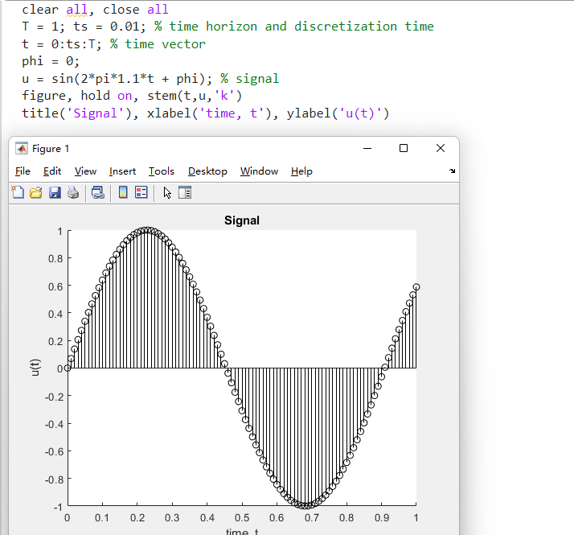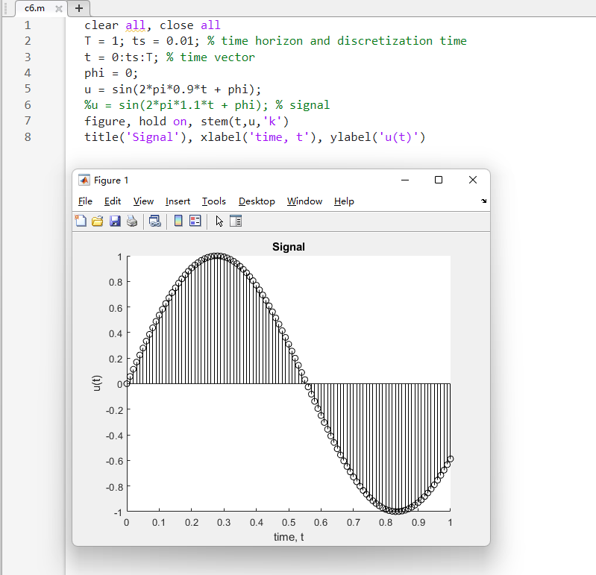

When you change the frequency, the number of oscillations in the given time interval will change accordingly. A higher frequency results in more oscillations per unit time, and vice versa.

Comparing the sequences generated with different frequencies will illustrate how changing the frequency affects the sinusoidal waveform.

Question 2

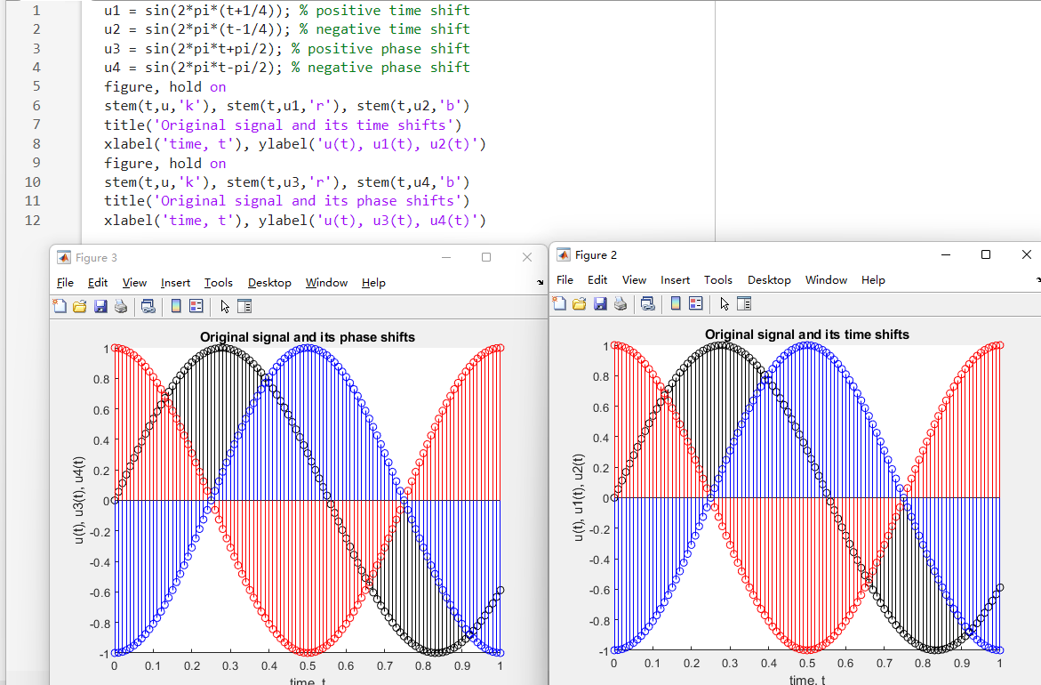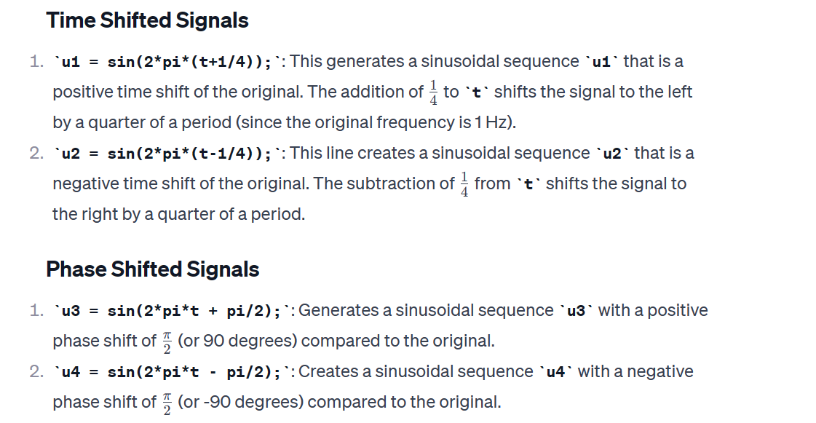

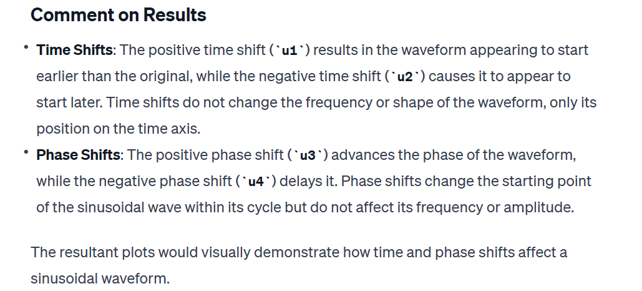

Question 3

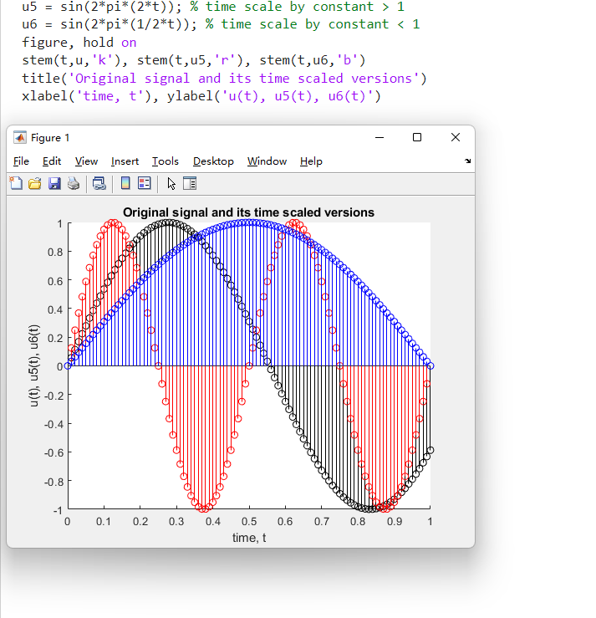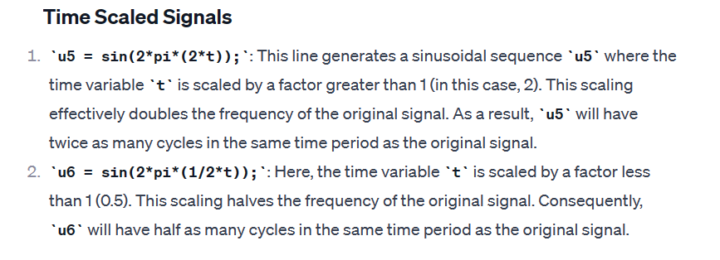

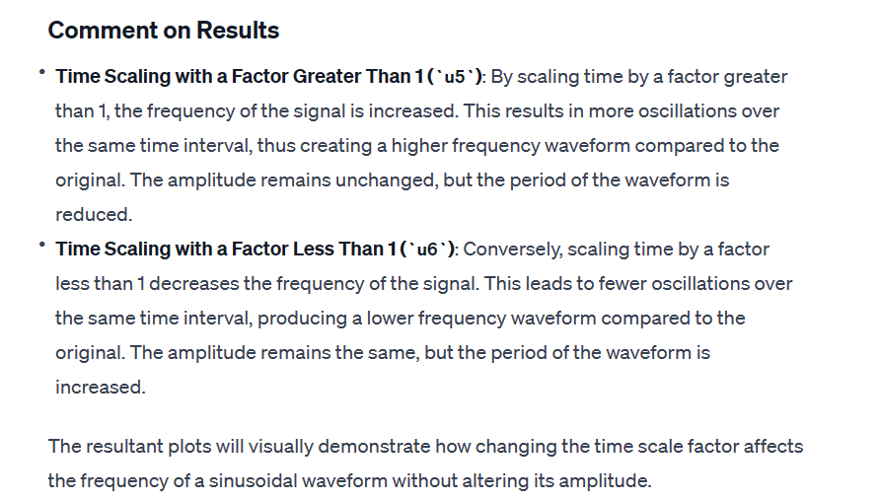

5.1

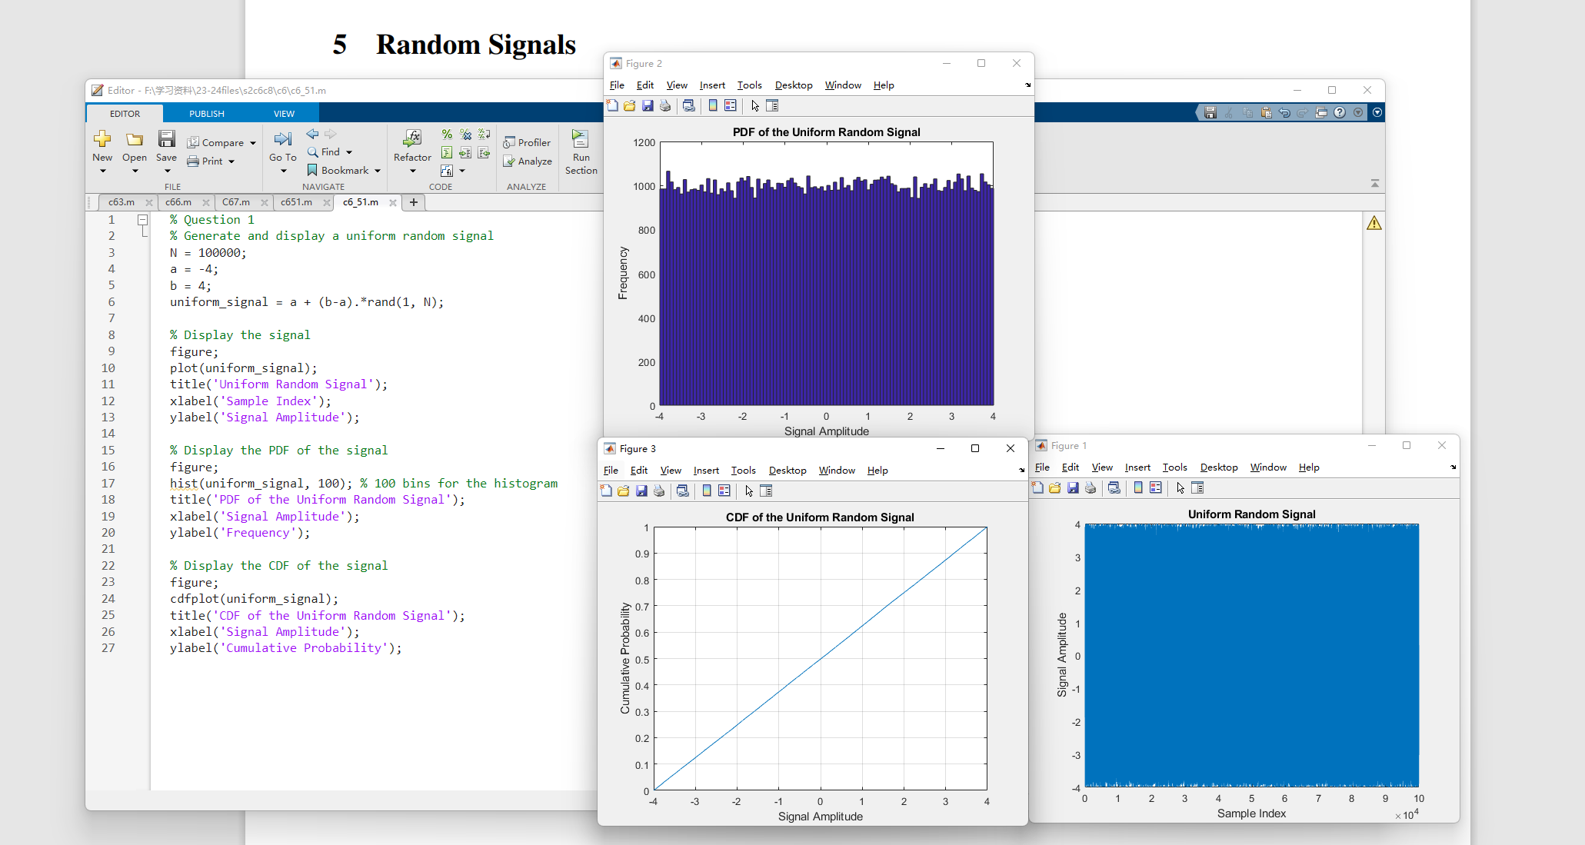

5.2

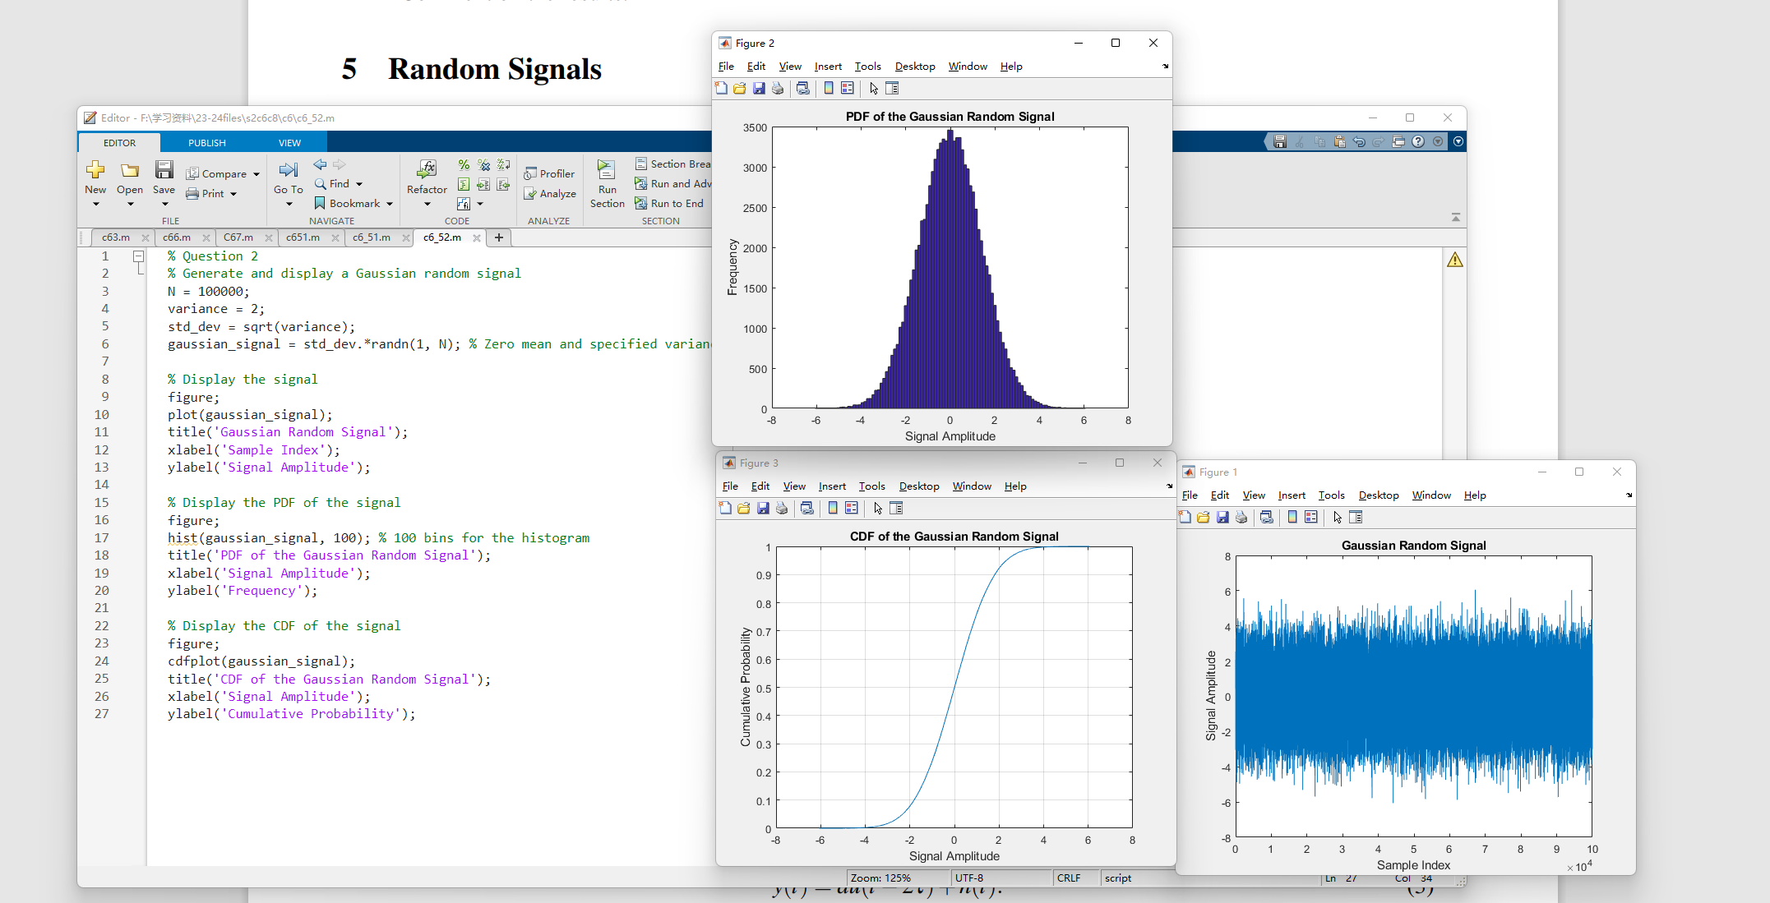

5.3

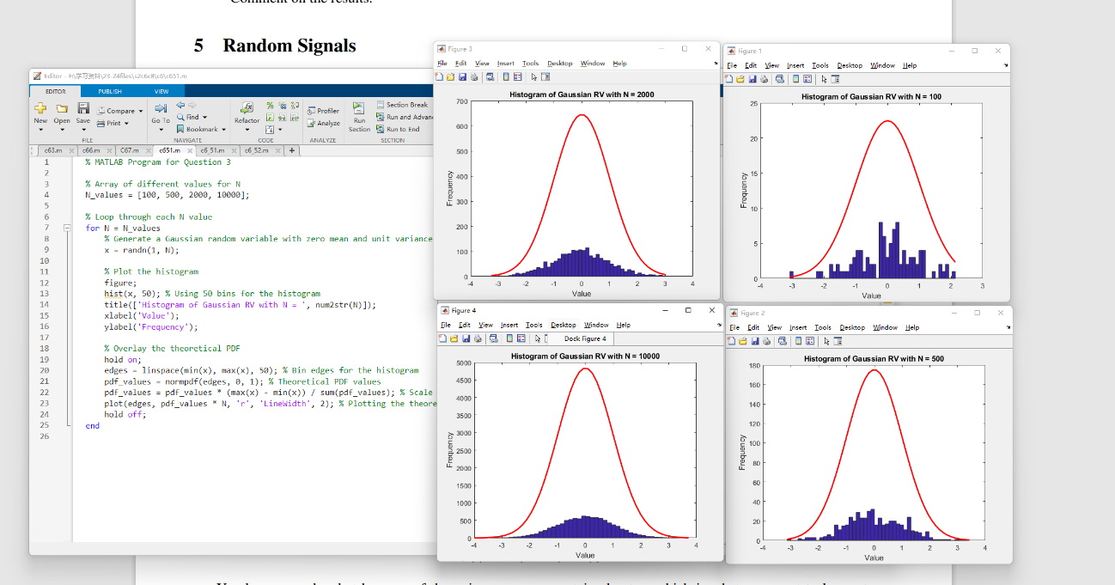

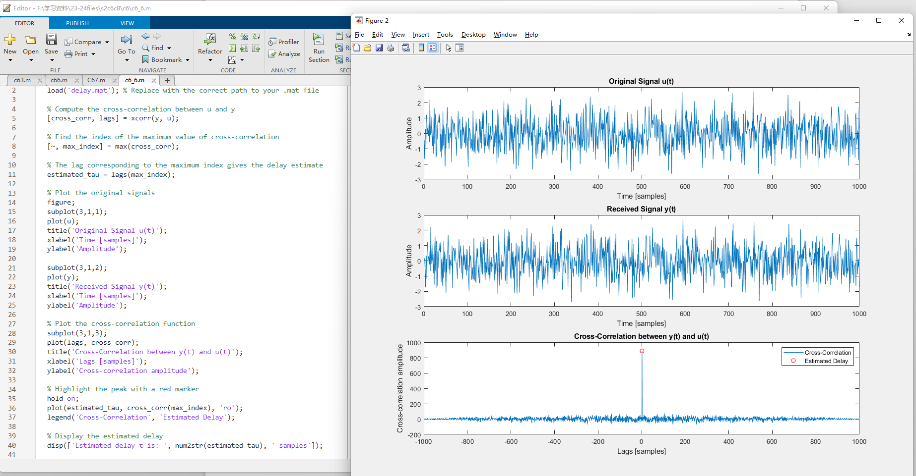6

7

