**Software Requirements Specification**

**for**

**CineTicket**

**Version 1.0**

**Prepared by**

**18050111011 Orhan Kaya**

**17050111030 Ceyda Patır**

**18050111021 Ismail Sancar Bal**

**19050151002 Aydın BAŞKARA**

**<date created>**

**Table of Contents**

**Table of Contents ii**

**Revision History ii**

**1. Introduction 1**

1.1 Purpose 1

1.2 Project Scope 1

1.3 References 1

1.4 Product Perspective 2

1.5 Operating Environment 2

1.6 Design and Implementation Constraints 2

1.7 User Documentation 2

**2. Functional Requirements 3**

2.1 Accessing the system 3

2.2 System Feature 2 (and so on) 4

**3. Nonfunctional Requirements 5**

3.1 Usability Requirements 5

3.2 Safety Requirements 5

3.3 Security Requirements 5

3.4 Software Quality Attributes 5

**4. User Stories 5**

**5. Database Design 5**

**6. Mock UI Screens 5**

**Appendix A: Glossary 5**

**Appendix B: Analysis Models 6**

**Appendix C: Issues List 6**

**Revision History**

| **Name** | **Date** | **Reason For Changes** | **Version** |
| --- | --- | --- | --- |
|  |  |  |  |
|  |  |  |  |

1. **Introduction**
   1. **Purpose**

*The purpose of this document is to give a detailed description of the requirements for the Cinema Ticket Sale System. It will illustrate the purpose and complete declaration for the development of the system. It will also explain system constraints and interface. This document is primarily intended to be recommended to the client for approval and to be used as a reference for the development team.*

* 1. **Project Scope**

*CineTicket is an online movie ticket purchasing system on which user can connect and have buy a movie ticket.*

* 1. **References**

*Karl E. Wiegers, 2002. Permission is granted to use, modify, and distribute. https://web.cs.dal.ca/~hawkey/3130/srs_template-ieee.doc*

* 1. **Product Perspective**

*CineTicket is a platform that brings a new perspective to today's cinema ticket sale system. It is an innovative and versatile production. Context level diagram of the project can be found in Figure 1*

* 1. **Operating Environment**

*The system will operate on Google Chrome. Users will be able to use the platform using desktop and mobile devices.*

* 1. **Design and Implementation Constraints**

*There are no design and implementation constraints.*

* 1. **User Documentation**

*User manuals, frequently asked questions and feedback via email will be provided by the system.*

1. **Functional requirements**

*This section includes the requirements that specify all the fundamental actions of the system.*

* 1. **Accessing the system**

*REQ-1: A user should be able to access the system via web browsers.*

* 1. **Logining**

*REQ-2: The user should login in the system.*

* 1. **Registering**

*REQ-3: The user should register in the system.*

* 1. **Viewing Movies**

*REQ-4: The user should view the existing movies in the system.*

* 1. **Filtering Movies**

*REQ-5: The user should filter and search the movies in the system according to the filters offered by the system.*

* 1. **Buying Tickets**

*REQ-6: Users should make the purchase of tickets by paying. (Registered users)*

*REQ-7: The user should choose a seat when buying a ticket.*

* 1. **Viewing Purchase History**

*REQ-8: Users should view past ticket purchases. (Registered Users)*

* 1. **Adding movies to the system**

*REQ-9: The employee should add movies to the system.*

* 1. **Updating a movie on the system**

*REQ-10: The employee should update and delete existing movies in the system.*

* 1. **Adding a Cinema Session**

*REQ-11: The employee should create a cinema session if it does not generate any systematic errors or conflict*

1. **Nonfunctional Requirements**
   1. **Usability Requirements**

* *Combo boxes, check boxes, text boxes, calendars, and other common web controls will be used to enter data*
* *User Interface will be responsive for both desktop and mobile screens.*
* *There will be buttons for applying and accepting.*
* *In each page there will be a logo and terms for acceptance of the company.*
  1. **Safety Requirements**
* *Constraints will be used for database tables*
* *The system will be protected against sql injection.*
  1. **Security Requirements**
* *All user passwords is encrypted*

1. **User Stories**

**1) As a potential customer, I want to search for movies so that I can decide which to buy**

**2) As a potential customer , I want to be able to register to system so that I can view my past ticket purchases**

**3) As a employee, I want to be able to change the movies section so that I can add new movies**

1. **Database Design**

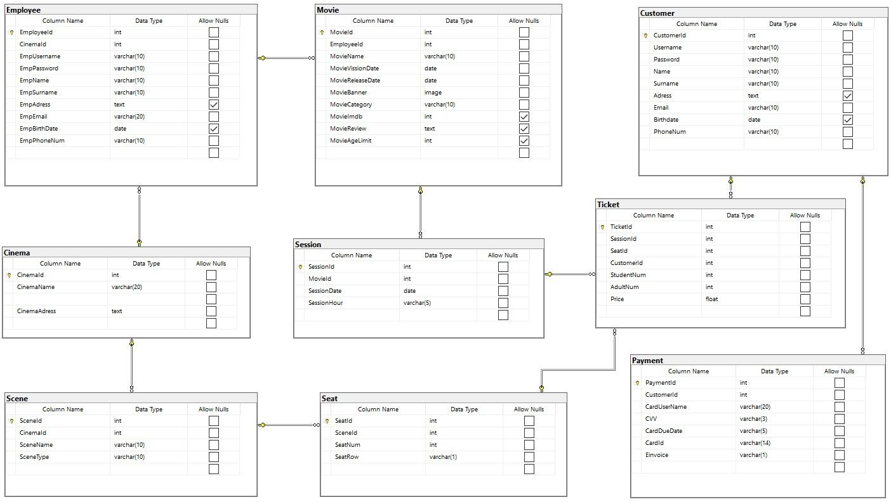

1. **Mock UI Screens**

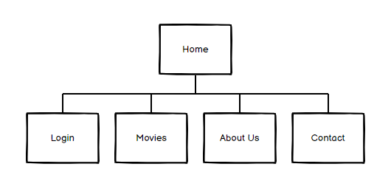

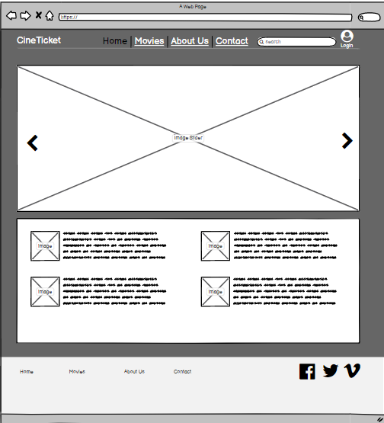

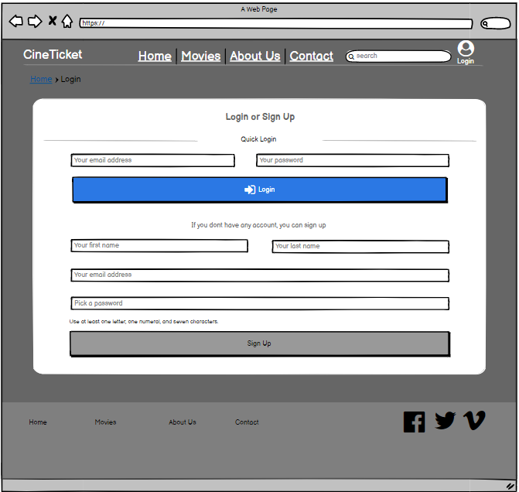

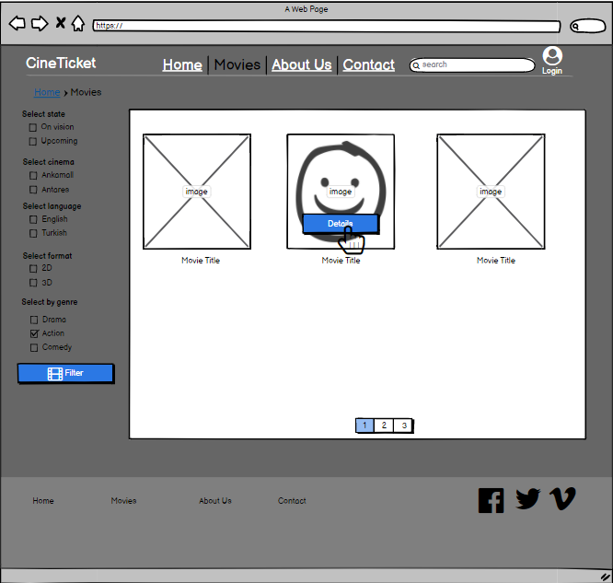

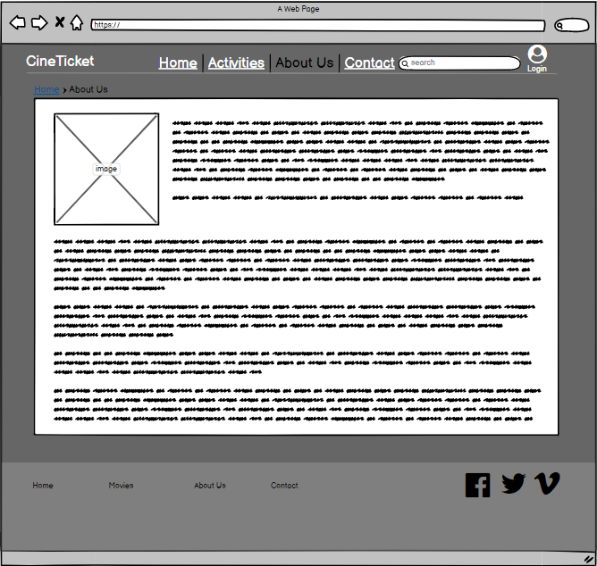

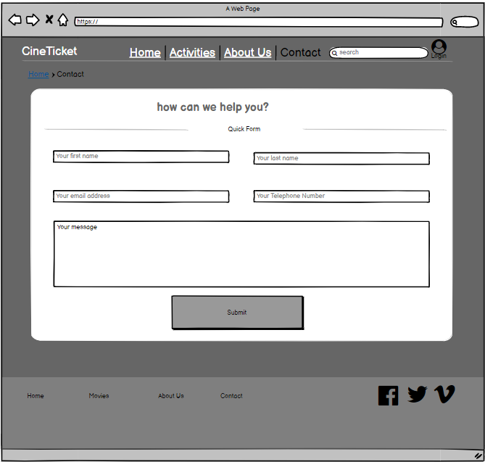

**Appendix A: Glossary**

*MVC – Model View Controller*

*SQL – Structured Query Language*

*TCP/IP – Transmission Control Protocol/Internet Protocol*

*SMTP – Simple Mail Transfer Protocol*

*HTTP – Hyper Text Transfer Protocol*