M04: Final Project Planning Assignment

(2021-9-14) dwilson

**Description**

The program will be designed around purchasing donation amounts for items for animal shelters. Primarily, the purchases will be shipped to a shelter of one’s choosing, with an option to receive a thank you letter from the organization.

**Selection Form**

Main form contains donation items to pick from – one to all items may be selected:

* Animal Food ($10)
* Toys ($15)
* Blankets ($20)
* Medicine ($30)
* Medical Services ($50)

The user may also choose *one* organization of their choice they would like to have the amount donated to:

* Shelter 1
* Shelter 2
* Shelter 3

The user may then enter their address credentials if they wish to receive a physical thank you letter from their organization of choice. (Additional fee of $1)

* Address

The user will be required to enter their email and name for order confirmation:

* Full Name
* Email

A [Clear] button will clear the selections made

A [Continue] button will continue on to the confirmation page:

**Confirmation Page**

The user will arrive at a confirmation page when all information is submitted. This page will display their information for their validation.

* Selected items listed
* Grand total amount
* Organization chosen
* Elected to receive a thank you note
* Email for order confirmation

A [Cancel] button will be available to close the program.

A [Confirm] button will be available to place the order.

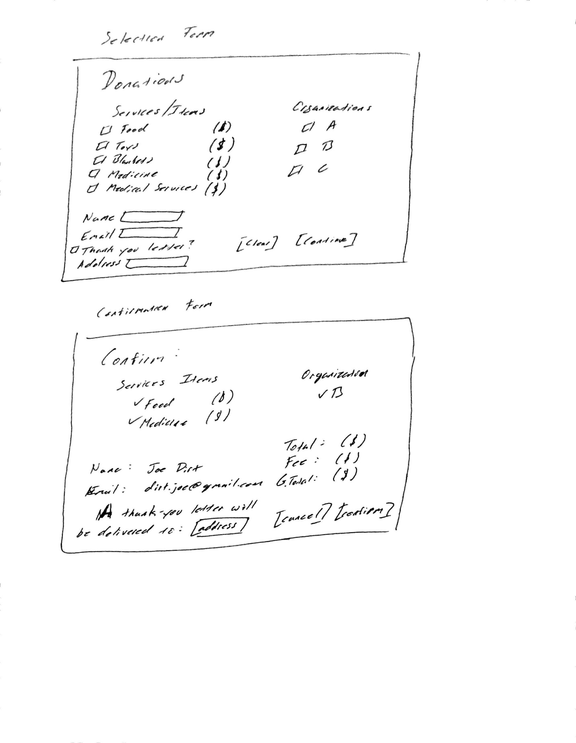

UI Elements:

* First Window
  + lblTitleDonations
  + lblDescription
  + abelFullName
    - txtFullName
  + lblEmail
    - txtEmail
  + btnThankYou – Check for thank you letter
    - labelAddress – When btnThankYou is checked: label displaying Address
      * txtAddress – When btnThankYou is checked: text field for Address
  + btnFood
  + btnToys
  + btnBlankets
  + btnMedicine
  + btnServices
  + btnOrgA
  + btnOrgB
  + btnOrgC
  + btnCancel – Button to clear all other text entry fields
  + btnConfirm – Button to validate, confirm, and move to second window
* Second Window:
  + lblFood
  + lblToys
  + lblBlankets
  + lblMedicine
  + lblServices
  + lblOrgA
  + lblOrgB

Window Positions:

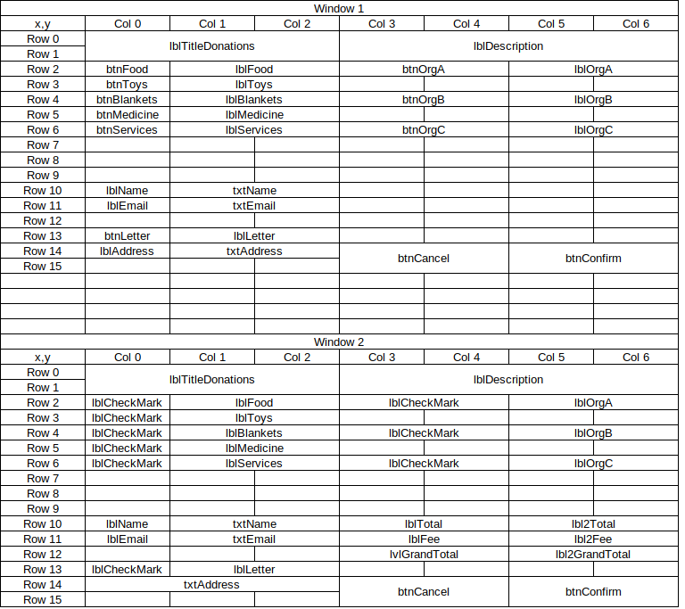

Events:

Selection buttons will be check-mark boxes

Window 1 Confirm button will calculation selected items and progress to Window 2

Window 2 replace applicable check-mark buttons with static check-mark images

Window 2 will display static labels providing cost amount totals for confirmation.

Window 2 Confirm button will finalize order.

Validation:

txtName will be registered as a string

txtEmail must validate as a correct email address ([email@domain.tld](mailto:email@domain.tld))

Window 1 btnConfirm will check/validate for at least one donation item selected, only ONE organization selection, and an address entered when btnLetter is selected.

Branding:

* Primary colors will be Blue and White.
* First window will be a checkered-pattern of blue and white squares.
* Second window will be identical to the first, except the colors will be inverted with each other.
* Company logo will consist of an animal print stamp in black; located in the upper right corner.