Thank you for participating in the Fur-Get Me Not Charity Drive. The associated program will allow a donor to select any number of items from our predetermined list, and any of the five organizations we have aligned this campaign for.

When completing the form, one of each item options you selected will be donated to each of the organization. (i.e., if you select Pet Food, Organization A, and Organization B: you will be charged $20 for two donations of Pet Food, with one going to each A and B.)

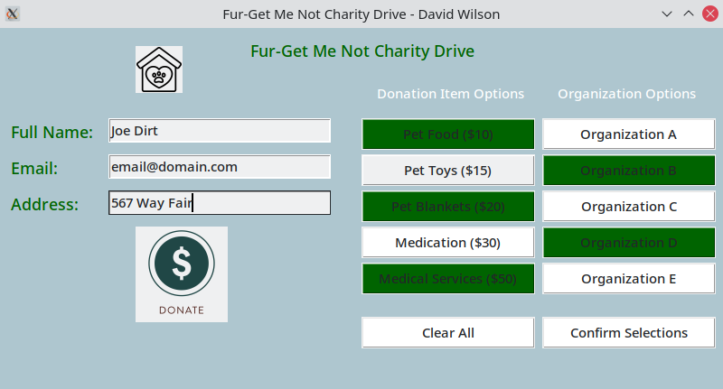

The main screen will contain three entry fields for your Full Name, Email, and Address.

Full Name requires your first and last name.

Email requires an email address in the format of [email@domain.tld](mailto:email@domain.tld)

The address field accepts only three-part formatted addresses, in the format of ### AAA BBB

You may select any number of Donation Items for your Organizations of choice, of which you may select any amount of Organizations as well.

Press Confirm Selections to continue to the Confirmation Window.

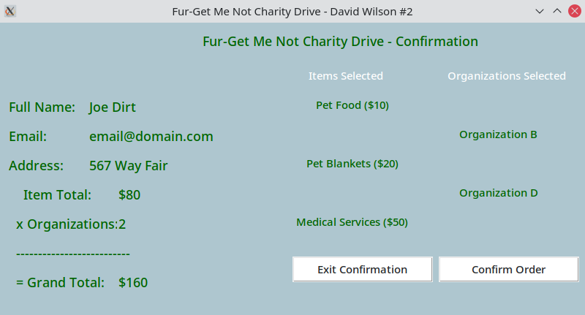

Among the confirmation window will be all the Items and Organizations you selected in the previous window, as well as a calculated total cost.

Pressing Exit Confirmation will close the application.

Pressing Confirm Order will confirm your order.