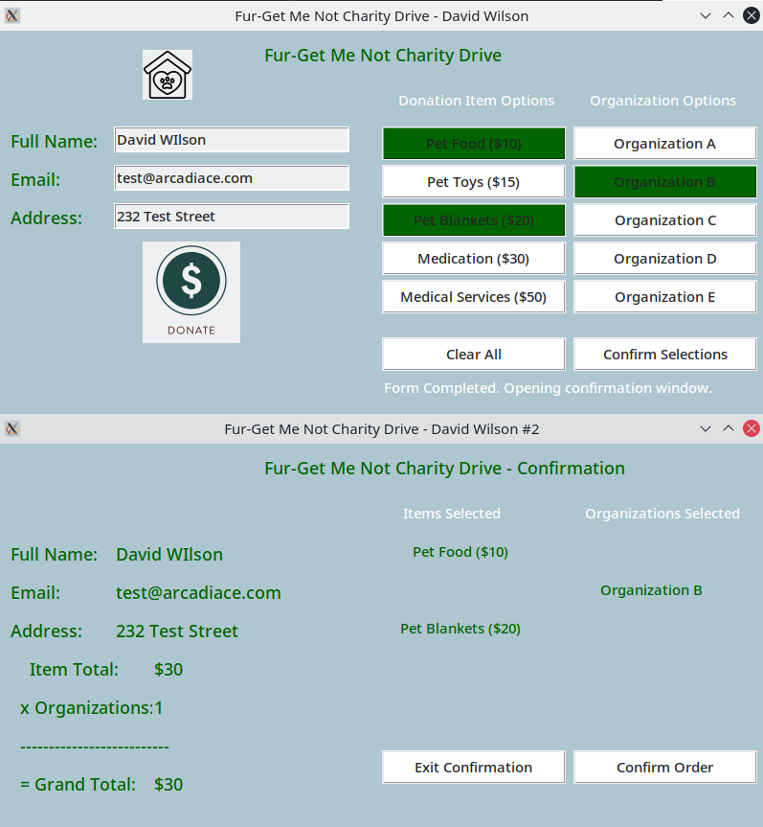

Calculates correctly, succeeds all data entry tests.

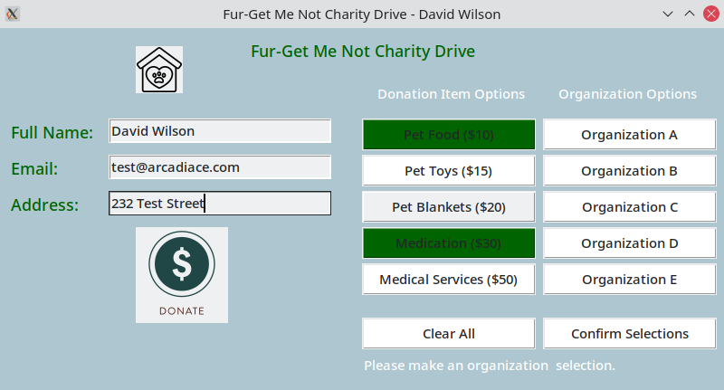

No organization selected

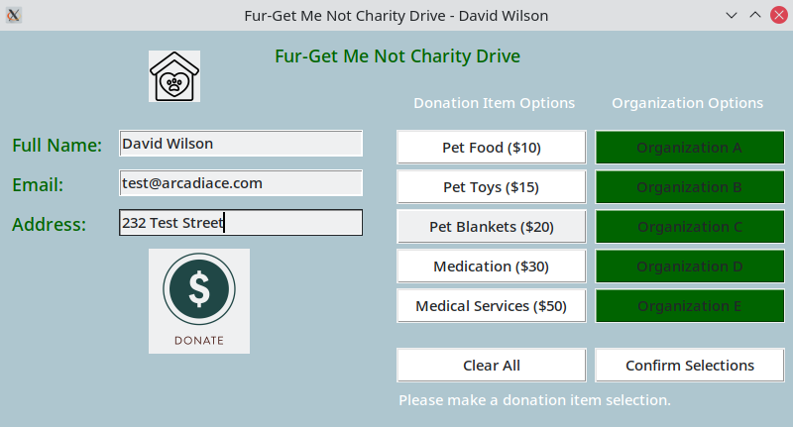

No donation items selected



tld missing from email validation

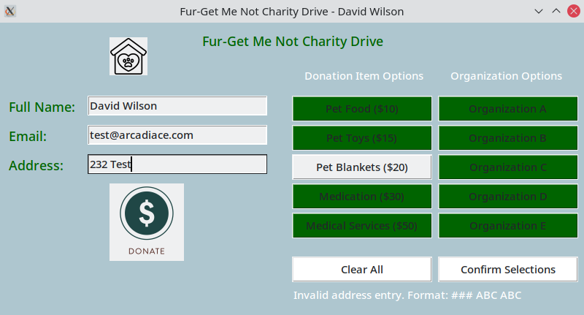

Incorrect address format

Testing selection output with Confirm Selections button | print()

Test function buttons for toggle ON/OFF | green/white state, incrementing and decrementing price

Changed price calculation in ContinueMain function to test for button states | Removed global variable

Test Clear All button for clearing button state and price variable

Tested various item and organization combinations for calculation total

Test various entry data for text entry fields