Screenshot of build first failing because of permissions:

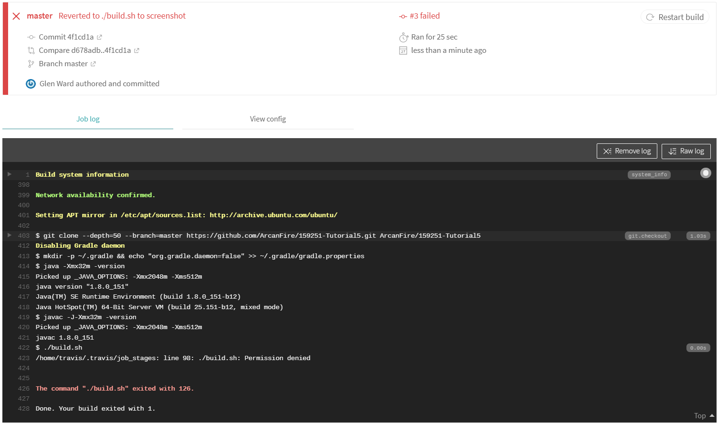

Changed './build.sh' to 'chmod +x build.sh && ./build.sh':

