

CSE370: Database Systems
Project Report
Project Title: Project Title Here

Group No: _2_, CSE370 Lab Section : _6_, Spring 2024
ID | Name | Contribution
20221032 | Fardeen Rahman | Everything

Table of Contents

Section  No | Content | Page No
1 | Introduction | 3
2 | Project Features | 3
3 | ER/EER Diagram | 4
4 | Schema Diagram | 5
5 | Frontend Development | 6
6 | Backend Development | 7-8
7 | Source Code Repository | 9
8 | Conclusion | 9
9 | References | 9

Introduction

In the ever-evolving digital age, where convenience and efficiency reign supreme, the implementation of robust online shopping databases has become imperative for businesses to thrive. The accompanying Enhanced Entity-Relationship (EER) and relational schema diagrams reflects a meticulously crafted database designed to streamline the complexities of e-commerce operations. This database caters to the intricate relationships between customers, orders, employees, products, and suppliers, encapsulating key details ranging from transaction processing to inventory management. With entities interconnected to reflect real-world interactions and dependencies, the schema is poised to handle multifaceted data, ensuring a seamless shopping experience for the end-user while providing the enterprise with a powerful tool for data-driven decision-making. Through this sophisticated database architecture, we aim to fortify the backbone of online shopping platforms, thus enhancing the capacity to serve a modern, discerning clientele.

Project Features

- Hierarchical Employee Structure
- Customer Management
- Supplier Management
- Inventory Management
- Management of Product Orders and Quantities
- Search Option

ER/EER Diagram

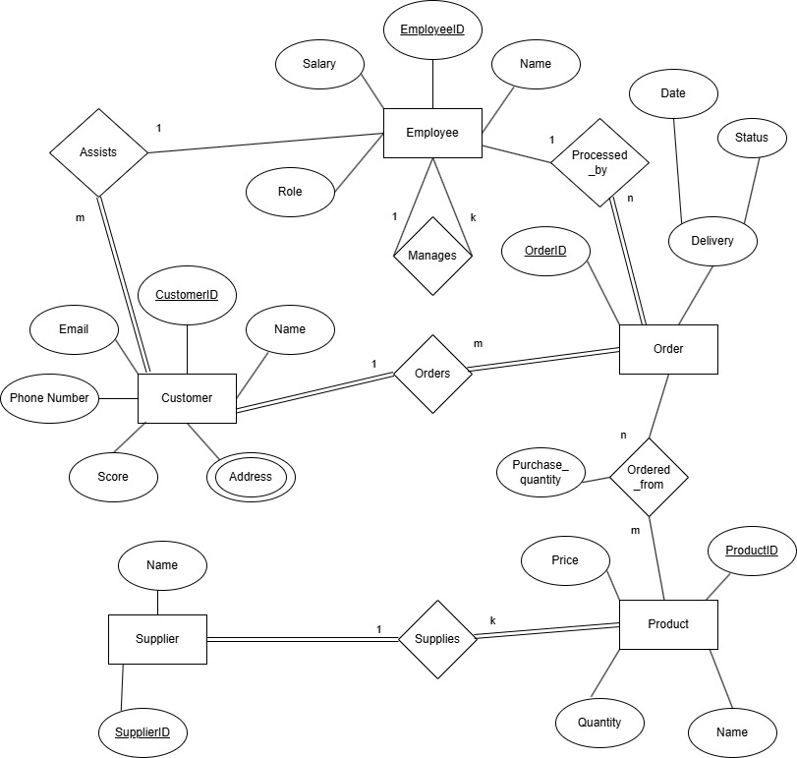

Schema Diagram

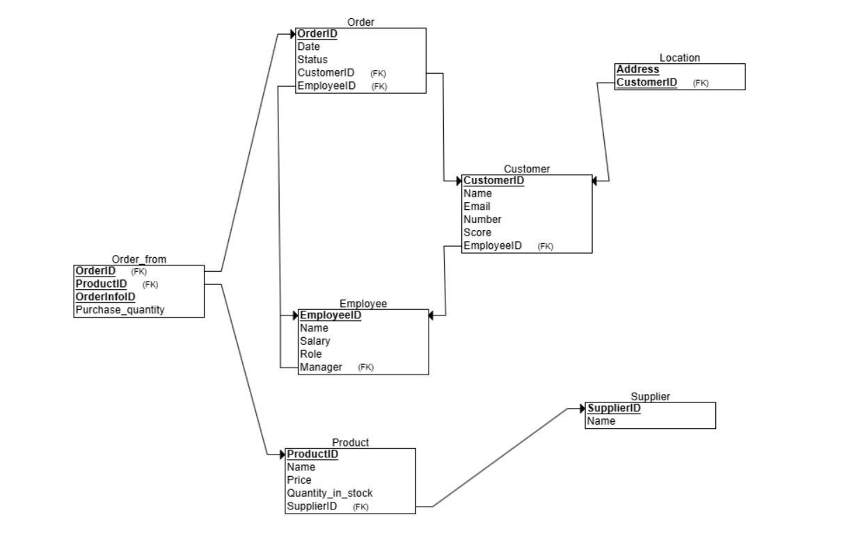

Frontend Development

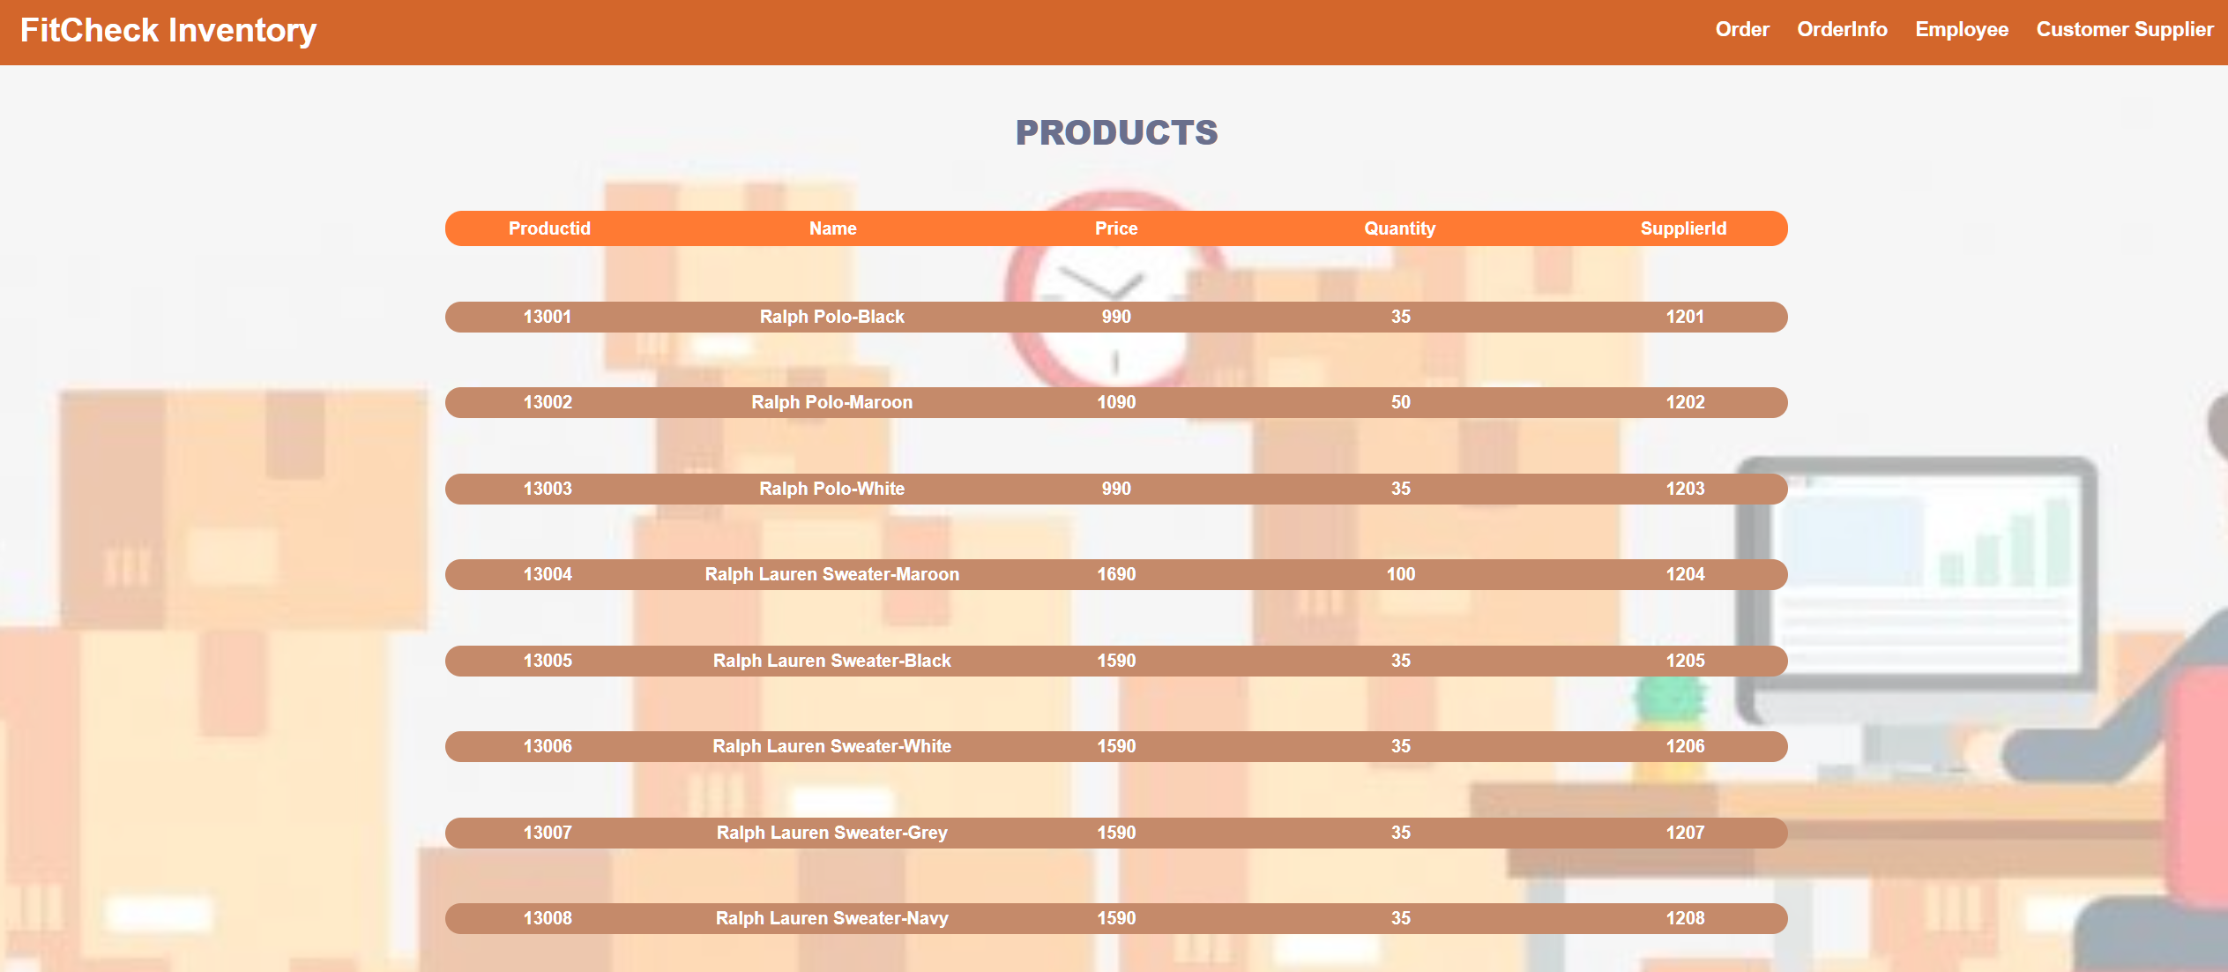

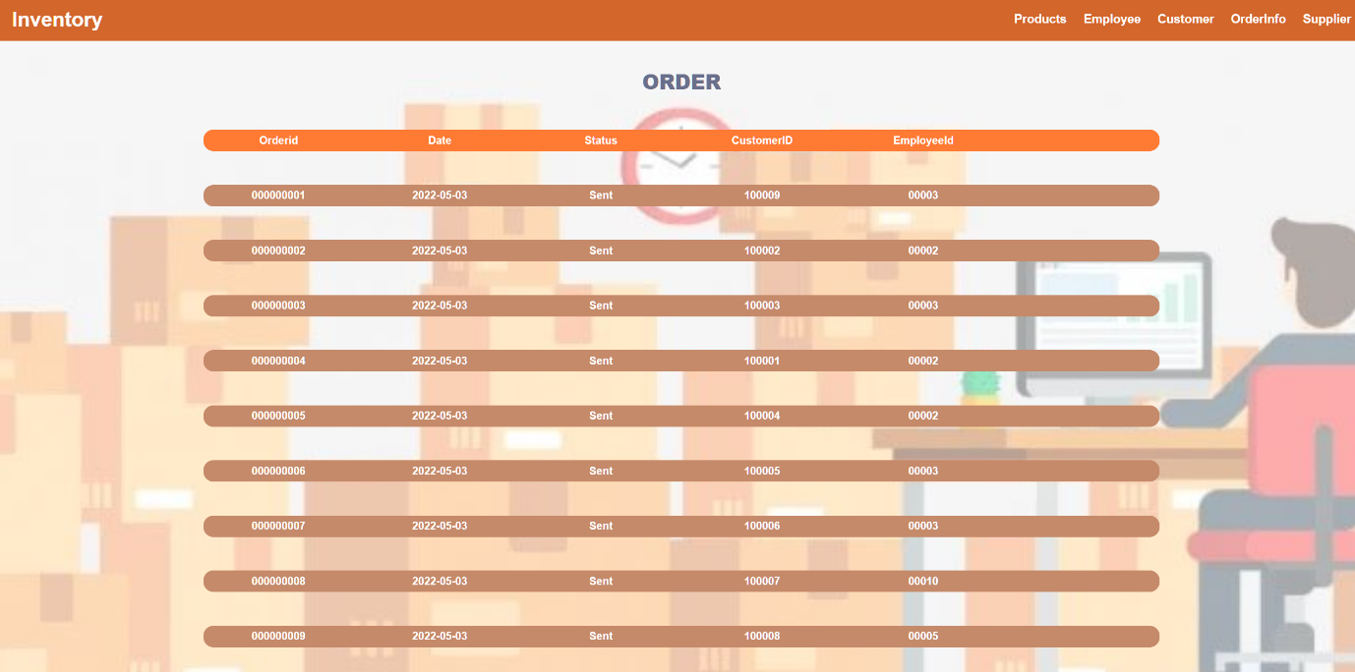

Backend Development

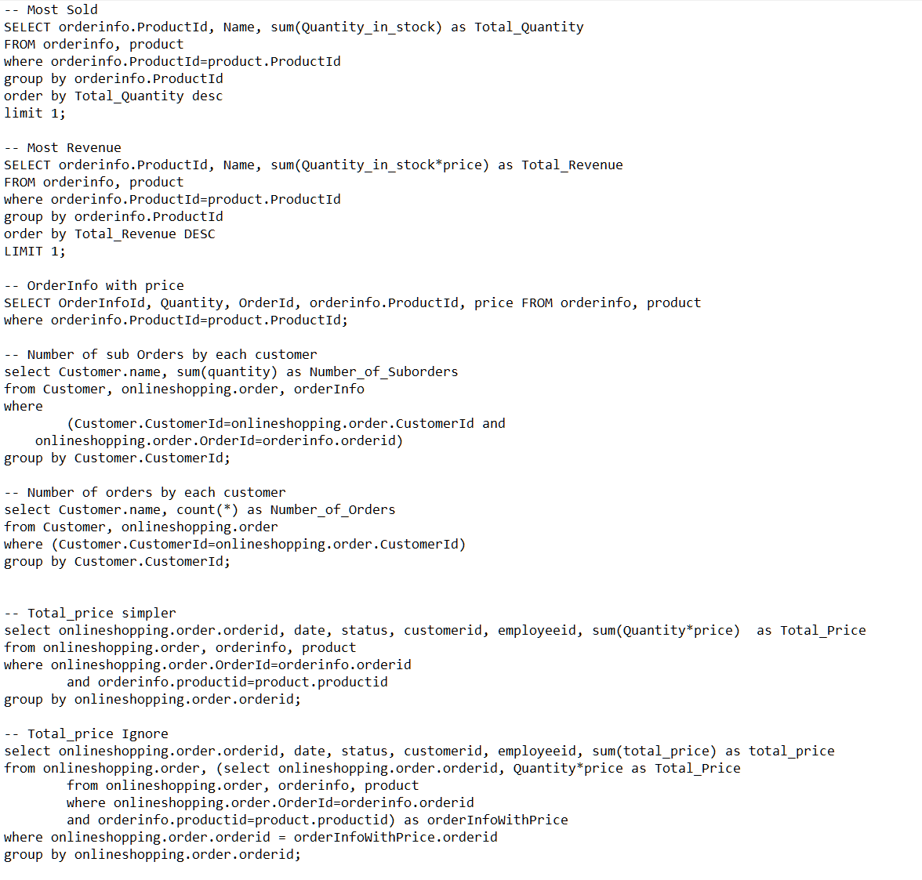

The backend development depicted in the image above showcases a series of SQL queries designed to interact with an e-commerce database. These queries serve various analytical and operational purposes:

- Most Sold: Identifies the product with the highest sales volume by counting the total quantity ordered for each product.
- Most Revenue: Determines which product has generated the most revenue, which is calculated by multiplying the quantity in stock by the product's price.
- OrderInfo with Price: Retrieves detailed order information along with the product price, which is essential for order processing and financial reporting.
- Number of Sub Orders by Each Customer: Provides insight into customer behavior by counting the number of individual suborders placed by each customer, indicating customer engagement levels.
- Number of Orders by Each Customer: Similar to the suborders query, this one focuses on the total number of orders per customer, which could be used for loyalty programs or marketing analysis.
- Total Price Simpler: A summarized view of each order's total price, which could be used for generating invoices or sales reports.
- Total Price More Complex: A more detailed query that calculates the total price of each order, likely accounting for various factors like discounts or different product prices, and it groups the results by order ID, providing a comprehensive financial snapshot of sales transactions.

These queries form the backbone of data retrieval for the inventory system, allowing the business to track sales performance, analyze customer purchasing patterns, and manage financial records efficiently.

Source Code Repository

https://drive.google.com/drive/folders/1LvDIxKkD48XOBXumcwBsZwDKNkPUf5Hp?usp=sharing

Conclusion

The completion of this online shopping database project marks a significant advancement in e-commerce technology. By meticulously crafting an Enhanced Entity-Relationship (EER) database and integrating comprehensive SQL queries, we have created a robust system that simplifies complex e-commerce interactions. This project delivers an intuitive shopping experience for users and a powerful analytical tool for the business, ensuring efficient management of products, orders, and customer data. With this scalable and flexible database, we are set to meet the demands of modern digital commerce, offering a strong foundation for future growth and innovation.

References

ChatGPT4

