

|  |
| --- |
| ***Ahsanullah University of Science & Technology***  Department of Computer Science & Engineering  **FALL 2021** |
| Admission Coaching Management System |
| CSE 3104: Project Proposal |
| Submitted By: |

|  |  |
| --- | --- |
| **ID** | **NAME** |
| 190204058 | Animesh Das Chowdhury |
| 190204060 | Mohammad Tanveer Shams |
| 190204088 | MD. Maruf Rusafi Arnob |
| 190204059 | Tonmoy Banik |

Table of Contents

1. Motivation of the project: 3
2. Project Goal 3
3. Project Cost Calculation 3
4. Potential Customers/Product Market 4
5. Requirement Analysis 4
6. Schema/Tables 5
7. Entity Relationship Diagram 6
8. Project Risks 7
9. SQL 7
10. Contribution 10
11. Conclusion 11

# Motivation of the Project

* Creating a platform for students to get notified about their results and positions.
* Making it easier for the organization to have all the necessary data stored in an organized way.
* Creating a comfort zone for teachers to manage their time schedule for different batches.

# Project Goal

* Ensuring a better environment for handling admission coaching management system.
* Digitalization of Coaching management system.
* Create, store and process more accurate and precise data sets for better analyzing and betterment of the organization.
* To eradicate corruption and ensure transparency among the employees.

# Project Cost Calculation

Time required to complete: 11 weeks.

Considering 4 people working on this project for 11 weeks, 4 days each week, 2 hours per day:

Total working hours: (11x4x2) = 88 hours

Estimated salary for each teammate for each hour: 250 BDT

Besides, side costs like transportation cost, electricity cost, internet bills and other unseen costs (approximately): 12,000 BDT

So, the final cost of the project will be: (250x4x88) + 12,000 = 1,00,000 BDT

For selling the software, we would consider starting price from

* 10,000 BDT per month
* 96,000 BDT per year (20% discount)

# Potential Customers/Product Market

# Entrepreneurs

# Any coaching center

# Basically, any institute willing to conduct admission coaching.

# Requirement Analysis

Some main features of our software are:

* + - Login-Registration: A student can admit to the coaching center through registration and a teacher can apply to the coaching center through registration. Both teacher and student can login to the system and view their details.
    - Branch Enlistment: If our coaching center expands in the future, then a new branch can be enlisted through the system.
    - Batch Management: Enlistments or transfers in different batches as well as formation of new batches can be done through the system.
    - Conducting Exams and Publishing Results: Our system not only manages to conduct classes but also keeps track about exams and results of students.
    - Admin Features: An admin can keep all the records, view and edit them in our system.
    - Appointing and Transferring Teachers: Our system can appoint teachers to a specific batch and can transfer to different batch according to the requirements.
    - Coaching Focus: Our system focuses on Engineering and Engineering + Biology only. A student can admit to only one course.

Software requirements:

* **Front-End:** Apache NetBeans IDE 14
* **Back-End:** SQL Server Management Studio
  1. Schema/Tables

Possible Entities:

|  |  |
| --- | --- |
| * Admin | * Classes |
| * Branch | * Subjects |
| * Student | * Course |
| * Teacher | * Batches |
| * Room | * Exams |
| * Schedule | * Results |

Possible Relationship:

|  |  |
| --- | --- |
| * Manages | * Teach |
| * Admits | * Takes |
| * Has | * Forms |
| * Assigned | * Includes |
| * Appoints | * Publish |
| * Conduct |  |

* 1. 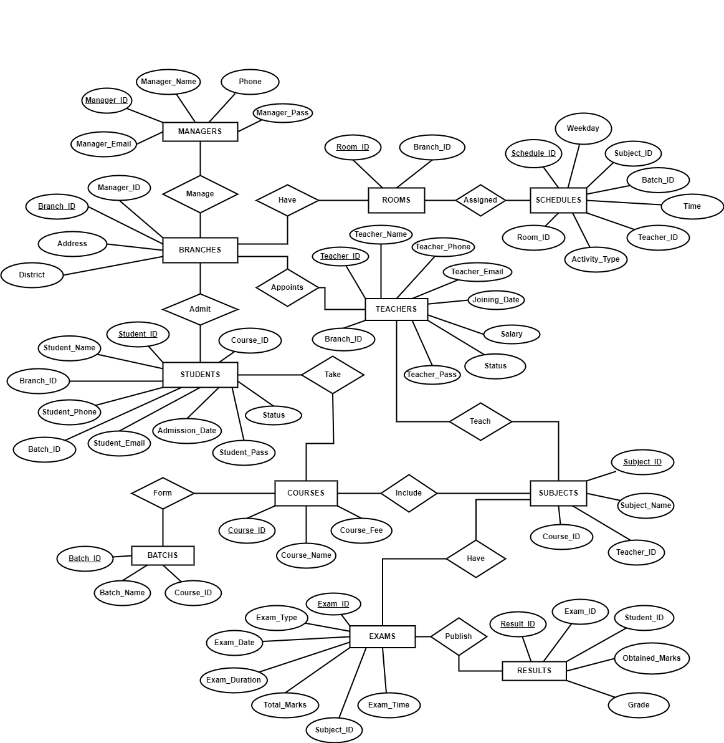 Entity Relationship Diagram
  2. Project Risks
* As time is limited, it might not be possible to fully implement the idea due to inexperience and lack of skills.
* As we are in a pandemic situation, COVID infection may hamper our progression of work.
  1. SQL

**/*LOGIN-REGISTRATION*/**

SELECT * FROM STUDENTS WHERE student_id="+UserID+" AND student_pass='"+Password+"'

SELECT * FROM TEACHERS WHERE teacher_id="+UserID+" AND teacher_pass='"+Password+"'

INSERT INTO STUDENTS VALUES('" + name + "','" + mobile + "','" + email + "','" + dtf.format(now) + "'," + courseid + ",'" + batchid + "','" + branchid + "','" + pass + "','UNREGISTERED')

INSERT INTO TEACHERS VALUES('" + name + "','" + email + "','" + mobile + "','25000','" + dtf.format(now) + "','" + branchid + "','" + pass + "','UNREGISTERED')

select course_name from COURSES

select branch_name from BRANCHES

SELECT * FROM COURSES WHERE course_name='"+course+"'

SELECT * FROM BATCHS WHERE batch_name='"+batch+"'

SELECT * FROM BRANCHES WHERE branch_name='"+branch+"'

SELECT batch_name FROM BATCHS INNER JOIN COURSES ON BATCHS.course_id=COURSES.course_id WHERE COURSES.course_name='"+coursename+"';

**/*STUDENT PART*/**

UPDATE STUDENTS SET student_name=?,student_email=?,student_phone=? WHERE student_id=?

SELECT * FROM STUDENTS WHERE student_id=?

SELECT * FROM BATCHS WHERE batch_id=?

SELECT * FROM COURSES WHERE course_id=?

SELECT * FROM BRANCHES WHERE branch_id=?

SELECT subject_id,subject_name,teacher_name,teacher_email,teacher_phone FROM SUBJECTS INNER JOIN TEACHERS ON SUBJECTS.teacher_id=TEACHERS.teacher_id WHERE course_id=?

SELECT exam_date as Exam_Date,subject_id as Subject,exam_total_marks as Total_Marks,result_obtained_marks as Obtained_Marks,result_grade as Grade,exam_type as Type FROM RESULTS INNER JOIN EXAMS ON RESULTS.exam_id=EXAMS.exam_id WHERE student_id=?

SELECT schedule_starting_time as Start_Time,schedule_activity_type as Activity,subject_id as Subject,room_id as Room,teacher_name as Teacher FROM SCHEDULES INNER JOIN TEACHERS ON SCHEDULES.teacher_id = TEACHERS.teacher_id WHERE schedule_weekday = ? and batch_id = ?

**/*TEACHER PART*/**

UPDATE TEACHERS SET teacher_name=?,teacher_email=?,teacher_phone=? WHERE teacher_id=?

SELECT * FROM TEACHERS WHERE teacher_id=?

SELECT course_id,subject_id, subject_name FROM SUBJECTS WHERE teacher_id = ?

SELECT subject_id,subject_name,teacher_name,teacher_email,teacher_phone FROM SUBJECTS INNER JOIN TEACHERS ON SUBJECTS.teacher_id=TEACHERS.teacher_id WHERE course_id=?

SELECT exam_date as Exam_Date,student_id as Student_ID, exam_total_marks as Total_Marks,result_obtained_marks as Obtained_Marks,result_grade as Grade,exam_type as Type FROM RESULTS INNER JOIN EXAMS ON RESULTS.exam_id=EXAMS.exam_id INNER JOIN SUBJECTS ON SUBJECTS.teacher_id = ?

SELECT schedule_starting_time as Start_Time,schedule_activity_type as Activity,subject_id as Subject,room_id as Room,teacher_name as Teacher FROM SCHEDULES INNER JOIN TEACHERS ON SCHEDULES.teacher_id = TEACHERS.teacher_id WHERE schedule_weekday = ? and SCHEDULES.teacher_id = ?

**/*MANAGER PART*/**

SELECT S.subject_name, C.course_name

FROM SUBJECTS S

FULL JOIN COURSES C

ON S.course_id = C.course_id

WHERE S.teacher_id = 2022030001;

SELECT S.subject_name, C.course_name FROM SUBJECTS S FULL JOIN COURSES C ON S.course_id = C.course_id WHERE S.teacher_id = ?;

SELECT T.teacher_id, T.teacher_name, T.teacher_phone, T.teacher_email, T.teacher_joining_date, T.teacher_reg_status, B.branch_name

FROM TEACHERS T

LEFT JOIN BRANCHES B

ON T.branch_id = B.branch_id

WHERE T.teacher_id=2022030001;

SELECT T.teacher_id, T.teacher_name, T.teacher_phone, T.teacher_email, T.teacher_joining_date, T.teacher_reg_status, B.branch_name

FROM TEACHERS T

LEFT JOIN BRANCHES B

ON T.branch_id = B.branch_id

WHERE T.teacher_id=?

SELECT *

FROM MANAGERS M

LEFT JOIN BRANCHES B

ON M.manager_id = B.manager_id

WHERE M.manager_id=?

SELECT S.student_id as ID,S.student_name as Name,S.student_phone as Phone,S.student_email as Email,S.student_admission_date as Admission_Date,C.course_name as Course, BA.batch_name as Batch, BR.branch_name as Branch

FROM STUDENTS S

INNER JOIN COURSES C ON C.course_id=S.course_id

INNER JOIN BATCHS BA ON BA.batch_id=S.batch_id

INNER JOIN BRANCHES BR ON BR.branch_id = S.branch_id

WHERE S.student_reg_status = 'UNREGISTERED'

SELECT T.teacher_id as ID,T.teacher_name as Name,T.teacher_phone as Phone,T.teacher_email as Email,T.teacher_joining_date as Joining_Date,T.teacher_salary as Salary, BR.branch_name as Branch

FROM TEACHERS T

INNER JOIN BRANCHES BR ON BR.branch_id = T.branch_id

WHERE T.teacher_reg_status = 'UNREGISTERED'

UPDATE TEACHERS

SET teacher_reg_status = 'UNREGISTERED'

WHERE teacher_id = 2022030002

select * from TEACHERS

select * from BRANCHES

select * from STUDENTS

select T.teacher_name,T.teacher_email,T.teacher_phone,T.teacher_salary,T.teacher_joining_date,B.branch_name

FROM TEACHERS T

INNER JOIN BRANCHES B

ON T.branch_id = B.branch_id

WHERE T.teacher_id = 2022030001

**/*ADMIN PART*/**

SELECT branch_id,branch_name,branch_address,branch_district,manager_name FROM BRANCHES B INNER JOIN MANAGERS M ON M.manager_id=B.manager_id

UPDATE BRANCHES set branch_name=?,branch_address=?,branch_district=?,manager_id=? WHERE branch_id=?

SELECT batch_id,batch_name,course_name FROM BATCHS B INNER JOIN COURSES C ON C.course_id=B.course_id

SELECT subject_id,subject_name FROM SUBJECTS WHERE course_id=?

UPDATE BATCHS set batch_name=?,course_id=? WHERE batch_id=?

SELECT exam_id,exam_type,exam_date,exam_duration,exam_total_marks,subject_id,exam_time FROM EXAMS

SELECT manager_id,manager_name,manager_phone,manager_email FROM MANAGERS

INSERT INTO BRANCHES VALUES(?,?,?,?)

* 1. Contribution
* Animesh Das Chowdhury (190204058) (27%)
* ERD
* Login (Backend)
* Registration (Backend)
* Table Design
* Manager Part
* Tonmoy Banik (190204059) (25%)
* ERD
* Teacher Part (Frontend)
* Teacher Part (Backend)
* Table Design
* Admin and Manager (Backend)
* Mohammad Tanveer Shams (190204060) (28%)
* ERD
* Student Part (Frontend)
* Student Part (Backend)
* Table Design
* Admin Part
* Maruf Rusafi Arnob (190204088) (20%)
* ERD
* Table Design
* Splash Screen and Logo Design
* Login and Registration (Frontend)
* SQL Part
  1. Conclusion

The aim to build this software is to utilize database management system and implement it in our daily life to make our life-style easier. In our country, admission coaching is a career deciding step for students and the demand of an organized admission coaching center is high. To maintain the reputation and educational quality, a coaching center must have to be well maintained, organized and transparent. Our project will save a lot of time for the coaching center, digitalize their entire record and relieve them from the hassle of maintaining all data manually.